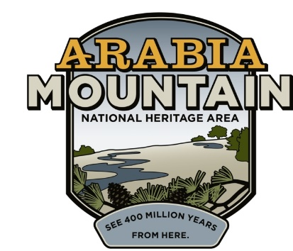Media Contact: Jeff Dingler, Communications Manager

Arabia Mountain Heritage Area Alliance

p: 678-699-2768 | e: jeff@arabiaalliance.org

FOR IMMEDIATE RELEASE

**August 5, 2025**

**Arabia Alliance Receives $80,000 Rivian Foundation Grant**

*The Rivian Foundation’s support is helping the Arabia Mountain Heritage Area Alliance to restore key cultural and ecological sites, including Oak Grove Junction Store and the historic Ragsdale House.*

**LITHONIA & STONECREST, GA** – The Arabia Mountain National Heritage Area just got a big boost in its mission to preserve and protect cultural, historical and ecological resources in the southeast Metro Area. The Arabia Alliance announced this week that it had received an $80,000 grant from the [Rivian Foundation,](https://rivianfoundation.org/) a nonprofit that supports high-impact efforts to protect and restore wild lands, waterways, oceans, and safeguard our climate.

Divvied out over a two-year period, the money from this grant will help the Arabia Alliance restore key cultural and ecological sites, including the Oak Grove Junction Store and the Ragsdale House, both in Stonecrest, making them hubs for engagement with nature. The Oak Grove Junction Store is a century-old gas station/corner store clad in Arabia Mountain stone; and the Ragsdale House is one of the oldest extant homes in DeKalb County and in dire need of stabilization and preservation.

The Arabia Alliance’s Executive Director Revonda Cosby and Assistant Executive Director Brigette Jones applied for the grant. “PJ Simmons, Executive Director of the Rivian Foundation, reached out to us, and I was wowed,” said Arabia Alliance Executive Director Revonda Cosby. “Brigette and I were tasked with trying to find more funding for the Arabia Alliance, and the Rivian Foundation was just that for us, and they supported a lot work that was very similar to what we were already doing. And that’s what inspired Brigette and I to submit the application.”

The grant will also enable the Arabia Alliance to expand outdoor education infrastructure for all ages, such as dedicated outdoor teaching spaces, e-bike programs, and improved trail access throughout the Heritage Area’s 40,000 acres to better serve local schools and groups. Additionally, the Rivian Foundation’s funding will support the launch of youth-focused programs like internships and interpretive training, and strengthen community engagement efforts that celebrate Black history, cultural identity, and the lived experiences of local residents through festivals, story-sharing, and interactive events.

“It’s a thrill,” said Brigette Jones about winning the competitive grant. “The mission of the Arabia Mountain Heritage Area Alliance is to protect, connect, and share the powerful history, rich culture, and engaging landscapes of this National Heritage Area for the benefit and enjoyment of all. Our vision for this work is to bring people from all walks of life to the NHA to explore, engage, and immerse themselves in 400 million years of history.”

The Arabia Mountain Heritage Area Alliance works to protect, connect, and share the ecological and cultural assets of the 40,000-acre Arabia Mountain National Heritage Area just east of Atlanta, Georgia. With a focus on inclusive storytelling and equitable access to nature, the Alliance brings to life the region’s rich history and biodiversity through community events, interpretive programs, and land stewardship across three counties: DeKalb, Rockdale and Henry. More info at [arabiaalliance.org](https://arabiaalliance.org/).