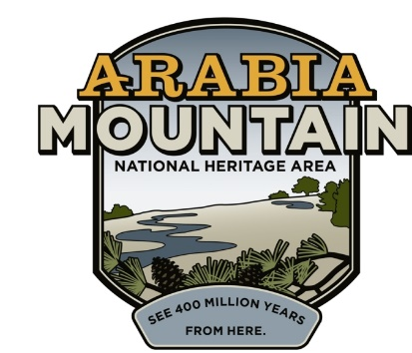
Media Contact: Jeff Dingler, Communications Manager
Arabia Mountain Heritage Area Alliance
p: 678-699-2768 | e: jeff@arabiaalliance.org

FOR IMMEDIATE RELEASE
Mar. 24, 2023

Junior Ranger Day 2023 To Highlight Local Wonders

Arabia Mountain Heritage Area Alliance and its partners will offer a fair-like day of hands-on learning about nature, culture and history.

STONECREST, GA – The Arabia Mountain Heritage Area Alliance is excited to host Junior Ranger Day 2023 at Panola Mountain State Park’s nature center. Junior Ranger Day is the kickoff of National Parks Week across the country, and the Arabia Alliance is glad to be hosting this event right here in Arabia Mountain National Heritage Area just 30 minutes east of Atlanta. It will be a fun-filled, fair-like day to invite young people to be stewards of the world around them and engage in the wonders of nature, culture and history so close to home in the national heritage area.

“I always look forward to Junior Ranger Day,” said Robby Astrove, long-term Preserve Manager for Davidson-Arabia Mountain Nature Preserve. “We’ll have several stations from National Heritage Area partners providing hands-on learning and experiences for young curious rangers. It’s a great opportunity for them to get their hands dirty and discover history, culture, and nature in their own backayrd.”

Children of all ages and their adults are welcome to join as they learn about the National Heritage Area in their backyard through a number of “Junior Ranger Stations,” each one operated by a different partner of the Arabia Alliance. Participants will plant sunflowers with a naturalist from the City of Stonecrest; help make stained glass with a monk from the Monastery of the Holy Spirit; explore ecology and geology with rangers of Panola and Arabia Mountain Parks; and learn about the area's wildlife and how to keep it safe with AWARE Wildlife Rescue and much more! Here is a general schedule of the day.

8:30 - Partner arrival and set up
9:30-10:00 - Participants arrival, check-in, welcome
10:00-11:30 - Station Rotations (5-6 stations)
11:30-12:00 - Pledge Ceremony
12:00 - Partner cleanup and depart

The event lasts from 9:30 am - 12:00 noon on Earth Day, Saturday, April 22, 2023. Tickets are $5 for kids (free for adults) and can be purchased here. Registration includes a Junior Ranger notepad, certification, and badge. Panola Mountain State Park charges $5/car for parking without a GA State Park pass.

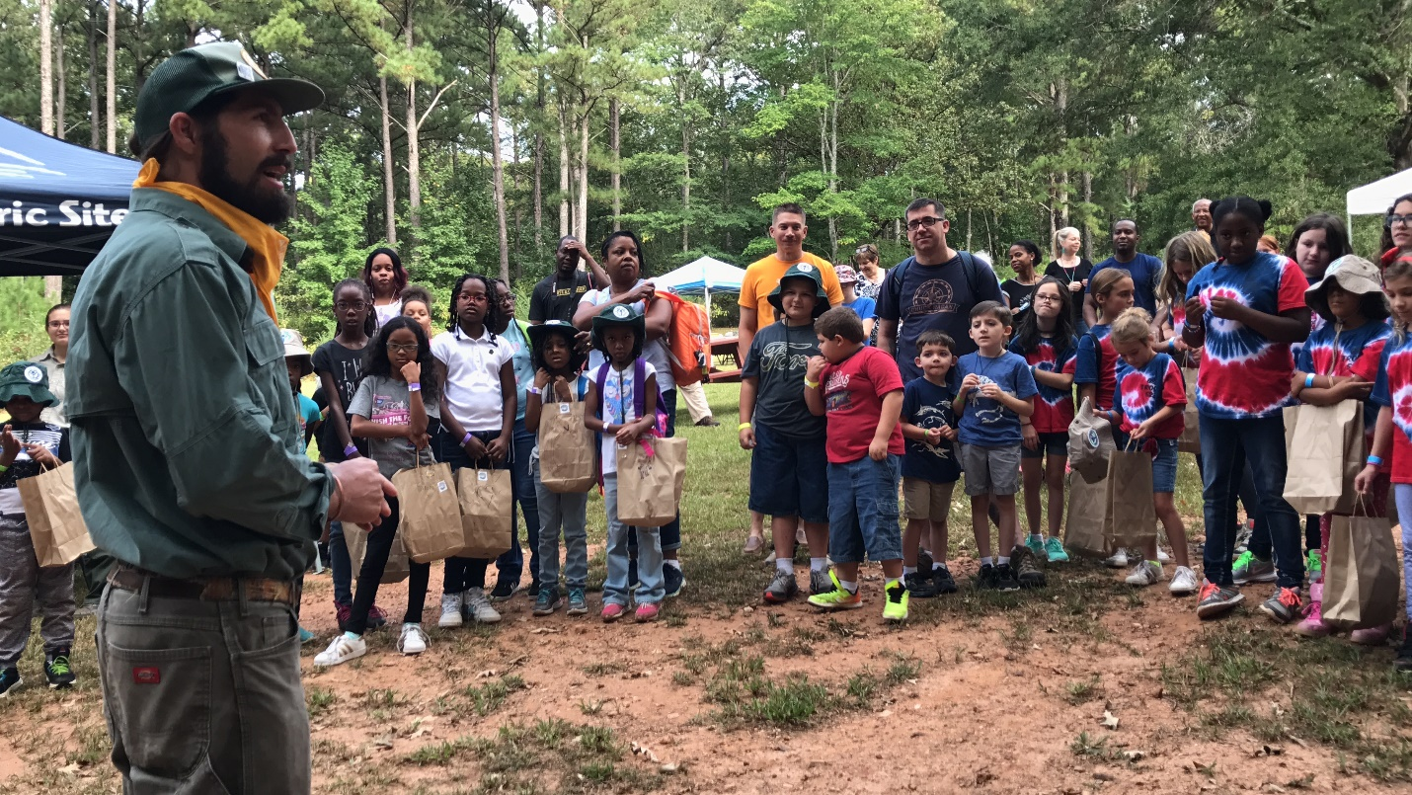
Ranger Robby Astrove and other Davidson-Arabia Mountain Nature Preserve Staff will guide children through the event.

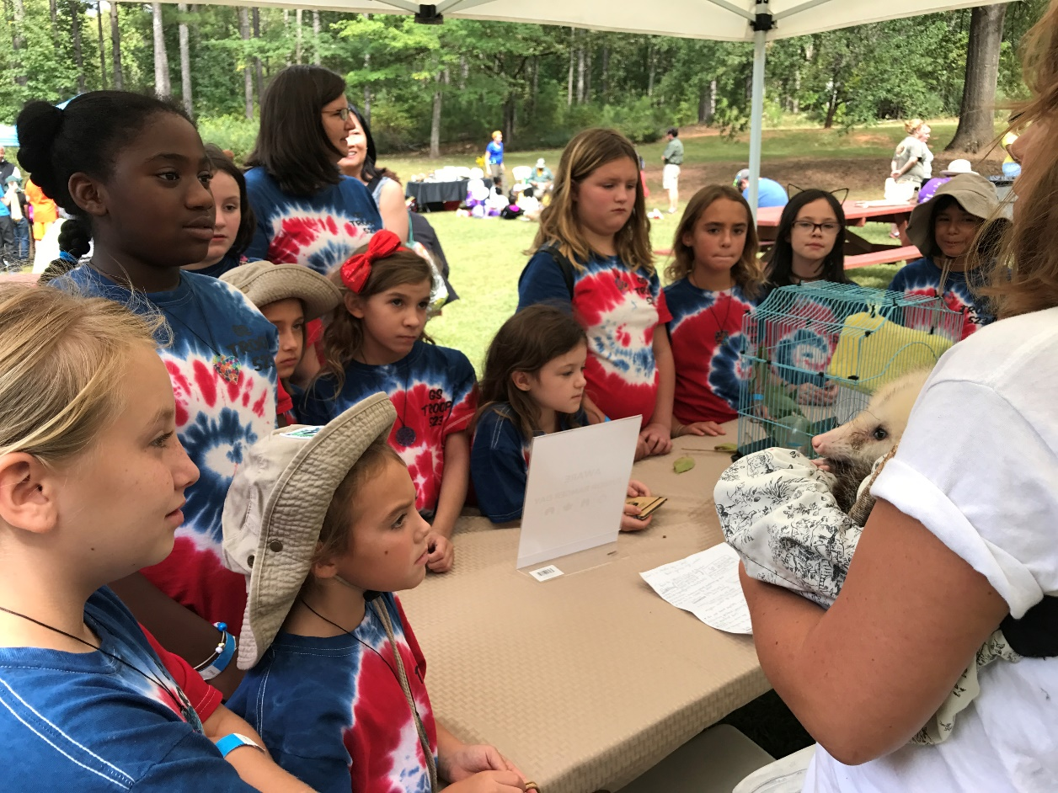
Kids will have the opportunity to learn about Georgia’s native wildlife with volunteers from the Atlanta Wild Animal Rescue Effort (AWARE).

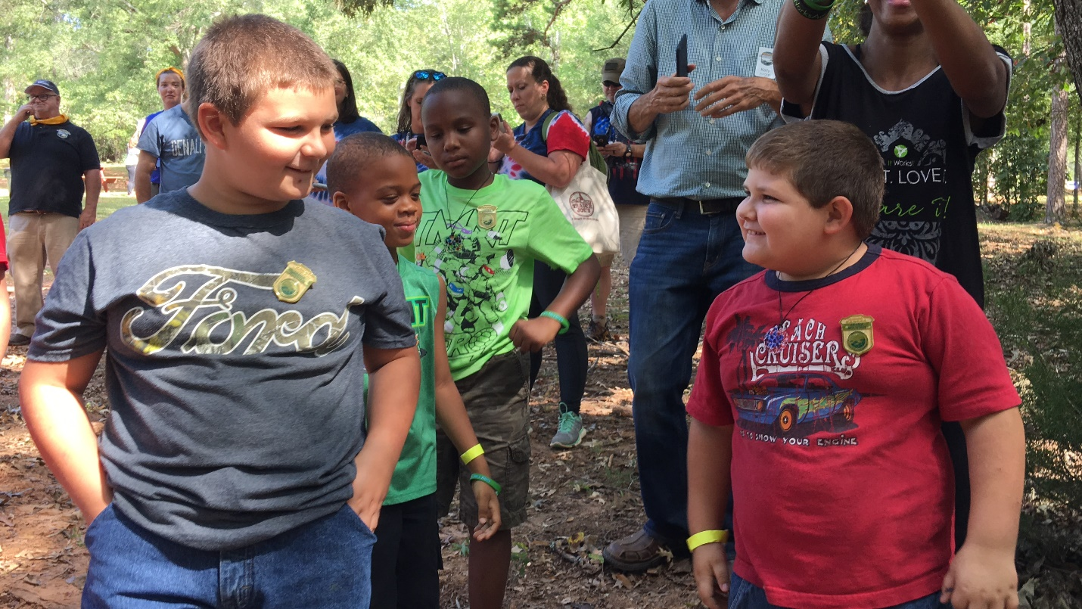
Newly-minted Junior Rangers sport their badges. Junior Ranger Day ends with a hike and swearing-in at Arabia Mountain.

Flyer for this year’s Junior Ranger Day, taking place on April 22nd from 9:30am to 12pm.

###

About the Arabia Alliance
The Arabia Mountain Heritage Area Alliance is dedicated to protecting, connecting and sharing the unique history, rich culture and engaging landscapes of the Arabia Mountain National Heritage Area (AMNHA) for the benefit and enjoyment of all. The staff and volunteer board of the Arabia Alliance work with partners across the AMNHA to ensure that everyone can benefit from the cultural and natural resources of the National Heritage Area. For more information, visit www.arabiaalliance.org.

