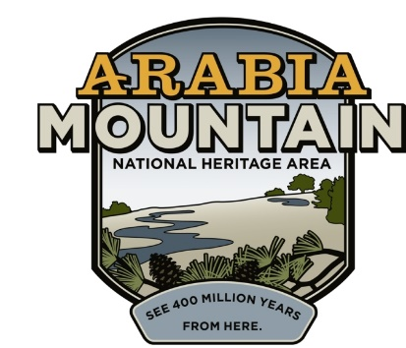
Media Contact: Jeff Dingler, Communications Manager
Arabia Mountain Heritage Area Alliance
p: 678-699-2768 | e: jeff@arabiaalliance.org

RELEASE DATE:
Mar. 15, 2023

$100K “Capital Campaign” for Bruce Street School Restoration Kicks Off On March 30th
The amount raised will clean up the school’s ruins for a future transformation into an open-air, community events space.

LITHONIA, Ga. – From the ruins comes history. Arabia Mountain Heritage Area Alliance is on a mission to transform the historic Bruce Street School (BSS), DeKalb County’s oldest free Black school, into an amphitheater and versatile community events center. At 1 pm, in front of the signature granite façade of the dilapidated school building, Revonda Cosby, Executive Director of the Arabia Alliance, will announce the launch of the BSS Capital Campaign. The kick-off will include a short parade in Lithonia from Union Mission Baptist Church to the East DeKalb at Bruce Street Senior Center with a local high school band, cheerleaders, and a fire truck. The fundraiser aims to raise $100,000 over several months to begin the preservation and revitalization of the structure that has languished for decades.

“This money is probably the most important penny on the project because it comes from the community,” said Cosby about the Capital Campaign. “It will singularly fund Phase 2 so that we can clean up and reclaim everything archeologists can find at this historic place. Once completed, we are shovel-ready and look forward to a partnership with DeKalb County and the City of Lithonia.”

When finished, the Bruce Street School will be reimagined as a multi-use, open-air structure with a picnic area, community garden, and food forest. An amphitheater will be formed within the walls of the historic building. At the opposite end, a more intimate and flexible gathering space will create a peaceful setting for small groups and classes.

“I’m so excited about it,” said Alene Harper, who went to school at the old stone structure from 4th through 11th grade before graduating in1956 from a new school that was built across the street. “I have so many memories there and I’m so looking forward to seeing the outcome of what the ruins are going to turn out to be. I'm just happy that I lived long enough to see this happen.”

Built through grassroots sweat and hard work, the Bruce Street School was the first African-American public school in DeKalb County and one of the oldest in the state. While the stone school (also known as “the old school building”) was built in the late 1930s from granite stones brought over from the local quarry, the Bruce Street School’s history of community-led education efforts goes back to the 1880s. The building ruins next to the East DeKalb at Bruce Street Senior Center stand as a legacy to African-American education, endurance and empowerment. Donations will be accepted through July 31st and can be made online at arabiaalliance.org.

###
About Arabia Alliance
The Arabia Mountain Heritage Area Alliance is dedicated to protecting, connecting and sharing the powerful history, rich culture and engaging landscapes of the Arabia Mountain National Heritage Area (AMNHA) for the benefit and enjoyment of all. The staff and volunteer board of the Arabia Alliance work with partners across the AMNHA to ensure that everyone can benefit from the cultural and natural resources of the National Heritage Area. For more information, visit www.arabiaalliance.org.

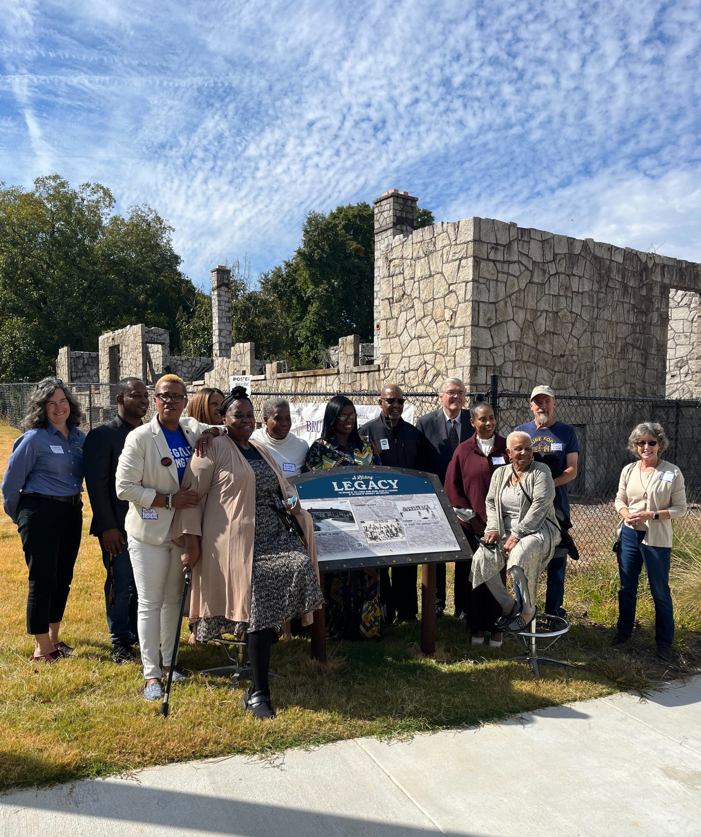

Above: A new historical sign in front of the old Bruce Street School that was unveiled in November 2022.

- more -

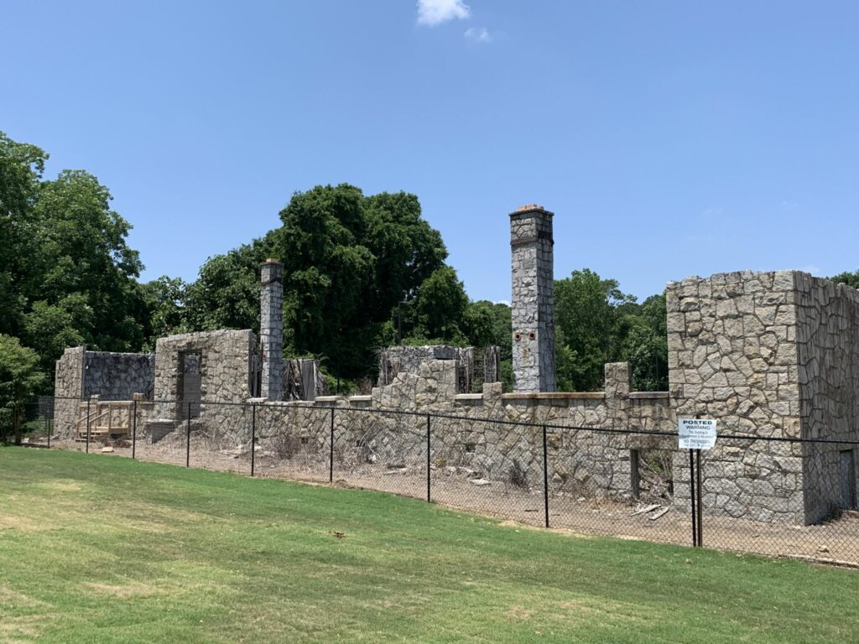
Above: The Bruce Street School ruins as they appear today.

- more -
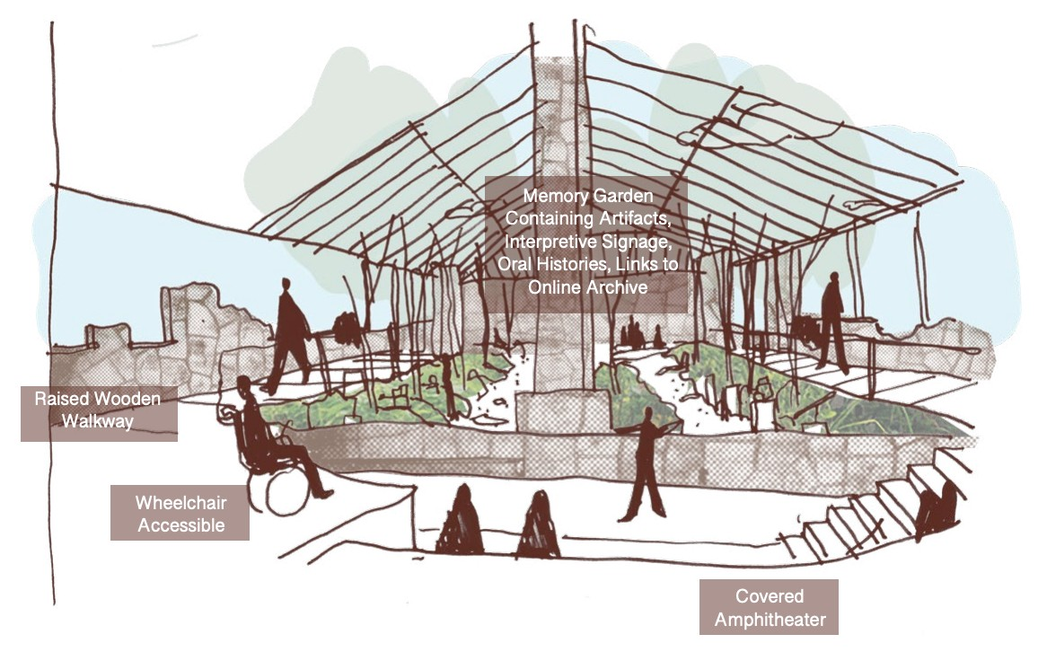
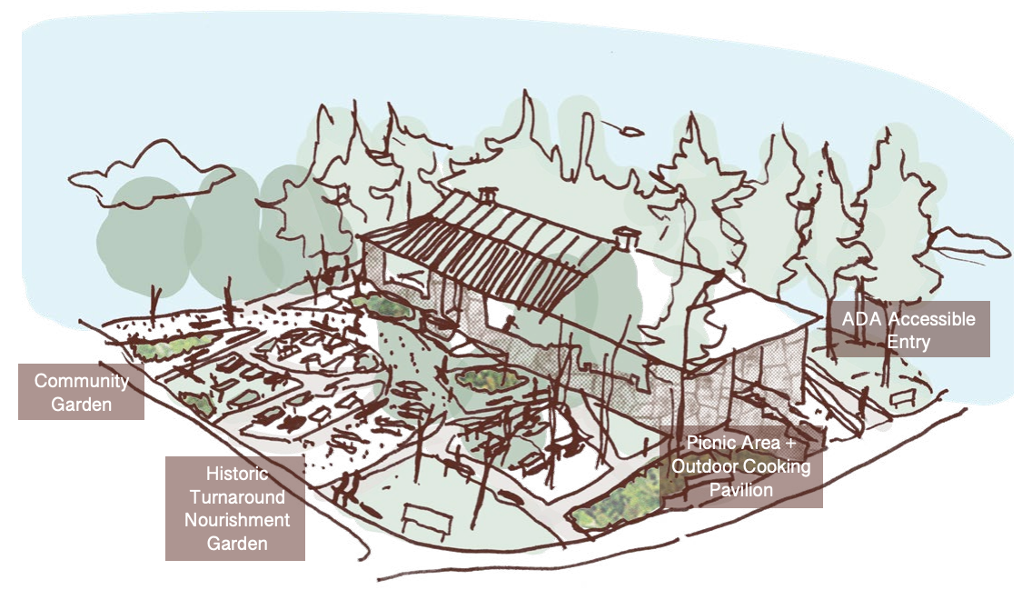

Above: Two preliminary renderings of what the Bruce Street School could look like once it’s transformed into a multi-use venue.

