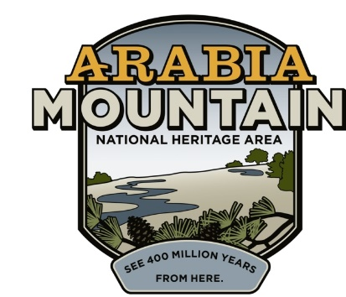Media Contact: Jeff Dingler, Communications Manager

Arabia Mountain Heritage Area Alliance

p: 678-699-2768 | e: jeff@arabiaalliance.org

FOR IMMEDIATE RELEASE

**Arabia Alliance Creates “Arabia Reads” Celebrating Local Authors**

*Started in 2024, the new Arabia Reads program at Arabia Mountain National Heritage Area hosts Georgia artists and authors for fun, interactive readings related to local history, nature and culture.*

**STONECREST, GA** – Bookworms delight! The Arabia Alliance, the nonprofit stewards of Arabia Mountain National Heritage Area, is proud to announce the creation of Arabia Reads, a new program featuring local authors and artists in *free*, unique and interactive readings. The program has two primary goals: 1) to shine a light on the recent publications and books of Georgia creatives and 2) to offer communities in the Heritage Area (DeKalb, Henry and Rockdale Counties) more cultural opportunities and events while cultivating literary awareness and appreciation for local artists and authors.

Started in March 2024, Arabia Reads has hosted a diverse collection of writers including local historian and politician Michael Thurmond, author and TV star of *Gullah Gullah Island*Ron Daise, award-winning poet/artist Andrea Jurjević, and celebrated Atlanta artist/author Kyle “BlackCatTips” Brooks. So far in 2025, Arabia Reads has hosted Hannah S. Palmer to talk about her seminal new book *The Pool Is Closed* and local artist/illustrator and NAACP Image Award recipient R. Gregory Christie to discuss the visual arts in publishing. Here is the spring and summer 2025 Arabia Reads schedule:

* **4/23 – Little Free Library Unveiling** **at Vaughters’ Barn –** Bring a book and take a book for the Arabia Alliance’s very own new Little Free Library. The unveiling will feature artist/author Kyle “BlackCatTips” Brooks and local librarians, from 4:30-5:30pm.
* **5/17 – Wildlife biologist Alex Troutman** – Troutman will discuss a new book he’s featured in: Dudley Edmondson’s *People the Planet Needs Now: Voices for Justice, Science, and a Future of Promise*. We’ll have a book talk and relaxed walk from 1-3pm at the Davidson-Arabia Mountain Nature Center.
* **6/14 – Book Launch for Jonah McDonald and Zana Pouncey –** McDonald and Pouncey will celebrate the launch of their new book, *Hiking Metro Atlanta’s Hidden Forests: An Hour or Less from Downtown.* We’ll have another book talk and walk at the Davidson-Arabia Mountain Nature Center from 2-4pm.
* **6/18** – **Historian Bennet Parten –** Parten will read from his new book *Somewhere Toward Freedom* about emancipation during Sherman’s infamous March to the Sea*.* From 1-3pm at the Black Dot Cultural Center in Lithonia, enjoy a history walking tour through downtown Lithonia and relive Civil War history as part of this reading.
* **10/4** – **Decatur Book Festival –** Like last year, the Arabia Alliance will be tabling at the Decatur Book Festival selling signed copies by Arabia Reads authors as well as hot apparel and other items from our new gear bank!
* **National Arts & Humanities Month** – In October, the Arabia Alliance will host local artists and authors for a celebration of National Arts & Humanities Month in the National Heritage Area. Date and artists TBD.

“It’s been a lot of fun and kind of a dream come true,” said Arabia Alliance Communications Manager Jeff Dingler, who started and manages the Arabia Reads program. In addition to his work at Arabia Mountain NHA, Dingler is a local journalist and writer who’s written for *New York Magazine, The Washington Post, WIRED, Slate, ArtsATL, Atlanta Magazine* and *The AJC*, among others. “I love reading and writing and wanted to do something with that in the Heritage Area. It was originally supposed to be a one-off event with then-CEO of DeKalb County Michael Thurmond and his new book about James Oglethorpe. But it’s been such a popular program, and the responses have been so popular, that we’ve kept it going a full year now. I can’t believe it!”

For 2026, the Arabia Alliance will be celebrating the launch of its own book about the National Heritage Area as part of Arcadia Publishing’s bestselling *Images of America* history series. Dingler is currently researching and writing that book with Arabia Alliance Assistant Executive Director and historian Brigette Jones, who’s been featured in *Garden & Gun, The Tennessean, NPR’s Moth Radio Hour* and the New York Times Bestselling book *A Point of Beauty: True Stories of Holding On and Letting Go.* “Building upon the impactful work done by past leadership of the Alliance has been a tremendous highlight of my time as Assistant Executive Director; and telling the stories that impact, inspire, and encourage keeps our team motivated to continue this amazing work!” said Jones.

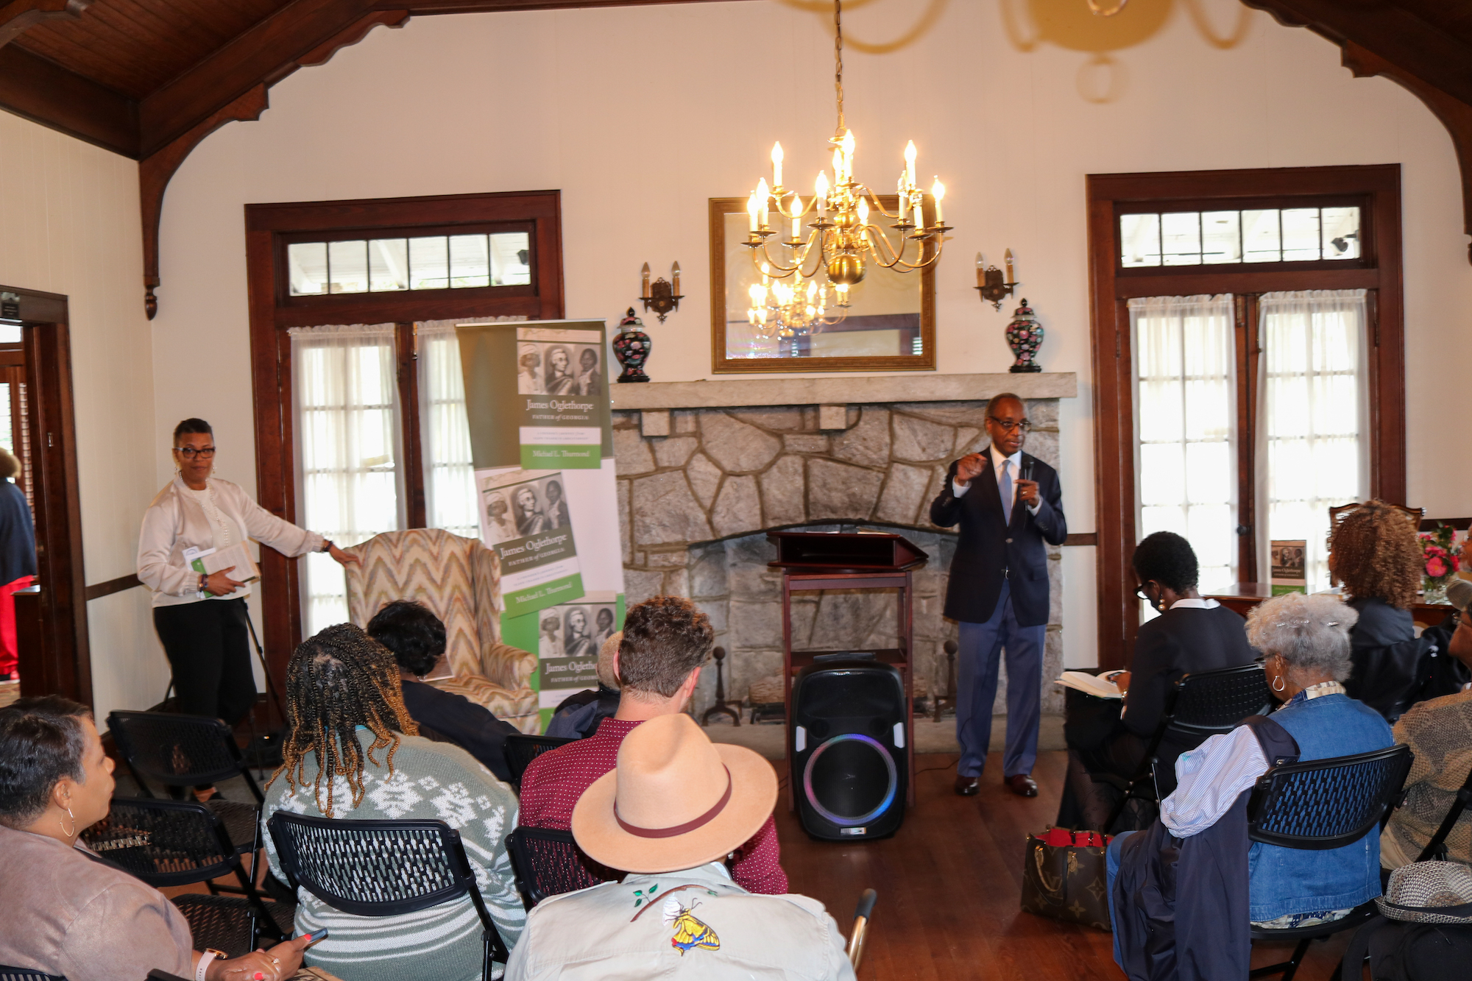

*Michael Thurmond (center) talking about his book at the Lithonia Woman’s Club for the first Arabia Reads in March 2024.*

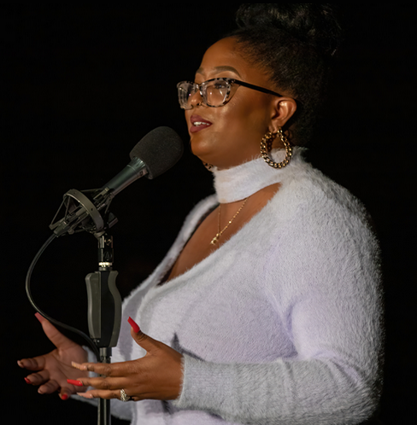

*Co-author for a future book about the Arabia Mountain National Heritage Area, Arabia Alliance Assistant Executive Director Brigette Jones delivers a powerful story for The Moth Radio Hour.*

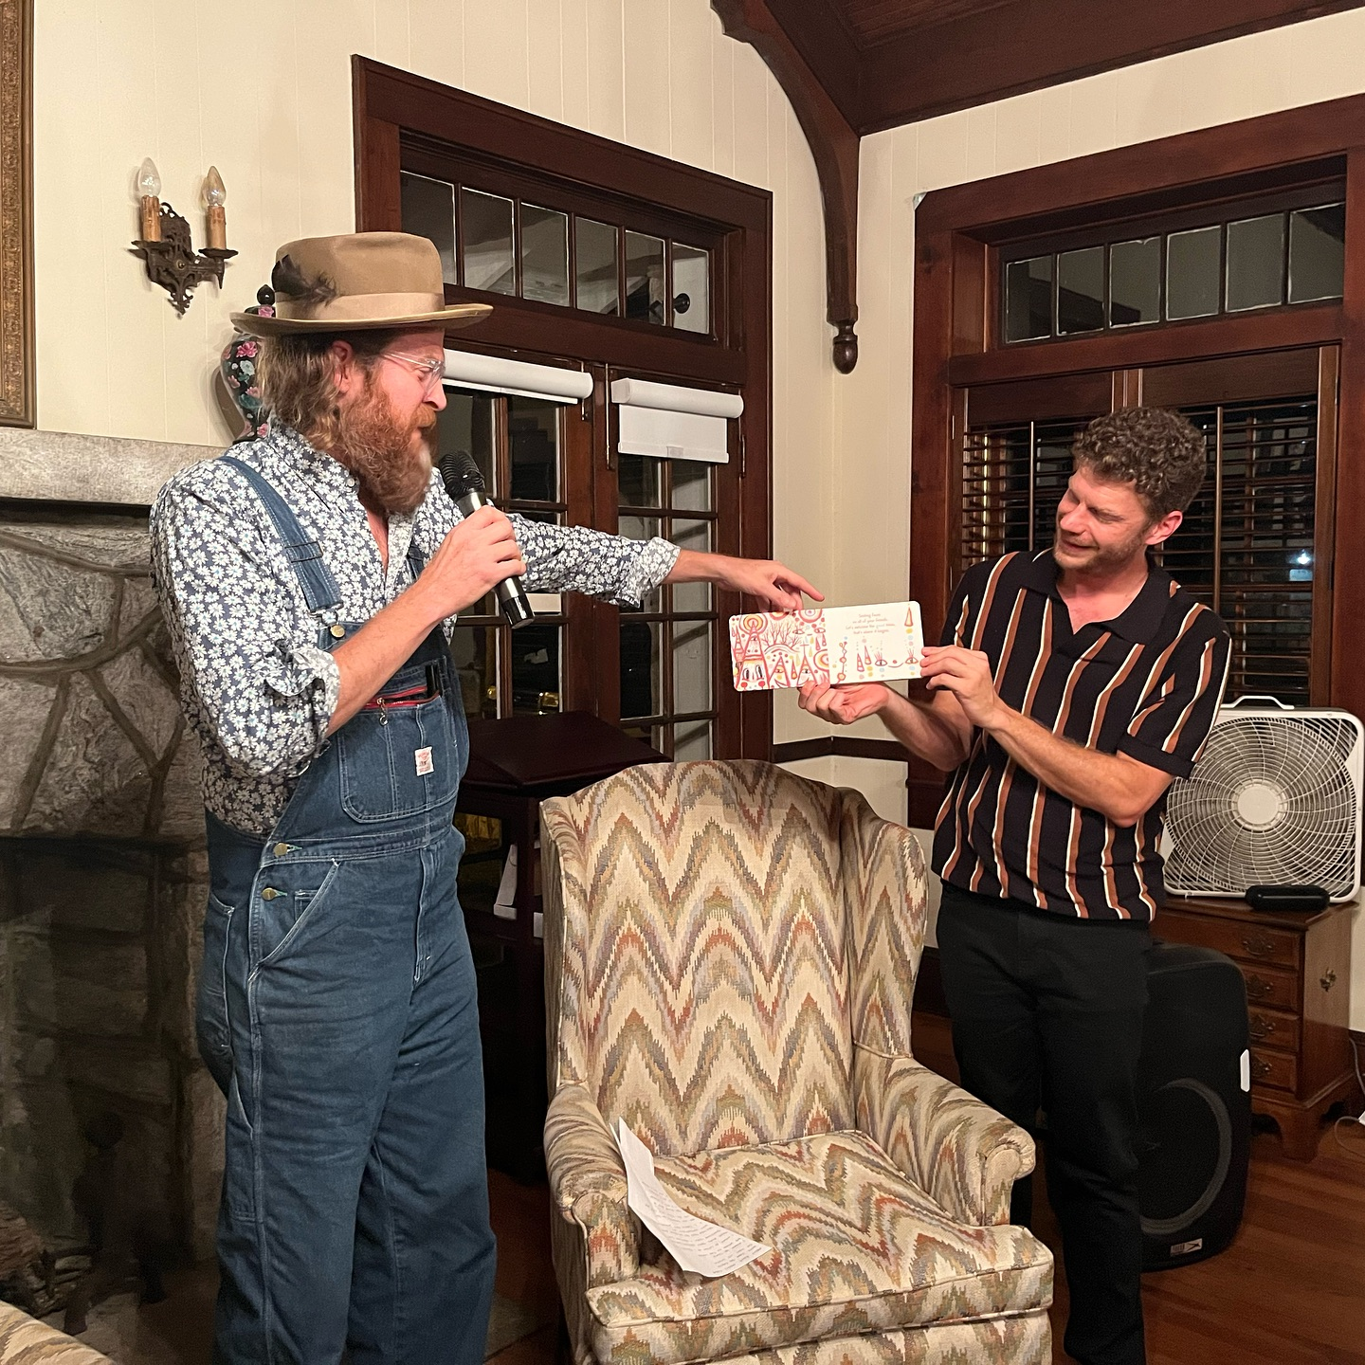

*Artist/author Kyle “BlackCatTips” Brooks (left) with Arabia Alliance Communications Manager Jeff Dingler during an Arabia Reads from October 2024 at the Lithonia Woman’s Club.*

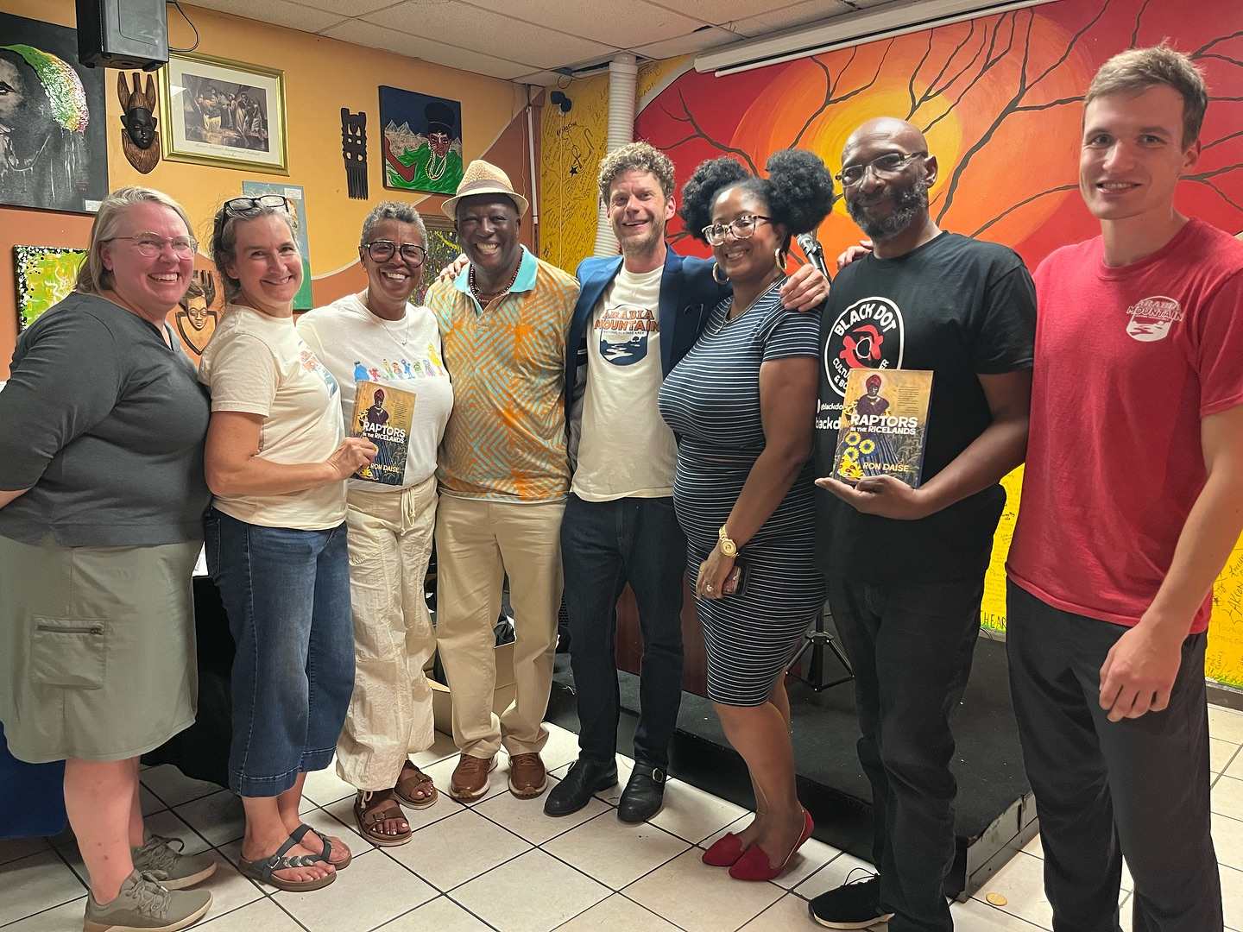

*Author Ron Daise (fourth from left) at Black Dot Cultural Center from an August 2024 Arabia Reads.*