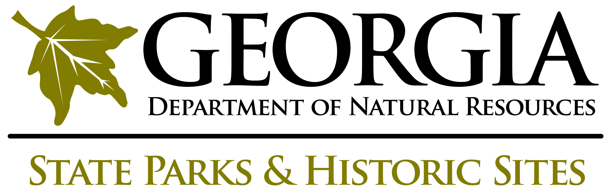
VOLUNTEER ADULT
WAIVER RELEASE

Date: ______________________

Volunteer Assignment: ______________________________________________________________

I understand that there are risks of injury or death or damage to property involved in my participation as a volunteer, that it is my responsibility to ensure the safety of any equipment used and to see that it is operated properly, and that the Georgia Department of Natural Resources and its staff and representatives assume no responsibility for the condition of such equipment, its operations, or safety of the activities involved in this volunteer assignment. I waive and release the Department and its staff and representatives from any and all claims of damages against the Department and its staff and representatives for injury or death or damage to property that may occur as a result of or in connection with this agreement, and I agree to pay, protect, indemnify, and save the Department and its staff and representatives harmless from and against all liabilities, demands, costs, expenses, causes of action, suits, demands, judgments, and claims of any nature whatsoever arising from, by reason of, or in connection with injury or death of persons or damage to property arising from, by reason of, or in connection with my participation as a volunteer.

I further warrant that my health and physical condition are sufficiently good to allow me to perform this assignment without danger to myself or to others.

Full Name (please print): _____________________________________________________

Street Address: ______________________________________________________________

City:______________________________ State:________________ Zip Code:___________

I have read this entire form, including the health acceptance of risk, waiver release, and indemnification provisions.

Signature:________________________________________________ Date: _____________

