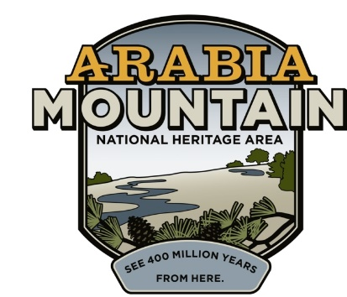
Media Contact: Zack Loehle, Communications Manager
Arabia Mountain Heritage Area Alliance
p: 678-699-2768 | e: zack@arabiaalliance.org

FOR IMMEDIATE RELEASE
Sept. 30, 2020

Junior Ranger Ramble Begins Monday, Oct. 5th
Digital Event Connects Kids, Families with Nature & History

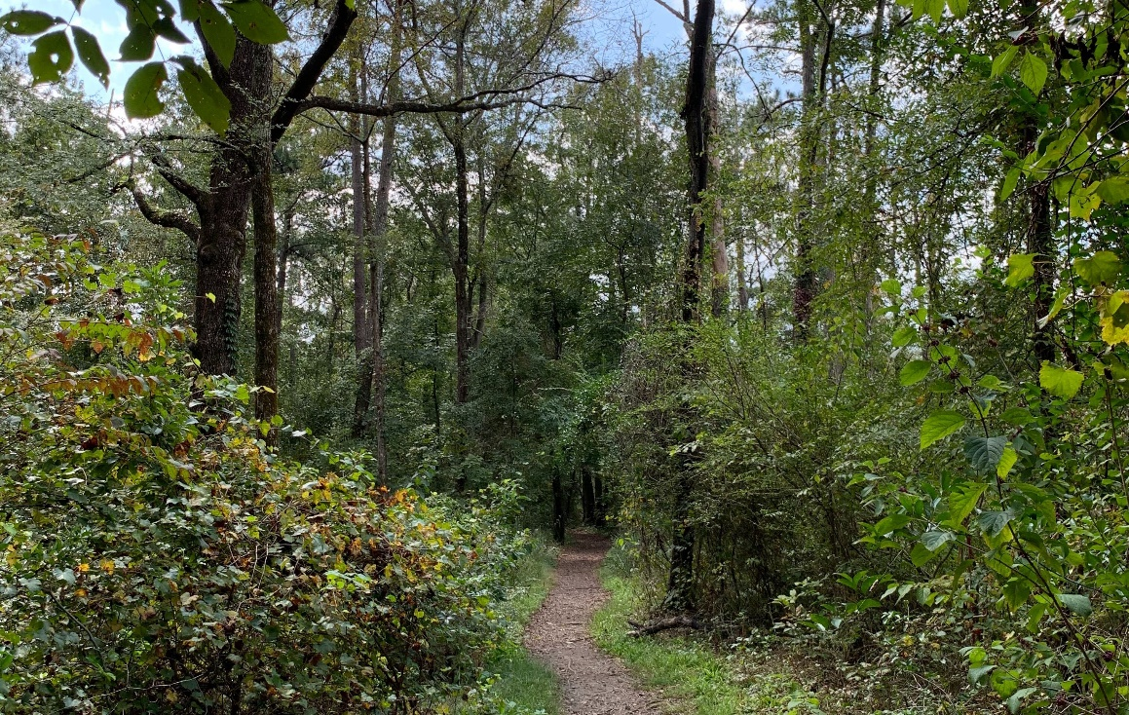
A trail in the Arabia Mountain National Heritage Area. Junior Ranger Ramble will guide participants through this nationally significant landscape.

STONECREST, Ga. – Beginning on Monday, Oct. 5th, the first-ever virtual Junior Ranger Ramble begins, an opportunity for kids, families and even adults to connect with the nature and history found in the Arabia Mountain National Heritage Area (and in their own backyards). This six week Junior Ranger journey will explore various facets of the nationally significant historic sites and biodiversity that make up the landscape of the National Heritage Area, while also revealing opportunities for exploration in the sidewalks, yards and even parking lots where we spend much of our time. The Junior Ranger Ramble is free, self-guided and accessible to all. Lasting six weeks, the program will culminate with a virtual swearing-in ceremony in mid-November.

Participants can enjoy a weekly series of videos and activities, with each week focusing on a different aspect of the National Heritage Area. Week One, for example, features Davidson-Arabia Mountain Nature Preserve, a DeKalb County greenspace that is home to the namesake Arabia Mountain and a host of rare and beautiful plant species. Other weeks will feature sites such as the Atlanta Wild Animal Rescue Effort (AWARE), the Flat Rock Archives, the Monastery of the Holy Spirit, Panola Mountain State Park and the South River. Coordinated by the Arabia Mountain Heritage Area Alliance, the nonprofit management entity of the National Heritage Area, the Junior Ranger Ramble will guide future rangers through the powerful history, rich culture and engaging landscapes found right outside of Atlanta.

Participation in the 2020 Junior Ranger Ramble is free; participants can register here. The Arabia Alliance is also offering special Discovery Kits for $15 (the cost of shipping). Discovery Kits offer kids several tools and supplies to further their outdoor exploration far beyond the completion of the Junior Ranger program. The Kits are not essential to complete the Junior Ranger Ramble.

“The Junior Ranger Ramble will give you a new perspective on this area’s rich natural and cultural legacy. There are wonderful natural and historic resources all around us that can enrich our lives,” said Sarah Lisle, Director of Interpretation for the Arabia Alliance. “We also want to thank all of our partners for making this happen, including the staff at Georgia State Parks, DeKalb County, Flat Rock Archives, the Monastery of the Holy Spirit, the South River Watershed Alliance and AWARE,” she added.

To sign up for the Junior Ranger Ramble, visit here. You can order your own Discovery Kit here.

- more -

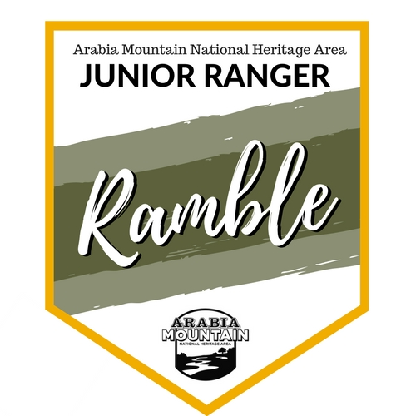
The 2020 Junior Ranger Ramble will be a digital program that begins on Oct. 5th. Participants will be able to enjoy a series of videos and outdoor activities over the course of six weeks, culminating with a virtual swearing-in ceremony for the new Junior Rangers.
.

###
About Arabia Alliance
The Arabia Mountain Heritage Area Alliance is dedicated to protecting, connecting and sharing the powerful history, rich culture and engaging landscapes of the Arabia Mountain National Heritage Area (AMNHA) for the benefit and enjoyment of all. The staff and volunteer board of the Arabia Alliance work with partners across the AMNHA to ensure that everyone can benefit from the cultural and natural resources of the National Heritage Area. For more information, visit www.arabiaalliance.org.

