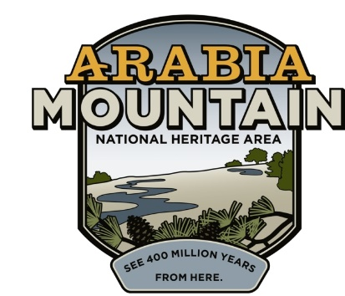
Media Contact: Zack Loehle, Communications Manager
Arabia Mountain Heritage Area Alliance
p: 678-699-2768 | e: zack@arabiaalliance.org

FOR IMMEDIATE RELEASE
Sep. 1, 2021

Hike Through Dazzling Daisies:
Arabia Alliance & Partners Host Virtual Hiking Challenge

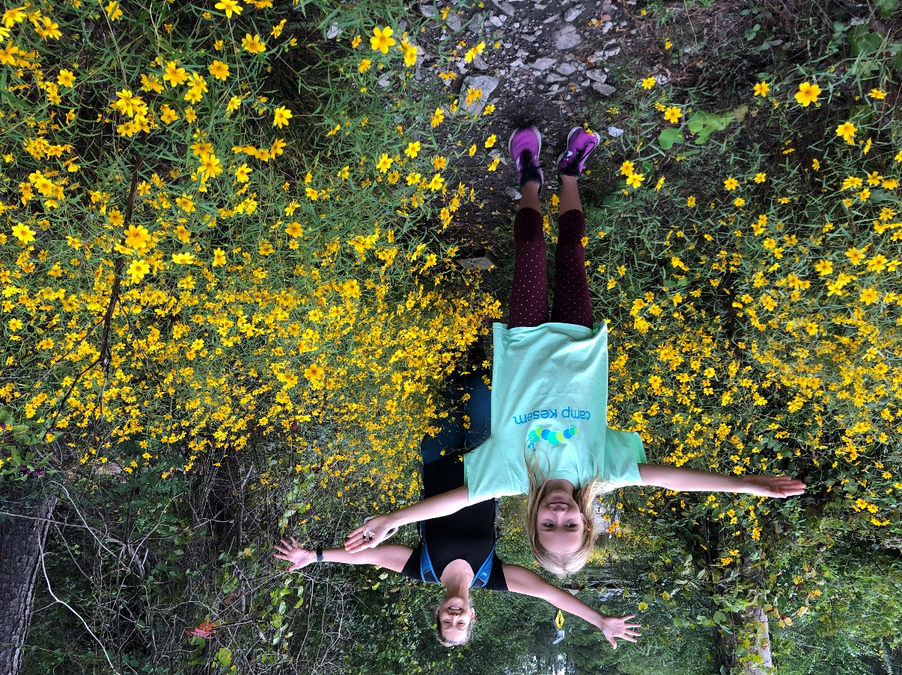
Hikers enjoying the scenery as part of the Daisy Days Triple Hike Challenge.

STONECREST, Ga. – Daisy Days, the celebration of metro-Atlanta’s autumn flowers, begins today and runs throughout the month of September. Participants can complete the Daisy Days Triple Hike Challenge by hiking three of four possible mountains to earn the prize: Arabia Mountain, Kennesaw Mountain, Panola Mountain, and Stone Mountain. The event is free (although parking may require a small fee). Get started here: arabiaalliance.org/activities/daisy-days/.

This event is presented by the Arabia Mountain Heritage Area Alliance, Davidson-Arabia Mountain Nature Preserve, Kennesaw Mountain National Battlefield Park, Panola Mountain State Park and the Stone Mountain Memorial Association. Step into Autumn by hiking Georgia’s granite mountains.

The yellow daisies (Helianthus porteri) are native to the rock outcrops of the Southeastern United States, especially in the granite formations of the Georgia Piedmont region. The metro-Atlanta area has a high concentration of the daisies, which bloom on our massive granite mountains. While these rock outcrops seem barren, especially during the scorching summers, fall and winter see a profusion of wildflowers grow out of patches of thin soil called “solution pits.” The Daisy Days Triple Hike Challenge is an opportunity to celebrate the botanical bounty growing on the rock outcrops (also called “monadnocks”) as autumn begins. Participants will also receive a souvenir. Learn more about the event here.

Due to the ongoing spread of COVID-19, please remember to take safety precautions as you hike to maintain your health and the health of others. That includes wearing a mask when around others and staying home if you feel sick.

The Daisy Days Triple Hike Challenge is free, self-guided and runs throughout the month of September. Visit arabiaalliance.org/activities/daisy-days/ to get started.

###
About Arabia Alliance
The Arabia Mountain Heritage Area Alliance is dedicated to protecting, connecting and sharing the powerful history, rich culture and engaging landscapes of the Arabia Mountain National Heritage Area (AMNHA) for the benefit and enjoyment of all. The staff and volunteer board of the Arabia Alliance work with partners across the AMNHA to ensure that everyone can benefit from the cultural and natural resources of the National Heritage Area. For more information, visit www.arabiaalliance.org.

