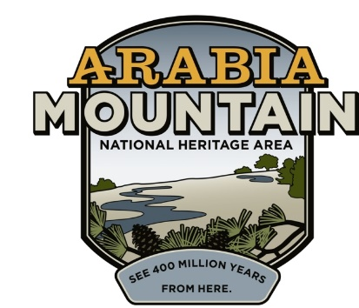
Media Contact: Zack Loehle, Communications Manager
Arabia Mountain Heritage Area Alliance
p: 678-699-2768 | e: zack@arabiaalliance.org

FOR IMMEDIATE RELEASE
Aug. 10, 2020

Daisy Days Goes Digital:
Arabia Alliance & Partners to Host Virtual Triple Hike Challenge

STONECREST, Ga. – Get out of the house, get some fresh air and enjoy the beautiful yellow daisies (Helianthus porteri) that are growing on Arabia, Stone and Panola Mountains with the Daisy Days Triple Hike Challenge, running throughout September. Hike on your own at all three sites or join a small guided hike to explore. As you go, fill out your passport (coming soon) to win a daisy-themed prize. Presented by the Arabia Mountain Heritage Area Alliance, Davidson-Arabia Mountain Nature Preserve, Friends of Panola Mountain State Park, Panola Mountain State Park and the Stone Mountain Memorial Association, this event invites you to step into Autumn by hiking Georgia’s granite monadnocks.

The yellow daisies are native to the rock outcrops of the Southeastern United States, especially in the granite formations of the Georgia Piedmont region. The metro-Atlanta area has a high concentration of the daisies, which bloom on our massive granite mountains. While these rock outcrops seem barren, especially during the scorching summers, fall and winter see a profusion of wildflowers grow out of patches of thin soil called “solution pits.” The Daisy Days Triple Hike Challenge is an opportunity to celebrate the botanical bounty growing on the rock outcrops (also called “monadnocks”) as autumn begins. Participants will also receive a souvenir. Learn more about the event here.

Please remember to take safety precautions as you hike to maintain your health and the health of others. That includes cleaning your hands regularly (either by washing or hand sanitizer), wearing a mask, and staying home if you feel sick.

The Daisy Days Triple Hike Challenge is the fall counterpart to the spring Monadnock Madness event, an outdoor extravaganza in which people can enjoy triple hikes, mountaintop yoga, photography workshops and dozens of other events throughout the month of March. Monadnock Madness accompanies another floral explosion on the granite outcrops, as plants such as the atamasco lily, granite stonecrop and diamorpha burst into vibrant spring bloom. Details for the 2021 Monadnock Madness will be announced in January.

- more -
Take on the Daisy Days Triple Hike Challenge to earn a daisy patch and enjoy the beauty of the granite outcrops in September. More information – including a passport – to come soon.

###
About Arabia Alliance
The Arabia Mountain Heritage Area Alliance is dedicated to protecting, connecting and sharing the powerful history, rich culture and engaging landscapes of the Arabia Mountain National Heritage Area (AMNHA) for the benefit and enjoyment of all. The staff and volunteer board of the Arabia Alliance work with partners across the AMNHA to ensure that everyone can benefit from the cultural and natural resources of the National Heritage Area. For more information, visit www.arabiaalliance.org.

