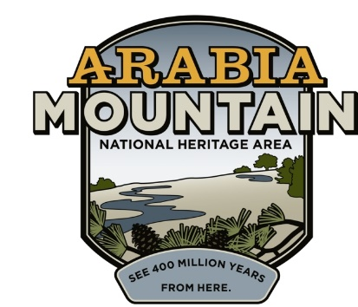
Media Contact: Zack Loehle, Communications Manager
Arabia Mountain Heritage Area Alliance
p: 678-699-2768 | e: zack@arabiaalliance.org

FOR IMMEDIATE RELEASE
Aug. 18, 2021

Daisies Will Dazzle in Autumn Hiking Extravaganza:
Arabia Alliance & Partners to Host Virtual Hiking Challenge

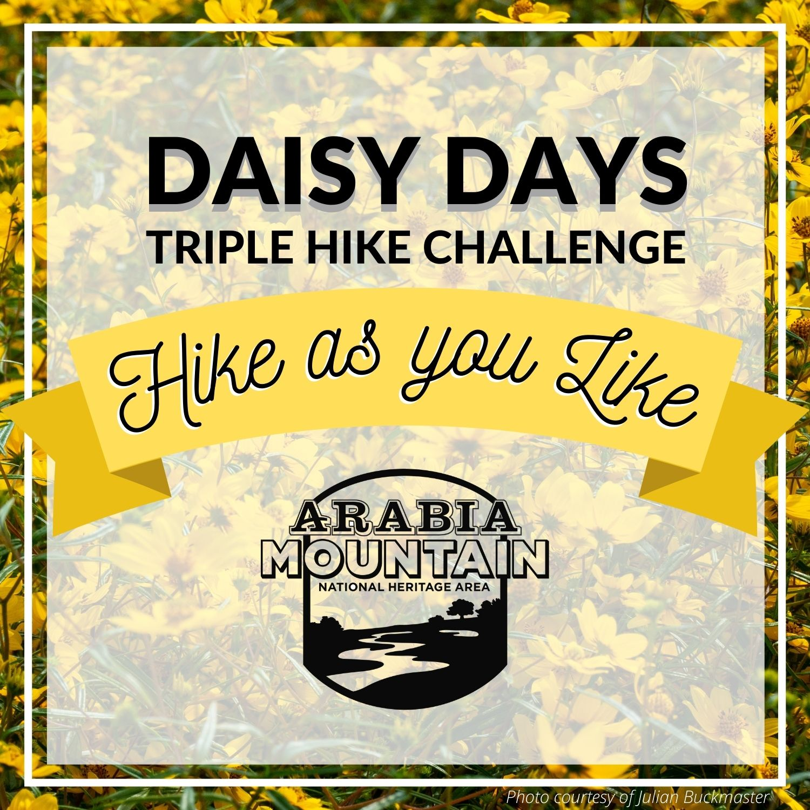
Take on the Daisy Days Triple Hike Challenge to earn a daisy patch and enjoy the beauty of the granite outcrops in September. More information – including a passport – to come soon.

STONECREST, Ga. – Get out of the house, get some fresh air and enjoy the beautiful yellow daisies (Helianthus porteri) that are growing around metro-Atlanta with the Daisy Days Triple Hike Challenge, running throughout September. The event is free (although parking may require a small fee). Participants must hike three of four possible mountains to earn the prize: Arabia Mountain, Kennesaw Mountain, Panola Mountain, and Stone Mountain. You can hike on your own or join a guided hike at some sites (note: Davidson-Arabia Mountain Nature Preserve and Stone Mountain Memorial Association are not currently offering guided hikes; you can still sign up for guided hikes at Kennesaw Mountain National Battlefield Park and Panola Mountain State Park).

As you go, fill out your passport (coming soon) to win a daisy-themed prize. Presented by the Arabia Mountain Heritage Area Alliance, Davidson-Arabia Mountain Nature Preserve, Kennesaw Mountain National Battlefield Park, Panola Mountain State Park and the Stone Mountain Memorial Association, this event invites you to step into Autumn by hiking Georgia’s granite monadnocks.

The yellow daisies (Helianthus porteri) are native to the rock outcrops of the Southeastern United States, especially in the granite formations of the Georgia Piedmont region. The metro-Atlanta area has a high concentration of the daisies, which bloom on our massive granite mountains. While these rock outcrops seem barren, especially during the scorching summers, fall and winter see a profusion of wildflowers grow out of patches of thin soil called “solution pits.” The Daisy Days Triple Hike Challenge is an opportunity to celebrate the botanical bounty growing on the rock outcrops (also called “monadnocks”) as autumn begins. Participants will also receive a souvenir. Learn more about the event here.

Please remember to take safety precautions as you hike to maintain your health and the health of others. That includes wearing a mask when around others and staying home if you feel sick.

The Daisy Days Triple Hike Challenge is the fall counterpart to the spring Monadnock Madness event, an outdoor extravaganza in which people can enjoy triple hikes, mountaintop yoga, photography workshops and dozens of other events throughout the month of March. Monadnock Madness accompanies another floral explosion on the granite outcrops, as plants such as the atamasco lily, granite stonecrop and diamorpha burst into vibrant spring bloom. Details for the 2022 Monadnock Madness will be announced in the spring.

###
About Arabia Alliance
The Arabia Mountain Heritage Area Alliance is dedicated to protecting, connecting and sharing the powerful history, rich culture and engaging landscapes of the Arabia Mountain National Heritage Area (AMNHA) for the benefit and enjoyment of all. The staff and volunteer board of the Arabia Alliance work with partners across the AMNHA to ensure that everyone can benefit from the cultural and natural resources of the National Heritage Area. For more information, visit www.arabiaalliance.org.

