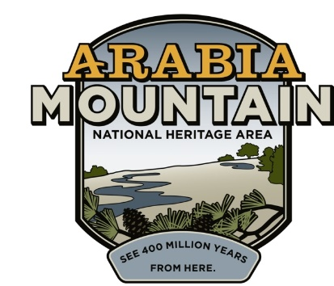
Media Contact: Zack Loehle, Communications Manager
Arabia Mountain Heritage Area Alliance
p: 678-699-2768 | e: zack@arabiaalliance.org

FOR IMMEDIATE RELEASE
July 26, 2021

Preserve Manager Robby Astrove Celebrates Ten Years at Arabia
Longtime Davidson-Arabia Mountain Nature Preserve Ranger Reflects on Past Successes, Years Ahead

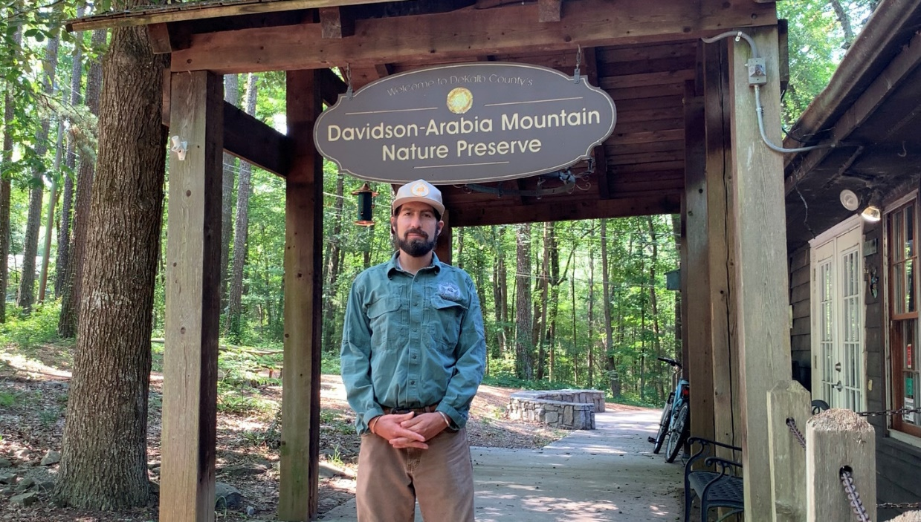
Preserve Manager Robby Astrove (often called “Ranger Robby”) at DeKalb County’s Davidson-Arabia Mountain Nature Preserve, part of the nationally significant Arabia Mountain National Heritage Area. Ranger Robby recently celebrated ten years as a park ranger at Arabia Mountain.

STONECREST, Ga. – For ten years, Preserve Manager Robby Astrove (often simply known as Ranger Robby) has worked to conserve the landscapes of Davidson-Arabia Mountain Nature Preserve and educate the public about this rare and beautiful natural resource right in Atlanta’s backyard. Since his first day on the job at the Nature Preserve on July 20th, 2011, Astrove has guided thousands of people on hikes, showcased the striking rare plants found on the area’s rock outcrops, and inspired countless visitors with his wonder for and knowledge of the natural world.

Ranger Robby has been tireless in his dedication to conservation and the natural landscapes of the Nature Preserve. As well as collaborating with staff and volunteers to maintain trails and facilities, expand community engagement and create interpretive signage, he has worked to significantly increase the educational hikes and tours offered at the Nature Preserve. “I’m just really proud of our delivery on experiential education. It’s one thing just to have people come to the park, but it’s another to provide an experience and opportunity with a guide and a ranger. It’s the difference between coming here and just having a good time versus coming here and leaving with a lifelong memory,” he said.

Robby has also seen a lot change over ten years – most of all, the number of people who come to visit the Davidson-Arabia Mountain Nature Preserve. “We always used to say that Arabia Mountain was DeKalb County’s best-kept secret, and over the course of 10 years we’ve had that secret get out. And we’ve had a lot of great success getting the story of the land and the people out,” he said. With more people, though, Ranger Robby and his team have had to deal with new land management problems: “It’s a double-edged sword – I love seeing people out here, enjoying nature and connecting. But we do have a sensitive landscape, and with the success of sharing the place comes the impact of having more people in the Nature Preserve.”

Ranger Robby emphasizes Leave No Trace hiking as essential to enjoying the landscape while also preserving the wild species that call it home. That means that visitors must hike with care when exploring Arabia Mountain’s massive rock outcrops. Dotting the surface of the rock are countless “solution pits,” patches of sand, water and mud that erosion has created in the rock face. In these innocuous patches thrive a variety of rare and endangered plant species, including the vibrant red diamorpha that dots the outcrop in winter and spring. A simple way to conserve the landscape is to “stay on the gray,” a phrase Ranger Robby tells guests often. It means to stick to the bare granite when hiking on the outcrop and avoiding any of the solution pits.

Arabia Mountain Heritage Area Alliance Executive Director Revonda Cosby praised Ranger Robby’s tireless dedication: “These words come to mind when I think of Robby Astrove – steward, steward, real naturalist. This guy is the epitome of a steward, and he is a real naturalist in every sense of the word. We hope he stays around another ten years! Over the past decade, he has created programs that serve a diverse DeKalb County. He has put maintenance and stewardship protocols in place that are repeatable, and he has worked extremely hard to attract and retain the best staff he can.”

Looking ahead, Ranger Robby says he wants to “continue to strengthen our mission for conservation, preservation and education.” That includes focusing on protecting the natural landscape and inspiring future generations of environmental stewards to conserve Arabia Mountain for years to come.

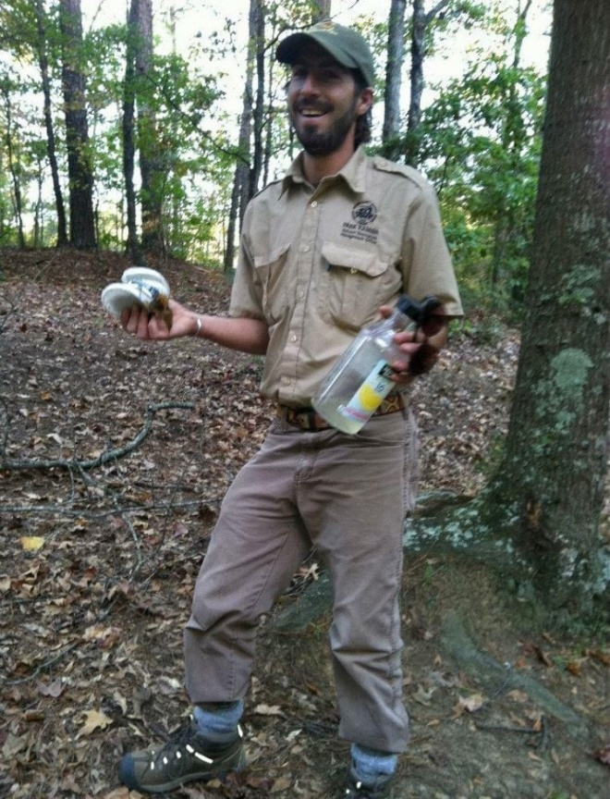
Photo from Ranger Robby’s first day on the job at Davidson-Arabia Mountain Nature Preserve (July 20th, 2011). Seen here picking up litter along the trail.

###

About the Arabia Alliance
The Arabia Mountain Heritage Area Alliance is dedicated to protecting, connecting and sharing the powerful history, rich culture and engaging landscapes of the Arabia Mountain National Heritage Area (AMNHA) for the benefit and enjoyment of all. The staff and volunteer board of the Arabia Alliance work with partners across the AMNHA to ensure that everyone can benefit from the cultural and natural resources of the National Heritage Area. Arabia Alliance Executive Director Revonda Cosby is also a Trustee of The Nature Conservancy Georgia. For more information, visit www.arabiaalliance.org.

