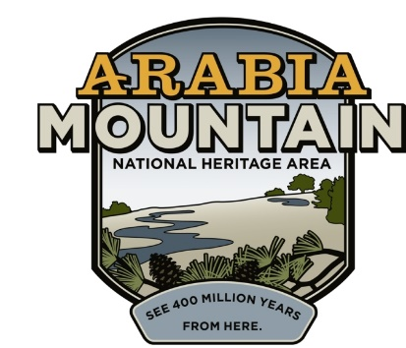
Media Contact: Zack Loehle, Communications Manager
Arabia Mountain Heritage Area Alliance
p: 678-699-2768 | e: zack@arabiaalliance.org

FOR IMMEDIATE RELEASE
July 20, 2021

Student Conservation Association Interns Complete Experience at Arabia Mountain National Heritage Area
Interns Assist with Trail Maintenance, Conservation
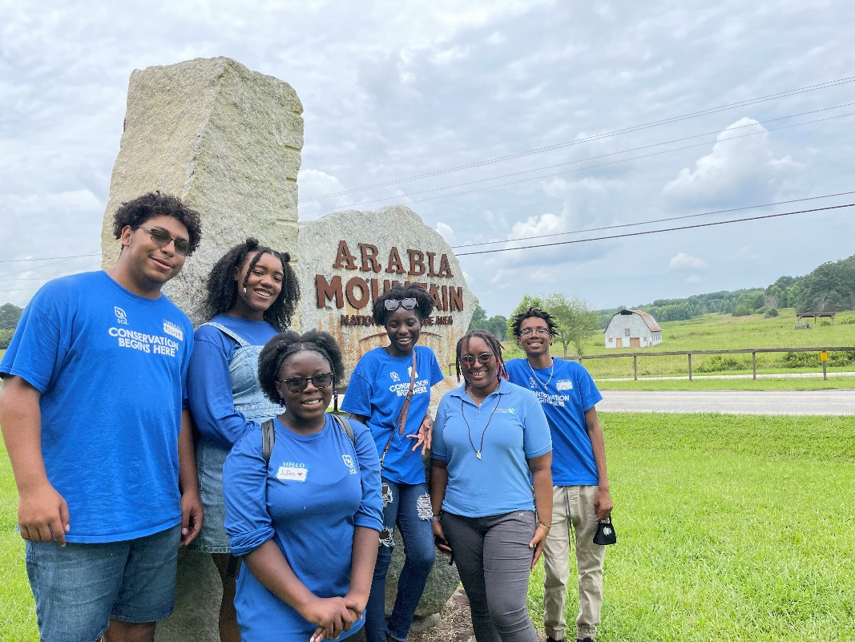
Five Student Conservation Association interns, sponsored by The Nature Conservancy of Georgia’s CITY program, took part in a six-week internship, maintaining trails and conserving ecosystems. Seen here with LA Allen, GDEI Training and Education Specialist at The Nature Conservancy, who helped manage the program.

STONECREST, Ga. – Sponsored by The Nature Conservancy of Georgia as part of the Conservation Involving Today’s Youth (CITY) program, a group of Student Conservation Association Interns recently completed a month-long internship maintaining trails and greenspace in the Arabia Mountain National Heritage Area (AMNHA). This paid internship brought five students from four Atlanta-area high schools into the National Heritage Area and other sites around Atlanta, teaching them job skills and supporting park rangers. While they spent their time working in the National Heritage Area and at the West Atlanta Watershed Alliance, the students also took trips to Martin Luther King, Jr. National Historical Park, the UPS Smart Hub and Kennesaw Mountain National Battlefield Park. The interns provided critical support to rangers and land managers in the AMNHA, helping to clean and conserve the trails and landscapes.

The Student Conservation Association hailed the internship’s success in a statement: “Atlanta this year joined a roster of nearly a dozen U.S. cities in which SCA offers hands-on conservation opportunities for local high school aged youth. We have a long-standing partnership with The Nature Conservancy nationally and are grateful to have been able to partner with TNC Georgia to provide this meaningful paid employment opportunity for Atlanta youth. The Student Conservation Association (SCA) is America’s oldest and largest youth conservation organization. SCA conserves lives and transforms lands by co-powering young people of all backgrounds to plan, act, and lead, while they protect and restore our natural and cultural resources. Founded in 1957, SCA’s mission is to build the next generation of conservation leaders, and seven in 10 of alumni worldwide are employed or studying in conservation-related fields. For more, visit www.thesca.org.” Questions about the SCA in Atlanta can be directed to SCA Atlanta Community Program Manager Jonathan Johnson at jjohnson@thesca.org.

“I hope SCA will continue to help other students such as myself because I know this experience will change my life for the better,” said one of the student interns. Guided by crew leader Susan Caolo, the students cleared trails, removed invasive species, cleaned up picnic areas, picked up litter, and more, all while learning about the nature, history and culture of the National Heritage Area. “These students don’t just see it as a summer job...they go beyond that. It’s an experience to connect students with the outdoors, to create stewardship for future generations,” Caolo said.

This internship program is part of a larger effort by SCA, The Nature Conservancy, and other sponsor organizations to support the next generation of conservation leaders. Speaking at a celebration ceremony for the interns, LA Allen, GDEI Training and Education Specialist at The Nature Conservancy, said: “The Nature Conservancy has several programs that allow students to get out into nature, but they are always focused on partnerships with environmental high schools. What makes Conservation Involving Today’s Youth (CITY) unique is that it’s an opportunity for local youth, no matter what high school they go to, to work in their own backyard on projects that they can share with their family, so that they also get to demonstrate their environmental ethic.”

For over 20 years, the Arabia Alliance and The Nature Conservancy have worked southeast of Atlanta to conserve landscapes and educate future generations. Now that the students have completed this first internship, they have opened up multiple opportunities for further internships and job training with SCA, The Nature Conservancy, and other organizations. Future interns will be able to follow in their footsteps, supporting the rangers who care for parks and historic sites while also taking their own steps towards a lifetime of environmental stewardship.

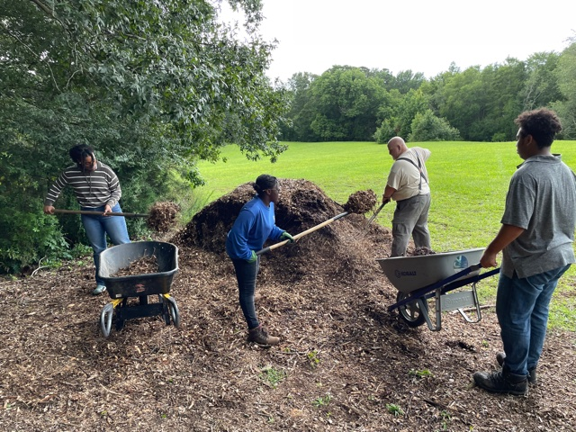
SCA interns helped park rangers spread mulch at a picnic area in the Davidson-Arabia Mountain Nature Preserve. Photo: Susan Caolo/SCA.

- more -

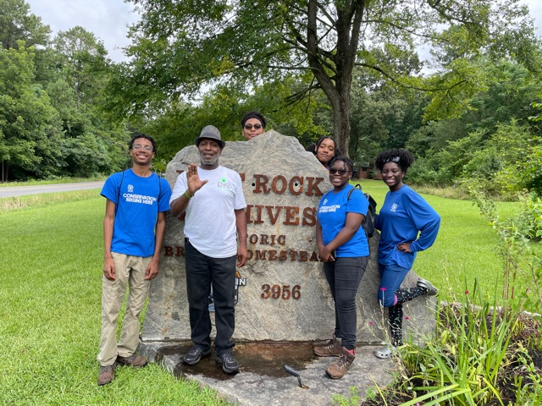
As well as working, the SCA interns spent time learning about the culture, history and nature of the National Heritage Area. That included a tour of the Flat Rock Archives, which preserves the history of the area’s oldest Black community. Photo: Susan Caolo/SCA.

###

About the Arabia Alliance
The Arabia Mountain Heritage Area Alliance is dedicated to protecting, connecting and sharing the powerful history, rich culture and engaging landscapes of the Arabia Mountain National Heritage Area (AMNHA) for the benefit and enjoyment of all. The staff and volunteer board of the Arabia Alliance work with partners across the AMNHA to ensure that everyone can benefit from the cultural and natural resources of the National Heritage Area. Arabia Alliance Executive Director Revonda Cosby is also a Trustee of The Nature Conservancy Georgia. For more information, visit www.arabiaalliance.org.

