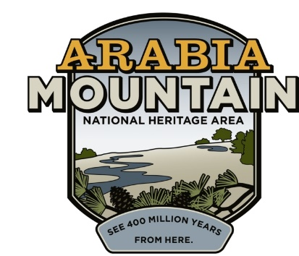
Media Contact: Zack Loehle, Communications Manager
Arabia Mountain Heritage Area Alliance
p: 678-699-2768 | e: zack@arabiaalliance.org

FOR IMMEDIATE RELEASE
July 19, 2021

Historic Bruce Street School Preservation Moving Forward
Martin Rickles Studio Selected for Initial Phase of Conceptual Design

LITHONIA, Ga. – Martin Rickles Studio, an Atlanta-based interdisciplinary design studio, has been selected for the conceptual design for the preservation and activation of the Bruce Street School ruins, the remnants of DeKalb County’s first Black public school. Also known as the Lithonia Negro School, the ruins are located next to the site of the soon to be completed East DeKalb Community and Senior Center, all within Lithonia’s historic Bruce Street community. Martin Rickles Studio staff will lead community engagement sessions to envision what is possible for the future of the ruins as a community and historic hub. Dates and times of community engagement sessions will be announced soon; those interested in the sessions can sign up here for updates.

The Bruce Street School dates back to the 1930’s, when Black local leaders bought land to build a much-needed community school. The first graduating high school class (around 1943) included three pupils. By 1968, when the Bruce Street School was closed, there were over a dozen elementary and eight high school classrooms. Although in ruins today, the old school building still speaks to the power and resilience of Lithonia’s Black community. People now have an opportunity to determine how this space can become an active part of the community once again. Along with local officials, Martin Rickles Studio staff will host community engagement sessions to shape the future of the ruins.

DeKalb County and City of Lithonia, as well as the Arabia Mountain Heritage Area Alliance (the nonprofit management entity of the Arabia Mountain National Heritage Area), continue to work collaboratively to ensure the community-focused historic preservation of the Bruce Street School ruins. “The partners agree that Martin Rickles Studio, with their genuine dedication to reflecting the needs and concerns of the community and track record of creative, thoughtful projects, are the best design contractors for this initiative,” said Arabia Alliance Executive Director Revonda Cosby. “We look forward to continuing the process of preserving and celebrating the remnants of DeKalb County’s first Black public school.” Rodney Reese, Senior Planner with the DeKalb County Department of Community Development: “DeKalb County is excited to partner with Arabia Alliance to work on this important historic preservation project that celebrates the rich educational history of the Bruce Street School. DeKalb looks forward to the creative opportunities that will present themselves through the community engagement process with Martin Rickles Studio during the conceptual design phase.”

Lithonia Mayor Shameka Reynolds says: “The Bruce Street School has always been dear to the City of Lithonia. We are glad that Martin Rickles Studio was selected to be one of the key partners as we begin historic preservation efforts. This is long overdue for the City of Lithonia – we still have former students who are living who are excited about saving the Bruce Street School. We are very excited about it and are waiting to see what comes next...it will be a school that we will continue to be proud of and are excited that the partners have come into play with this endeavor.”

Based in Atlanta, Martin Rickles Studio utilizes an interdisciplinary background including landscape, interior, and graphic design, as well as a background in art, to create lasting and effective spatial designs. Martin Rickles Studio said in a statement: "We are thankful to the Arabia Mountain Heritage Area Alliance for entrusting our team to shepherd the legacy of the Bruce Street School into a twenty-first century context. To guide this important work, we have assembled an interdisciplinary team which we believe is uniquely suited to handle this delicate and deeply meaningful process with precision, care, skill, and empathy. We look forward to working closely with the Arabia Mountain Heritage Area Alliance, DeKalb County, members of the Lithonia community and community stakeholders to compose a plan for the future of the Bruce Street School.” They have completed projects in Atlanta and Los Angeles.

The Martin Rickles design team consists of artist and architect Amy Landesberg, Co-Founder and Principal Jennifer Martin, architectural historian Scott Morris, artist Iman Person, Co-Founder and Principal Carley Rickles and design researcher Anh-Ton Tran.

Anyone with artifacts related to the Bruce Street School – including photos, records, yearbooks and stories to use in potential exhibits – is especially encouraged to join the community engagement sessions. A sign-up link can be found at arabiaalliance.org/join-the-conversation/.

For more information about the project, please visit arabiaalliance.org/brucestreet and fill out the community engagement form. A presentation about the project can be found here.

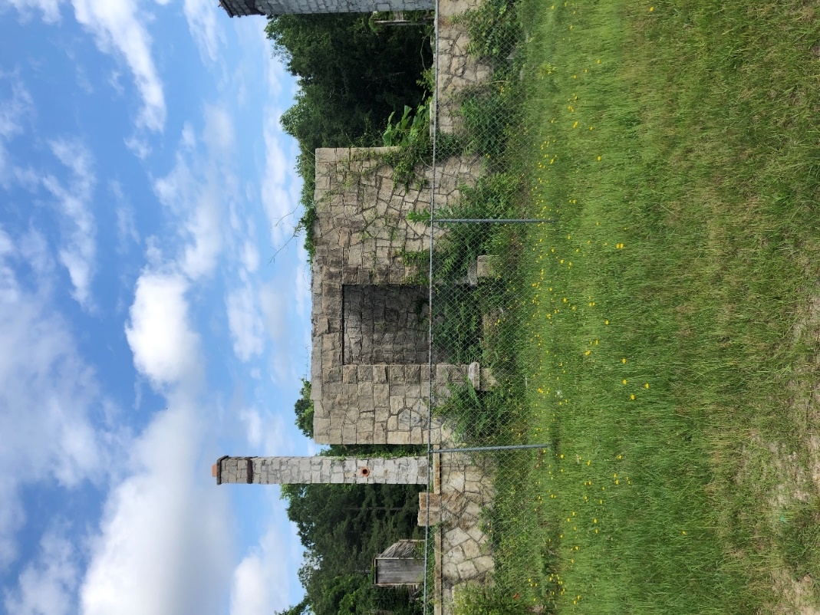
The current status of the Bruce Street School ruins, prior to historic preservation efforts.

###

About the Arabia Alliance
The Arabia Mountain Heritage Area Alliance is dedicated to protecting, connecting and sharing the powerful history, rich culture and engaging landscapes of the Arabia Mountain National Heritage Area (AMNHA) for the benefit and enjoyment of all. The staff and volunteer board of the Arabia Alliance work with partners across the AMNHA to ensure that everyone can benefit from the cultural and natural resources of the National Heritage Area. For more information, visit www.arabiaalliance.org.

