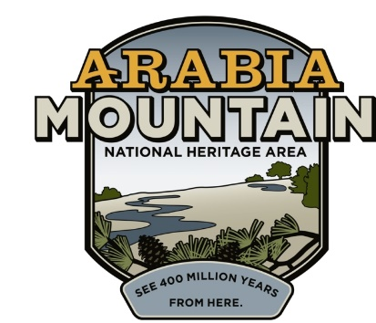
Media Contact: Zack Loehle, Communications Manager
Arabia Mountain Heritage Area Alliance
p: 678-699-2768 | e: zack@arabiaalliance.org

FOR IMMEDIATE RELEASE
June 30, 2021

Atlanta Wild Animal Rescue Effort (AWARE) Reopening Free Weekly Tours on July 3rd
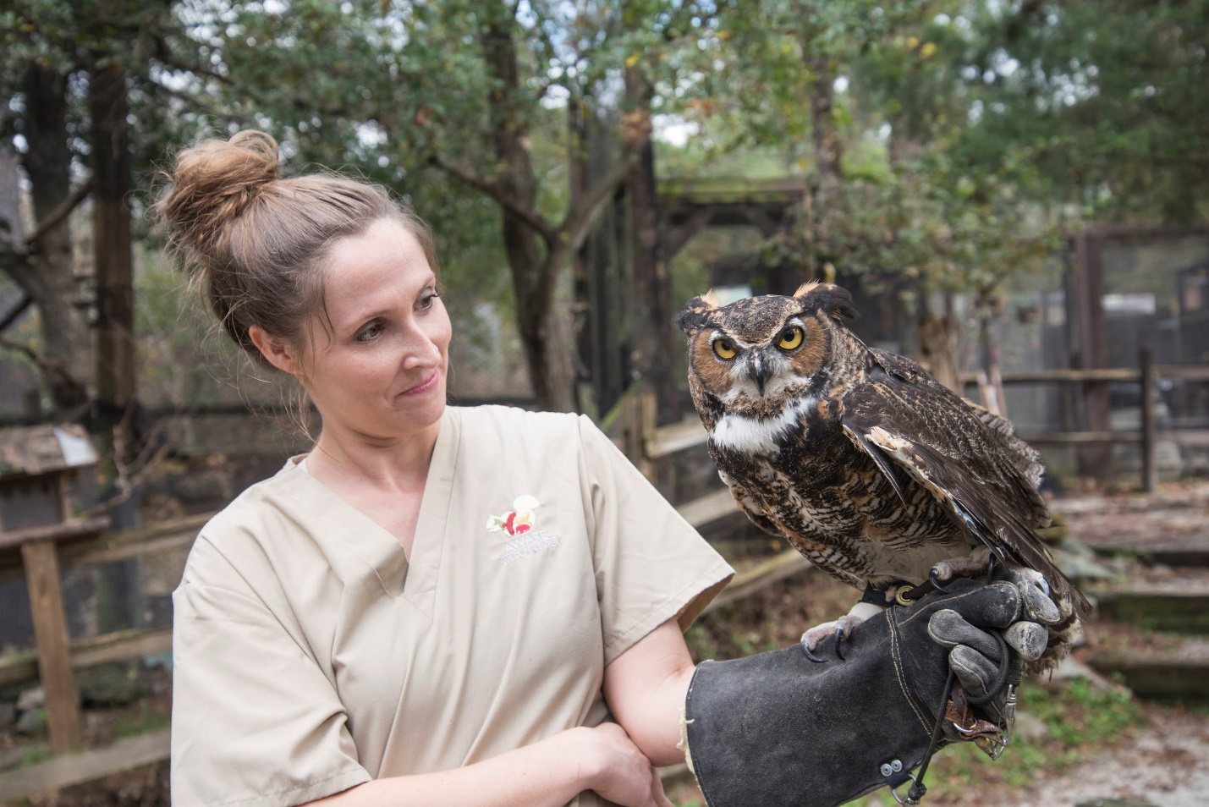
AWARE tours begin again on Saturday, July 3rd at 1pm. Photo: Arabia Mountain Heritage Area Alliance/AWARE.

STONECREST, Ga. – After a hiatus due to COVID-19, weekly tours of the Atlanta Wild Animal Rescue Effort (AWARE) facilities will begin again on Saturday, July 3rd at 1pm. Visitors are invited to stop by the wildlife center that day to meet some of the ambassador animals (individuals that, due to their injuries, cannot be released back into the wild) and see the facilities. Tours will occur weekly at 1pm on Saturday and Sunday from July 3rd onward.

“AWARE Wildlife Center's free weekend public tours will be returning July 3rd and 4th, just in time for the holiday! Going forward, every Saturday and Sunday at 1pm, weather permitting, visitors can come behind the AWARE gates to meet some permanent resident ambassador animals, hear their stories, and learn how to peacefully coexist with wildlife,” said AWARE Executive Director Scott Lange.

Tours will last around 30 minutes and be outside-only. Masks are optional and vaccinations are strongly encouraged. Limited public parking is available at the Arabia Mountain lot at 4158 Klondike Road, Stonecrest, GA 30038. Visitors can also reach AWARE by walking or biking from the main Davidson-Arabia Mountain Nature Preserve lot, located at 3787 Klondike Road.

AWARE has been operating at the base of Arabia Mountain since 2006. The nonprofit rescues sick and injured native wildlife, rehabilitates the animals and returns them to the wild. Individuals that cannot be re-released stay at AWARE and become ambassador animals, helping to teach visitors about Georgia’s native wildlife and how we can all protect nature. Learn more at awarewildlife.org.

###

About the Arabia Alliance
The Arabia Mountain Heritage Area Alliance is dedicated to protecting, connecting and sharing the powerful history, rich culture and engaging landscapes of the Arabia Mountain National Heritage Area (AMNHA) for the benefit and enjoyment of all. The staff and volunteer board of the Arabia Alliance work with partners across the AMNHA to ensure that everyone can benefit from the cultural and natural resources of the National Heritage Area. For more information, visit www.arabiaalliance.org.

