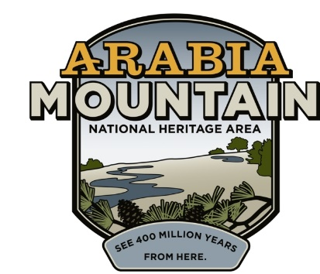
Media Contact: Zack Loehle, Communications Manager
Arabia Mountain Heritage Area Alliance
p: 404-998-8384 | e: zack@arabiaalliance.org

FOR IMMEDIATE RELEASE
June 17, 2020

Virtual Flat Rock Historic Cemetery Tour Scheduled for Juneteenth
Arabia Mountain Heritage Area Alliance and Flat Rock Archives Presenting Tour of Historic African-American Cemetery via Facebook

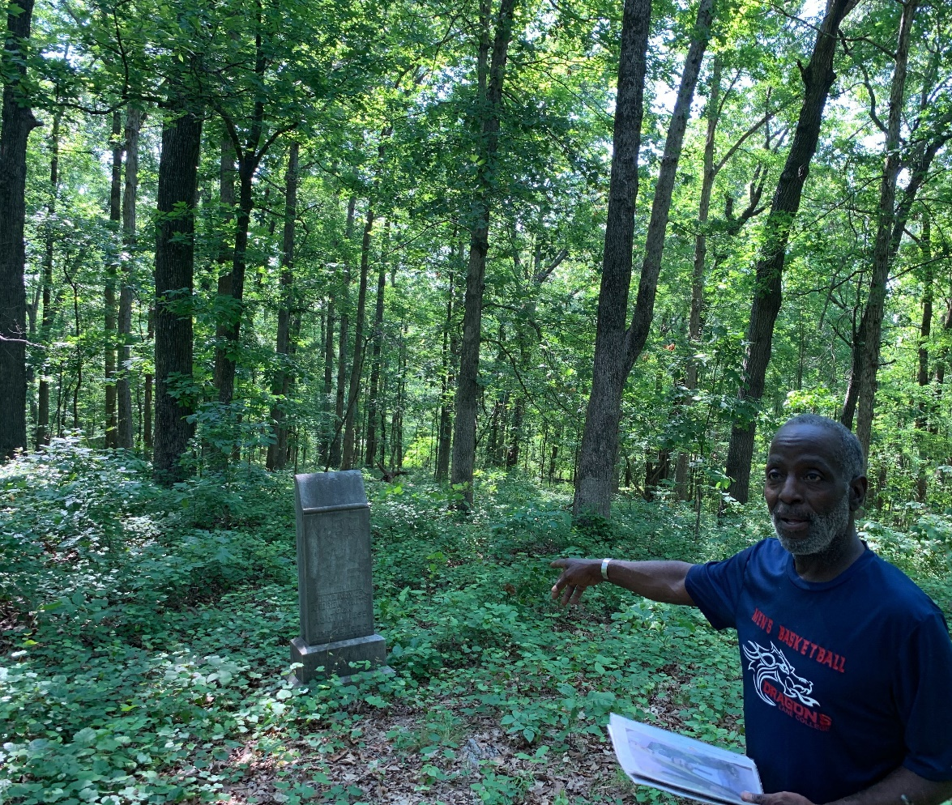
Flat Rock Archives President and Co-Founder, Johnny Waits, discussing the Flat Rock Cemetery.

STONECREST, Ga. – In partnership with the Flat Rock Archives, the Arabia Mountain Heritage Area Alliance will stream a virtual, live tour of the Flat Rock Historic Cemetery at 12pm on Juneteenth (6/19). In celebration of the holiday and to honor Flat Rock’s ancestors (both enslaved and free), Flat Rock Archives Co-Founder and President Johnny Waits will lead the virtual tour of the cemetery. Participants can join via the Arabia Mountain National Heritage Area’s Facebook page (@ArabiaMountainNationalHeritageArea), where a live video will begin streaming at noon.

A historic centerpiece of the Arabia Mountain National Heritage Area (AMNHA), the community of Flat Rock is one of the oldest African-American communities in Georgia, with a history of resilience stretching to the early 1800’s. Although now paused due to COVID-19, the Flat Rock Archives normally leads tours of the community, stopping at sites such as the historic Lyon Farm, the Cemetery, and the T. A. Bryant, Sr. House and Homestead, where the Archives is now headquartered. This virtual tour will introduce viewers to the historic community and provide a taste of the full Flat Rock tour experience. “It’s important that we celebrate Juneteenth and the ancestors that brought us to where we are today,” said Revonda Cosby, Executive Director of the Arabia Mountain Heritage Area Alliance, the nonprofit partner of the AMNHA. “We are thrilled to be sharing the powerful stories of the people of Flat Rock with the world.”

The Arabia Mountain Heritage Area Alliance is encouraging viewers to post their questions on the livestream as it happens, so the questions can be incorporated into the tour by staff. The first person to post a question on the Facebook livestream will receive a free family tour of the Flat Rock Archives, to be scheduled when tours are once again possible.

###
About Arabia Alliance
The Arabia Mountain Heritage Area Alliance is dedicated to protecting, connecting and sharing the powerful history, rich culture and engaging landscapes of the Arabia Mountain National Heritage Area (AMNHA) for the benefit and enjoyment of all. The staff and volunteer board of the Arabia Alliance work with partners across the AMNHA to ensure that everyone can benefit from the cultural and natural resources of the National Heritage Area. For more information, visit www.arabiaalliance.org.

