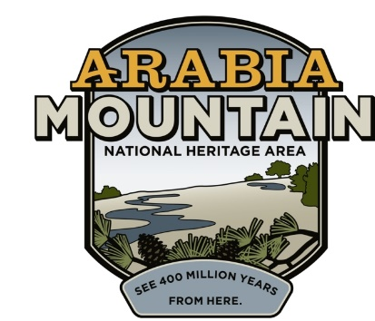
Media Contact: Zack Loehle, Communications Manager
Arabia Mountain Heritage Area Alliance
p: 678-699-2768 | e: zack@arabiaalliance.org

FOR IMMEDIATE RELEASE
May 24, 2021

Arabia Mountain Heritage Area Alliance Hosting Booth at New Black Wall Street Market Memorial Day Weekend Festival

STONECREST, Ga. – On May 29th and 30th, board, staff and partners of the Arabia Mountain Heritage Area Alliance will host a booth at the New Black Wall Street Market’s Outdoor Market Festival, located at 8109 Mall Parkway, Stonecrest, GA 30038. The festival will be open from 10am until 7pm both days. Alongside business and food vendors, the Arabia Mountain National Heritage Area booth will showcase the beautiful natural spaces and powerful history of the area in and around Stonecrest.
“We are very excited to be participating in the New Black Wall Street Market’s inaugural event,” said Revonda Cosby, Executive Director of the Arabia Mountain Heritage Area Alliance. “Increasing access to the National Heritage Area for diverse people from all backgrounds is a major goal of the Arabia Alliance, and I look forward to spreading the word and introducing people to the natural and historic resources right in Atlanta’s backyard.”
The festival takes place 100 years after the burning of Black Wall Street, a prosperous Black community in Tulsa, OK, destroyed by a white mob in 1921. The New Black Wall Street Market event will commemorate the 1921 tragedy while celebrating local Black businesses, performers and more.
Further details about the festival can be found at newblackwallstreetmarket.com.

- more -

The New Black Wall Street Market festival event will take place on May 29th and 30th from 10am to 7pm each day.

###

About the Arabia Alliance
The Arabia Mountain Heritage Area Alliance is dedicated to protecting, connecting and sharing the powerful history, rich culture and engaging landscapes of the Arabia Mountain National Heritage Area (AMNHA) for the benefit and enjoyment of all. The staff and volunteer board of the Arabia Alliance work with partners across the AMNHA to ensure that everyone can benefit from the cultural and natural resources of the National Heritage Area. For more information, visit www.arabiaalliance.org.

