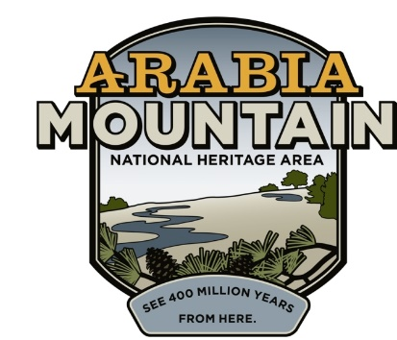
Media Contact: Zack Loehle, Communications Manager
Arabia Mountain Heritage Area Alliance
p: 404-998-8384 | e: zack@arabiaalliance.org

FOR IMMEDIATE RELEASE
Apr. 3, 2019

Metro-Atlanta Loves Monadnocks
Annual Monadnock Madness Wraps Up Seventh Year of Hiking Celebration

STONECREST, Ga. – Lunar landscapes, stunning views and a month of adventure: Monadnock Madness continues to grow and celebrate Georgia’s iconic granite outcrops. The seventh year of this event celebrated nature at Arabia, Panola and Stone Mountains throughout March. The outdoor extravaganza brought people from around Atlanta and the region to participate in hikes, workshops, yoga and more at the three parks. Encompassing over 40 events throughout the month, the festivities included the ever-popular Triple Hike Challenge as well as the first year of a geocaching challenge. Event organizers are already beginning to plan 2020’s Monadnock Madness; preliminary dates will be released soon.

Organized by the Arabia Mountain Heritage Area Alliance, Davidson-Arabia Mountain Nature Preserve, Panola Mountain State Park and the Stone Mountain Memorial Association, Monadnock Madness invites visitors to explore the wonders of the three parks. These large rock outcrops have shaped the environment and history of this area in numerous ways and their otherworldly landscapes continue to inspire awe. “We loved it, we’re going to come back. If you don’t do it, you’re missing out,” said Gina Miller, who came from Florida to participate in the event. Her wife, Deborah Parise, agreed: “This is mother nature at her finest.”
The DeKalb Convention and Visitors’ Bureau and Keep DeKalb Beautiful provided generous sponsorship for the month-long series of events.

Each year, one of the biggest events is the Triple Hike Challenge, in which participants summit Arabia, Panola and Stone Mountains to receive a prize. Guided hikes on March 2nd, 16th and 30th led participants to summit all three mountains in one day. The guided triple hikes ended with s’mores at the base of Panola Mountain – a well-earned treat after a day of hiking. Other people completed the Triple Hike Challenge on their own with the Hike As You Like option. Participants could pick up a passport and receive a stamp from rangers as they hiked each mountain at their own pace to complete the Challenge.

2019 was the first year of another Monadnock Madness challenge, this one based around geocaching. A mix of high-tech adventure and old-fashioned exploration, geocaching involves using a smartphone or GPS to find treasures hidden across the landscape. Finding a specified series of geocaches was another way to earn the Monadnock Madness prize. The selected Monadnock Madness caches are just part of the Arabia Mountain NHA’s larger geocaching program – anyone hooked on this outdoor activity during March can continue finding caches throughout the year.

If you missed Monadnock Madness, diamorpha and other springtime flowers are still in bloom, making this the perfect time to get out and hike. Visit Arabia or Panola Mountains to experience the beauty of these granite outcrops. Plan your April excursion here.

Photos from this year’s Monadnock Madness (as well as previous years) can be found at the Arabia Alliance’s Flickr page. Granite outcrop enthusiasts can keep an eye on updates to next year’s schedule and ticket release date at https://monadnockmadness.com/.

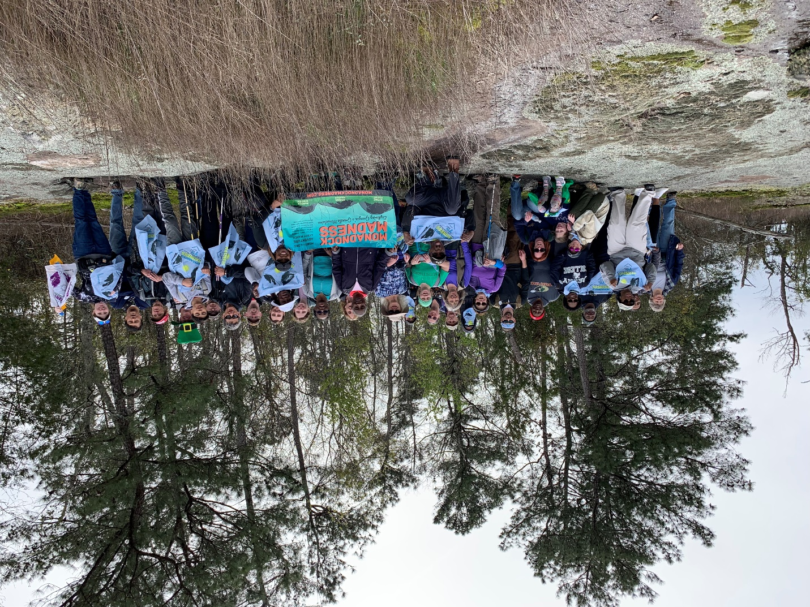
Triumphant triple hikers summit Panola Mountain with a guided Monadnock Madness hike.

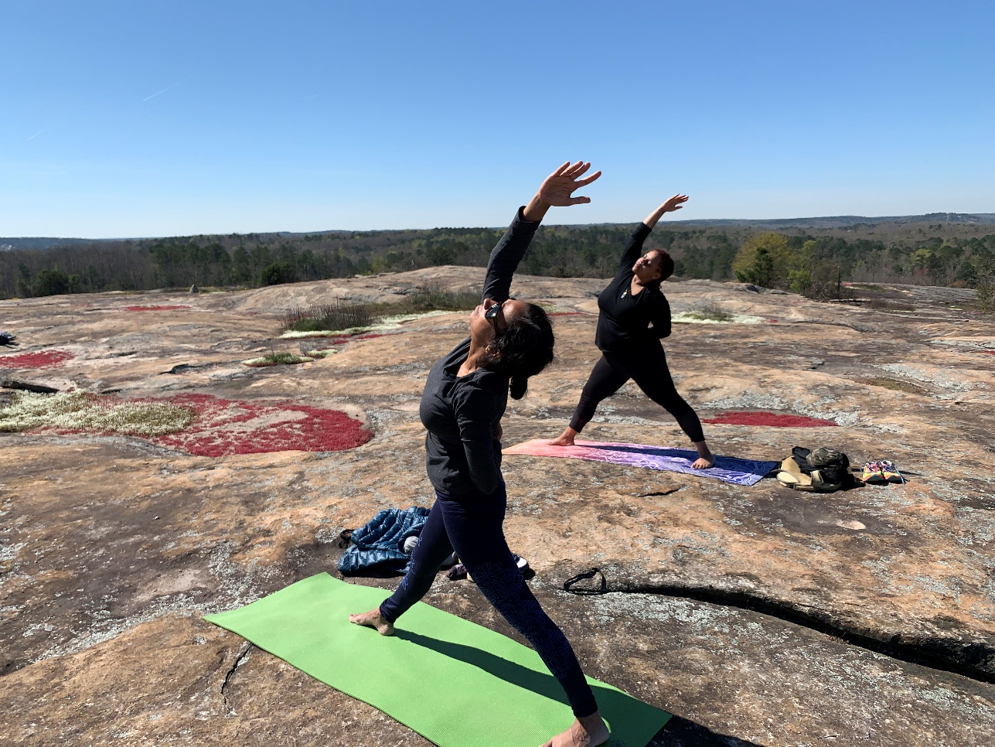
Each year, Monadnock Madness features a yoga class on top of Arabia Mountain.

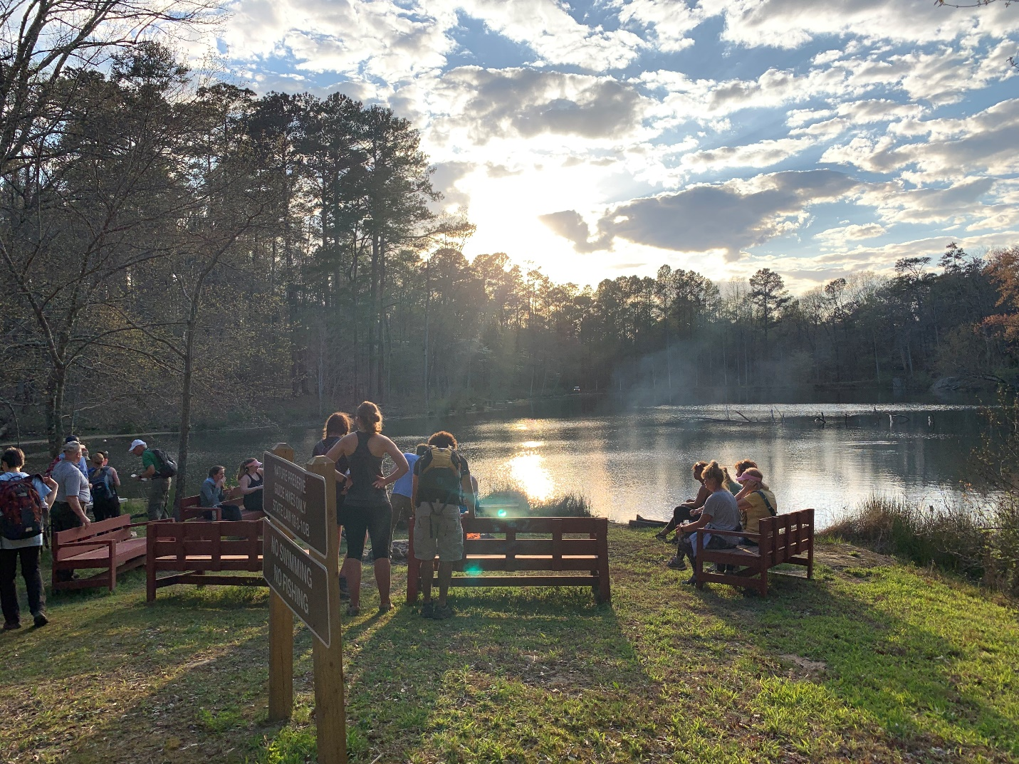
Triple hikers enjoy s’mores after a day of summiting all three monadnocks.
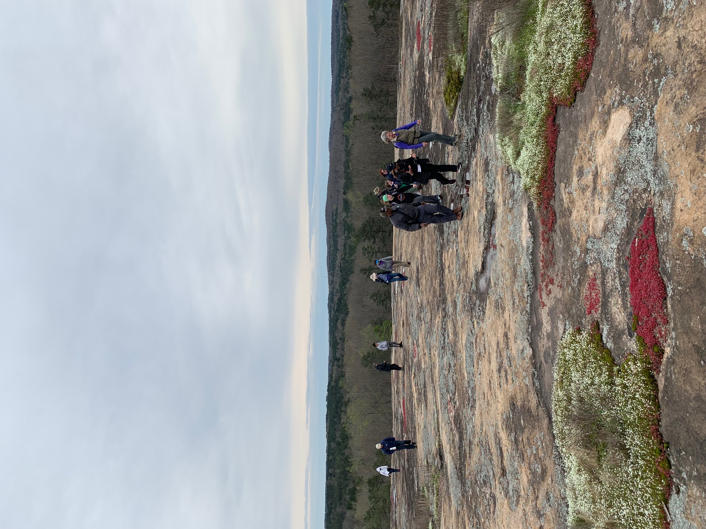
A group of hikers climbs Arabia Mountain during Monadnock Madness.
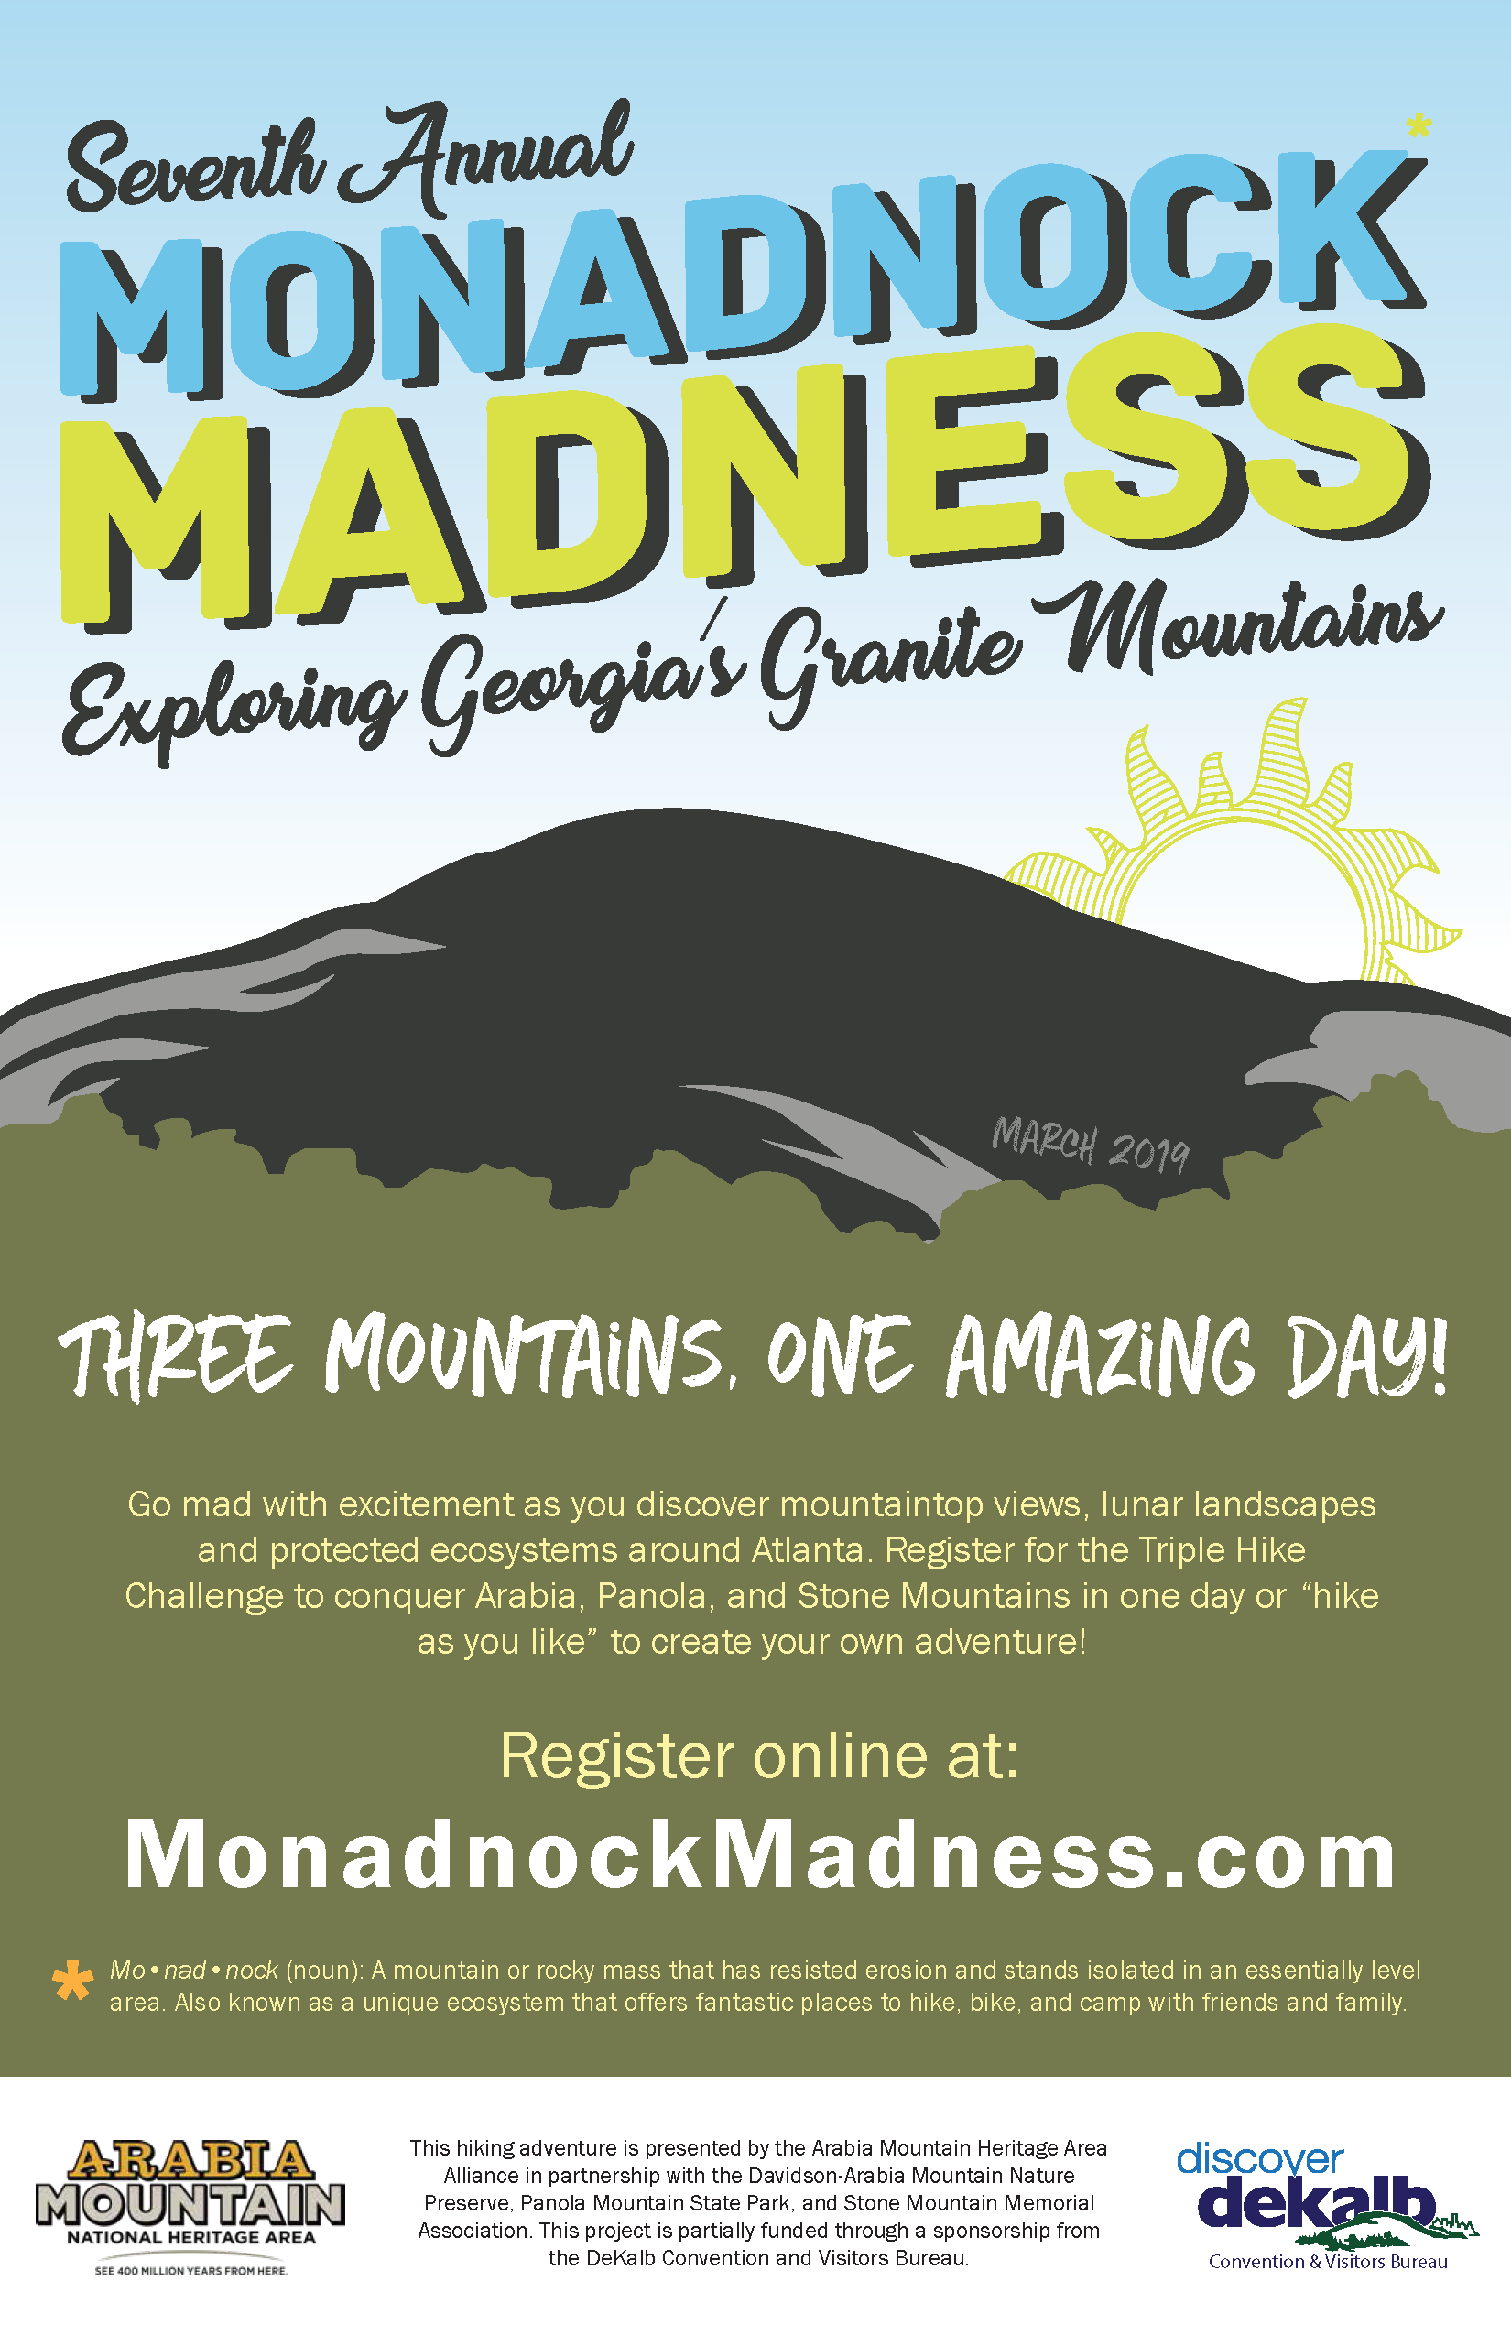
The 2019 Monadnock Madness poster, advertising Hike As You Like as well as the guided Triple Hikes.

###
About Arabia Alliance
The Arabia Mountain Heritage Area Alliance is dedicated to protecting, connecting and sharing the unique history, rich culture and engaging landscapes of the Arabia Mountain National Heritage Area (AMNHA) for the benefit and enjoyment of all. The staff and volunteer board of the Arabia Alliance work with partners across the AMNHA to ensure that everyone can benefit from the cultural and natural resources of the National Heritage Area. For more information, visit www.arabiaalliance.org.

