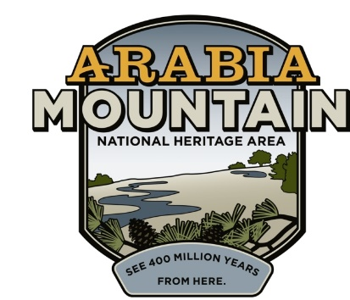
Media Contact: Zack Loehle, Communications Manager
Arabia Mountain Heritage Area Alliance
p: 678-699-2768 | e: zack@arabiaalliance.org

FOR IMMEDIATE RELEASE
Apr. 22, 2021

National Parks Week at Arabia Mountain:
Junior Ranger Day Adapted for Rain, Flexibility

STONECREST, Ga. – Due to the likelihood of inclement weather on Saturday, the Arabia Mountain National Heritage Area Junior Ranger Day scavenger hunt will now be offered from Friday, April 23rd through Saturday, May 1st. Participants can pick up their scavenger hunt materials from the Arabia Mountain Heritage Area Alliance office (3350 Klondike Road) and return for their badge at the same location. Additionally, the office will be open the following Saturday (May 1st) for participants to return and earn their badge, allowing for a full week to complete the scavenger hunt. The extended options are intended to allow for greater flexibility and ease of participation in the National Junior Ranger Day event.

After picking up the scavenger hunt materials, participants have until May 1st to complete the challenge. Staff will be available at the times below for check-in and check-out at the Arabia Alliance office:
- Friday, Apr. 23rd, 1-6pm
- Saturday, Apr. 24th, 10am-3pm
- Sunday, Apr. 25th 1-5pm
- Saturday, May 1st, 10am-3pm
Guide pick-up and swearing-in will all occur at the Arabia Mountain Heritage Area Alliance office, 3350 Klondike Road. Participants can stop by at any point during these days to pick up their guide and/or receive the Junior Ranger badge.

The Junior Ranger scavenger hunt is part of National Junior Ranger Day, the penultimate day of National Park Week. The scavenger hunt will take participants across the National Heritage Area where they will look for clues hidden in the landscape to earn their Junior Ranger Badge. After participants pick up their scavenger hunt materials at the Arabia Alliance office (3350 Klondike Road), they will spend some time in historic downtown Lithonia before heading off across the AMNHA. Sites will include Vaughters’ Farm (part of Panola Mountain State Park), the Flat Rock Archives and the Davidson-Arabia Mountain Nature Preserve. The scavenger hunt will end at the Monastery of the Holy Spirit with one last activity before returning to the Arabia Alliance office for the swearing-in and retrieving the Junior Ranger badge. You can sign up here.

In order to ensure safety (and maximize fun), the event takes place outdoors and is predominately self-guided. Participants can set their own pace as they earn their badge and are encouraged to take their time and thoroughly experience the nature and history of the National Heritage Area. The extended timeline of the event allows for even more exploration at participants’ leisure.

###
About Arabia Alliance
The Arabia Mountain Heritage Area Alliance is dedicated to protecting, connecting and sharing the powerful history, rich culture and engaging landscapes of the Arabia Mountain National Heritage Area (AMNHA) for the benefit and enjoyment of all. The staff and volunteer board of the Arabia Alliance work with partners across the AMNHA to ensure that everyone can benefit from the cultural and natural resources of the National Heritage Area. For more information, visit www.arabiaalliance.org.

