Media Contact: Zack Loehle, Communications Manager
Arabia Mountain Heritage Area Alliance
p: 678-699-2768 | e: zack@arabiaalliance.org

FOR IMMEDIATE RELEASE
Apr. 14, 2021

Best Bike Trailheads at Arabia Mountain
National Heritage Area Urges Bicyclists to Use
Additional Designated Parking Areas

STONECREST, Ga. – The Arabia Mountain Heritage Area Alliance, in partnership with DeKalb County Recreation, Parks and Cultural Affairs, urges bicyclists to park at some of the less-crowded trailheads in the National Heritage Area for the best biking experience. With springtime bringing bicyclists and hikers to enjoy the Arabia Mountain National Heritage Area’s over 34 miles of contiguous paved trail, the most popular trailheads have become overcrowded on busy weekends. A little farther away from the trailheads at the base of Arabia Mountain, free parking is available and the trails are wide-open for bike riding. A few trailhead highlights include:
- Stonecrest Library: 3123 Klondike Road, Stonecrest, GA 30038
- Polebridge Trailhead: 6262 Browns Mill Road, Stonecrest, GA 30038
- Lorraine Trailhead: 3465 Hwy 138 SE, Stockbridge, GA 30281
- Monastery of the Holy Spirit: 2625 Hwy 212 SW, Conyers, GA 30094

“With this beautiful spring weather, many visitors have been coming to enjoy the Arabia Mountain National Heritage Area. By parking at these trailheads, bicyclists can avoid the crowds and hop on the trail,” said Kelly Jordan, Co-Founder of the Arabia Mountain Heritage Area Alliance. “We hope that, by starting at some of these underutilized trailheads, cyclists can get on the trail faster and ride farther than they might have otherwise.” The Arabia Mountain National Heritage Area consists of 40,000 acres, with the paved PATH connecting sites across the NHA.
A recent extension of the PATH into Henry County brings even more routes through Georgia’s forests and rolling hills into reach for anyone seeking outdoor recreation. Starting at Panola Mountain State Park’s Nature Center Trailhead (2620 Hwy 155 SW), the new trail segment is the last piece of the original National Heritage Area trail vision laid out in the 1990’s. Through the Nature Center trailhead and the trailhead at Alexander Lakes (4965 Flat Bridge Road SW), the State Park is another easy parking location for bicyclists and a green jewel of the Arabia Mountain National Heritage Area.
Note that parking at Panola Mountain State Park costs $5.
- more -
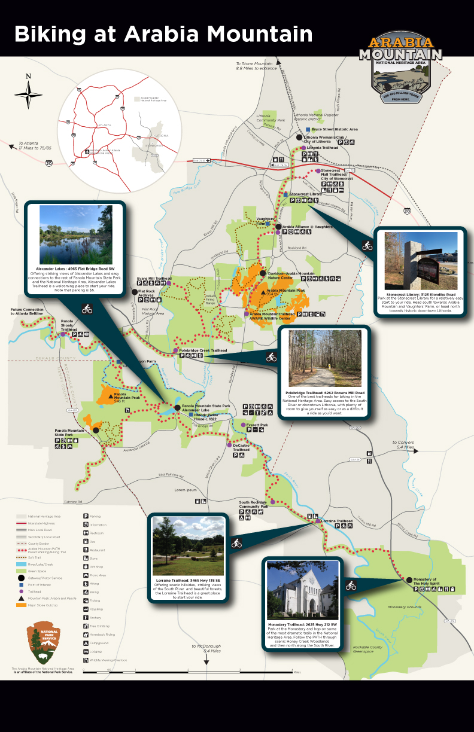
A map showing the location of the recommended trailheads across the National Heritage Area.

###

About the Arabia Alliance
The Arabia Mountain Heritage Area Alliance is dedicated to protecting, connecting and sharing the powerful history, rich culture and engaging landscapes of the Arabia Mountain National Heritage Area (AMNHA) for the benefit and enjoyment of all. The staff and volunteer board of the Arabia Alliance work with partners across the AMNHA to ensure that everyone can benefit from the cultural and natural resources of the National Heritage Area. For more information, visit www.arabiaalliance.org.

