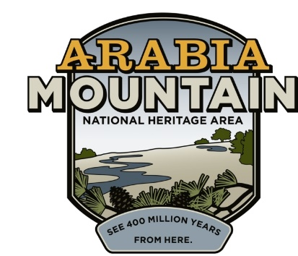
Media Contact: Zack Loehle, Communications Manager
Arabia Mountain Heritage Area Alliance
p: 678-699-2768 | e: zack@arabiaalliance.org

FOR IMMEDIATE RELEASE
Mar. 30, 2021

Arabia Mountain Heritage Area Alliance Presenting Atlanta Wild Animal Rescue Effort (AWARE) Night Owl 5K Fundraiser
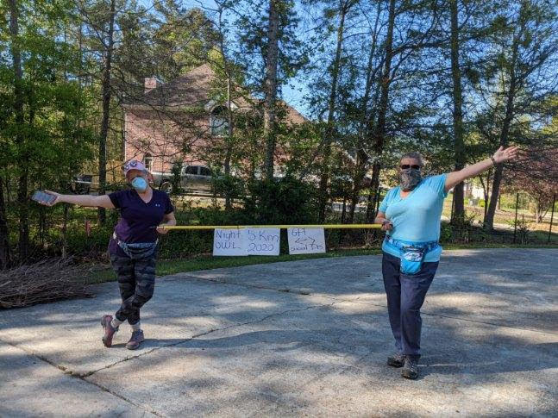
Participants in the 2020 AWARE Night Owl 5K. Credit: Atlanta Wild Animal Rescue Effort (AWARE)

STONECREST, Ga. – From April 9-18, nature enthusiasts can show their support for Georgia’s native wildlife by participating in the virtual Atlanta Wild Animal Rescue Effort (AWARE) Night Owl 5K, presented by the Arabia Mountain Heritage Area Alliance. Taking place virtually in order to ensure COVID-19 safety, participants can walk, stroll or run the 5K and win prizes. Proceeds from the event fund AWARE’s year-round work in rehabilitating Georgia’s injured and orphaned native animals, including owls, squirrels, beavers, egrets, hawks, turtles and many more. Registration is online.

All participants will receive a t-shirt, specially designed for the event. Medals will be given to the fastest finishers in each age group, as well as awards for best costumes. The first place overall finishers (male and female) will receive gift cards and paintings created by AWARE wildlife ambassadors, the animals that cannot be released back into the wild and which live at AWARE. Sign up today! The official date of the race is April 10th, but times can be recorded and submitted between April 9th and 18th.

- more -

AWARE is part of the 40,000-acre Arabia Mountain National Heritage Area, a nationally significant landscape designated by congress as an affiliate of the National Park Service. The Arabia Alliance, the nonprofit management entity of the National Heritage Area, works to protect and promote the powerful history, rich culture and striking natural landscape.

Not only is the Arabia Alliance supporting the 5K – staff and board members will be participating in the event as well. “AWARE is one of the core partners of the National Heritage Area, and their work has a tremendous impact on the wildlife endemic to Georgia,” said Revonda Cosby, Executive Director of the Arabia Alliance. “As soon as we made the decision to sponsor the event, our staff started asking, ‘Can we join in?’ Now we’ll have several board and staff members running in the race. They can’t wait!”

Winners will be announced following the April 18th completion date.

###
About Arabia Alliance
The Arabia Mountain Heritage Area Alliance is dedicated to protecting, connecting and sharing the powerful history, rich culture and engaging landscapes of the Arabia Mountain National Heritage Area (AMNHA) for the benefit and enjoyment of all. The staff and volunteer board of the Arabia Alliance work with partners across the AMNHA to ensure that everyone can benefit from the cultural and natural resources of the National Heritage Area. For more information, visit www.arabiaalliance.org.

