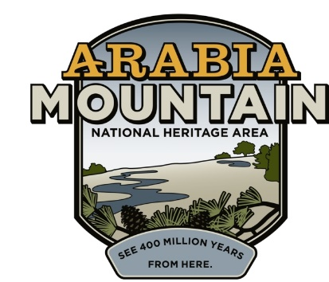
Media Contact: Zack Loehle, Communications Manager
Arabia Mountain Heritage Area Alliance
p: 404-998-8384 | e: zack@arabiaalliance.org

FOR IMMEDIATE RELEASE
Mar. 18, 2020

Guided Monadnock Madness Events
Suspended Due to COVID-19 Outbreak
Parks Still Open, Self-Guided “Hike As You Like” Option Available

STONECREST, Ga. – Due to the worsening outbreak of COVID-19 in the Atlanta area and nationwide, the Monadnock Madness Guided Triple Hikes have been suspended. Hikers can still celebrate Monadnock Madness with the “Hike As You Like” self-guided option, which allows participants to visit Arabia, Kennesaw, Panola and Stone Mountains and receive a stamp and prize on their own schedule. You can pick up your passport online and email info@arabiaalliance.org for stamps once you have completed the hikes. People can also complete the Monadnock Madness Geocaching Challenge on their own. The parks are all remaining open as of the time of this press release. It is important that hikers remember to practice social distancing and frequent handwashing to prevent the further spread of the outbreak.
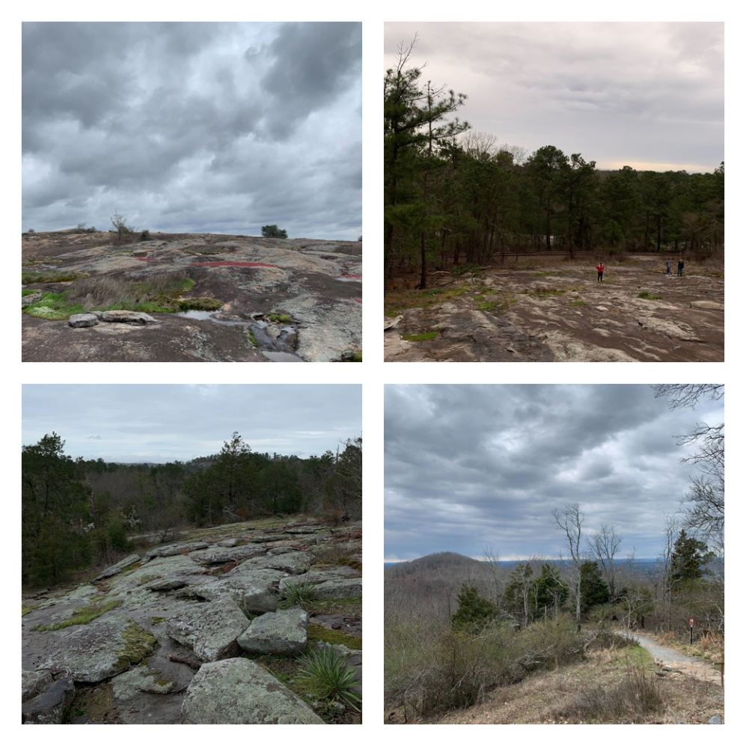
Clockwise from top left: Arabia, Stone, Kennesaw and Panola Mountains. Although guided Monadnock Madness events have been canceled due to COVID-19, hikers can still participate in the Hike As You Like challenge.

Georgia’s monadnocks boast a variety of natural wonders, and Monadnock Madness gives participants plenty of opportunities to discover the natural resources hidden in Atlanta’s backyard. See rare plants such as diamorpha, vibrant vernal pools and landscapes unique to the American Southeast. While guided events have been cancelled, visitors can still enjoy these beautiful landscapes by hiking on their own while practicing proper social distancing. More information at monadnockmadness.com.

“Although we are saddened to have to cancel the guided Monadnock Madness hikes, the safety of participants and staff is of the utmost importance. We strongly recommend following all protocols and guidelines from the CDC and other health organizations during this difficult time,” said Arabia Mountain Heritage Area Alliance Executive Director Revonda Cosby. “We hope that people will still participate in this exciting challenge through the Hike As You Like option, which can give kids and adults the opportunity to get outside while maintaining social distance.”

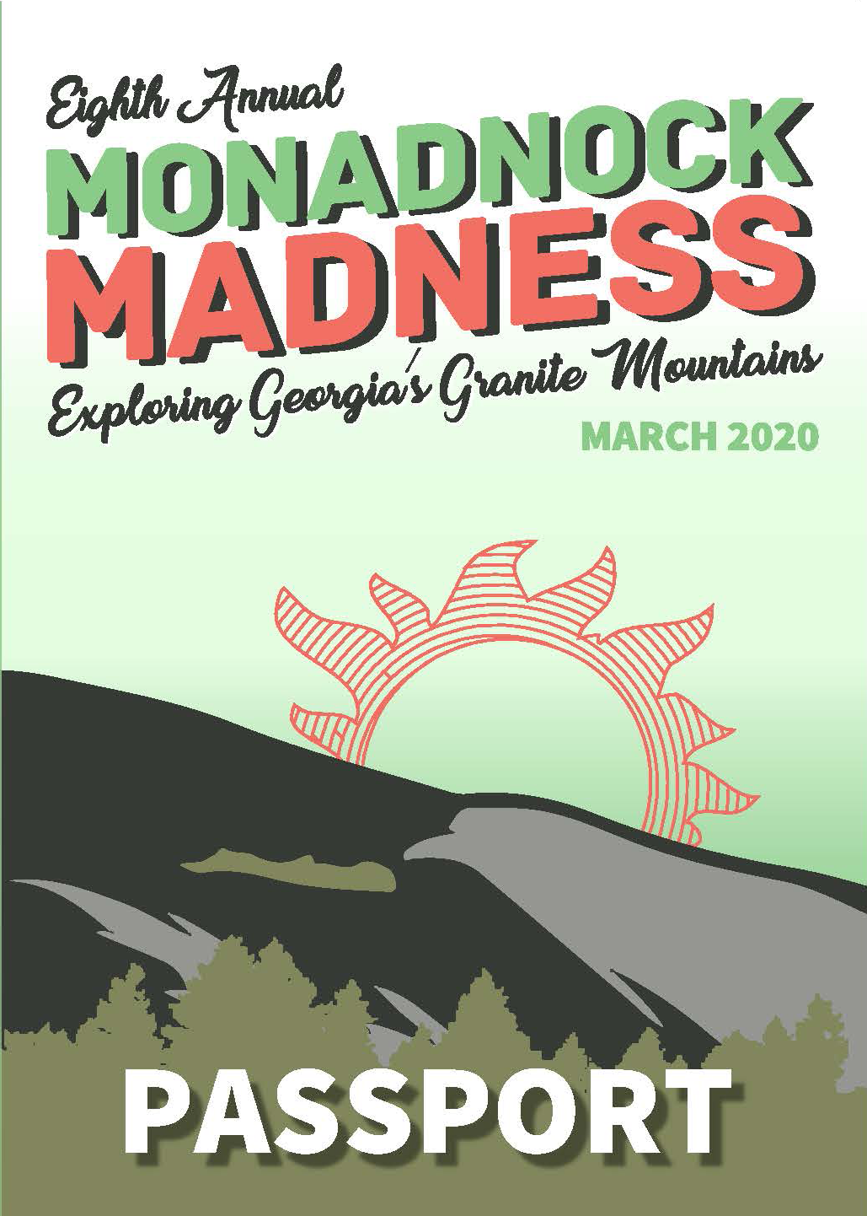
This year’s Monadnock Madness passport. Participants get a passport stamp as they hike each mountain and earn a prize. More information available online at
https://monadnockmadness.com/wp-content/uploads/2020-Passport-LowRes.pdf.

The Arabia Alliance and partners are discussing rescheduling the Guided Triple Hikes for a tentative date in May. More details will be forthcoming, and are subject to relevant public health recommendations. Monadnock Madness is presented by the Arabia Mountain Heritage Area Alliance in partnership with the Davidson-Arabia Mountain Nature Preserve, Panola Mountain State Park and the Stone Mountain Memorial Association. Special thanks to our sponsors. Visit www.monadnockmadness.com for details.

###
About Arabia Alliance
The Arabia Mountain Heritage Area Alliance is dedicated to protecting, connecting and sharing the powerful history, rich culture and engaging landscapes of the Arabia Mountain National Heritage Area (AMNHA) for the benefit and enjoyment of all. The staff and volunteer board of the Arabia Alliance work with partners across the AMNHA to ensure that everyone can benefit from the cultural and natural resources of the National Heritage Area. For more information, visit www.arabiaalliance.org.

