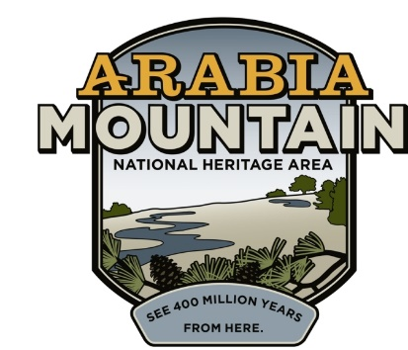
Media Contact: Zack Loehle, Communications Manager
Arabia Mountain Heritage Area Alliance
p: 678-699-2768 | e: zack@arabiaalliance.org

FOR IMMEDIATE RELEASE
Feb. 22, 2021

Expanding Metro Atlanta’s Recreation Opportunities:
Henry County PATH Trail Phase I Complete
Phase II Expansion Underway

HENRY COUNTY, Ga. – The popular Arabia Mountain PATH (AMP) trail system now includes a 1.3-mile segment into Henry County, further expanding the now over 34-mile contiguous trail. Emerging out of Panola Mountain State Park, the new trail segment brings bikers, walkers and hikers over GA-155 and through the lush, wooded hillsides of the Georgia Piedmont. Visitors can access the new trail segment, called the Panola Mountain Greenway, from the Nature Center at 2620 GA-155. The PATH Foundation, representatives from Henry County government, Georgia State Parks & Historic Sites and the Arabia Mountain Heritage Area Alliance celebrated the new trail extension with a ribbon-cutting at Panola Mountain State Park on Friday, February 19.

Phase II of the Henry County PATH expansion is now in design and will connect the trail segment to a new trailhead near Austin Road Middle School. Currently, the new trail can only be accessed from the Panola Mountain State Park Nature Center. The extension was recently approved by the Henry County Board of Education in a unanimous vote. “This is one of the signature projects south of I-20,” said Henry County Commissioner Bruce Holmes at the ribbon-cutting on Friday. “I’m proud to announce that the Henry County Board of Education just recently approved the process where we can extend the trail all the way to Austin Road Middle School, giving people in Henry County an opportunity to start the trail in Henry County, come to Panola Mountain State Park...we can actually take this trail, without driving, to the City of Stonecrest, and hopefully to the Atlanta Beltline in the very near future,” he said.

The multiuse Arabia Mountain PATH currently connects greenspace and historic sites throughout the Arabia Mountain National Heritage Area (AMNHA), a congressionally designated, nationally significant landscape in the southeast Atlanta metro. This paved trail allows for walkers, bikers, hikers and runners (as well as those in wheelchairs and parents with strollers) to enjoy the forests, meadows and history of the National Heritage Area. It connects sites across 40,000 acres of land, including the Monastery of the Holy Spirit, downtown Lithonia and the historic Flat Rock community. The expansion of the PATH out from Panola Mountain State Park (also part of the AMNHA and a National Natural Landmark) provides even more opportunities for outdoor recreation across three metro-Atlanta counties: DeKalb, Henry and Rockdale.

“We met about 20 years ago with the PATH foundation...and sketched out a vision of a trail system that would connect all three of these counties together, and this is the final piece of the original vision that we’re cutting the ribbon on today,” said Kelly Jordan, Co-Founder and Board Treasurer of the Arabia Mountain Heritage Area Alliance, the nonprofit entity that works to protect and promote the entire AMNHA. He added that “the citizens of Henry County have an incredible amenity thanks to these folks right here...It’s a great day to celebrate interconnectedness and folks working together to make the world a better place, something we could all use a little more of right now.”

- more -

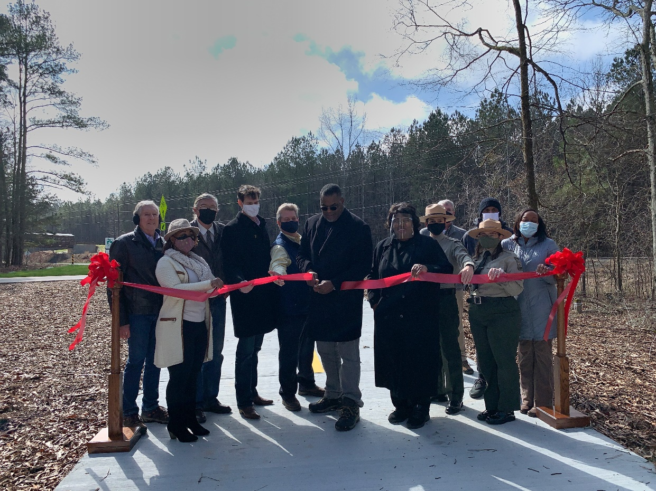
Henry County District 5 Commissioner Bruce Holmes, flanked by representatives of Henry County Government, Georgia State Parks and Historic Sites, PATH Foundation, and the Arabia Mountain Heritage Area Alliance, cuts the ribbon to celebrate the opening of the new PATH trail segment.

###
About Arabia Alliance
The Arabia Mountain Heritage Area Alliance is dedicated to protecting, connecting and sharing the powerful history, rich culture and engaging landscapes of the Arabia Mountain National Heritage Area (AMNHA) for the benefit and enjoyment of all. The staff and volunteer board of the Arabia Alliance work with partners across the AMNHA to ensure that everyone can benefit from the cultural and natural resources of the National Heritage Area. For more information, visit www.arabiaalliance.org.

