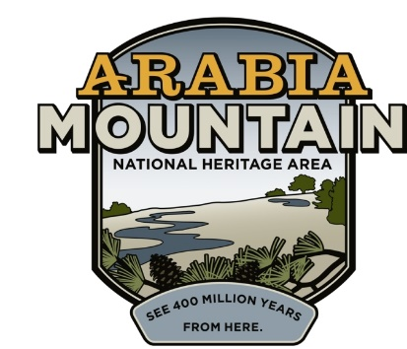
Media Contact: Zack Loehle, Communications Manager
Arabia Mountain Heritage Area Alliance
p: 404-998-8384 | e: zack@arabiaalliance.org

FOR IMMEDIATE RELEASE
Feb. 2, 2021

Save the Date: Monadnock Madness Coming Soon
Enjoy COVID-Safe Hiking, Photography and Yoga on Georgia’s Granite Giants
Tickets Now On Sale

STONECREST, Ga. – Are you ready to rock? This March, get out and explore Georgia’s granite giants – Arabia, Panola, and Stone Mountains – during the annual Monadnock Madness. Adapted for COVID-19 safety, the annual outdoor event will offer socially-distanced nature photography and yoga workshops, as well as a hike-as-you-like version of the popular Triple Hike Challenge (including a special fourth-mountain hike, Kennesaw Mountain). Ticket sales are now open for the photography and yoga events, and the hike-as-you-like option allows people to visit each greenspace on their own time and complete the hiking challenge at their own pace.

Georgia’s massive granite outcrops (called “monadnocks”) support a variety of natural wonders and the month-long outdoor celebration gives participants plenty of opportunities to discover the natural resources hidden in Atlanta’s backyard. See rare plants such as diamorpha, vibrant vernal pools and landscapes unique to the American Southeast. Throughout March, hikers can join photography workshops, several different yoga and mindfulness workshops, and self-guided hiking. Wherever you go, please leave no trace.

In order to maintain physical distance, event organizers have replaced the guided triple mountain hikes with the hike-as-you-like option. Participants visit Arabia, Panola and Stone Mountains on their own, taking a photo (preferably a selfie) on the trails. Then, once they are done hiking, hikers upload the images to an online passport. When they have sent in the passport, they earn their prize. Online passport opens on March 1st. There is an additional prize for hiking Kennesaw Mountain, a fourth-mountain option you can add to your hiking challenge.

During the ongoing COVID-19 pandemic, parks and outdoor spaces around the country have seen dramatic increases in visitation, including in the National Heritage Area and around Atlanta. During Monadnock Madness, that makes practicing Leave No Trace hiking all the more important. As visitors enjoy Georgia’s iconic granite outcrops, we ask that they take only pictures, avoid stepping in vegetation, dispose of waste properly, and respect the animal and plant life that thrives in these oases of nature. Learn more about Leave No Trace hiking here.

People can also sign up for guided hikes, tree climbing, and more at Panola Mountain State Park. (If you want to reach the top of Panola Mountain, you can only do so with a guided hike.) Be sure to check the State Park website for information about events, and call (770) 389-7801 to sign up. Please note that events at Panola Mountain State Park have been filling up very quickly, so call sooner rather than later. For a full list of available events, visit arabiaalliance.org/activities/monadnock-madness.

Monadnock Madness is presented by the Arabia Mountain Heritage Area Alliance in partnership with the Davidson-Arabia Mountain Nature Preserve, Panola Mountain State Park, the Stone Mountain Memorial Association and Kennesaw Mountain National Battlefield Park. Special thanks to our sponsors.

- more -
Monadnock Madness highlights for this year include the following activities which require pre-registration:

Photography Workshops – March 13th and 21st; tickets $15. Purchase tickets here.

Yoga & Mindfulness Workshops – March 7th, 20th and 28th; tickets $25. Purchase tickets here.

Photos from previous years’ Monadnock Madness are also available to view here. Visit arabiaalliance.org/activities/monadnock-madness for more information.
###
About Arabia Alliance
The Arabia Mountain Heritage Area Alliance is dedicated to protecting, connecting and sharing the powerful history, rich culture and engaging landscapes of the Arabia Mountain National Heritage Area (AMNHA) for the benefit and enjoyment of all. The staff and volunteer board of the Arabia Alliance work with partners across the AMNHA to ensure that everyone can benefit from the cultural and natural resources of the National Heritage Area. For more information, visit www.arabiaalliance.org.

