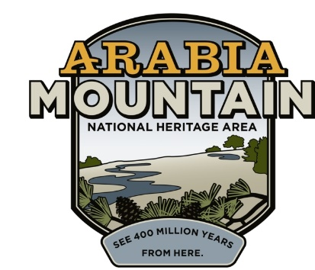
Media Contact: Zack Loehle, Communications Manager
Arabia Mountain Heritage Area Alliance
p: 678-699-2768 | e: zack@arabiaalliance.org

FOR IMMEDIATE RELEASE
Feb. 15, 2021

Save the Date:
10th and Final Year of Monadnock Madness Begins March 1st
Enjoy Hiking, Photography and Yoga on Georgia’s Granite Giants
Special Event Tickets Now On Sale

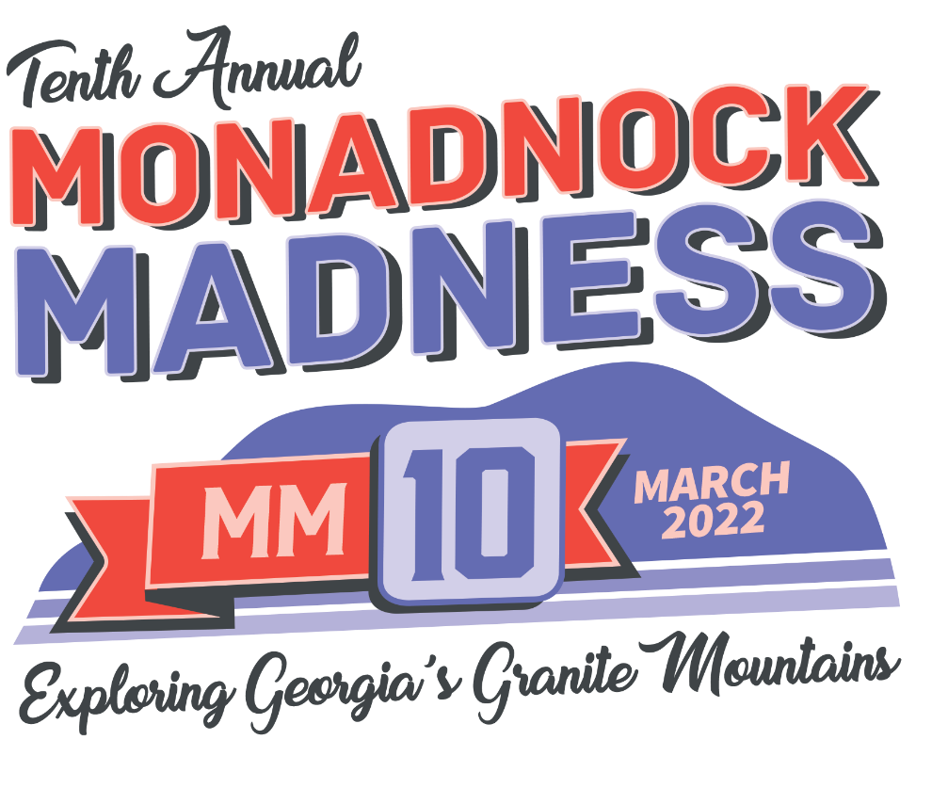
Above: Logo for the 10th annual Monadnock Madness.

STONECREST, Ga. – Are you ready to rock? This March, get out and explore Georgia’s granite giants – Arabia, Panola, and Kennesaw Mountains – during the 10th and final Monadnock Madness. Adapted for COVID-19 safety, the outdoor event will offer socially-distanced nature photography and yoga workshops, as well as a the popular Triple Hike Challenge. Ticket sales are now open for the photography and yoga events, and Triple Hike Challenge will formally begin on March 1st. The Triple Hike Challenge will be in a hike-as-you-like format, allowing people to visit each greenspace on their own time and complete the hiking challenge at their own pace. This is the 10th and final year of the event, begun in 2012 as a way to promote hiking across metro-Atlanta’s greenspaces.

Georgia’s massive granite outcrops (called “monadnocks”) support a variety of natural wonders and the month-long outdoor celebration gives participants plenty of opportunities to discover the natural resources hidden in Atlanta’s backyard. See rare plants such as diamorpha, vibrant vernal pools and landscapes unique to the American Southeast. Throughout March, hikers can join photography workshops, several different yoga and mindfulness workshops, and self-guided hiking. Wherever you go, please leave no trace.

For the Triple Hike Challenge, participants visit Arabia, Panola and Kennesaw Mountains on their own, taking a photo (preferably a selfie) on the trails. Then, once they are done hiking, hikers upload the images to an online passport located at monadnockmadness.com (passport will go live on March 1st). When they have sent in the passport, they earn their prize.

As visitors enjoy Georgia’s iconic granite outcrops, we ask that they take only pictures, avoid stepping in vegetation, dispose of waste properly and respect the animal and plant life that thrives in these oases of nature. Learn more about Leave No Trace hiking here.

“Monadnock Madness has been a wonderful and vibrant part of programming in these parks across metro-Atlanta,” said Revonda Cosby, Executive Director of the Arabia Mountain Heritage Area Alliance, the nonprofit management entity of the Arabia Mountain National Heritage Area. “Over the past ten years, people have built connections, realized the similarities between these parks, and discovered a world of wonder right in Atlanta’s backyard. We will keep that spirit of excitement and love of nature in outdoor programming, this final year of Monadnock Madness and in the other events to come.”

People can also sign up for guided hikes and other events at the three parks. For a full list of available events, visit monadnockmadness.com.

Monadnock Madness is presented by the Arabia Mountain Heritage Area Alliance in partnership with the Davidson-Arabia Mountain Nature Preserve, Panola Mountain State Park, and Kennesaw Mountain National Battlefield Park. Special thanks to our partners, instructors and program participants.

Monadnock Madness highlights for this year include the following activities which require pre-registration:

Photography Workshops – March 12th and 20th; tickets $15. Sign up here.

Yoga & Mindfulness Workshops – March 13th and 27th; tickets $25. Sign up here.

Photos from previous years’ Monadnock Madness are also available to view here. Visit monadnockmadness.com for more information.

- more -
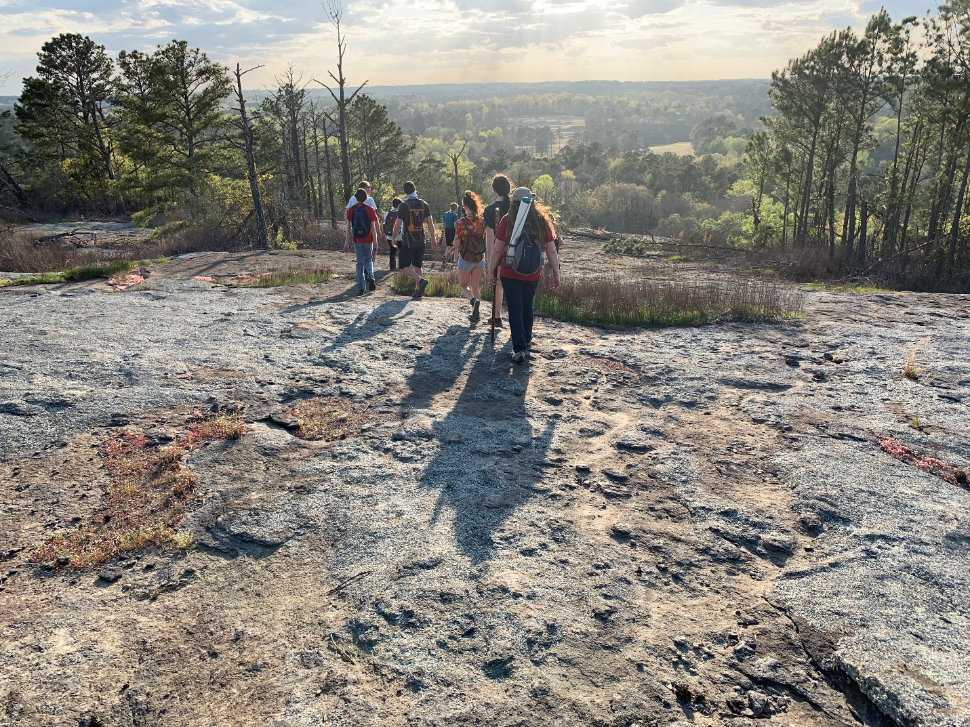
Above: Participants enjoy a guided hike on Panola Mountain in a previous year’s Monadnock Madness. Part of Panola Mountain State Park, Panola Mountain is a National Natural Landmark and rare example of a pristine granite outcrop ecosystem.

- more -
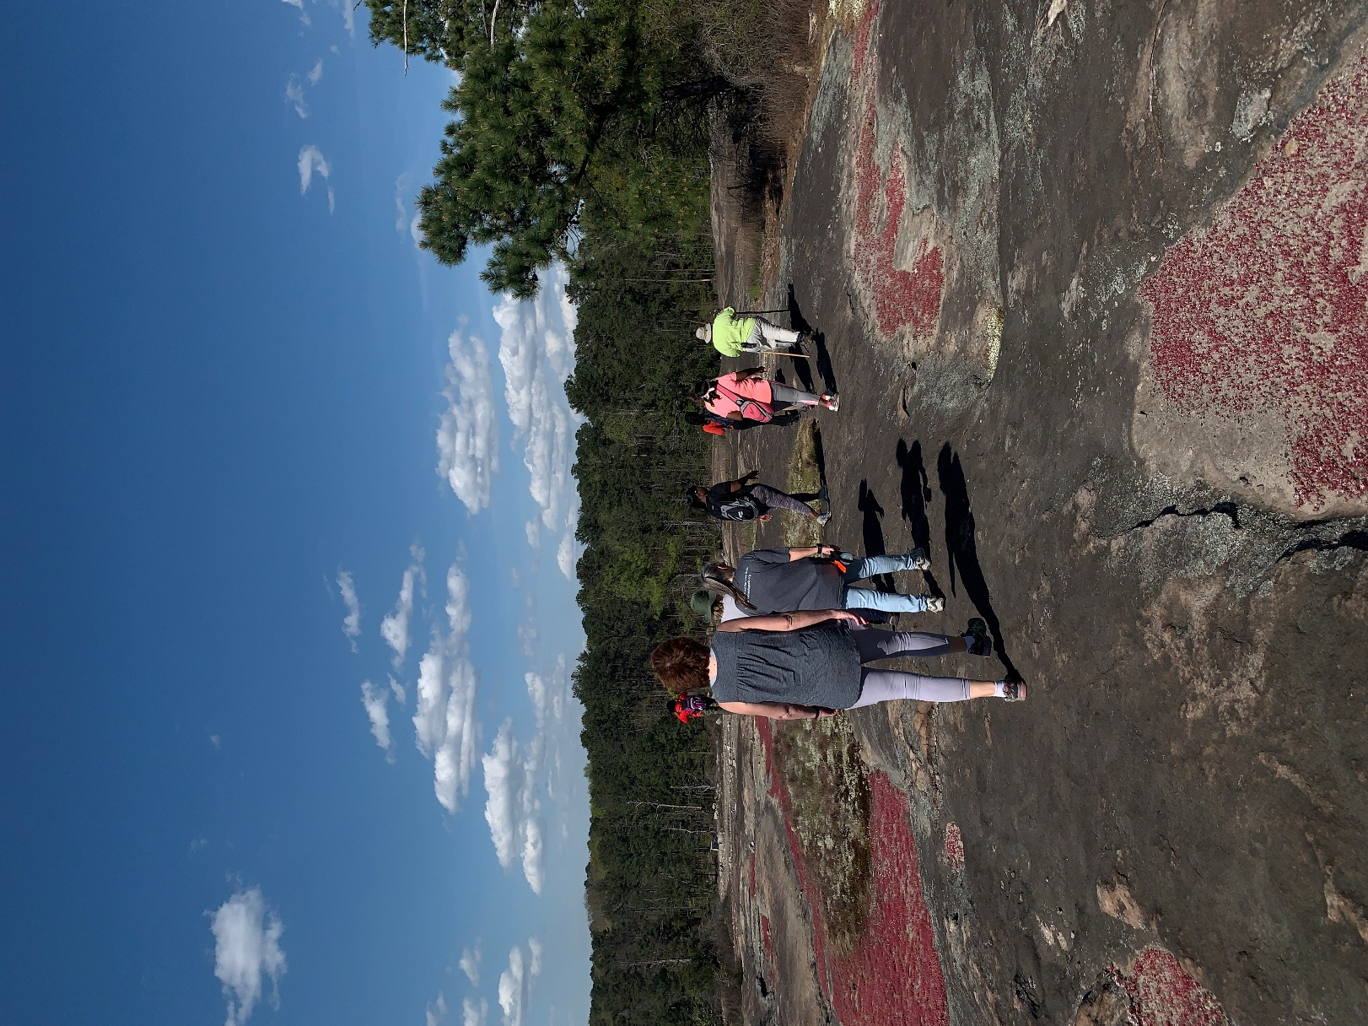
Above: Hikers on Arabia Mountain (part of Davidson-Arabia Mountain Nature Preserve), hiking among patches of the red diamorpha in bloom.

- more -

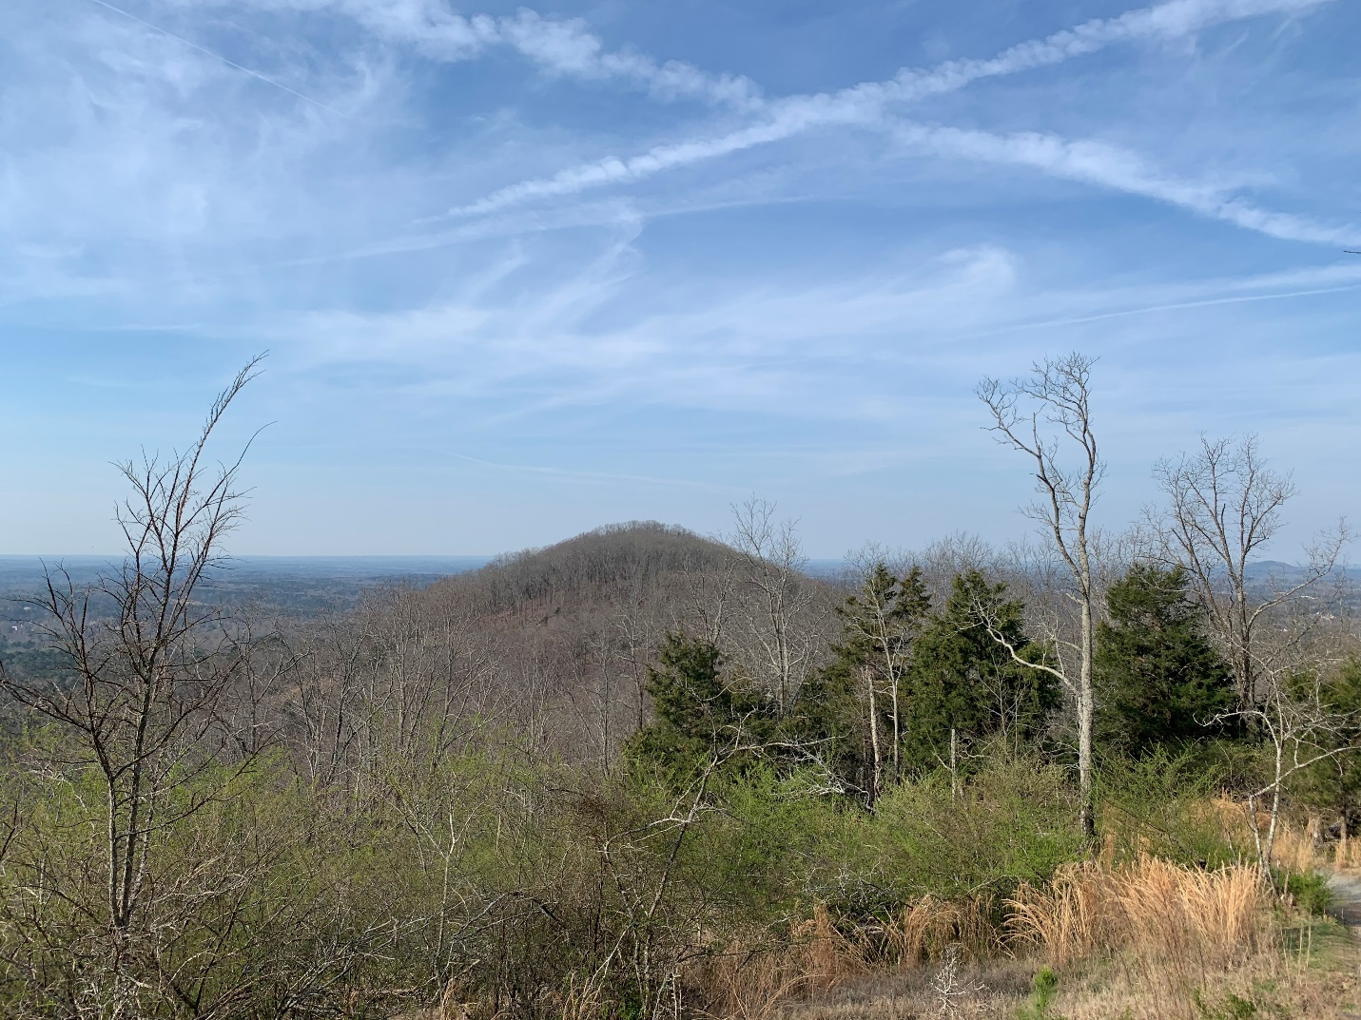
Kennesaw Mountain, the centerpiece of Kennesaw Mountain National Battlefield Park, is also a monadnock – from the top, you can see the relatively flat landscape all around the mountain.
###
About Arabia Alliance
The Arabia Mountain Heritage Area Alliance is dedicated to protecting, connecting and sharing the powerful history, rich culture and engaging landscapes of the Arabia Mountain National Heritage Area (AMNHA) for the benefit and enjoyment of all. The staff and volunteer board of the Arabia Alliance work with partners across the AMNHA to ensure that everyone can benefit from the cultural and natural resources of the National Heritage Area. For more information, visit www.arabiaalliance.org.

