Media Contact: Zack Loehle, Communications Manager
Arabia Mountain Heritage Area Alliance
p: 404-998-8384 | e: zack@arabiaalliance.org

FOR IMMEDIATE RELEASE
Feb. 14, 2019

Roots and Resilience: Discover the History of Flat Rock
New DeKalb History Center Exhibit Chronicles Historic African-American Community

DECATUR, Ga. – Flat Rock, one of the oldest African-American communities in the state of Georgia and a part of the Arabia Mountain National Heritage Area, is the subject of a new exhibit created by the DeKalb History Center and the Flat Rock Archives. The exhibit, Deep Roots in DeKalb: The Flat Rock Story of Resilience, opens in Decatur at the end of the month. As visitors learn about the people of Flat Rock and DeKalb County, they will discover a story of strength, ingenuity and resilience that continues to this day.

From the days of enslavement to its rise as a close-knit agricultural community, Flat Rock thrived because of the selflessness of its leaders and the communal bond of its citizens. It was founded in 1822 with the birth of DeKalb County. The first post office was built in 1837; the area became Lithonia, Georgia, in 1856. Following the Civil War, some African-American families remained in the community of Flat Rock, working together to ensure success and safety in rural Georgia. One of the local leaders, T. A. Bryant, Sr., was pivotal in ensuring the successful development of this African-American community, purchasing and providing land to local families. Though dogged by marginalization and animosity, the people of Flat Rock flourished.

The new exhibit at the DeKalb History Center was developed in partnership with the Flat Rock Archives, an organization dedicated to preserving Flat Rock and DeKalb County’s history and cultural legacy. “We are looking forward to the number of people that will learn about DeKalb County’s African-American history,” said Johnny Waits, President and Co-Founder of the Archives. “The exhibit will be up for two years, and we hope that we can draw more interest in black history in DeKalb County.” Visitors can learn more about the Archives, and plan a visit, at http://www.flatrockarchives.com/.

The DeKalb History center will host an opening reception on Thursday, February 28th, from 6-8 pm at the Historic DeKalb Courthouse (101 East Court Square, Decatur GA 30030). The reception is free and open to the public. The exhibit will be on display at the DeKalb History Center from February 2019 to February 2021. More information about the exhibit can be found at the DeKalb History Center’s website.

- more -
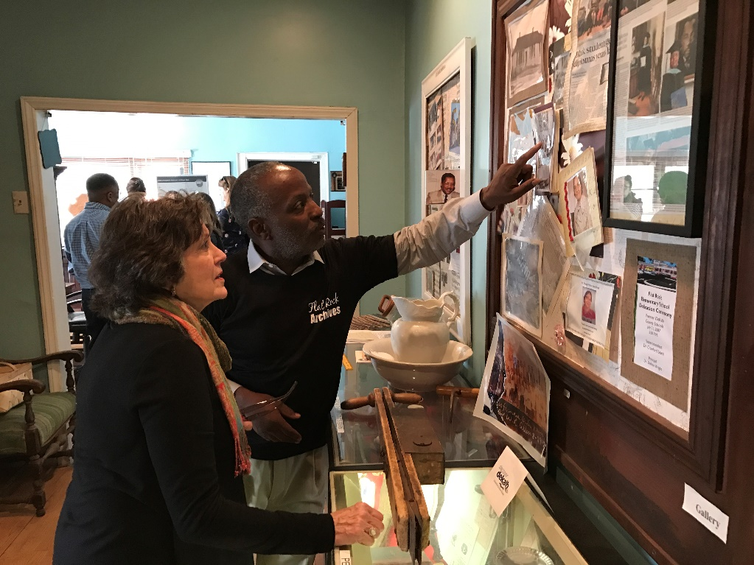
Flat Rock Archives President and Co-Founder Johnny Waits gives a tour of the Archives.

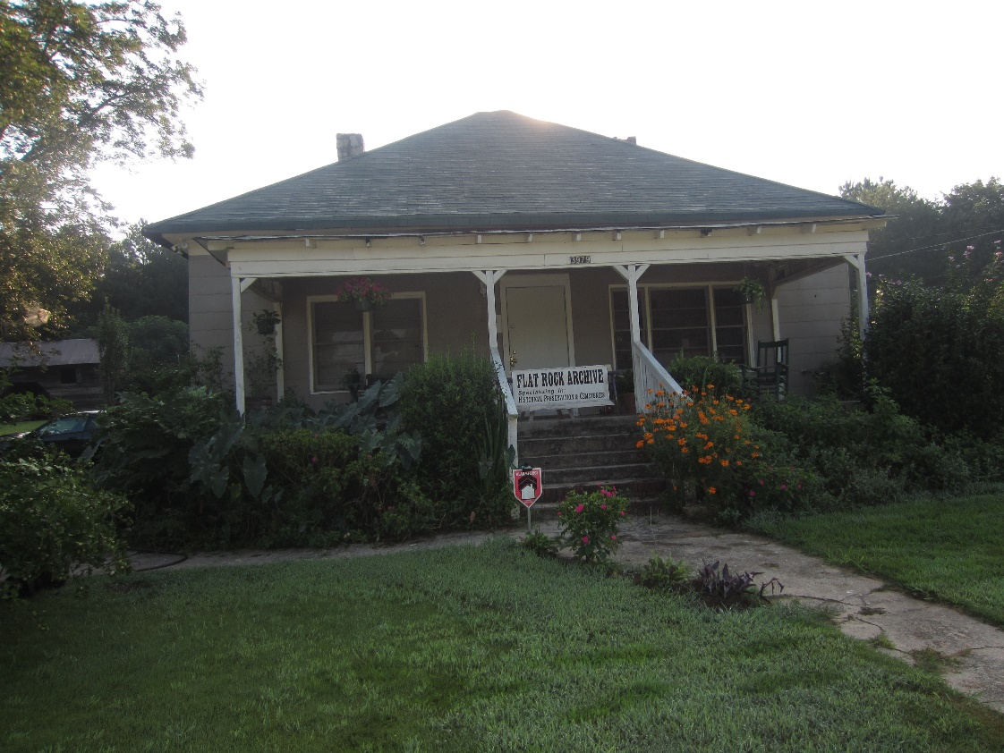
The historic T. A. Bryant, Sr., house and homestead in Stonecrest, GA, now home to the Flat Rock Archives.

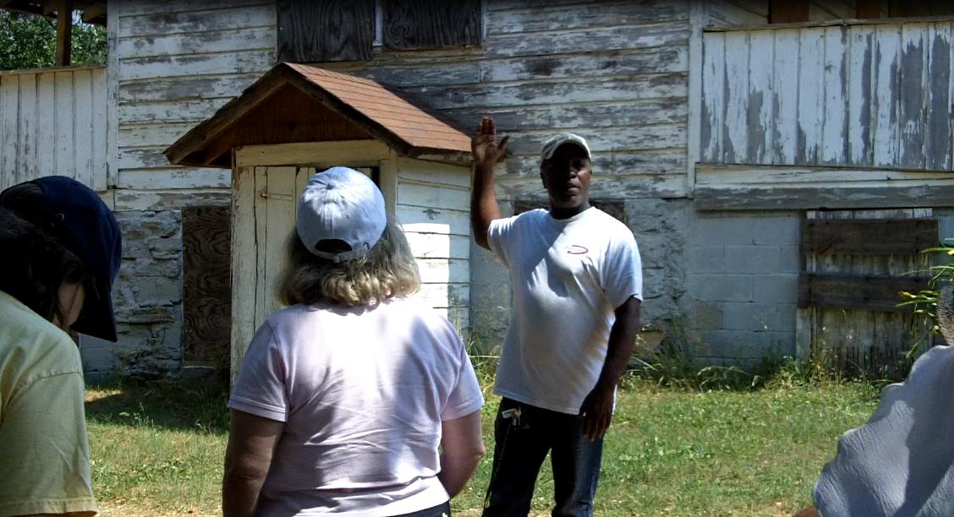
Johnny Waits of the Flat Rock Archives leading visitors on an educational tour of the Lyon Homestead. One of the oldest homesteads in the area, it is also the site where some Flat Rock founders and citizens were enslaved.

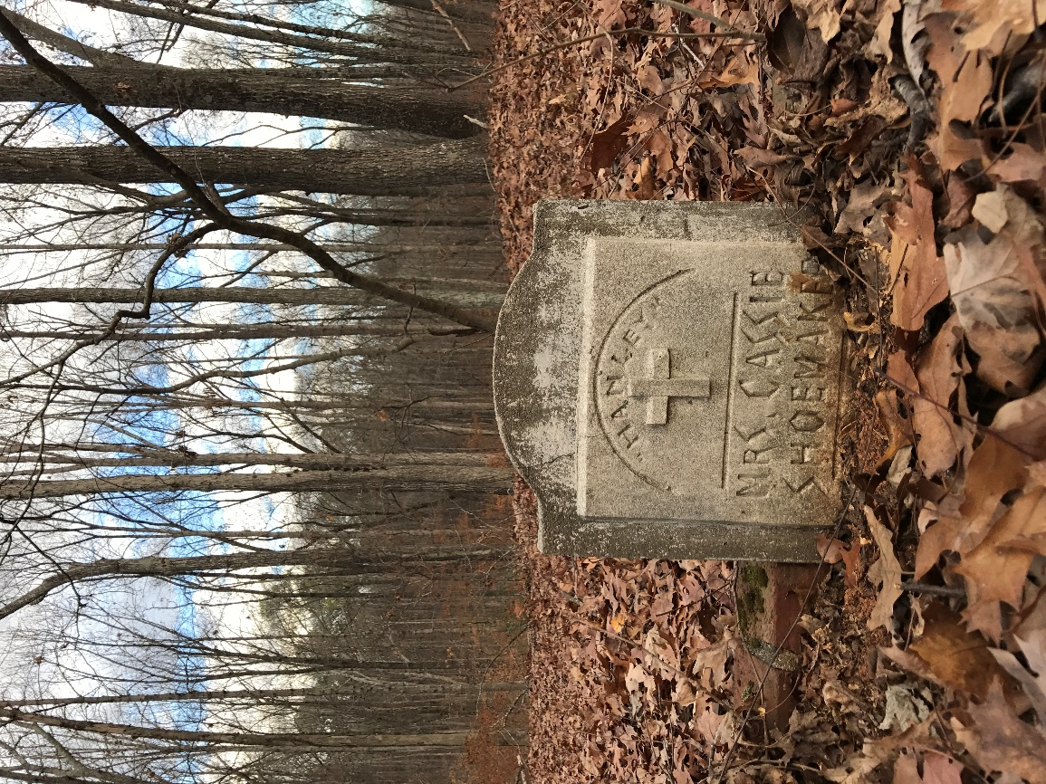
A tombstone in the historic Flat Rock cemetery.

Poster for the event at the DeKalb History Center. Opening reception on Thursday, February 2019 from 6-8pm. The event is free and open to the public.

###
About the Arabia Alliance
The Arabia Mountain Heritage Area Alliance is dedicated to protecting, connecting and sharing the unique history, rich culture and engaging landscapes of the Arabia Mountain National Heritage Area (AMNHA) for the benefit and enjoyment of all. The staff and volunteer board of the Arabia Alliance work with partners across the AMNHA to ensure that everyone can benefit from the cultural and natural resources of the National Heritage Area. For more information, visit www.arabiaalliance.org.

