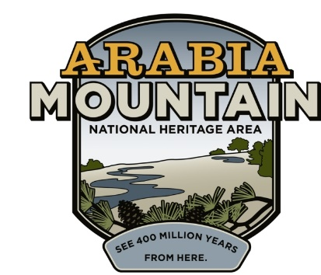
Media Contact: Zack Loehle, Communications Manager
Arabia Mountain Heritage Area Alliance
p: 404-998-8384 | e: zack@arabiaalliance.org

FOR IMMEDIATE RELEASE
Feb. 12, 2020

Monadnock Madness Guided Triple Hike Tickets Sold Out
Mountaintop Sunset Yoga, Nature Photography Workshops Still Open

STONECREST, Ga. – Guided Triple Hikes for Monadnock Madness, the annual celebration of metro-Atlanta’s granite mountains, are now sold out. However, tickets remain open for Mountaintop Sunset Yoga and the Nature Photography Workshops. You can also enjoy the Hike As You Like option by visiting each of the three parks and receiving a passport stamp during the month of March. Everyone who completes the Triple Hike Challenge (guided or Hike As You Like) will receive a Monadnock Madness souvenir while supplies last.

“There’s a lot of excitement this year,” said Revonda Cosby, Executive Director of the Arabia Mountain Heritage Area Alliance, the nonprofit partner of the Arabia Mountain National Heritage Area. “It’s unusual to have the guided hikes sell out this fast. We’re really thrilled that so many people want to come out and hike these natural wonders right in Atlanta’s backyard.” People who still want to join a Guided Triple Hike can sign up for the waiting list here.

Monadnock Madness encompasses dozens of events taking place throughout the month of March. Organized by the Arabia Mountain Heritage Area Alliance, Davidson-Arabia Mountain Nature Preserve, Panola Mountain State Park and the Stone Mountain Memorial Association, all events center around the parks’ iconic granite outcrops (monadnocks). For the first time, Kennesaw Mountain National Battlefield Park has joined the event as a fourth-mountain hiking option. After completing the other three hikes, participants can hike Kennesaw Mountain for an extra stamp and prize. You can complete the Hike As You Like Triple Hike Challenge by visiting each park on your own and stopping by the Nature Center for a stamp, or by signing up for other events taking place during the month.

On Sunday, March 29th, visitors to Davidson-Arabia Mountain Nature Preserve can join Sandra Bonkiene of Bakari Yoga for Mountaintop Yoga at Arabia Mountain. Anyone wanting to expand their photography skills can sign up for one of the Nature Photography Workshops, which take place on March 3rd and 15th. Anyone can explore the variety of other hikes and activities at all three parks on the Monadnock Madness website.

For the more technology-minded, the Geocaching Challenge mixes high-tech adventure with old-fashioned exploration for a different view of the monadnocks. Completing the specified geocaches (treasure troves hidden across the landscape, found via smartphone or GPS) is another way to receive a Monadnock Madness prize.

To learn more about this month-long series of hiking festivities, or to sign up for an event, visit https://monadnockmadness.com/.

- more -

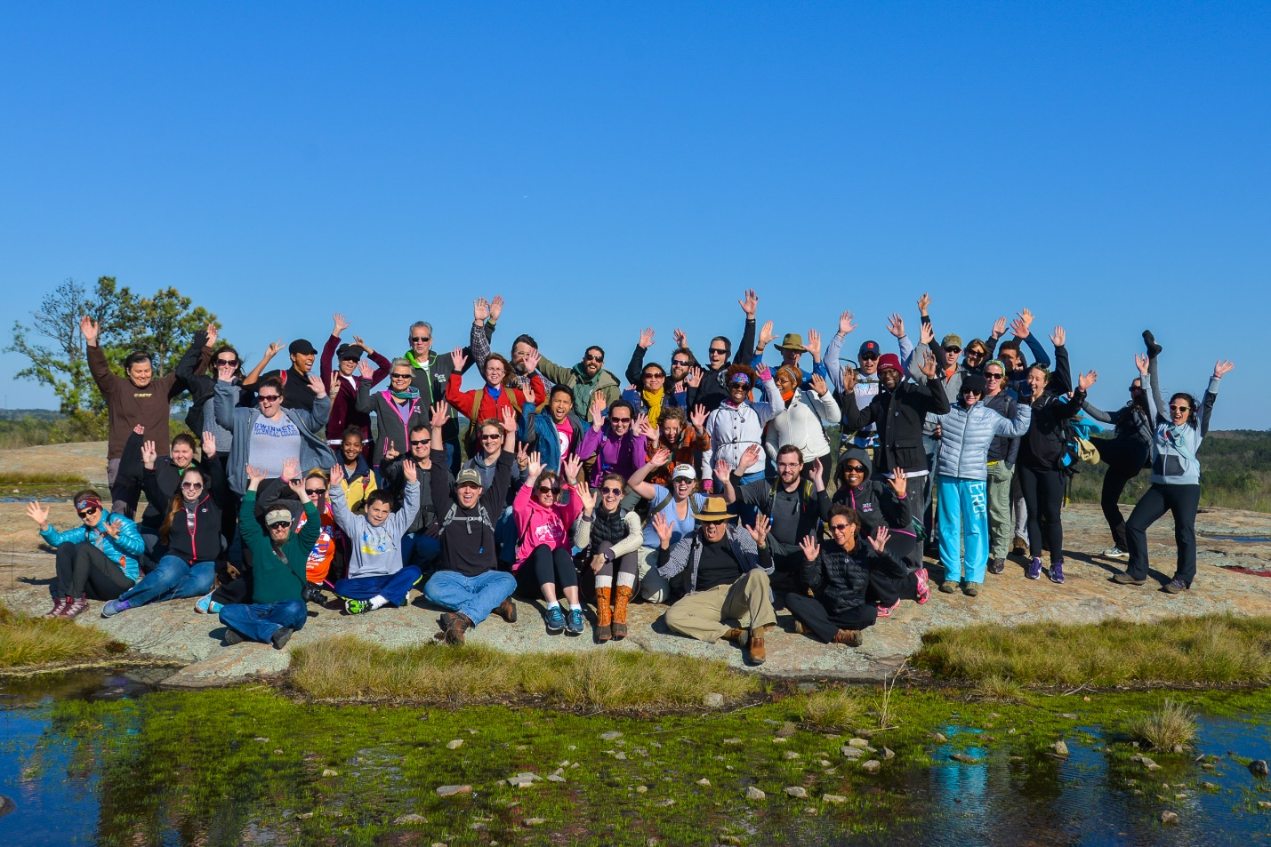
Triumphant triple hikers summit Arabia Mountain with a guided Monadnock Madness hike.

- more -

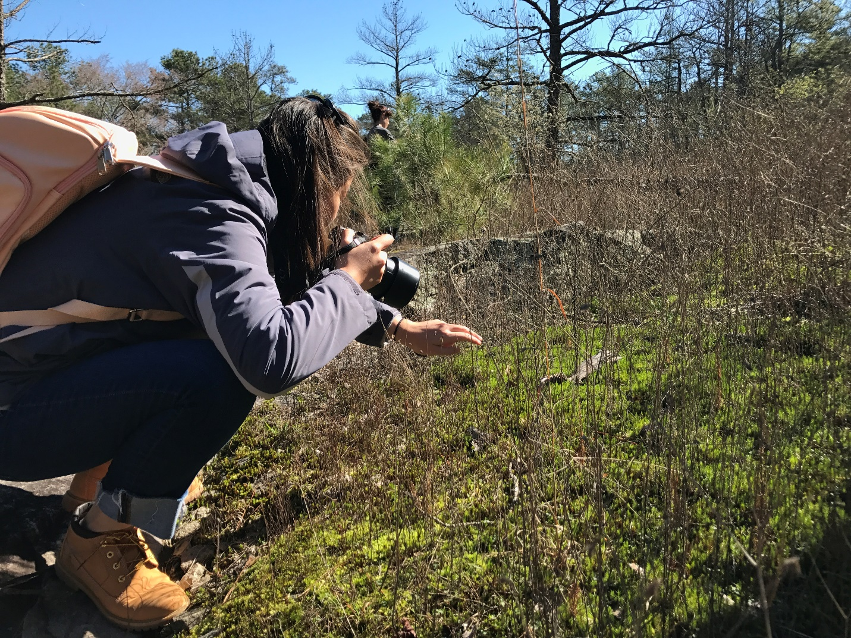A participant of the Nature Photography Workshop practices their photography skills. Longtime nature photographer Larry Winslett guides participants through landscape, macro and wildlife photography.

- more -

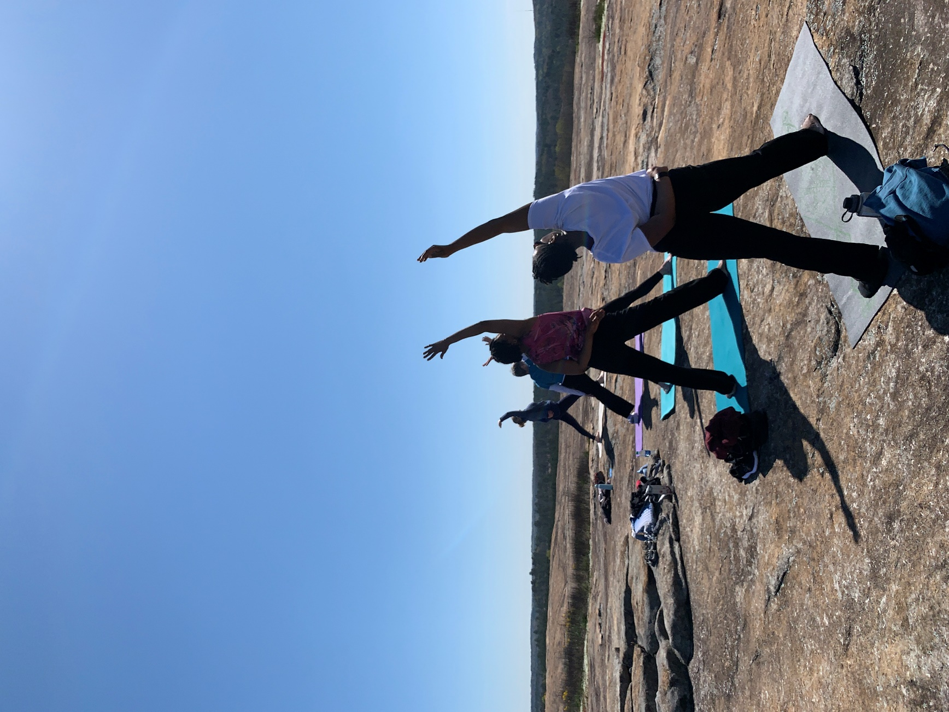Mountaintop yoga will occur at sunset this year. Led by instructor Sandra Bonkiene, the event guides participants through an accessible, all-levels practice on top of Arabia Mountain.
- more -

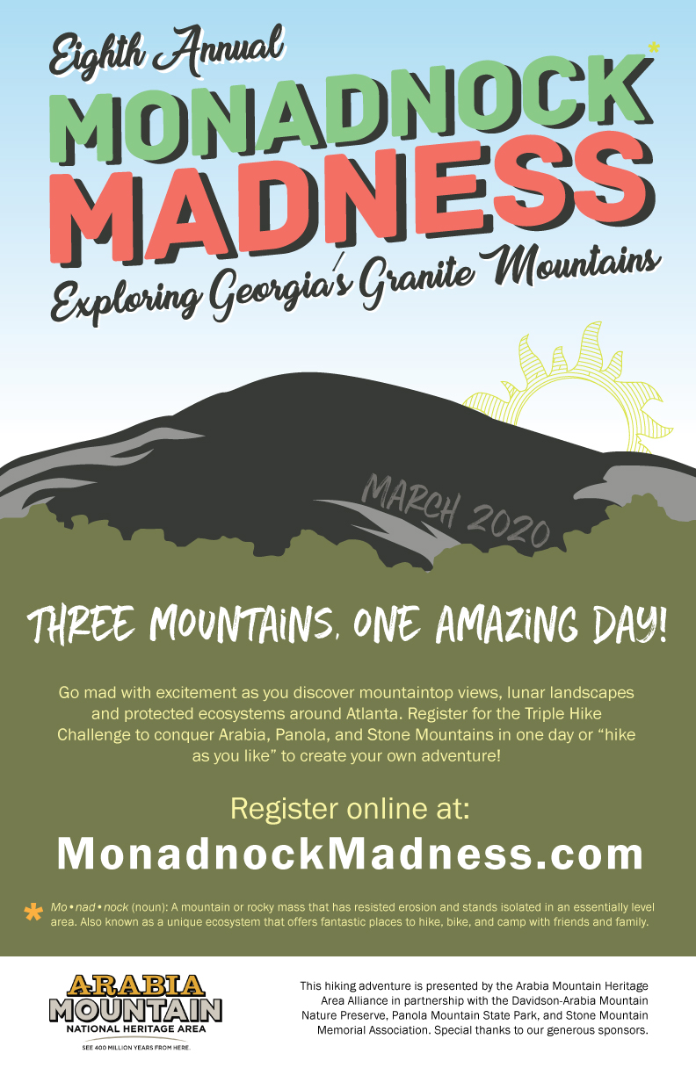
The 2020 Monadnock Madness poster, advertising Hike As You Like as well as the guided Triple Hikes.

###
About Arabia Alliance
The Arabia Mountain Heritage Area Alliance is dedicated to protecting, connecting and sharing the powerful history, rich culture and engaging landscapes of the Arabia Mountain National Heritage Area (AMNHA) for the benefit and enjoyment of all. The staff and volunteer board of the Arabia Alliance work with partners across the AMNHA to ensure that everyone can benefit from the cultural and natural resources of the National Heritage Area. For more information, visit www.arabiaalliance.org.

