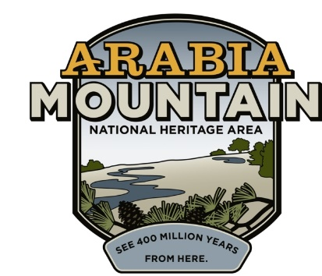
Media Contact: Zack Loehle, Communications Manager
Arabia Mountain Heritage Area Alliance
p: 678-699-2768 | e: zack@arabiaalliance.org

FOR IMMEDIATE RELEASE
Dec. 7, 2021

Join Second Community Engagement Session to Shape Future of DeKalb’s First Black Public School
Event to Take Place 1-4pm at 2449 Bruce St., Lithonia on Saturday, Dec. 11

Above: People take part in the first community feedback session to shape the future of the Bruce Street School ruins. The second community engagement session will take place on Saturday, Dec. 11.
Photo: Talecia Tucker/Martin Rickles Studio.

LITHONIA, Ga. – On Saturday, Dec. 11, from 1-4pm, community members will again gather to shape the future of the Bruce Street School ruins, the remnants of DeKalb County’s first Black public school. The event will take place onsite at 2449 Bruce Street, Lithonia, GA 30058. This event is the second in a series designed to gather community feedback and direct the ultimate historic preservation of the school site. The event will be led by Martin Rickles Studio, an Atlanta-based interdisciplinary design studio; staff members from the Arabia Mountain Heritage Area Alliance; and volunteers.

Also known as the Lithonia Negro School and the Lithonia Colored School, the Bruce Street School was built and run by Lithonia’s Black community prior to integration. The school’s first graduating high school class (around 1943) included three pupils. By 1968, when the Bruce Street School was closed, there were over a dozen elementary and eight high school classrooms – several outbuildings, now lost, had to be constructed in order to support the growing student body. The school building contains a rich history, and now people have an opportunity to determine how this space can become an active part of the community once again. This event is part of a process of community engagement and outreach that will proceed throughout winter 2021 and spring 2022; future events to be announced in the new year.

Street parking is available in the surrounding neighborhood; please be respectful of residents’ driveways. Some seating will be available, but it is recommended that participants bring a chair for their convenience. While this community engagement session will be completely in-person, future sessions will feature a virtual component for those who are unable to physically attend.

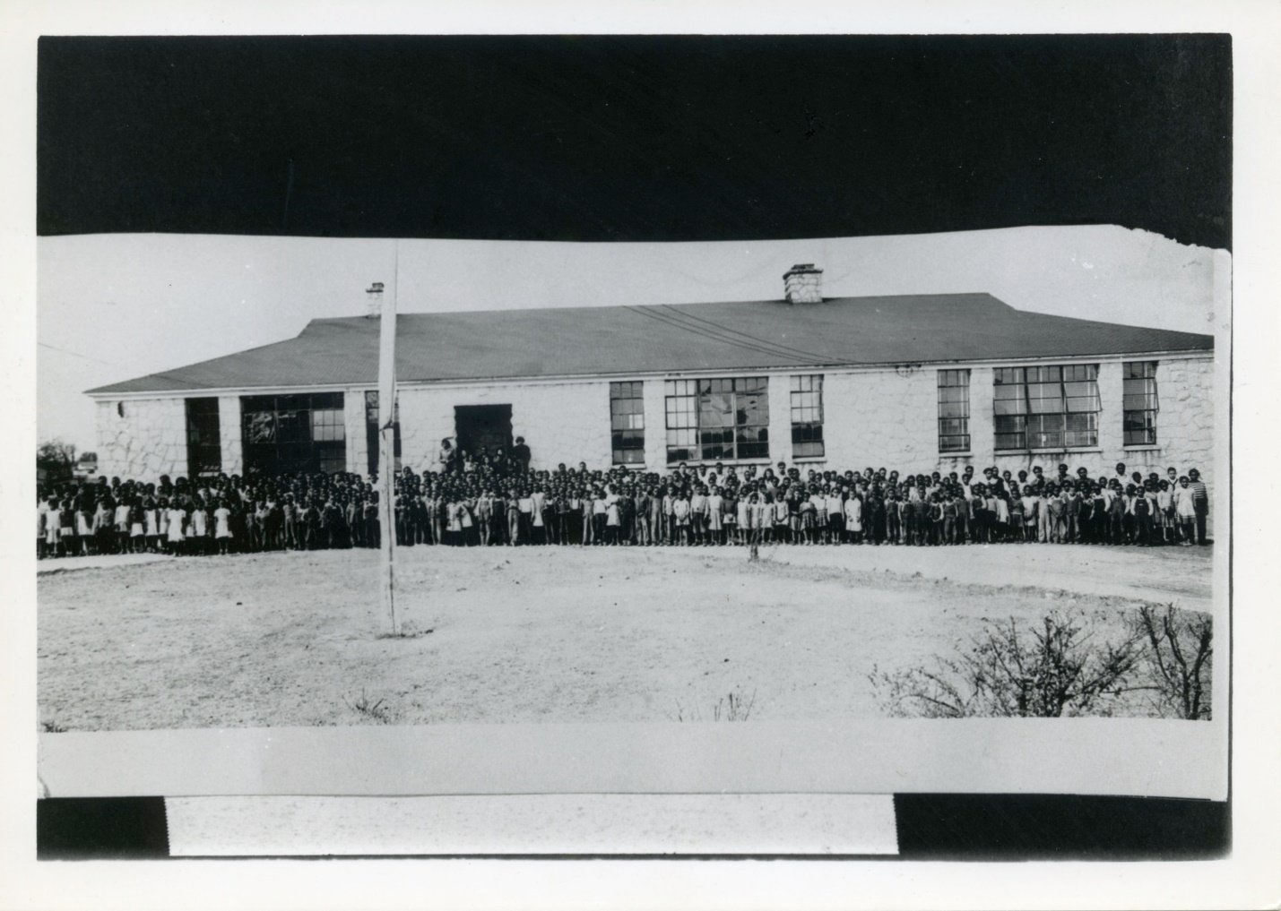
Above: Undated photograph of the Bruce Street School, courtesy of the DeKalb History Center.

This project is a collaboration between the City of Lithonia, DeKalb County, and the Arabia Mountain Heritage Area Alliance. Funding has been provided by DeKalb County District 5 Commissioner Mereda Davis Johnson.

Anyone with artifacts related to the Bruce Street School – including photos, records, yearbooks and stories to use in potential exhibits – is especially encouraged to join the community engagement sessions.

For more information about the project, please visit arabiaalliance.org/brucestreet.

###

About the Arabia Alliance
The Arabia Mountain Heritage Area Alliance is dedicated to protecting, connecting and sharing the powerful history, rich culture and engaging landscapes of the Arabia Mountain National Heritage Area (AMNHA) for the benefit and enjoyment of all. The staff and volunteer board of the Arabia Alliance work with partners across the AMNHA to ensure that everyone can benefit from the cultural and natural resources of the National Heritage Area. For more information, visit www.arabiaalliance.org.

