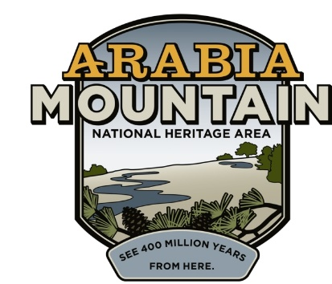
Media Contact: Zack Loehle, Communications Manager
Arabia Mountain Heritage Area Alliance
p: 678-699-2768 | e: zack@arabiaalliance.org

FOR IMMEDIATE RELEASE
Dec. 16, 2021

Guided Hikes, Ranger Programs to Resume at Davidson-Arabia Mountain Nature Preserve on January 2nd
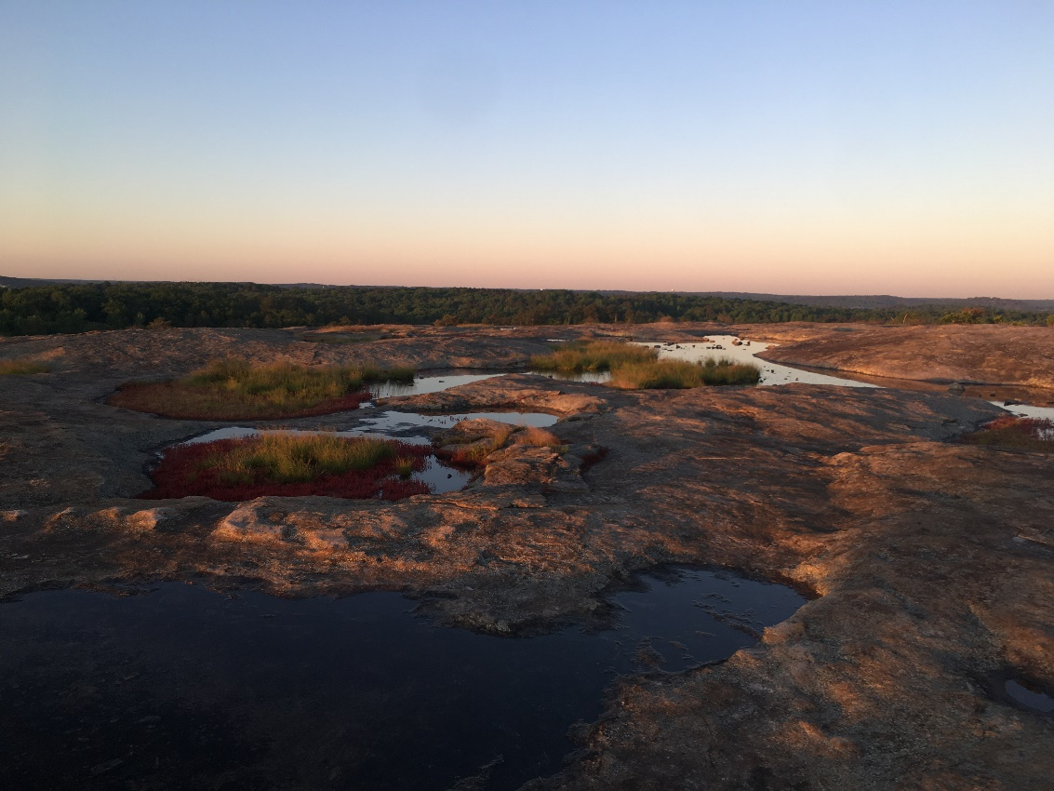
Davidson-Arabia Mountain Nature Preserve.
Photo: Abby Stanga/Arabia Mountain Heritage Area Alliance.

STONECREST, Ga. – Beginning with a “New Year’s Resolution Hike” on January 2nd, guided hikes, education and community events are returning to Davidson-Arabia Mountain Nature Preserve after a pandemic hiatus. The Nature Preserve has released the schedule for January and February events; a full list can be seen here.

Recurring events include morning interpretive and recreational hikes with park naturalists, which take place every Friday and Sunday at 9:00 am; and the afternoon walk-it-out hike, every Wednesday at 4:00 pm. These events were popular prior to the pandemic and park rangers are looking forward to resuming these opportunities for nature exploration and connection.

The rangers are not just bringing back hikes – events like “Stewardship Saturday” (taking place on January 15th) offer opportunities to volunteer in the Nature Preserve, helping maintain the trails and public spaces that people use every day. In February, volunteer events will include assisting the staff of the Flat Rock Archives to help preserve sites associated with the history of one of Georgia’s oldest Black communities, right down the road from the Nature Center. An Arbor Day tree planting is also planned.

“We're so excited to be resuming our public programs in 2022...As the park's newest Naturalist, I'm looking forward to engaging the community at this amazing greenspace during this meaningful year,” said Park Naturalist Zana Pouncey, who will be leading the first hike of the year.

To sign up for events and see the whole list of offerings, visit: arabiaalliance.org/organizer/davidson-arabia-mountain-nature-preserve/.

###

About the Arabia Alliance
The Arabia Mountain Heritage Area Alliance is dedicated to protecting, connecting and sharing the powerful history, rich culture and engaging landscapes of the Arabia Mountain National Heritage Area (AMNHA) for the benefit and enjoyment of all. The staff and volunteer board of the Arabia Alliance work with partners across the AMNHA to ensure that everyone can benefit from the cultural and natural resources of the National Heritage Area. For more information, visit www.arabiaalliance.org.

