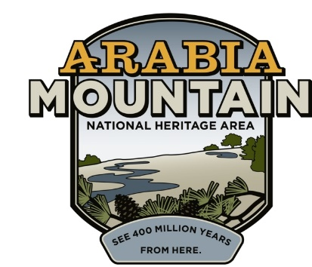
Media Contact: Mera Cardenas, Executive Director
Arabia Mountain Heritage Area Alliance
p: 404-998-8384 x8 | e: mera.cardenas@arabiaalliance.org

FOR IMMEDIATE RELEASE
Nov. 9, 2017

Arabia Alliance to Begin Stabilization of Historic Vaughters’ Barn
Work Underway to Preserve Dekalb County’s Rural Past

Stonecrest, Ga. – Vaughters’ Barn, a former dairy farm that makes up part of the Arabia Mountain National Heritage Area (AMNHA), is currently undergoing renovations to stabilize this historic building. Renovations began at the end of October. Water damage, structural factors, and general wear and tear have led to some structural instability. Upon completion of the project, the barn will again be a stable part of the landscape, as well as offering increased opportunities for education about county history.

DeKalb County was at one point the biggest dairy producer in the state of Georgia, and S. B. Vaughters was one of the most successful dairy farmers in the area. As urban sprawl inched out of Atlanta over the course of the 20th century, Mr. Vaughters sought a different future for his land. “Nearly all the rest of Dekalb County is covered up with homes and businesses. You can drive from Lithonia to Dunwoody and not find a piece of open land. I didn’t want that here,” he said. He sold his land to the state in 2002. Today, Vaughters’ farm is a popular part of the AMNHA and offers visitors a glimpse of Dekalb’s rural past.

Over the course of his career as a farmer, Vaughters used the barn for cows – first Jersey cows, producing dairy, and later for Angus cattle – and horses. The animals inhabited the first floor of the building, while the spacious second story was used for storage. Like many of the agricultural buildings found throughout the AMNHA, Vaughters’ Barn was built as a functional structure: as S. B. Vaughters’ needs changed, so did the barn itself. Without that continuous input, utilitarian farm buildings such as this one can fall into disrepair. In the case of the barn, the walls and roof have begun to bow outwards and water damage has impacted the interior.

Dedicated to preserving the historic structures throughout the National Heritage Area, the Arabia Alliance has been advocating for building restoration for the past several years. Restoration is no easy process: the project will cost “around $200,000, with half of the funds coming from the state and half of the funds coming from the Alliance,” said Mera Cardenas, Arabia Alliance Executive Director.

When finished, the barn will once again be stable. Renovators will also make some minor changes to the first-floor ceiling, allowing visitors to see inside the hay loft and better appreciate Vaughters’ decades of successful farming. The Arabia Alliance plans on leading guided tours through this historic building.

-more-

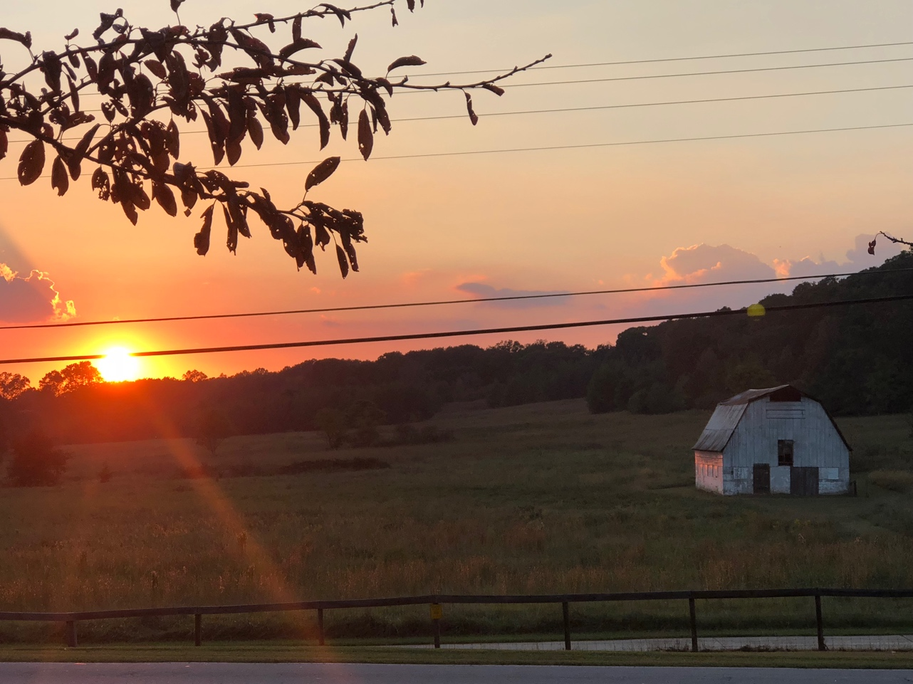
Sunset behind Vaughters’ Barn, part of the Arabia Mountain National Heritage Area in Stonecrest, GA (prior to renovation).

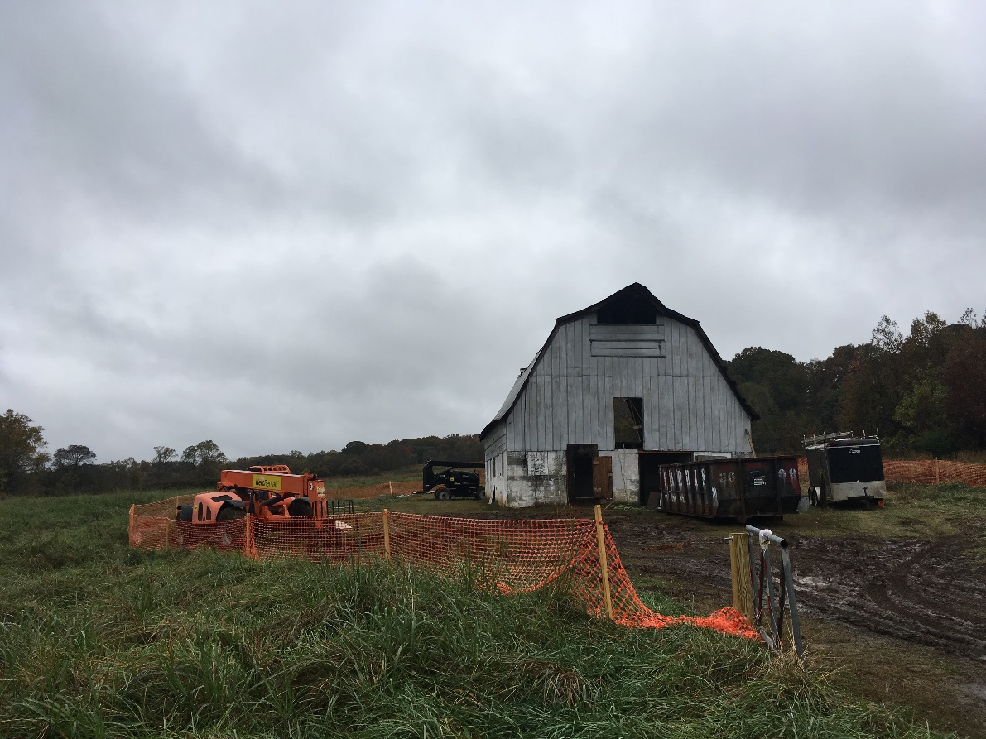
Vaughters’ Barn, currently being renovated in the interest of historic preservation.

View of Vaughters’ Barn, date unknown. Horse paddock and livestock pasture are visible to the west of the barn.

###

About the Arabia Alliance
The Arabia Alliance, a locally run nonprofit, is dedicated to protecting, connecting and sharing the unique history, rich culture and engaging landscapes of the National Heritage Area for the benefit and enjoyment of all generations. The nonprofit was named in the 2006 Congressional legislation to coordinate and oversee the activities of the Arabia Mountain Heritage Area. Its board is made up of citizens or representatives of the three counties of the National Heritage Area as well as representatives of tourism sites, neighborhood organizations and conservation groups.

