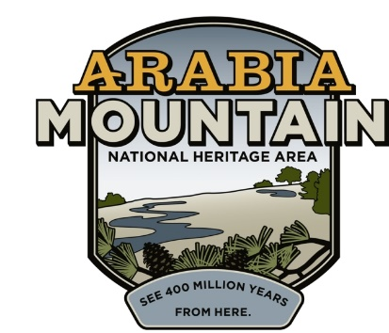
Media Contact: Zack Loehle, Communications Manager
Arabia Mountain Heritage Area Alliance
p: 678-699-2768 | e: zack@arabiaalliance.org

FOR IMMEDIATE RELEASE
Nov. 23, 2020

Leave No Trace as You #OptOutside
Arabia Mountain Heritage Area Alliance Asks People to Take Care
as They Enjoy Trails Over the Holiday

STONECREST, Ga. – As Thanksgiving approaches, the Arabia Mountain Heritage Area Alliance, the nonprofit management entity of the Arabia Mountain National Heritage Area, is asking that visitors remember to practice ‘leave no trace’ hiking practices when they visit the trails over the holiday, especially as they #OptOutside on Black Friday. During the COVID-19 pandemic, greenspaces across the metro-Atlanta area have seen unprecedented use as people seek to get out of the home while remaining safe. Staff and partners of the Davidson-Arabia Mountain Nature Preserve and other greenspace sites throughout the National Heritage Area are preparing for a large influx of people and emphasizing the importance of taking nothing but pictures and leaving nothing behind.

‘Leave no trace’ hiking is an international movement to conserve the wild spaces we enjoy as they experience more visitation. As more and more people enjoy the National Heritage Area’s outdoor spaces, it becomes even more important that visitors pick up any litter, stay on the trail, and take only photos when they leave. In the National Heritage Area, that means walking, running or biking only on the trail (either the paved PATH or soft trails through the woods). When the trails go out onto rock outcrops, please ‘stay on the gray,’ meaning walking only on the bare rock and avoiding all puddles, pits and sandy patches. Stepping in these depressions in the rock face can damage the fragile ecosystem and hurt the plants that depend on that thin layer of soil to survive. Staying on the gray will help prevent endangering the natural habitat and ensure that future visitors can enjoy the hike as well.

Additionally, while outdoor spaces are safer than indoors, the COVID-19 pandemic remains prevalent. Visitors to the National Heritage Area are asked to please wear a mask, wash or sanitize their hands, and maintain physical distance from other people as they enjoy the outdoors. These safety measures are especially important in light of the expected influx of hikers to the trails this holiday weekend. You can find suggestions for National Heritage Area trails less travelled here.

###

About the Arabia Alliance
The Arabia Mountain Heritage Area Alliance is dedicated to protecting, connecting and sharing the powerful history, rich culture and engaging landscapes of the Arabia Mountain National Heritage Area (AMNHA) for the benefit and enjoyment of all. The staff and volunteer board of the Arabia Alliance work with partners across the AMNHA to ensure that everyone can benefit from the cultural and natural resources of the National Heritage Area. For more information, visit www.arabiaalliance.org.

