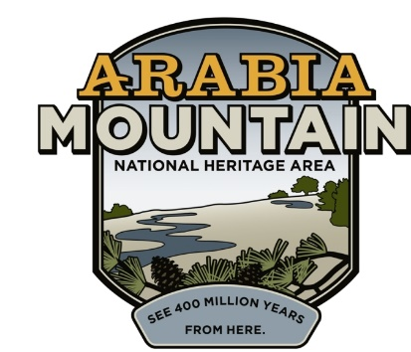
Media Contact: Zack Loehle, Communications Manager
Arabia Mountain Heritage Area Alliance
p: 678-699-2768 | e: zack@arabiaalliance.org

FOR IMMEDIATE RELEASE
Oct. 8, 2020

DeKalb’s Oldest Homestead Garners Historic Preservation Honor
Southeast Chapter of the Society of Architectural Historians (SESAH) Awards Lyon Farm ‘Best of the South: Preserving Southern Architecture Award’

STONECREST, Ga – On Thursday, Oct. 1, DeKalb County’s oldest homestead received a ‘Best of the South’ award from the Southeast Chapter of the Society of Architectural Historians (SESAH). Given in recognition of historic preservation efforts on the historic Lyon Farmhouse, as well as the added interpretive signage that educates visitors about the property’s significance, the award honors the ongoing efforts to preserve and tell the story of the landscape of the Arabia Mountain National Heritage Area. “The project is an outstanding example of organizations and individuals coming together in a preservation project that will have a lasting impact on the history of DeKalb County,” SESAH said in a statement. Historic preservation efforts at the Lyon Homestead are an ongoing collaboration between the Arabia Mountain Heritage Area Alliance, DeKalb County government and the Flat Rock Archives, as well as other community and government partners.

The Lyon Family established their homestead in the shadow of Panola Mountain in the 1820s. For nearly 150 years, the family carved out a rural life where they cultivated crops and raised livestock. A log cabin was likely the first structure built on the property in the 1820s. The footprint was expanded multiple times over the years, creating the house that still stands today. Members of the historic Flat Rock community, one of Georgia’s oldest Black communities, were enslaved at this site prior to the Civil War, relocating nearby following emancipation. Today, the Flat Rock Archives leads tours of the community’s history that begin at the Lyon Farm. Prior to the COVID-19 outbreak, visitors had come from “all over the world” to see the Lyon Farm and learn about the history of the Flat Rock community, said Flat Rock Archives President and Co-Founder Johnny Waits.

The Lyon Farm, over 100 acres, was purchased by the DeKalb County Department of Watershed Management (DWM) in 2003 as part broader conservation efforts in the Arabia Mountain National Heritage Area. In 2016, the historic structures were placed on the Georgia Trust for Historic Preservation’s “Places in Peril” list due to excessive damage to the roof and other structural elements. In November of 2018, the Arabia Mountain Heritage Area Alliance (the nonprofit management entity of the Arabia Mountain National Heritage Area), the Flat Rock Archives, DeKalb County DWM and contractors F. H. Paschen kicked off work. The massive historic preservation project included jacking and leveling the entire structure, stabilizing the foundation, rebuilding part of one of the chimneys and replacing the roof and siding. “The ongoing preservation of the Lyon Farm is an exciting initiative within the Arabia Mountain National Heritage Area,” said Kelly Jordan, Co-Founder of the Arabia Alliance, at a celebration of the Lyon House’s stabilization on May 31, 2019. Jordan added that “future preservation efforts will explore the complicated, rich history of this compelling landscape and its people.”

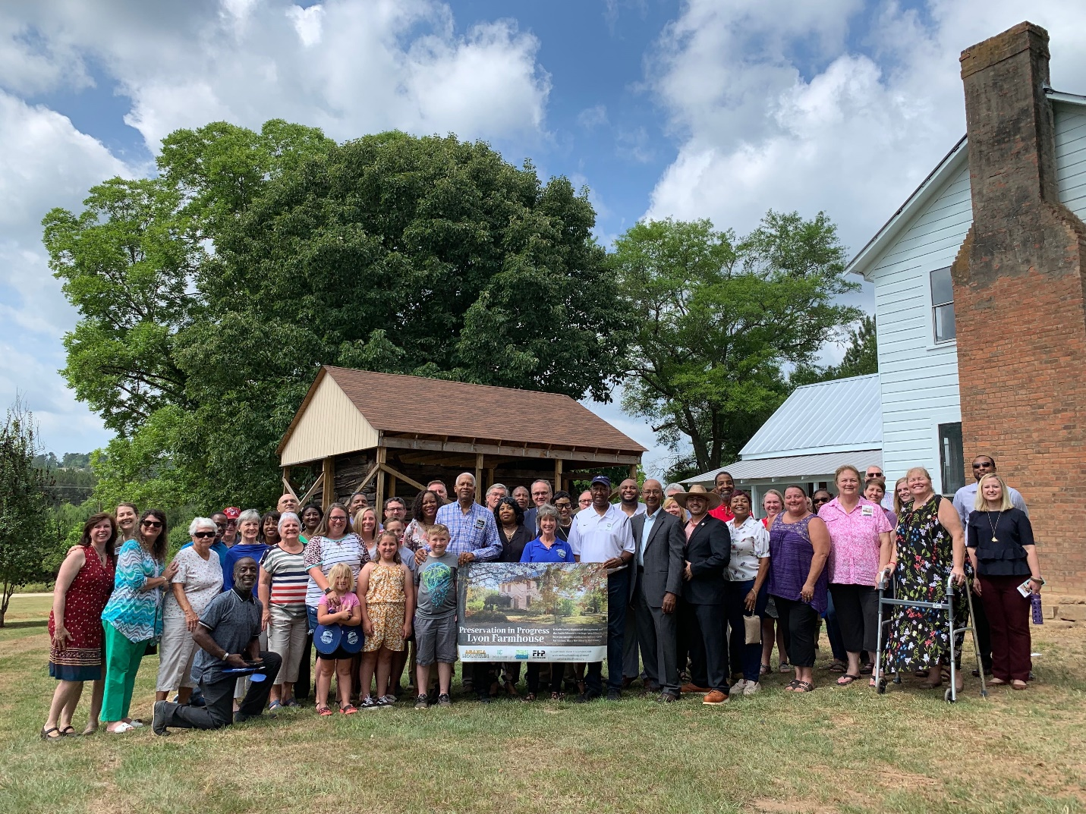
Lyon family members and National Heritage Area Partners celebrate the stabilization of the historic Lyon Farmhouse on May 31, 2019.

The SESAH honor comes as partners are initiating Phase II of historic preservation at the Lyon Farm. With the historic farmhouse stabilized and educational signage added throughout the property, the Arabia Alliance, DeKalb County and other partners are ready to focus on preserving the farm’s outbuildings. That includes the much-needed stabilization of the smokehouse (currently held together by an external wooden frame) as well as historic preservation work on a shed and other farm structures. DeKalb County has allocated $260,000 for the project, which will be managed as a collaboration between the DeKalb County DWM and the Arabia Alliance.

The Lyon Farm is already part of the Flat Rock gateway to the Arabia Mountain National Heritage Area, a nationally significant landscape affiliated with the National Park Service, located just outside Atlanta. Other sites within the Flat Rock gateway include the Bryant Homestead (another historic homestead, home to the Flat Rock Archives itself), the historic Flat Rock Church site and the Flat Rock Historic Cemetery. Visitors can learn more about the Flat Rock archives and the role of Flat rock in the National Heritage Area here. You can also visit the Lyon Farm and take a self-guided tour of the signs by walking or biking along the Arabia Mountain PATH, a 30+ mile, paved trail connecting sites throughout the National Heritage Area.

- more -
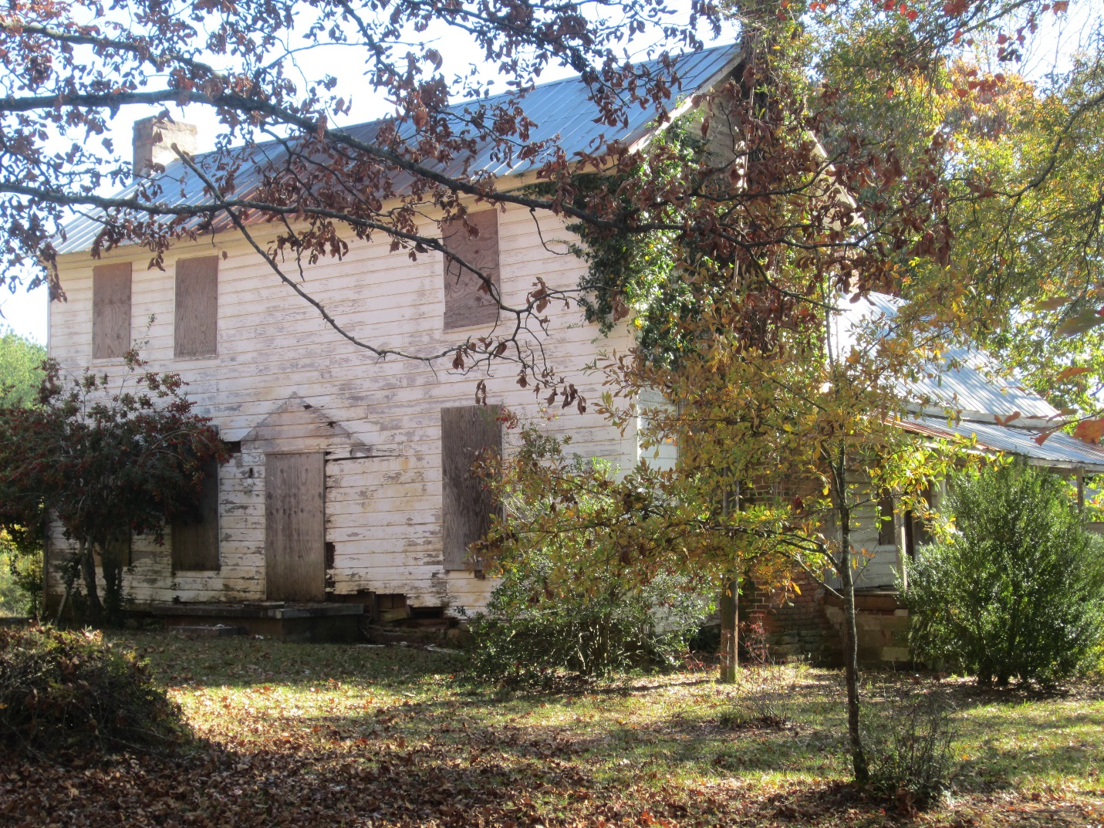
The Lyon Farmhouse prior to the 2018-2019 stabilization efforts. The structure was included in the Georgia Trust of Historic Preservation’s “Places in Peril” list in 2016.

- more -

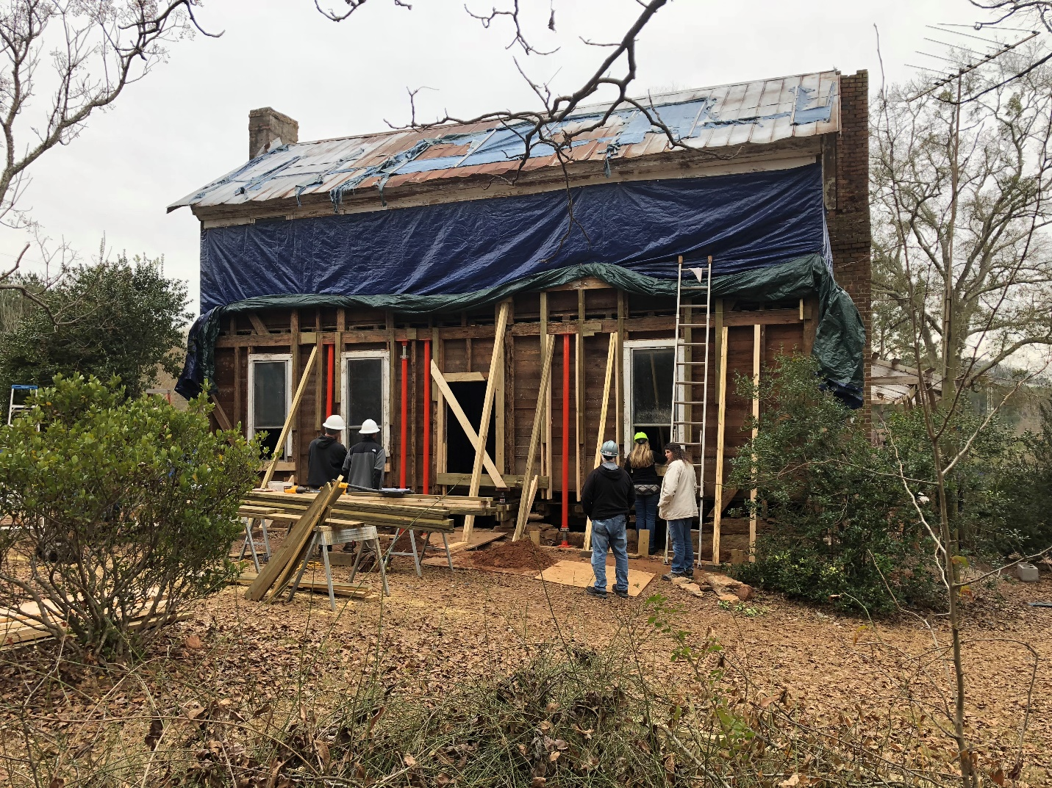
The Lyon Farmhouse, under construction in December 2018.

- more -

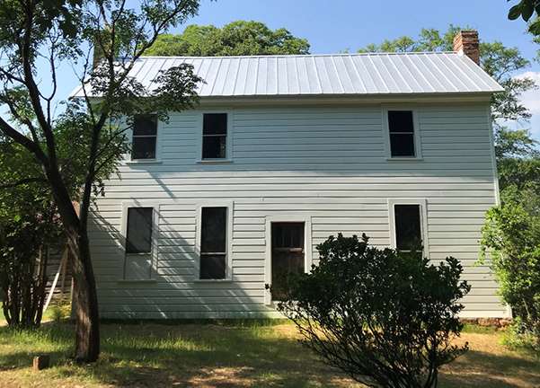
The front of the Lyon Farmhouse following successful stabilization. Educational signage was added in the summer of 2019. Phase II of historic preservation at the Lyon Farm, beginning in late 2020, will work to ensure the stability of the smokehouse and other farm structures.

- more -

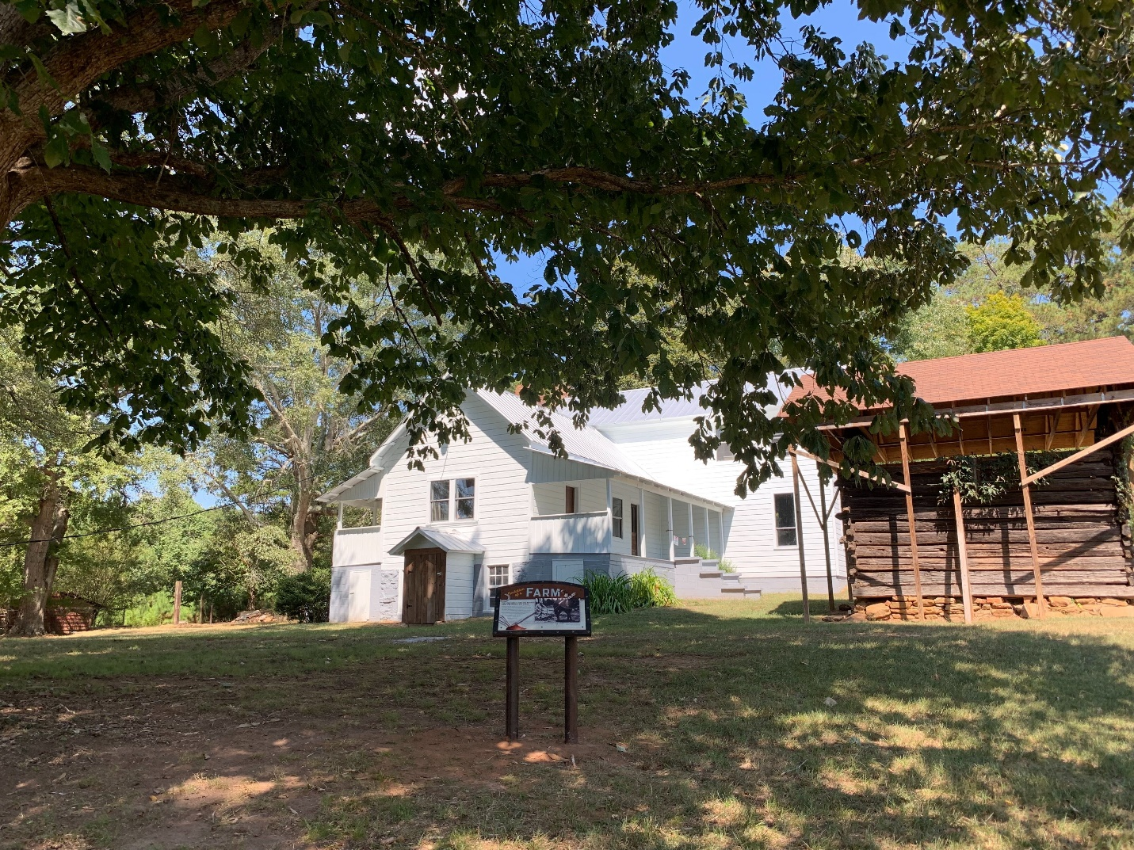
Educational signs are placed throughout the historic homestead, guiding visitors through the history of the Lyon Farm and its connection to Flat Rock.

###

About the Arabia Alliance
The Arabia Mountain Heritage Area Alliance is dedicated to protecting, connecting and sharing the unique history, rich culture and engaging landscapes of the Arabia Mountain National Heritage Area (AMNHA) for the benefit and enjoyment of all. The staff and volunteer board of the Arabia Alliance work with partners across the AMNHA to ensure that everyone can benefit from the cultural and natural resources of the National Heritage Area. For more information, visit www.arabiaalliance.org.

