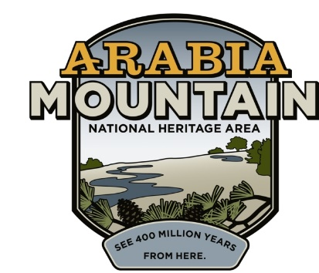
Media Contact: Zack Loehle, Communications Manager
Arabia Mountain Heritage Area Alliance
p: 404-998-8384 | e: zack@arabiaalliance.org

FOR IMMEDIATE RELEASE
Oct. 29, 2019

Preservation & Progress: Discover the Lyon Farm at DeKalb History Center Lunch & Learn Event
Arabia Mountain Heritage Area Alliance Staff to Present on Ongoing Historic Preservation Efforts

DECATUR, Ga. – Catch up on a year of historic preservation efforts at one of DeKalb County’s oldest homesteads, the Lyon Farm. Join staff of the Arabia Mountain Heritage Area Alliance, the nonprofit coordinating partner of the Arabia Mountain National Heritage Area, at the DeKalb History Center on November 5th for a Lunch & Learn about the ongoing process of restoring the Lyon Farm. Arabia Alliance Executive Director Mera Cardenas and Director of Interpretation Sarah Lisle will discuss the historic farmhouse, which recently underwent a monthslong stabilization to protect the structure. Cardenas and Lisle will highlight what has changed at the site over the past year and what the plans are for the future of the Lyon Farm.

The Lyon Family established their homestead in the shadow of Panola Mountain in the 1820s. For nearly 150 years, the family carved out a rural life where they cultivated crops and raised livestock. A log cabin was likely the first structure built on the property in the 1820s. The footprint was expanded multiple times over the years, creating the house that still stands today. Following the Civil War, formerly enslaved people from the Lyon Farm and other surrounding farms would form the community of Flat Rock, which today stands as one of the oldest African-American communities in Georgia.

The Arabia Alliance gave a Lunch and Learn presentation about the Lyon Farm in the fall of 2018, shortly after stabilization work began on the endangered farmhouse. Over the winter and spring of 2019, contractors were busy raising and leveling the entire structure, stabilizing the foundation and rebuilding part of one of the chimneys, among other major repairs. “The ongoing preservation of the Lyon Farm is an exciting initiative within the Arabia Mountain National Heritage Area,” said Kelly Jordan, Board Member of the Arabia Alliance, adding that “future preservation efforts will explore the complicated, rich history of this compelling landscape and its people.”

The Lunch & Learn will take place on the second floor of the DeKalb History Center (101 East Court Square, Decatur, GA 30030) at 12pm on November 5th. The event is free and open to the public.

- more -

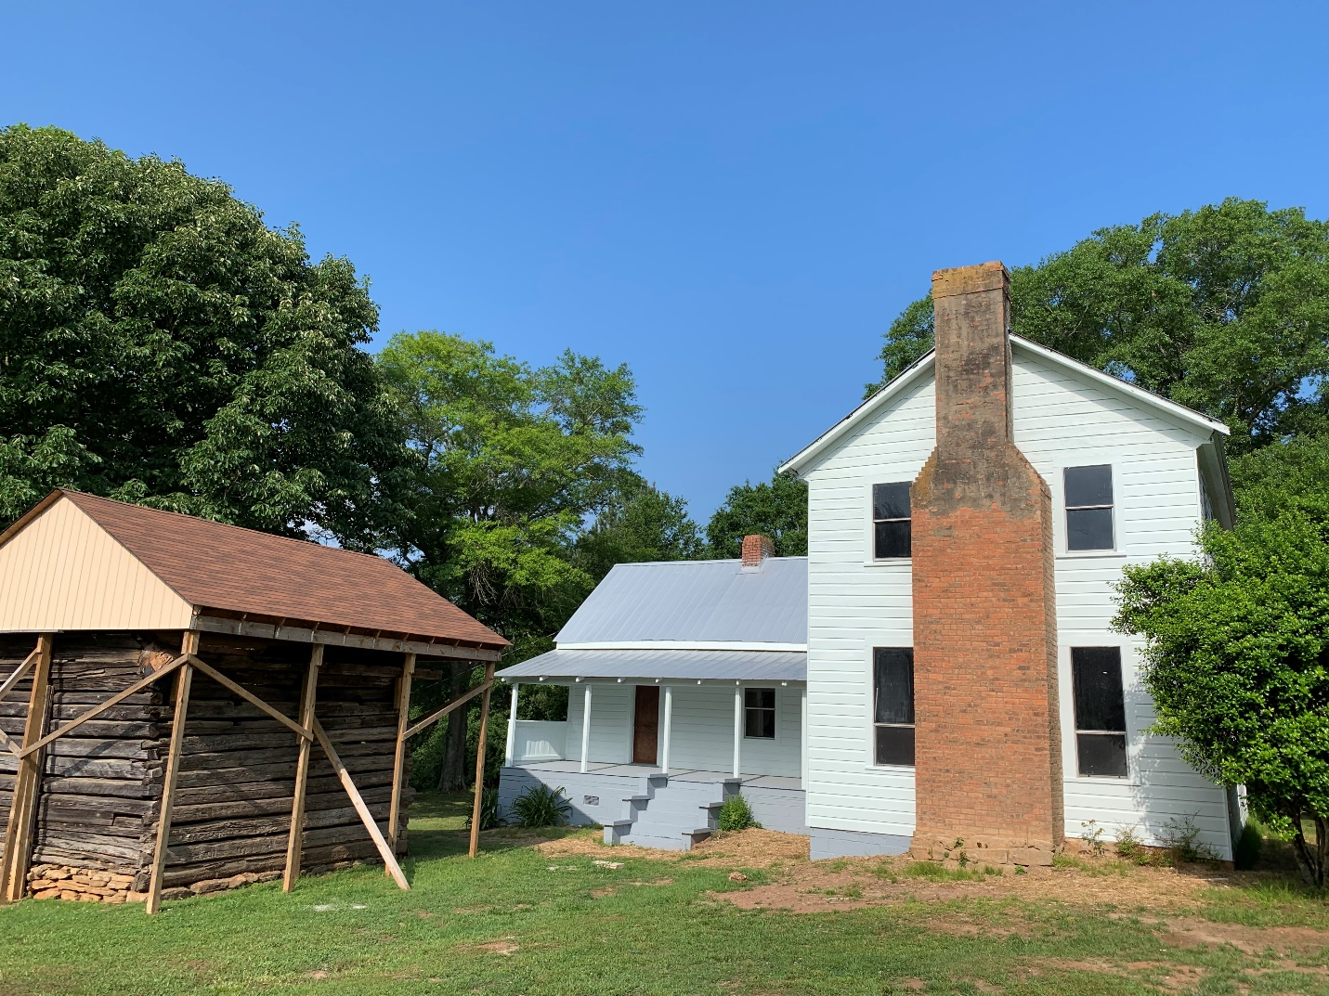
The historic Lyon Farm, with smokehouse (at left) and farmhouse (at right). The Lyon Farmhouse underwent a major stabilization effort from November 2018 through May 2019.

###
About the Arabia Alliance
The Arabia Mountain Heritage Area Alliance is dedicated to protecting, connecting and sharing the powerful history, rich culture and engaging landscapes of the Arabia Mountain National Heritage Area (AMNHA) for the benefit and enjoyment of all. The staff and volunteer board of the Arabia Alliance work with partners across the AMNHA to ensure that everyone can benefit from the cultural and natural resources of the National Heritage Area. For more information, visit www.arabiaalliance.org.

