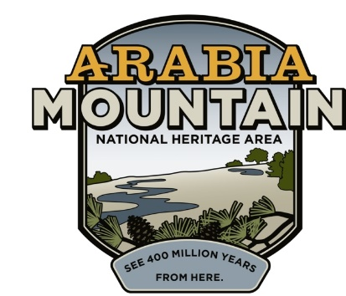
Media Contact: Zack Loehle, Communications Manager
Arabia Mountain Heritage Area Alliance
p: 678-699-2768 | e: zack@arabiaalliance.org

FOR IMMEDIATE RELEASE
Oct. 28, 2020

Arabia Alliance to Discuss Parks & Pandemic at Atlanta Regional Commission Webinar
Arabia Alliance’s Revonda Cosby to Join Staff from Park Pride, Peachtree Creek Greenway & Trust for Public Land on Virtual Panel

ATLANTA – On Thursday, Oct. 29th at 2:30pm, Revonda Cosby, Executive Director of the Arabia Mountain Heritage Area Alliance, will participate in a virtual panel discussion about the status of parks during the COVID-19 pandemic titled “People, Parks, Paths and the Pandemic.” She will join Alabama & Georgia State Director for the Trust for Public Land George Dusenbury, Park Pride Executive Director Michael Halicki and Betsy Eggers, Founder of Peachtree Creek Greenway, Inc. The panel will be moderated by the Atlanta Regional Commission’s (ARC) Mike Alexander, who serves as the ARC’s Director for the Center for Livable Communities. The webinar is free to the public.

Looking for ways to safely get out of the home, people have flooded into metro-Atlanta’s greenspaces over the course of the COVID-19 pandemic. Parks and other outdoor spaces provide numerous benefits in terms of mental health and physical wellbeing, things that have become all the more important over the past year. At the ARC panel, four leaders in metro-Atlanta’s parks will discuss the importance of the outdoors, how the pandemic has changed parks, and their plans for a future, post-COVID world.

The event is free and will take place from 2:30 to 4:00pm, EST. Registration is available online.

###

About the Arabia Alliance
The Arabia Mountain Heritage Area Alliance is dedicated to protecting, connecting and sharing the powerful history, rich culture and engaging landscapes of the Arabia Mountain National Heritage Area (AMNHA) for the benefit and enjoyment of all. The staff and volunteer board of the Arabia Alliance work with partners across the AMNHA to ensure that everyone can benefit from the cultural and natural resources of the National Heritage Area. For more information, visit www.arabiaalliance.org.

