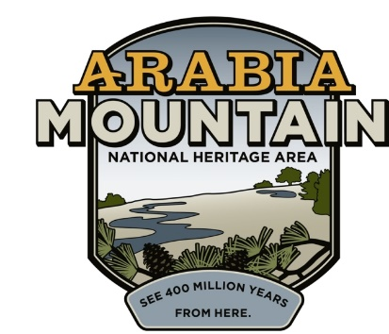
Media Contact: Zack Loehle, Communications Manager
Arabia Mountain Heritage Area Alliance
p: 678-699-2768 | e: zack@arabiaalliance.org

FOR IMMEDIATE RELEASE
Oct. 18, 2021

Save the Dates:
Nov. 14 & Dec. 11 Community Engagement Sessions Announced for Historic Preservation of DeKalb’s First Black Public School
Martin Rickles Studio to Coordinate Sessions

LITHONIA, Ga. – Taking place on Nov. 14 and Dec. 11, 2021, on-site at the Historic Bruce Street School Ruins (2449 Bruce St., Lithonia, GA 30038), community engagement sessions will help determine the future of the remnants of DeKalb County’s first Black public school, the Bruce Street School in Lithonia. Martin Rickles Studio, an Atlanta-based interdisciplinary design studio, will lead the sessions to envision what is possible for the future of the ruins as a community and historic hub. The Nov. 14 event will take place in the afternoon (exact times TBA).

Also known as the Lithonia Negro School, the ruins are located next to the site of the soon to be completed East DeKalb Community and Senior Center, all within Lithonia’s historic Bruce Street community. The Bruce Street School dates back to the 1930’s, when Black local leaders bought land to build a much-needed community school. The first graduating high school class (around 1943) included three pupils. By 1968, when the Bruce Street School was closed, there were over a dozen elementary and eight high school classrooms. Although in ruins today, the old school building still speaks to the power and resilience of Lithonia’s Black community. People now have an opportunity to determine how this space can become an active part of the community once again. Along with local officials, Martin Rickles Studio staff will host the community engagement sessions to shape the future of the ruins.
DeKalb County and City of Lithonia, as well as the Arabia Mountain Heritage Area Alliance (the nonprofit management entity of the Arabia Mountain National Heritage Area), continue to work collaboratively to ensure the community-focused historic preservation of the Bruce Street School ruins. DeKalb County District 5 Commissioner Mereda Davis Johnson, a longtime resident of Lithonia, secured the funds to support this next step in the project. The Commissioner said, "I have a long and deep connection to the City of Lithonia, and this historic site is critical to connecting the City's past to its future. The Bruce Street School ruins are a significant historic asset for the City and for DeKalb County as a whole, and an essential part of the story of America. That is why I am proud to have utilized my discretionary funds to partner with the Arabia Mountain Heritage Area Alliance in retaining the conceptual rendering services of Martin Rickles Studio as we move forward with preserving the Bruce Street School site. This step paves the way for these powerful ruins to stand as a place to gather, to reflect, and to value those who came before us and paved the way to today."
The Martin Rickles design team consists of artist and architect Amy Landesberg, Co-Founder and Principal Jennifer Martin, architectural historian Scott Morris, artist Iman Person, Co-Founder and Principal Carley Rickles and design researcher Anh-Ton Tran.

Anyone with artifacts related to the Bruce Street School – including photos, records, yearbooks and stories to use in potential exhibits – is especially encouraged to join the community engagement sessions.

For more information about the project, please visit arabiaalliance.org/brucestreet. A presentation about the project can be found here.

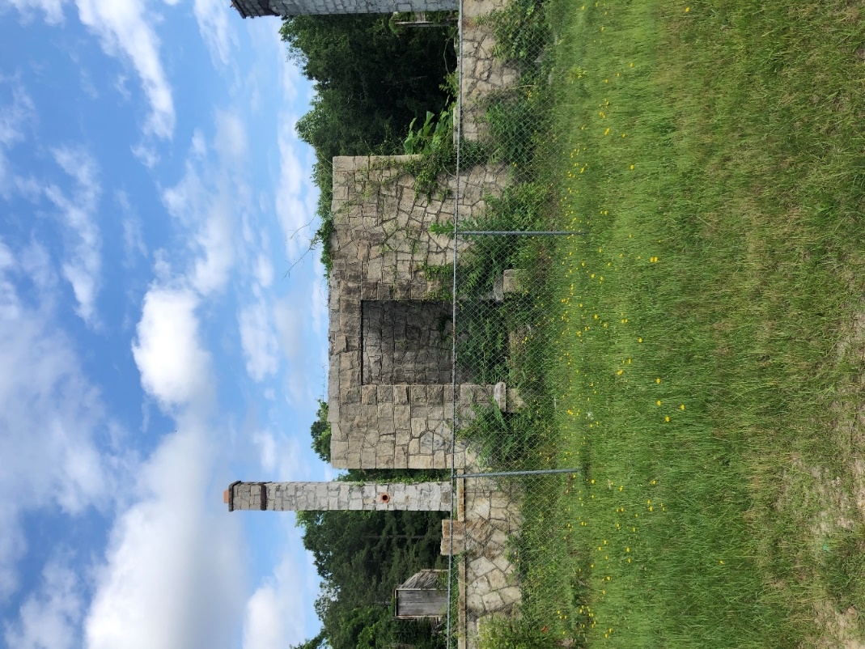
The current status of the Bruce Street School ruins, prior to historic preservation efforts.

###

About the Arabia Alliance
The Arabia Mountain Heritage Area Alliance is dedicated to protecting, connecting and sharing the powerful history, rich culture and engaging landscapes of the Arabia Mountain National Heritage Area (AMNHA) for the benefit and enjoyment of all. The staff and volunteer board of the Arabia Alliance work with partners across the AMNHA to ensure that everyone can benefit from the cultural and natural resources of the National Heritage Area. For more information, visit www.arabiaalliance.org.

