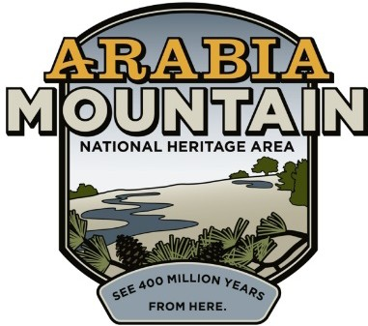
Media Contact: Zack Loehle, Communications Manager Arabia Mountain Heritage Area Alliance
p: 678-699-2768 | e: zack@arabiaalliance.org

FOR IMMEDIATE RELEASE Oct. 11, 2021

Atlanta Wild Animal Rescue Effort (AWARE) to Host Wild Night OutSIDE, Celebrating and Supporting Georgia’s Native Animals
Intown Ace Hardware to Serve as Title Sponsor, Arabia Mountain Heritage Area Alliance Sponsoring as Well

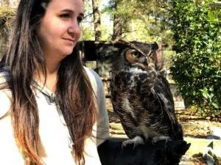
Owlscar the Grouch, seen above with handler, will be one of the ambassador animals present at the event.

ROCKDALE COUNTY, Ga. – Featuring live music, auction items, raffle prizes and wildlife encounters, Atlanta Wild Animal Rescue Effort (AWARE)’s Wild Night OutSIDE offers a fun, celebratory bash that supports a good cause. The event will take place at the Rockdale Art Farm (4420 Flat Bridge Rd. SW, Stockbridge, GA 30281) from 4-7pm on October 23rd. All of the funds raised will support AWARE’s work in rescuing and rehabilitating Georgia’s injured and orphaned wildlife. The event is being presented by the Intown Ace Hardware; the Arabia Mountain Heritage Area Alliance is also a sponsor. Learn more and purchase tickets at awarewildlife.org/wildnightoutside.

Located at the base of Arabia Mountain, AWARE works year-round to heal and rehabilitate injured and orphaned animals. When animals cannot be released back into the wild, AWARE makes sure that the wild creatures are placed in a good, safe home in a wildlife center elsewhere, or makes room for the animal to stay at AWARE itself. Some of these “ambassador animals” – including Owlscar the Grouch, seen above – will be present at the Wild Night OutSIDE, letting guests see the animals closeup and educating them about the many wild animals that call Georgia home.

Event highlights include live music, drinks – including signature cocktails – and delicious food from the Good Food Truck. Raffle and auction items will also be available; more event details forthcoming. The entire event will take place as an outdoor picnic in order to ensure COVID-19 safety. Visit awarewildlife.org/wildnightoutside to learn more about the event, or go straight to buy your ticket here.

###

About the Arabia Alliance
The Arabia Mountain Heritage Area Alliance is dedicated to protecting, connecting and sharing the powerful history, rich culture and engaging landscapes of the Arabia Mountain National Heritage Area (AMNHA) for the benefit and enjoyment of all. The staff and volunteer board of the Arabia Alliance work with partners across the AMNHA to ensure that everyone can benefit from the cultural and natural resources of the National Heritage Area. For more information, visit www.arabiaalliance.org.

