Media Contact: Zack Loehle, Communications Manager
Arabia Mountain Heritage Area Alliance
p: 404-998-8384 | e: zack@arabiaalliance.org

FOR IMMEDIATE RELEASE
Jan. 17, 2020

Monadnock Madness Returns with Even More Outdoor Adventure
Arabia, Panola, Stone and Now Kennesaw Mountains Offer Outdoor Extravaganza During Month of March
Tickets on sale January 21st

STONECREST, Ga. – Are you ready to rock? This March, get out and explore Georgia’s granite giants – Arabia Mountain, Panola Mountain, Stone Mountain and, new to the event, Kennesaw Mountain – during the annual Monadnock Madness. Come celebrate these four major Atlanta-area monadnocks through hikes, workshops, classes and fitness throughout the month. That includes the ever-popular Triple Hike Challenge, in which hikers summit three granite mountains in a single day. For the first time, Kennesaw Mountain National Battlefield Park will join the event as a special “fourth mountain” option, allowing hikers to gain an extra prize. A celebration of nature, wildlife and some darn big rocks, Monadnock Madness will change how you see Atlanta’s wild places. Registration for triple hikes, photography workshops and mountaintop yoga opens on Jan. 21st (Tuesday).

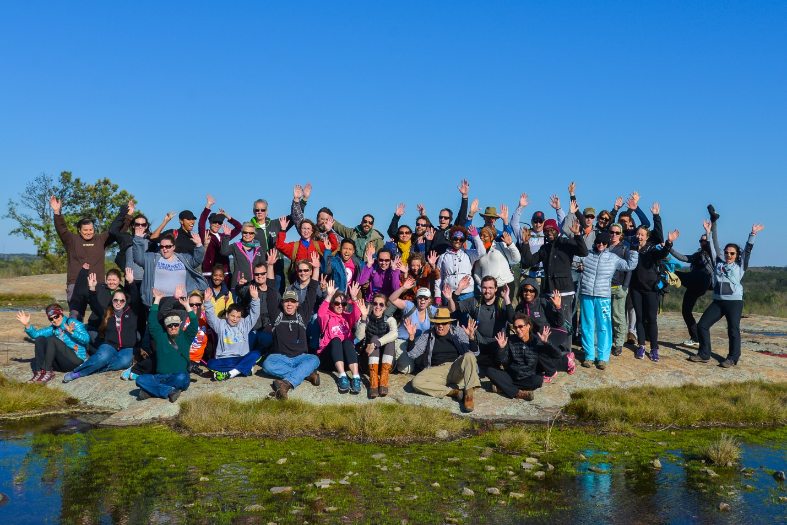
Hikers on top of Arabia Mountain, part two of the guided Triple Hike Challenge. The day starts at Stone Mountain before hiking Arabia and then Panola Mountain, ending with s’mores at the base of Panola. Photo: Chad Belifanti.
- more -
Georgia’s monadnocks boast a variety of natural wonders and the month-long outdoor extravaganza gives participants plenty of opportunities to discover the natural resources hidden in Atlanta’s backyard. See rare plants such as diamorpha, vibrant vernal pools and landscapes unique to the American Southeast. Throughout March, hikers can join in on a variety of activities including photography workshops, mountaintop yoga, a geocaching challenge, various guided hikes and other exciting programs at the parks.

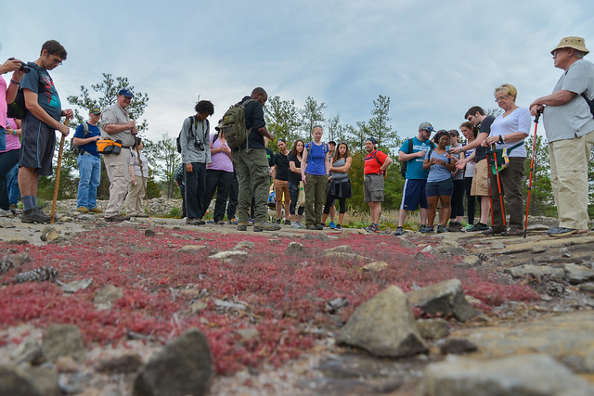
Hikers and rangers admire rare plants such as Diamorpha, the red plant seen at front. All of the Triple Hikes are led by experienced guides who reveal the natural beauty and history of each mountain.

- more -

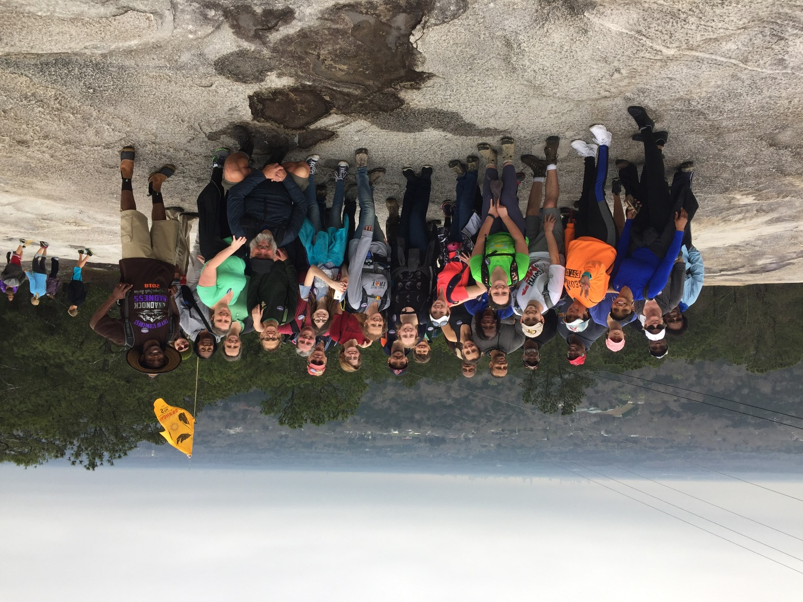
Monadnock Madness hikers during the Triple Hike Challenge at Stone Mountain.

All hikers will earn a commemorative souvenir after completing the Triple Hike Challenge, and an extra souvenir for taking the challenge a step farther and hiking Kennesaw Mountain. If you are interested in completing the challenge at your own pace, each park offers visitors the option to “hike as you like,” a self-guided tour of the monadnocks. Pick up a passport at one of the parks or online during the month of March. You can also earn a prize through the Monadnock Madness Geocaching Challenge, in which participants use a smartphone to find treasures hidden across the landscape. More information at monadnockmadness.com.

- more -

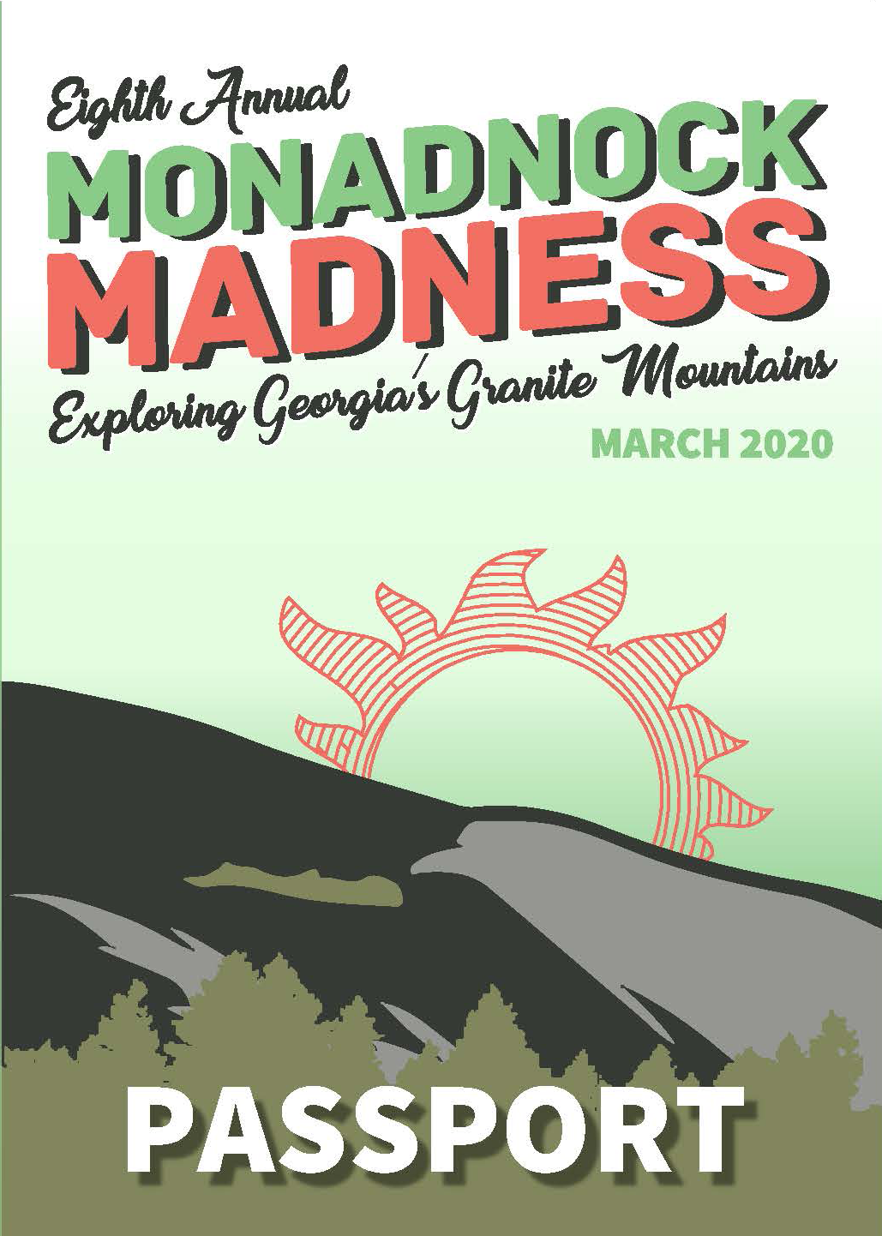
This year’s Monadnock Madness passport cover. Participants get a passport stamp as they hike each mountain and earn a prize. More information available online at monandockmadness.com.

- more -

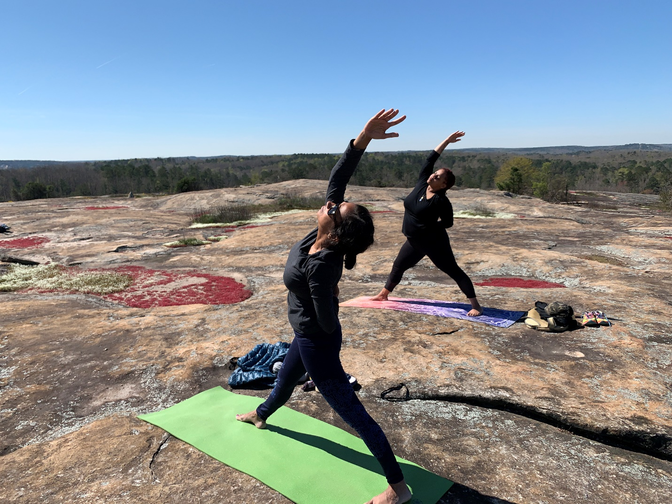
Mountaintop yoga is a popular event during Monadnock Madness, featuring a simple guided practice on top of Arabia Mountain. This year’s yoga class will occur at sunset on March 29th.

- more -

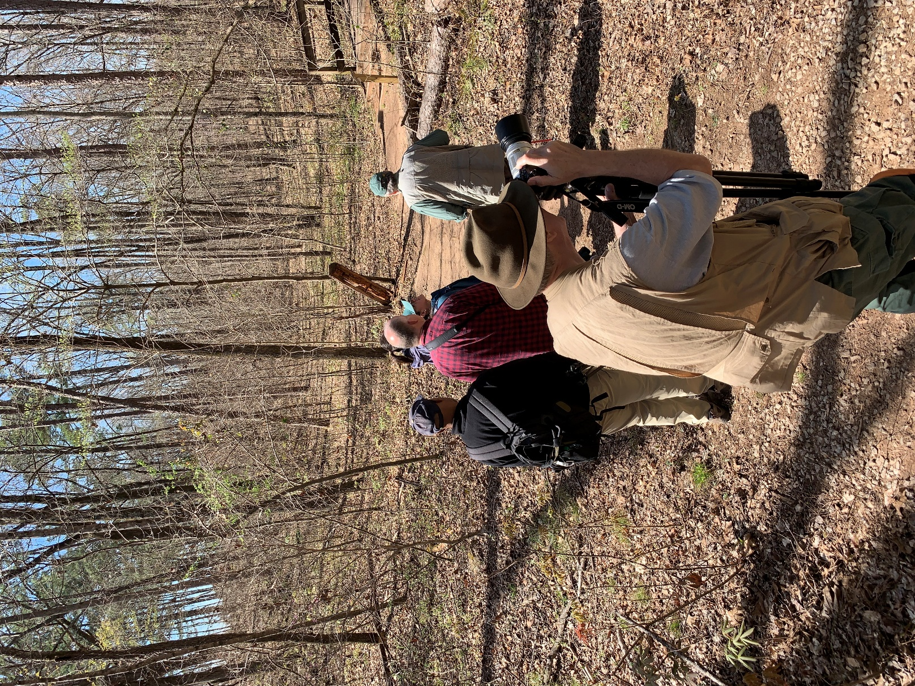
Participants in the Nature Photography Workshops enjoy instruction from seasoned nature photographer Larry Winslett and practice different kinds of nature photography at Stone, Arabia and Panola Mountains.

-more-
“You meet the neatest people, you are out in nature – it is extremely beautiful,” said Christina, a 2019 Guided Triple Hike participant. “I did not expect to learn so much but I learned a lot, and guess what, at the end: s’mores!”

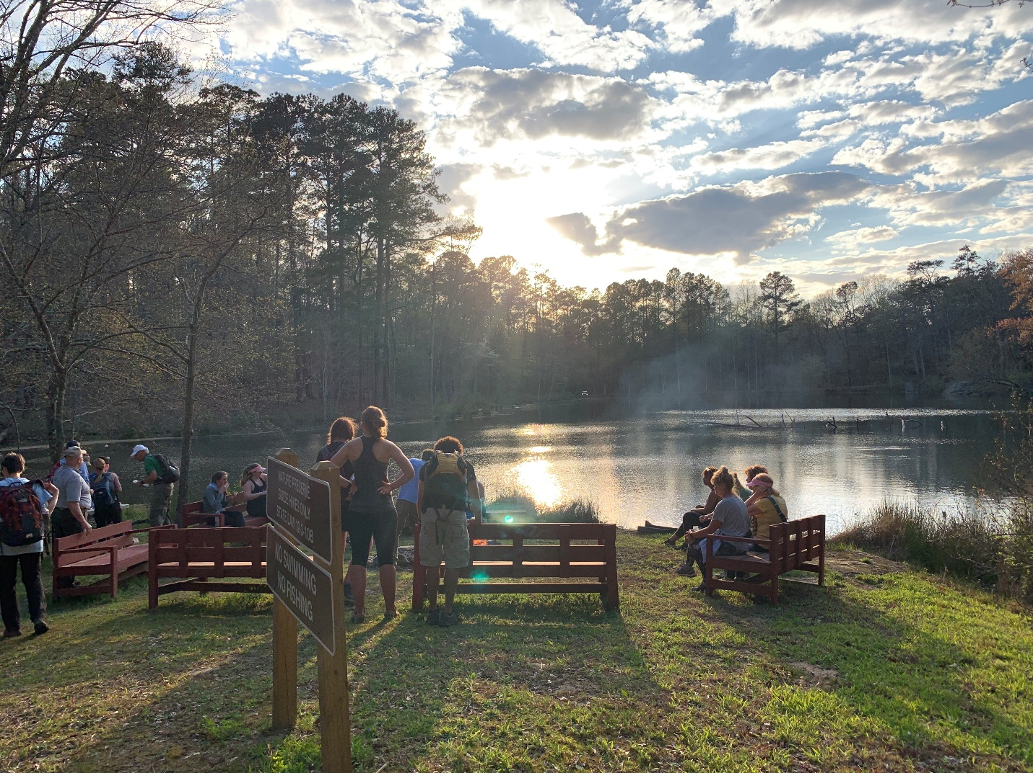
Following a long day of hiking, Guided Triple Hike participants enjoy s’mores at the base of Panola Mountain.

Monadnock Madness is presented by the Arabia Mountain Heritage Area Alliance in partnership with the Davidson-Arabia Mountain Nature Preserve, Panola Mountain State Park and the Stone Mountain Memorial Association. Special thanks to our sponsors.

Monadnock Madness highlights for this year include the following activities which require pre-registration:

Triple Hike Challenge – March 7, 21 and 28. Note that there are 2 triple hike opportunities per day on the 21st and 28th. Tickets $15 adult; $7 child. https://monadnockmadness.bpt.me

Photography Workshop – March 7 and 15; tickets $10. https://mmphotographyworkshop.bpt.me

Sunset Yoga at Arabia Mountain - March 29th at 6pm; tickets $20. https://arabiamountainyoga.bpt.me

Keep an eye out for more information coming soon, including a full list of activities, the full 2020 Triple Hike Challenge passport and details about prizes. Photos from last year’s Monadnock Madness are also available to view here. Visit www.monadnockmadness.com for details.

###
About Arabia Alliance
The Arabia Mountain Heritage Area Alliance is dedicated to protecting, connecting and sharing the powerful history, rich culture and engaging landscapes of the Arabia Mountain National Heritage Area (AMNHA) for the benefit and enjoyment of all. The staff and volunteer board of the Arabia Alliance work with partners across the AMNHA to ensure that everyone can benefit from the cultural and natural resources of the National Heritage Area. For more information, visit www.arabiaalliance.org.

