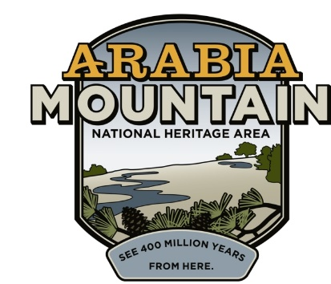
Media Contact: Zack Loehle, Communications Manager
Arabia Mountain Heritage Area Alliance
p: 404-998-8384 | e: zack@arabiaalliance.org

FOR IMMEDIATE RELEASE
Jan. 16, 2019

Monadnock Madness Returns for Seventh Year
Adventurers invited to explore Georgia’s geological gems
Tickets on sale January 22nd

STONECREST, Ga. – Are you ready to rock? This March, get out and explore Georgia’s granite giants – Arabia Mountain, Panola Mountain and Stone Mountain – during the annual Monadnock Madness. Come celebrate these three major Atlanta-area monadnocks through hikes, workshops, classes and fitness throughout the month. That includes the ever-popular Triple Hike Challenge, in which hikers summit all three granite mountains in a single day. A celebration of nature, wildlife and some darn big rocks, Monadnock Madness will change how you see Atlanta’s wild places. Registration for triple hikes, photography workshop and mountaintop yoga opens on Jan. 22nd.

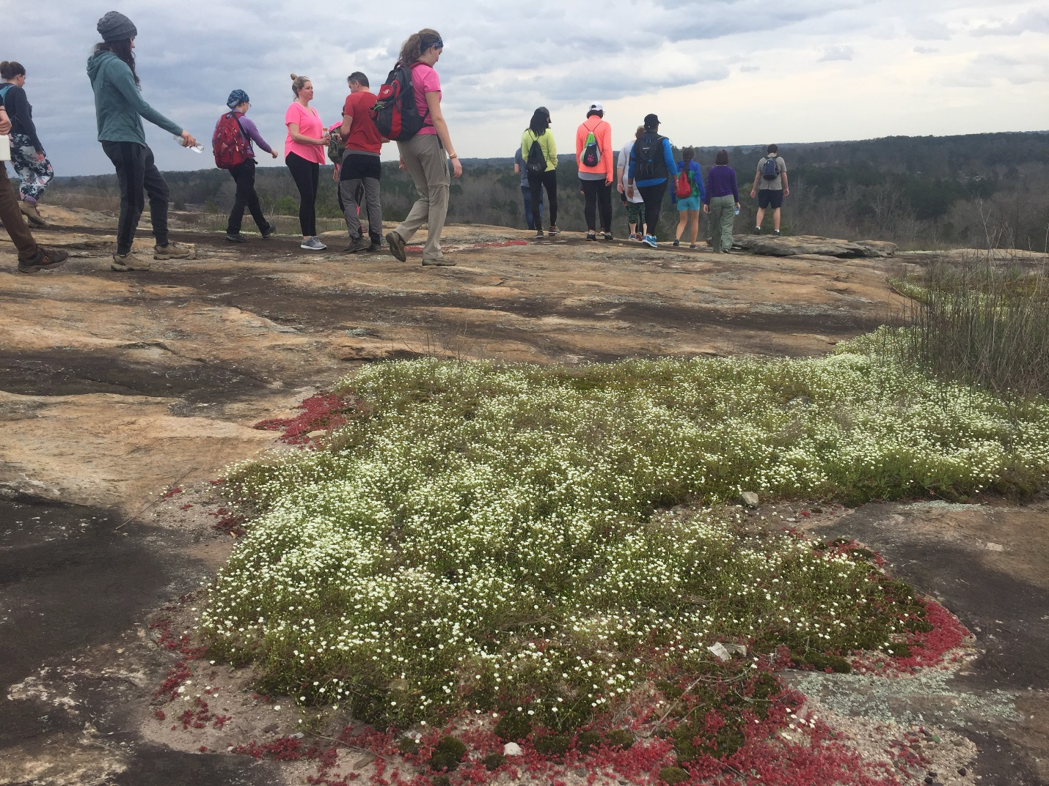
Diamorpha and moss on top of Arabia Mountain. Discover these beautiful plants through the guided triple hike, or via the self-guided “hike as you like” option.
-more-

Now in its seventh year, the month-long outdoor extravaganza gives participants an opportunity to see rare, red diamorpha – also called elf orpine – with white blooms, vibrant vernal pools and out-of-this-world landscapes. Hikers can also join in on a variety of activities including photography workshops, mountaintop yoga, various guided hikes and other special programs at all three sites. “This is a great way to roll into spring,” said Mera Cardenas, Executive Director of the Arabia Alliance. “These are ecosystems not found anywhere else in the country, right here in Atlanta’s backyard.”

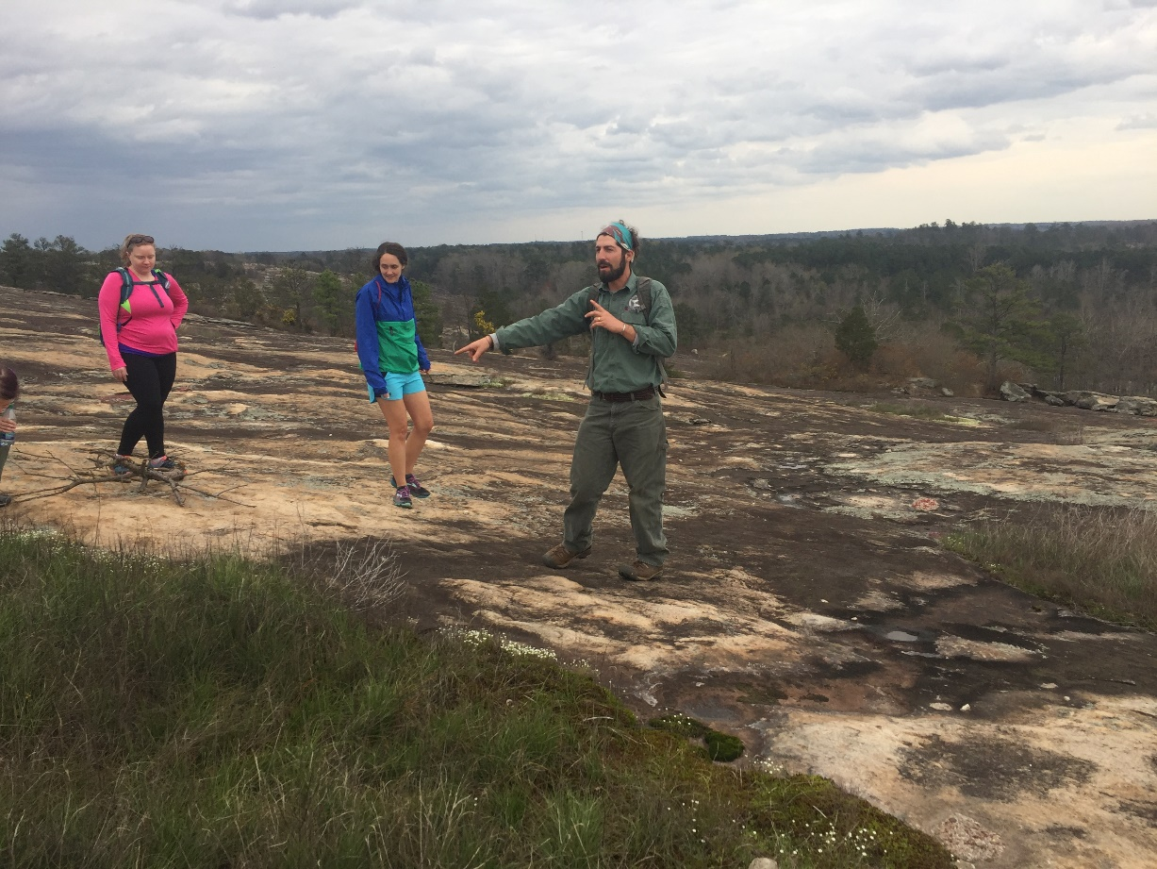
Ranger Robby Astrove at the summit of Arabia Mountain. All of the Triple Hikes are guided by experienced rangers who reveal the natural beauty and history of each mountain.

-more-
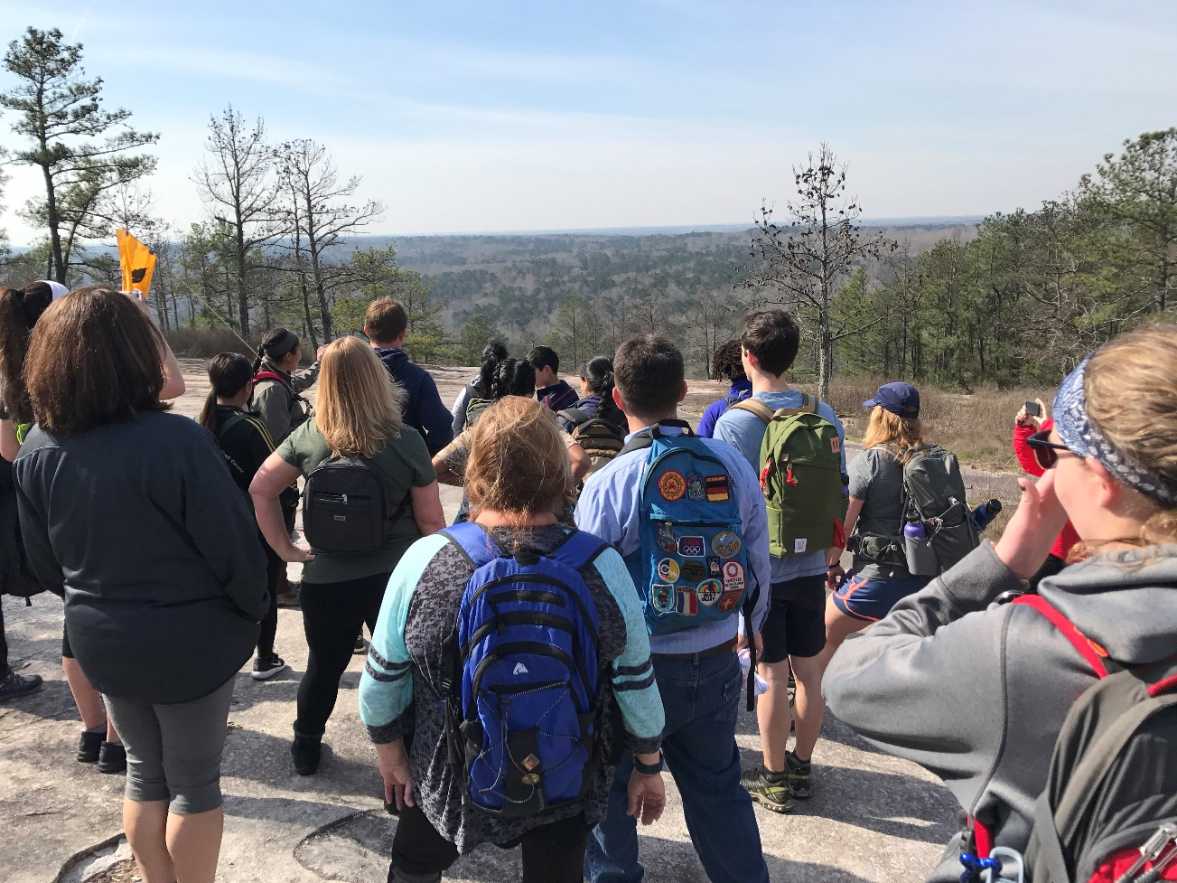
Monadnock Madness hikers during the Triple Hike Challenge at Stone Mountain.

All hikers will earn a commemorative souvenir after completing the Triple Hike Challenge. If you are interested in completing the challenge at your own pace, each park offers visitors the option to “hike as you like,” a self-guided tour of the three monadnocks. Pick up a passport at one of the parks or online at monadnockmadness.com during the month of March.

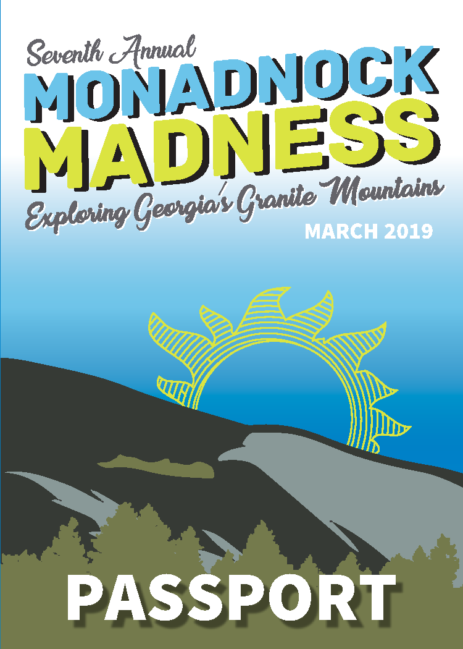
The 2019 Monadnock Madness passport cover. More details to come soon.
-more-

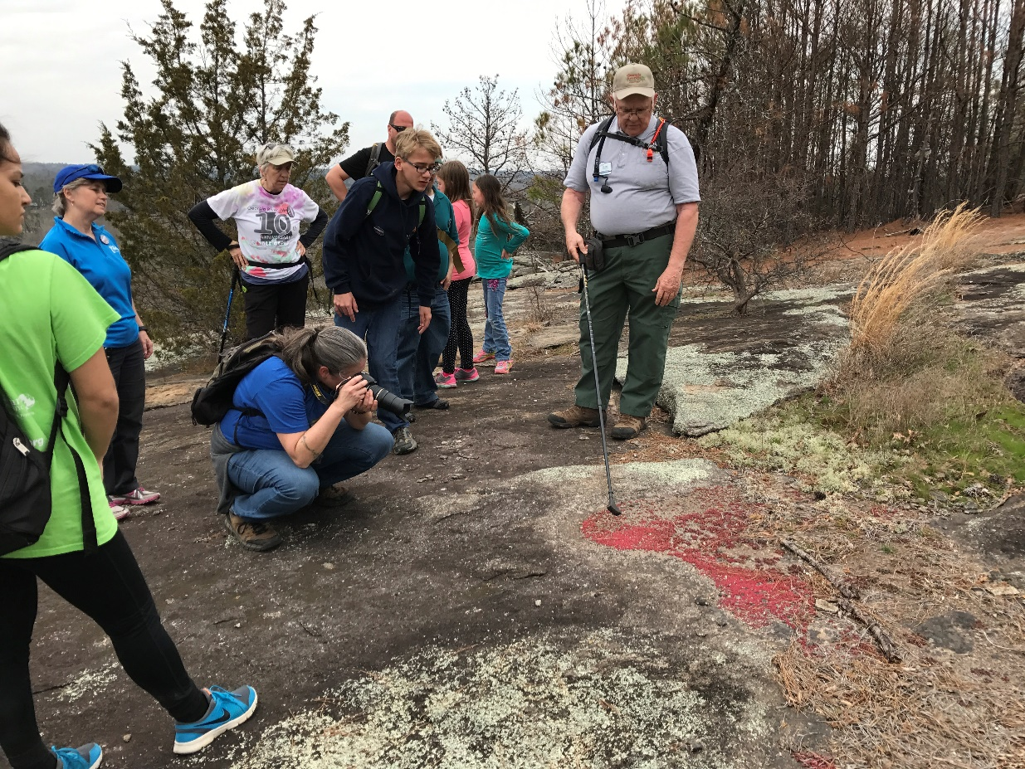
Monadnock Madness hikers getting a glimpse of diamorpha on the pristine
granite outcrop at Panola Mountain.

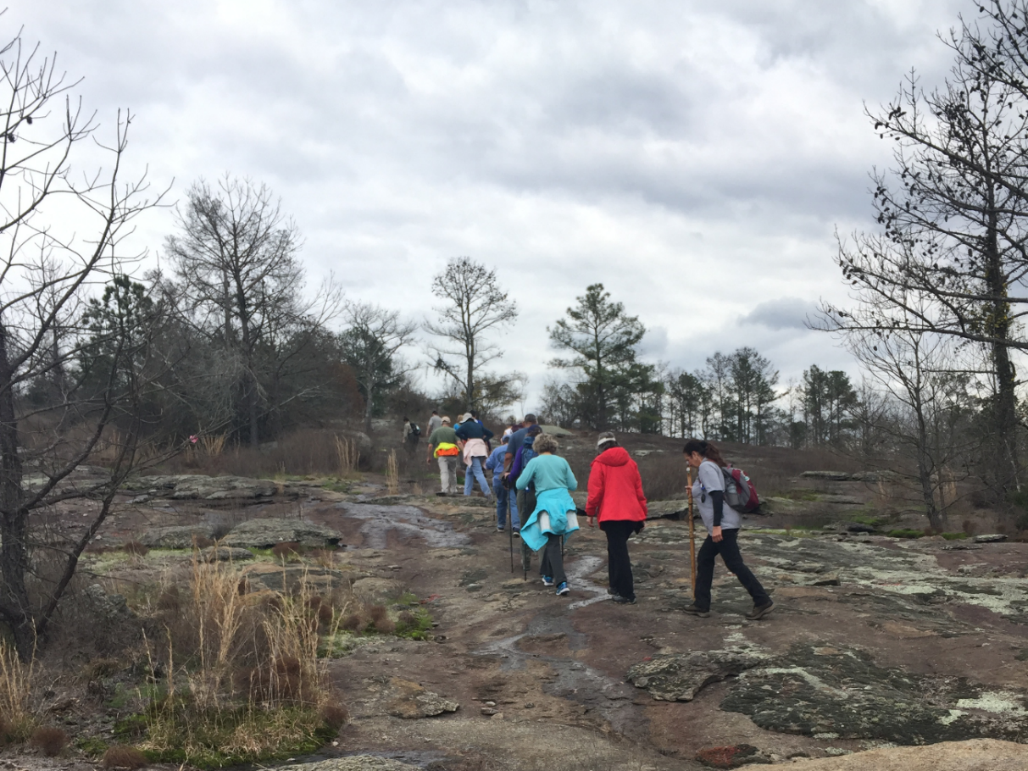
Hikers at Panola Mountain, experiencing the only of the three monadnocks to never be quarried, leaving a pristine ecosystem for all to enjoy.

-more-
“My favorite part of Monadnock Madness was getting to experience the parts of Panola Mountain available only on the guided hike. The views are refreshing and breathtaking. The trees and plants are just starting to wake up for spring and lovely to see. Panola is pristine and such a wonderful treat to explore,” said past participant Cindy Hays. “I also enjoyed the other two monadnocks, Arabia and Panola Mountains, and the camaraderie with the other hikers.”

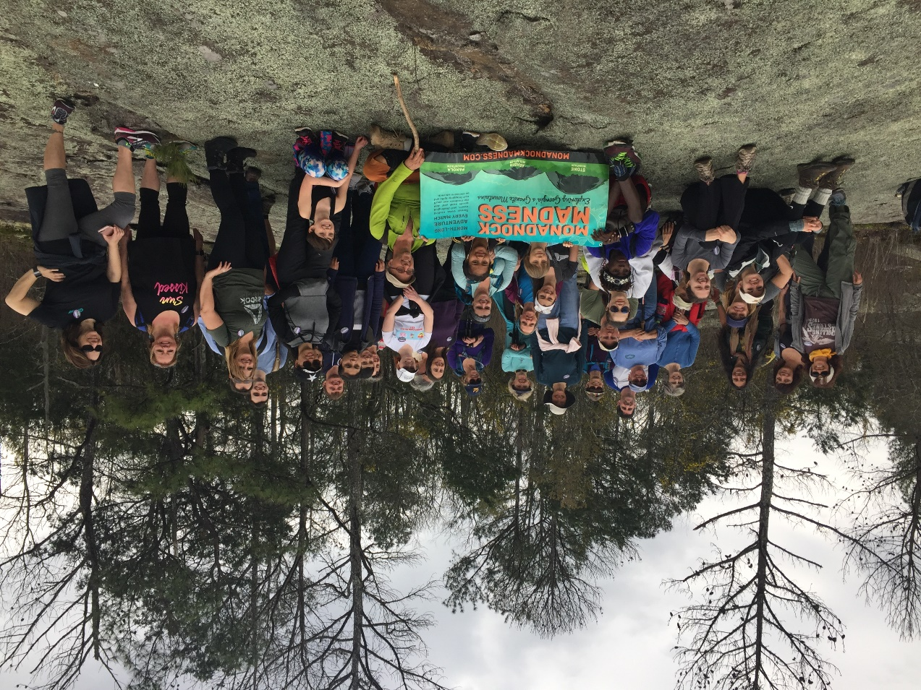
Hikers celebrating on top of Panola Mountain after completing a triple hike – summiting all three monadnocks in a single day.

Monadnock Madness is presented by the Arabia Mountain Heritage Area Alliance in partnership with the Davidson-Arabia Mountain Nature Preserve, Panola Mountain State Park and Stone Mountain Memorial Association. Special thanks to our sponsors from Discover DeKalb Convention & Visitors Bureau and Keep DeKalb Beautiful.

Monadnock Madness highlights for this year include the following activities which require pre-registration:

Triple Hike Challenge – March 2, 16 and 30. Note that there are 2 triple hike opportunities per day on the 16th and 30th. Tickets $15 adults; $7 child. https://monadnockmadness.bpt.me

Photography Workshop and Contest – March 2 and 17; tickets $10. https://mmphotographyworkshop.bpt.me

Sunset Yoga at Arabia Mountain - March 23rd from 11 am to 1 pm; tickets $20. https://arabiamountainyoga.bpt.me

To download a full list of month-long activities, and for information about ticketing and how to earn prizes, visit www.monadnockmadness.com. Photos from last year’s Monadnock Madness are also available to view here.

###
About Arabia Alliance
The Arabia Mountain Heritage Area Alliance is dedicated to protecting, connecting and sharing the unique history, rich culture and engaging landscapes of the Arabia Mountain National Heritage Area (AMNHA) for the benefit and enjoyment of all. The staff and volunteer board of the Arabia Alliance work with partners across the AMNHA to ensure that everyone can benefit from the cultural and natural resources of the National Heritage Area. For more information, visit www.arabiaalliance.org.

