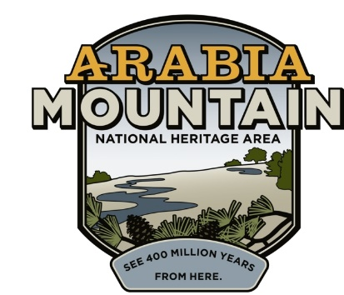
Media Contact: Zack Loehle, Communications Manager
Arabia Mountain Heritage Area Alliance
p: 404-998-8384 | e: zack@arabiaalliance.org

FOR IMMEDIATE RELEASE
Jan. 11, 2021

Phase II of Historic Preservation Underway at Lyon Farm
DeKalb County, Arabia Mountain Heritage Area Alliance Coordinating Stabilization of Farm Outbuildings

STONECREST, Ga – Historic preservation efforts continue at the Lyon Farm, one of the oldest homesteads in DeKalb County and a part of the history of the African-American Flat Rock community. In early January, DeKalb County Board of Commissioners, the DeKalb County Department of Watershed Management, the Arabia Mountain Heritage Area Alliance, Flat Rock Archives and Lewallen Construction began Phase II of the farm’s preservation. While Phase I focused on stabilizing the farmhouse, the centerpiece of the property, Phase II is focused on a variety of agricultural outbuildings essential to the property’s history. That includes a smokehouse, workshed, and barn remnants.

The Lyon Family established their homestead in the shadow of Panola Mountain in the 1820s. For nearly 175 years, the family carved out a rural life where they cultivated crops and raised livestock. A log cabin was likely the first structure built on the property in the 1820s. The footprint was expanded multiple times over the years, creating the house that still stands today. Following the Civil War, formerly enslaved people from the Lyon Farm and other surrounding farms would form the community of Flat Rock, which today stands as one of the oldest Black communities in Georgia.

The property was purchased by the DeKalb County Department of Watershed Management (DWM) in 2003. In 2016, the historic structures were placed on the Georgia Trust for Historic Preservation’s “Places in Peril” list due to excessive structural decay. In November of 2018, the Arabia Mountain Heritage Area Alliance (the nonprofit management entity of the Arabia Mountain National Heritage Area), Flat Rock Archives, DeKalb County DWM and contractors F. H. Paschen kicked off Phase I of historic preservation. Construction completed the following spring, with the historic farmhouse and slave quarters being jacked, levelled, and components of the building rebuilt or replaced.

Tours of the historic Flat Rock community by the Flat Rock Archives begin at the Lyon Farm. Although currently paused due to the pandemic and construction, these tours will begin again in the future and offer critical insight into the early settlers of DeKalb County and the lives of one of Georgia’s oldest Black communities. “This is the first leg of the tour – this is where we meet at, right here at the Lyon house,” said Johnny Waits, Executive Director and Co-Founder of the Flat Rock Archives, adding that visitors have come from all over the world to learn about Flat Rock and discover the history of the Lyon property. Phase II of historic preservation efforts at the site will further enhance this powerful historic resource and ensure that the Lyon Farm and Flat Rock community continue to be a historic centerpiece of the Arabia Mountain National Heritage Area.

Phase II of the project includes completely dismantling and then re-building the historic smokehouse, as well as stabilizing other historic farm structures. The sorghum mill will also be preserved.

- more -

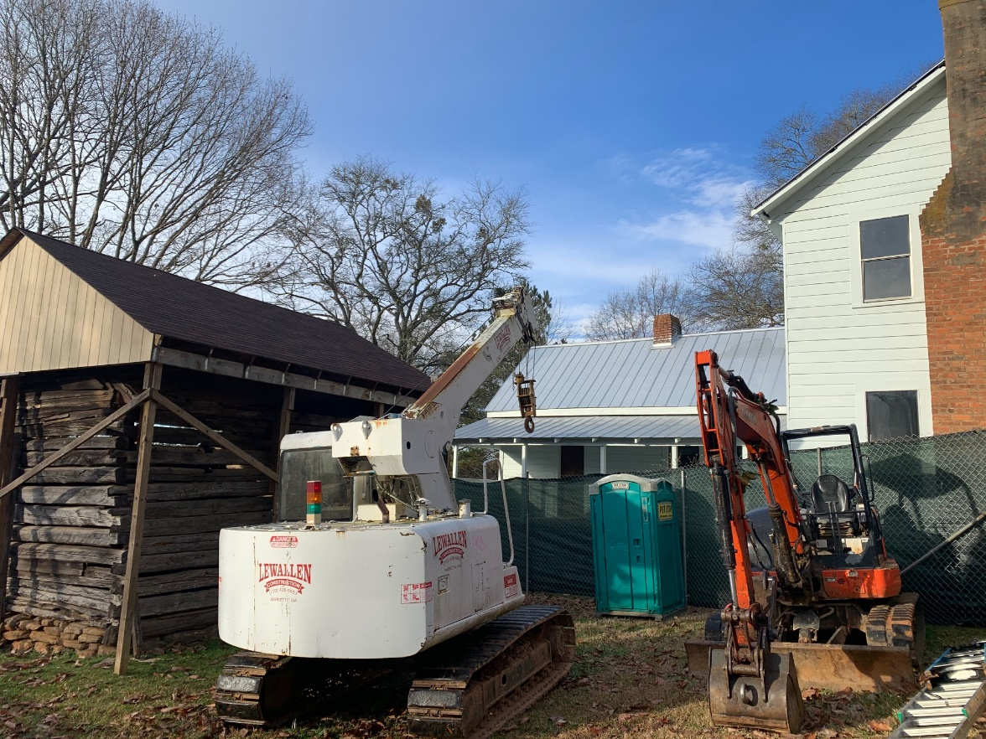
Preparations for construction have begun at the Lyon Farm. Phase II of historic preservation work at the site will focus on the smokehouse (at left) and other farm structures.

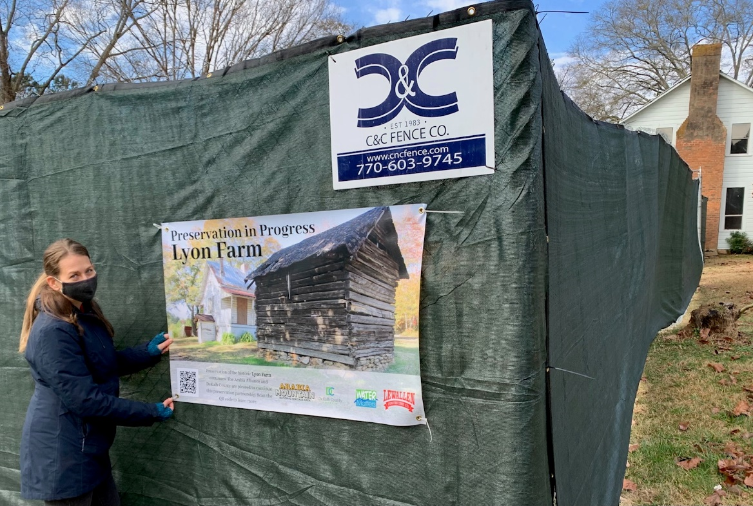
Arabia Mountain Heritage Area Alliance Director of Interpretation Sarah Lisle hangs an educational banner on construction fencing. The Lyon Farm is located right next to the popular Arabia Mountain PATH trail.

###

About the Arabia Alliance
The Arabia Mountain Heritage Area Alliance is dedicated to protecting, connecting and sharing the powerful history, rich culture and engaging landscapes of the Arabia Mountain National Heritage Area (AMNHA) for the benefit and enjoyment of all. The staff and volunteer board of the Arabia Alliance work with partners across the AMNHA to ensure that everyone can benefit from the cultural and natural resources of the National Heritage Area. For more information, visit www.arabiaalliance.org.

