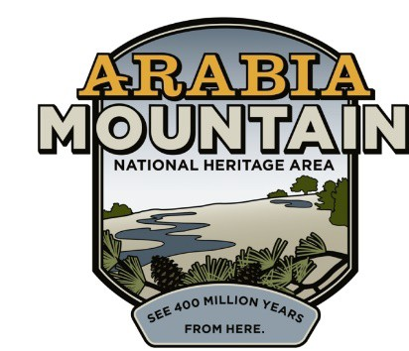Media Contact: Zack Loehle, Communications Manager
Arabia Mountain Heritage Area Alliance
p: 404-998-8384 | e: zack@arabiaalliance.org

FOR IMMEDIATE RELEASE Sept. 20, 2019

Arabia Mountain Heritage Area Alliance Honored at 2019 Governor’s
Tourism Conference

LAGRANGE, Ga. – Georgia’s top tourism leaders recently recognized the Arabia Mountain Heritage Area Alliance for leading the pack in promoting outdoor recreation. The Arabia Alliance is honored to have received the Paul Nelson Award for Outdoor Recreation and Preservation at the 2019 Georgia Governor’s Tourism Conference in LaGrange. This award recognizes the Arabia Alliance’s accomplishments in protecting and promoting the rich natural resources and engaging landscapes of the National Heritage Area for the education and enjoyment of all. The Paul Nelson Award is named after the longtime Georgia State Parks Marketing Manager and Assistant State Parks Director, who worked tirelessly to promote Georgia’s beautiful greenspace and historic sites.

“We are honored to receive this award,” said Mera Cardenas, Arabia Alliance Executive Director. “The Arabia Alliance holds a deep commitment to promoting this nationally significant landscape. The Arabia Mountain National Heritage Area contains powerful history and otherworldly natural beauty, from the peace of the Monastery of the Holy Spirit and the fascinating story of Flat Rock to the granite monadnocks of Arabia and Panola Mountains. The Alliance would not be able to complete any of our work without our partners – including the PATH Foundation, which has helped us construct an over 30-mile multiuse trail that connects sites throughout the NHA. From hiking to history tours to our many outdoor events, we enjoy the privilege of introducing people from in-state and around the country to the National Heritage Area in Atlanta’s backyard. Thank you to everyone who makes our work possible. We are grateful for this honor and are excited to continue to support outdoor tourism in the State of Georgia.”

- more -

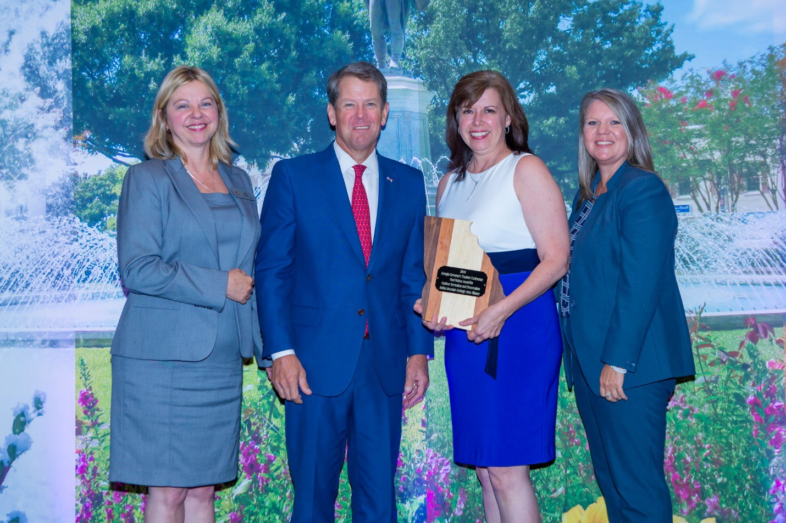

Georgia Governor Brian Kemp presenting the Paul Nelson Award for Outdoor Recreation and Preservation to Mera Cardenas, Executive Director of the Arabia Mountain Heritage Area Alliance, standing with Georgia Department of Economic Development Interim Deputy Commissioner, Tourism Division (Explore Georgia) Lisa Love at left and Georgia Association of Convention and Visitors Bureaus President Rashelle Beasley at right. Photo: Georgia Governor’s Tourism Conference.

- more -

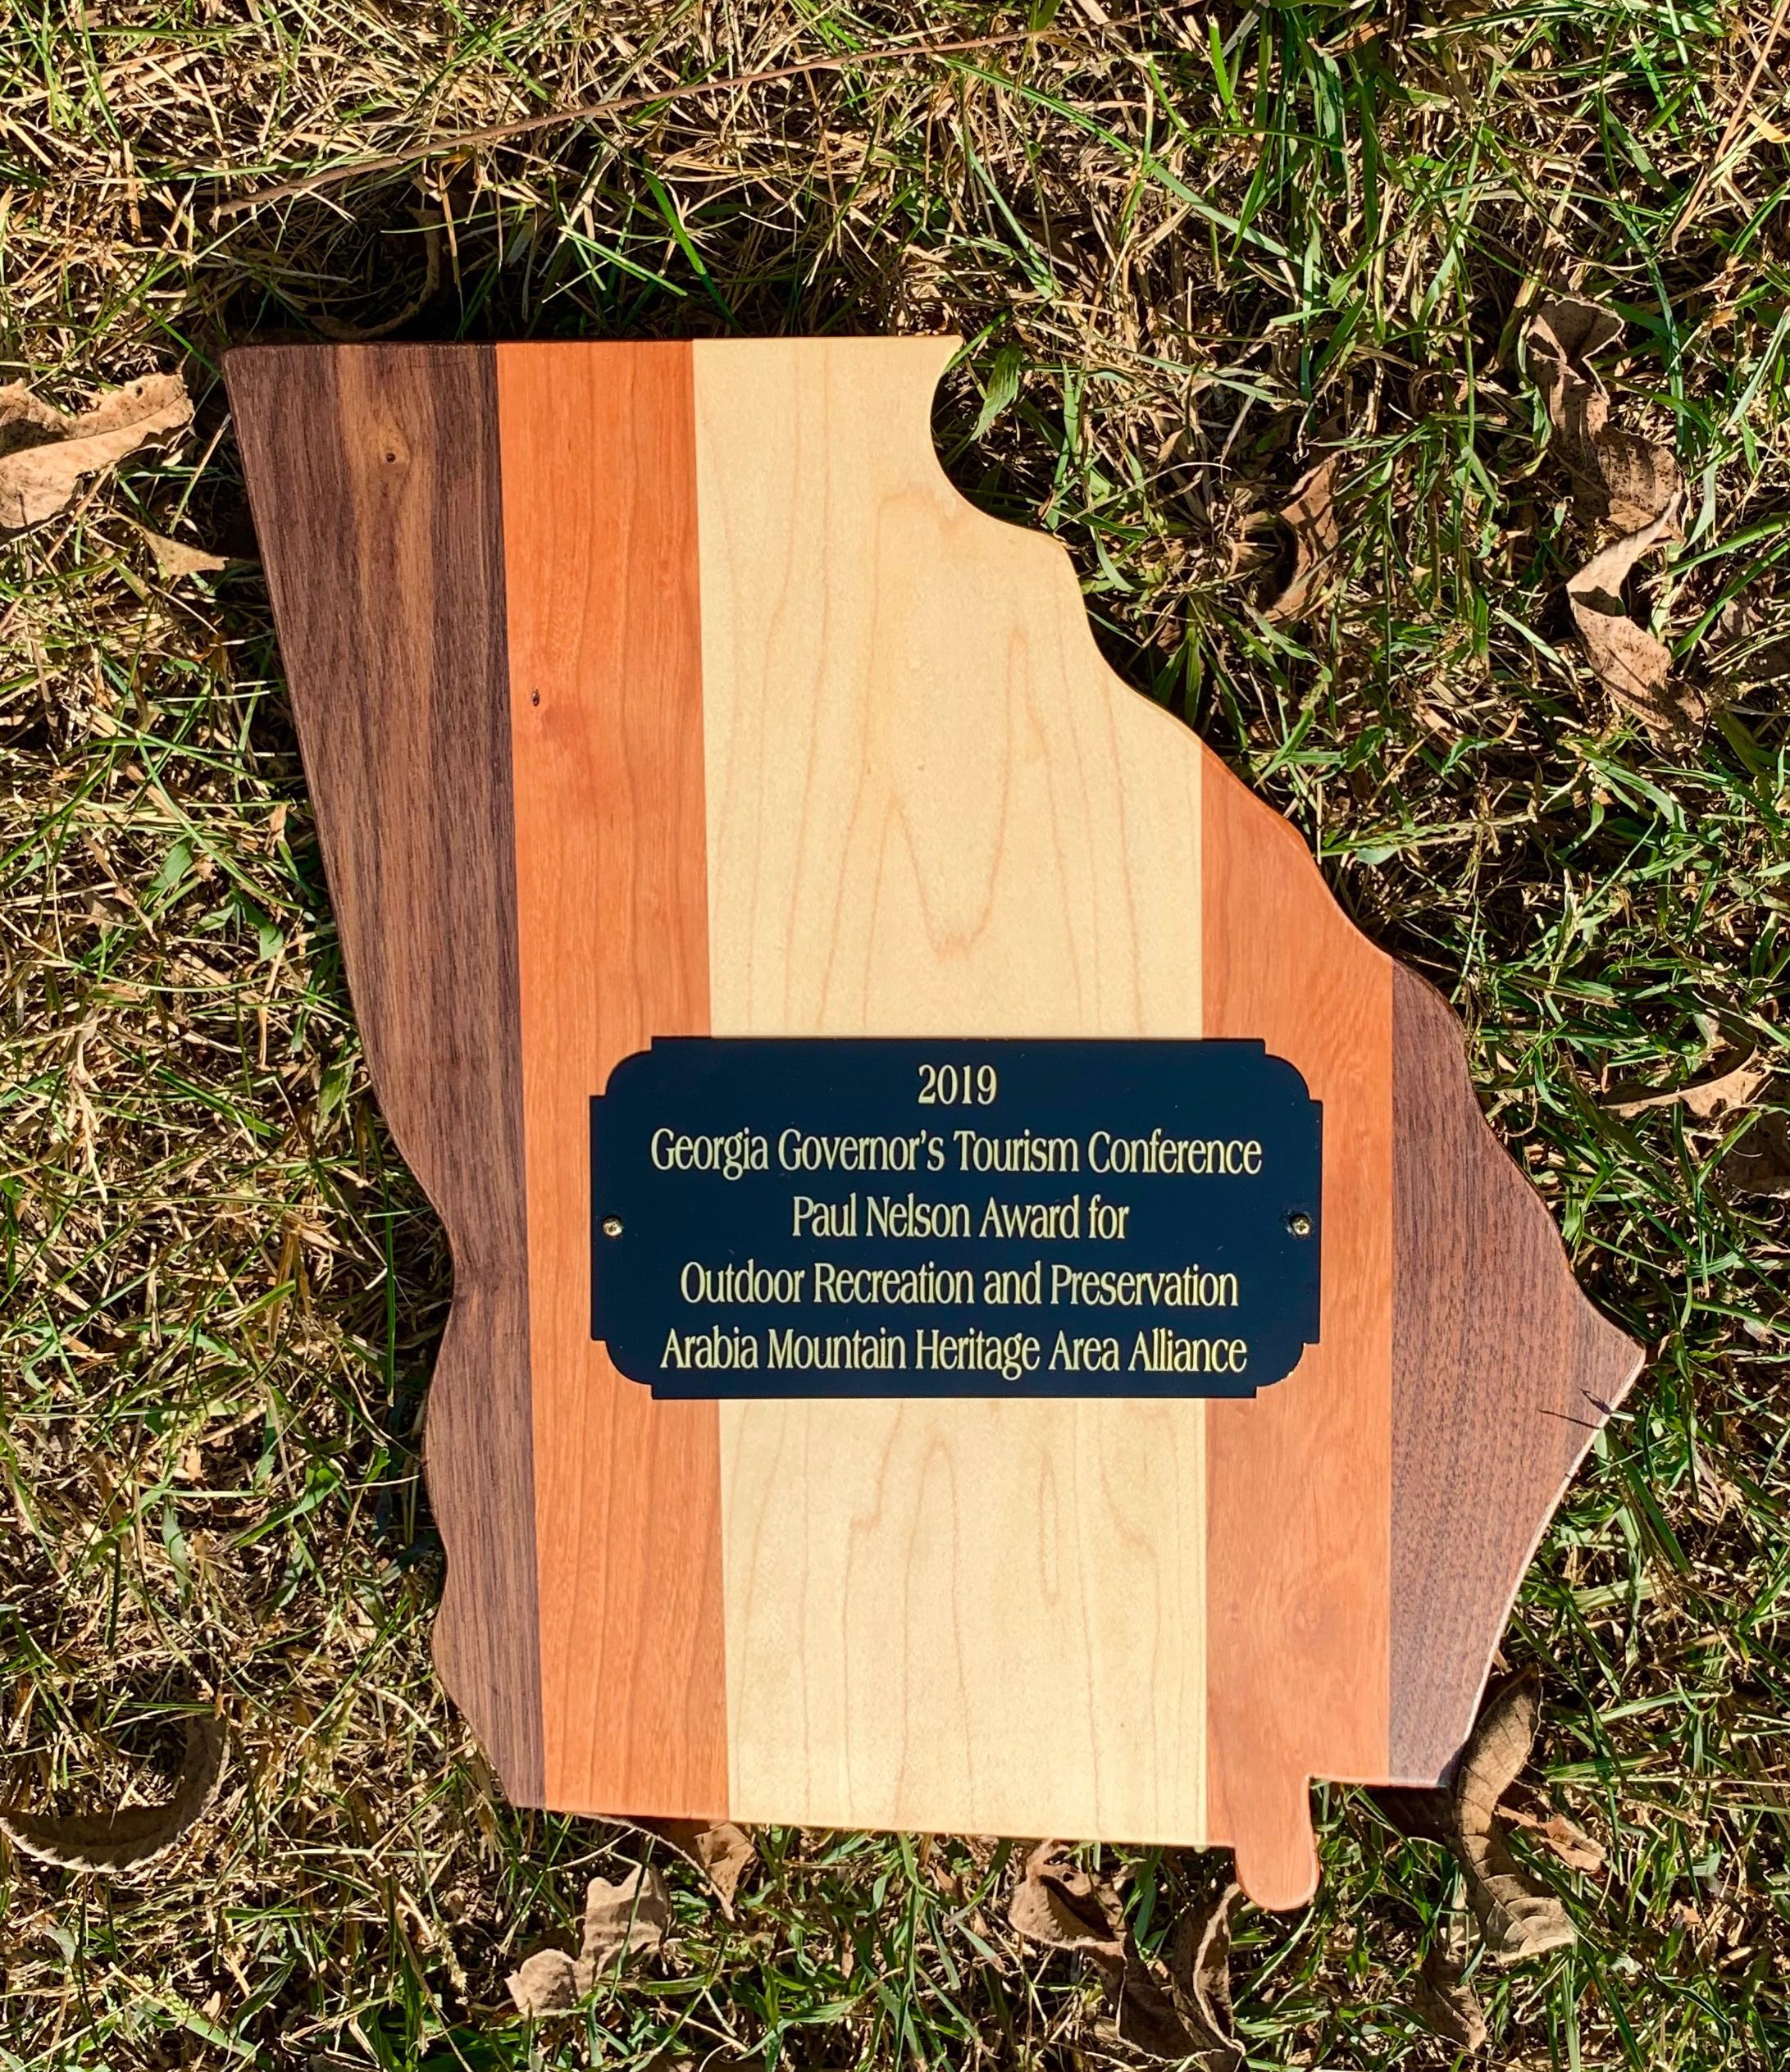

The Paul Nelson Award for Outdoor Recreation and Preservation honorary plaque.

The 2019 Georgia Governor’s Tourism Conference took place at the Great Wolf Lodge in LaGrange, GA from September 8-11. The conference draws representatives from convention and visitors bureaus, local governments, attractions, state government agencies, and other tourism professionals from across the state. As well as attending and receiving the Paul Nelson Award, Arabia Alliance Executive Director Mera Cardenas joined a panel presentation about the power of partnerships with Georgia State Parks and Historic Sites (a division of the Georgia Department of Natural Resources).

About Arabia Alliance
###

The Arabia Mountain Heritage Area Alliance is dedicated to protecting, connecting and sharing the powerful history, rich culture and engaging landscapes of the Arabia Mountain National Heritage Area

(AMNHA) for the benefit and enjoyment of all. The staff and volunteer board of the Arabia Alliance work with partners across the AMNHA to ensure that everyone can benefit from the cultural and natural resources of the National Heritage Area. For more information, visit www.arabiaalliance.org.

