Media Contact: Zack Loehle, Communications Manager
Arabia Mountain Heritage Area Alliance
p: 404-998-8384 | e: zack@arabiaalliance.org

FOR IMMEDIATE RELEASE
Aug. 14, 2019

Daisy Days On the Horizon: Hikers to Explore Fall Flowers with Mountain Triple Hike
Tickets now on sale

STONECREST, Ga. – Celebrate the explosion of yellow blooms that will soon cover local granite outcrops with a fall Triple Hike, summiting Stone, Arabia and Panola Mountains all in one day. Presented by the Arabia Mountain Heritage Area Alliance, Davidson-Arabia Mountain Nature Preserve, Friends of Panola Mountain State Park, Panola Mountain State Park and the Stone Mountain Memorial Association, the guided Daisy Days Triple Hike showcases the vibrant yellow daisies that bloom on the mountains during the fall. Event tickets can be purchased at daisydays.bpt.me.

The yellow daisies are native to the rock outcrops of the Southeastern United States, especially in the granite formations of the Georgia Piedmont region. The metro-Atlanta area has a high concentration of the daisies, which bloom on our massive granite mountains. While these rock outcrops seem barren, especially during the scorching summers, fall and winter see a profusion of wildflowers grow out of patches of thin soil called “solution pits.” The Daisy Days Triple Hike is an opportunity to celebrate the botanical bounty growing on the rock outcrops (also called “monadnocks”) as autumn begins. Participants will also receive a special souvenir.

The Daisy Days Triple Hike is the fall counterpart to the spring Monadnock Madness event, an outdoor extravaganza in which people can enjoy triple hikes, mountaintop yoga, photography workshops and dozens of other events throughout the month of March. Monadnock Madness accompanies another floral explosion on the granite outcrops, as plants such as the atamasco lily, granite stonecrop and diamorpha burst into vibrant spring bloom. Details for the 2020 Monadnock Madness will be announced in January.

Come marvel at the beauty of monadnocks at the beginning of fall and see one of Georgia’s botanical wonders. Purchase tickets at daisydays.bpt.me.

Yellow Daisies blossoming at Arabia Mountain, one of three mountains on the Daisy Days Triple Hike.
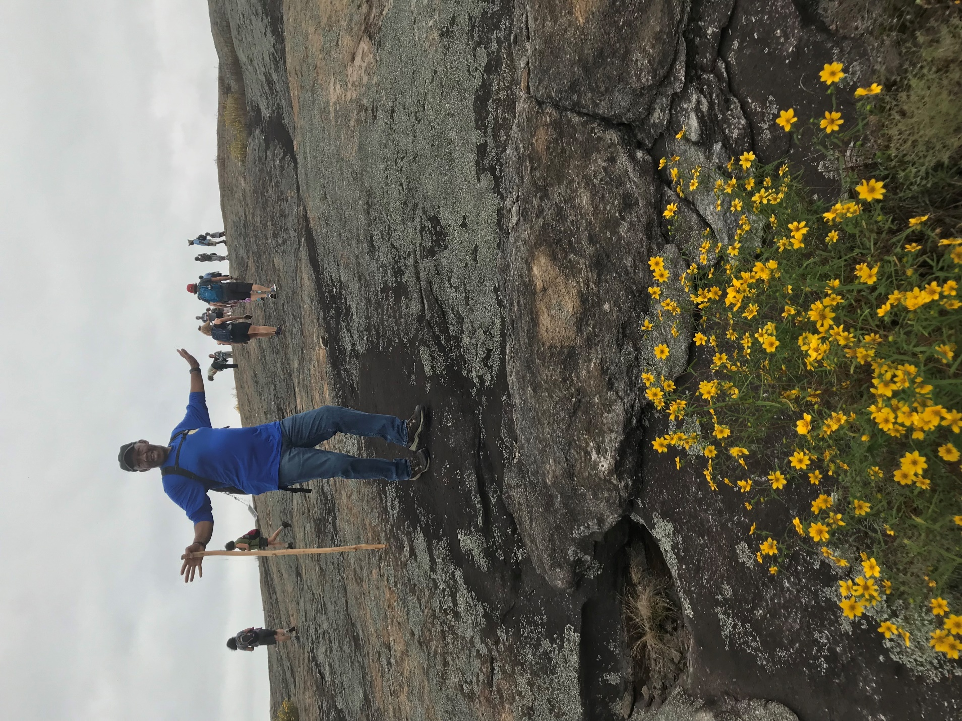
Ron Williams, Board Chair of the Arabia Mountain Heritage Area Alliance, enjoys the Daisy Days Triple Hike.

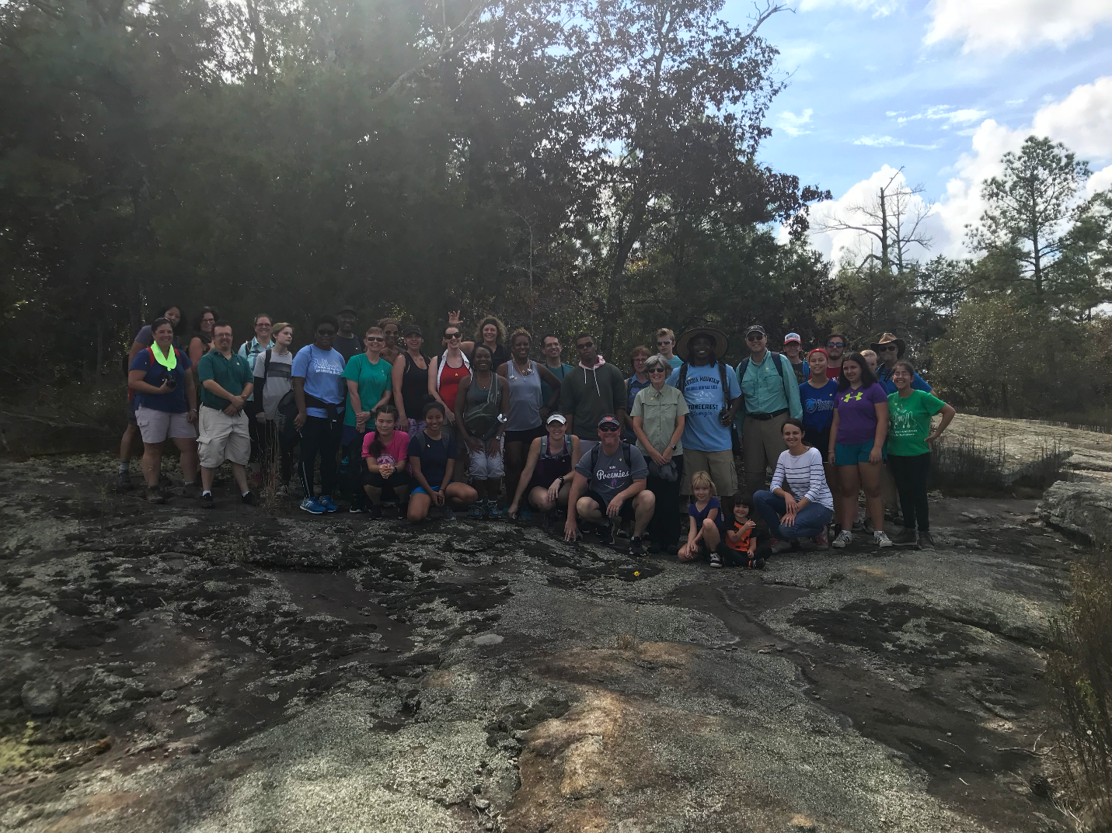
Hikers complete the Daisy Days Triple Hike at Panola Mountain, a National Natural Landmark and carefully conserved granite outcrop ecosystem.

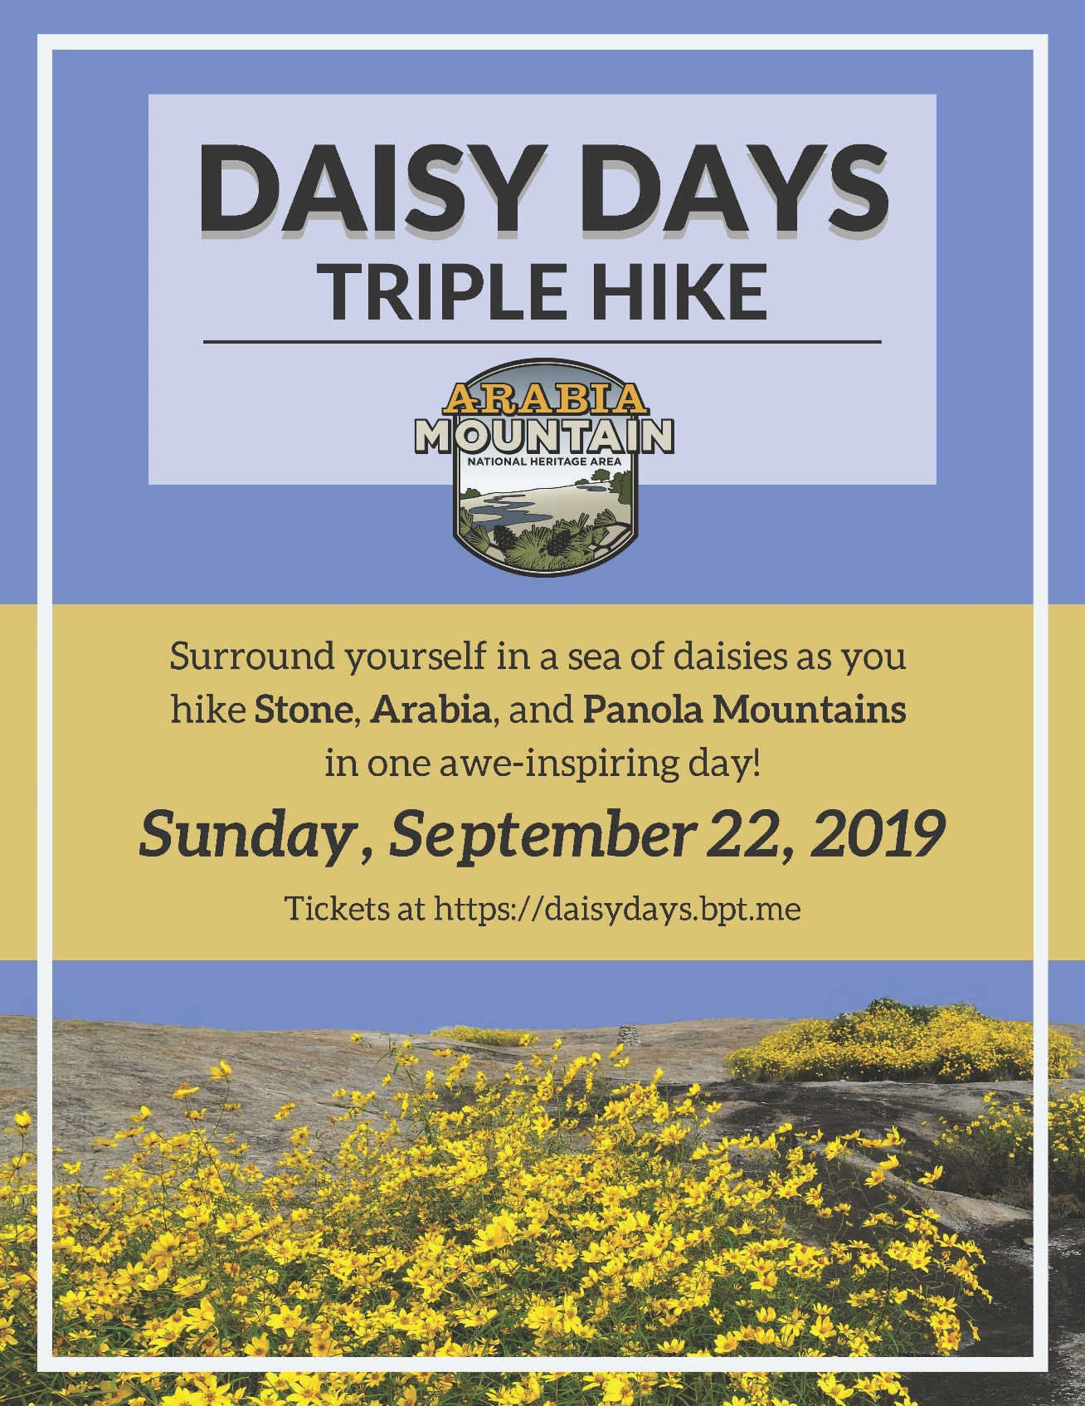
Flyer for the Daisy Days guided Triple Hike on September 22, 2019. Tickets can be purchased at daisydays.bpt.me.

###
About Arabia Alliance
The Arabia Mountain Heritage Area Alliance is dedicated to protecting, connecting and sharing the unique history, rich culture and engaging landscapes of the Arabia Mountain National Heritage Area (AMNHA) for the benefit and enjoyment of all. The staff and volunteer board of the Arabia Alliance work with partners across the AMNHA to ensure that everyone can benefit from the cultural and natural resources of the National Heritage Area. For more information, visit www.arabiaalliance.org.

