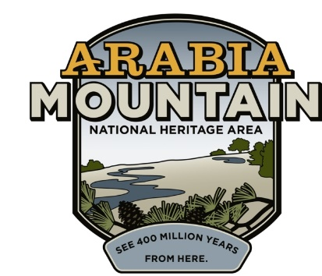
Media Contact: Zack Loehle, Communications Manager
Arabia Mountain Heritage Area Alliance
p: 404-998-8384 | e: zack@arabiaalliance.org

FOR IMMEDIATE RELEASE
August 1, 2019

A Gateway to Heritage: New Lithonia Garden Now Open
The Ruth Carroll Dally Johnson Interpretive Garden Introduces Visitors to Lithonia’s Rich History

Lithonia, Ga. – A newly designed garden celebrating Lithonia’s rich and impactful history opened to the public on Friday, July 26. Officials and community members from the City of Lithonia, DeKalb County and the Arabia Mountain Heritage Area Alliance gathered at the Ruth Carroll Dally Johnson Interpretive Garden (located at 2564 Wiggins Street) on Friday morning to announce the opening. The new garden includes signage discussing major figures in the history of the city and the importance of the Lithonia Woman’s Club, as well as orientation to the Arabia Mountain National Heritage Area (AMNHA).

“It’s an awesome time to just know that this history of all of the foot soldiers in the City of Lithonia is being preserved. I think this should serve as an example for other communities to store their history so that generations after them will know the sacrifices that were made for their freedom,” said DeKalb County District 5 Commissioner Mereda Davis Johnson. Along with the Commissioner, the assembled crowd enjoyed remarks from DeKalb County District 7 Commissioner Lorraine Cochran-Johnson, City of Lithonia Mayor Deborah Jackson and Arabia Mountain Heritage Area Alliance Executive Director Mera Cardenas. The new garden, which is privately owned but free and open to the public, is an easy walk from the shops along Lithonia’s Main Street.

The newly-opened Ruth Carroll Dally Johnson Interpretive Garden serves as a Historic Gateway to the National Heritage Area, introducing visitors to the people and industry that shaped this nationally significant landscape. Lithonia arose as a bustling quarry town, shipping granite across the country first for construction and then, later, for use in agriculture. Lithonia was a hub for an industry that literally built American monuments. As the town prospered on its rock-solid foundation, it also became part of broader social movements sweeping the country. The Lithonia Woman’s Club, founded in 1924, gave women the ability to impact their community at a time when they were excluded from elected government and business; the club also housed DeKalb County’s first public library. The new garden is named after the family of Martha Josephine Johnson, a botanist and scholar who earned her PhD from the University of Georgia and studied endangered species native to Arabia Mountain. The property was donated by her Estate after her death in 2012 and, in keeping with her wishes, named for her mother.

While the Woman’s Club created a space of empowerment for some women, others were noticeably excluded: racial segregation remained a deep and systemic part of life through the 1960’s. It took figures such as Lucious Sanders, David Albert and Maggie Woods, working in tandem with and as part of the national Civil Rights movement, to break open the doors to opportunity for African-Americans. Their legacy as local leaders continues to shape Lithonia today. “My uncle was all about integration, he was all about bringing the black and white communities together...he was a pillar of the community,” said Patrilla Arrington, Lucious Sanders’ niece, at the garden opening.

Both Sanders and Woods imparted their commitment to community and justice to younger generations. In fact, Maggie Woods’ children went on to serve in various roles in Lithonia’s government, including as a City Councilmember (Barbara Lester), the first black Chief of Police (Jerome Woods) and the first black woman to be Mayor (Marcia Glenn Hunter). “It’s just like a washing machine: you use a washing machine to get the dirt out of your clothes. And that’s how I look at my family – we were like a washing machine, back in those days when things were not so nice, when things were dirty, we were those agitators that got that dirt out of that nasty laundry. And now we can see the results of our efforts, and it has made life better for our next generation,” said Hunter.

As well as opening up the new garden to the public, speakers announced the upcoming extension of the Arabia Mountain PATH, a paved hiking and biking trail that connects greenspace and historic sites across the National Heritage Area, right into downtown Lithonia. “We have the PATH here in the city and we are very excited that our city council has agreed to make Wiggins Street one way so that we can extend the PATH trail up from Council [Street] and Johnson [Street], where it ends now, to come up Wiggins, past this beautiful facility, up to Main Street,” said Mayor Jackson at the event on Friday. More details about the planned PATH extension will be announced as the project progresses.

The Ruth Carroll Dally Johnson Interpretive Garden is open from dawn to dusk every day of the week. It is located at 2564 Wiggins Street, Lithonia, GA 30058. Visitors can learn more about the AMNHA, and see where to hop on the trails, at arabiaalliance.org.

Note: An earlier name for the new garden was the Martha Johnson Interpretive Garden. That has been changed to the Ruth Carroll Dally Johnson Interpretive Garden, in accordance with Martha Johnson’s wishes.

-more-
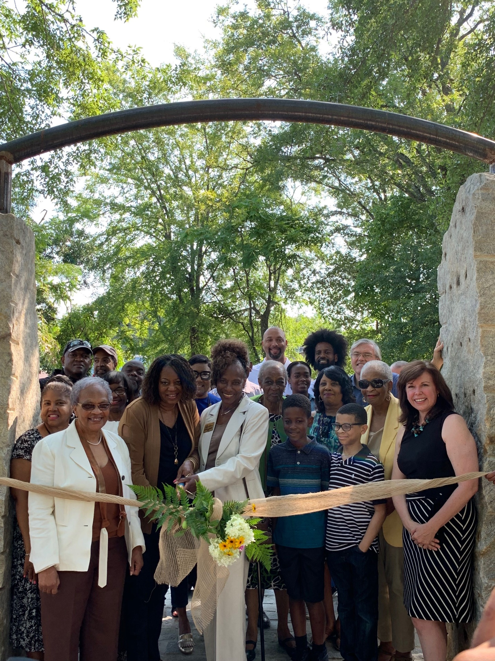
Officials and community members cut the ribbon at the Ruth Carroll Dally Johnson Interpretive Garden, located at 2564 Wiggins Street, Lithonia, GA 30058.
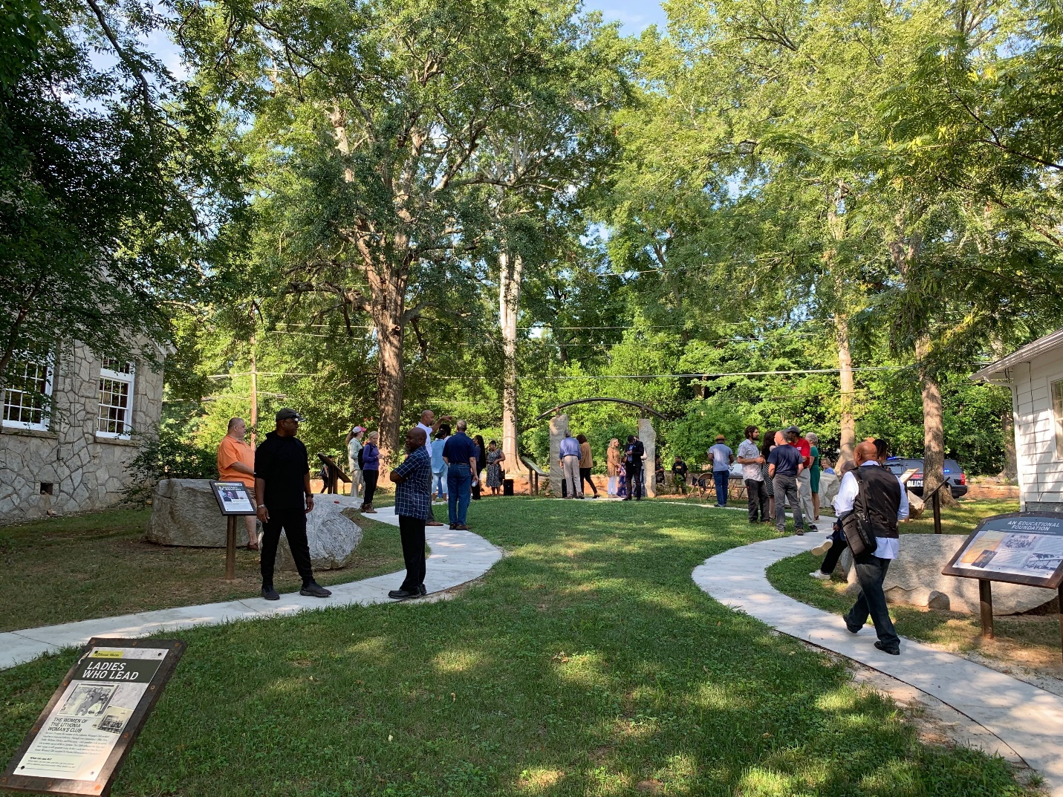
Event attendees enjoy the newly opened Ruth Carroll Dally Johnson Interpretive Garden.

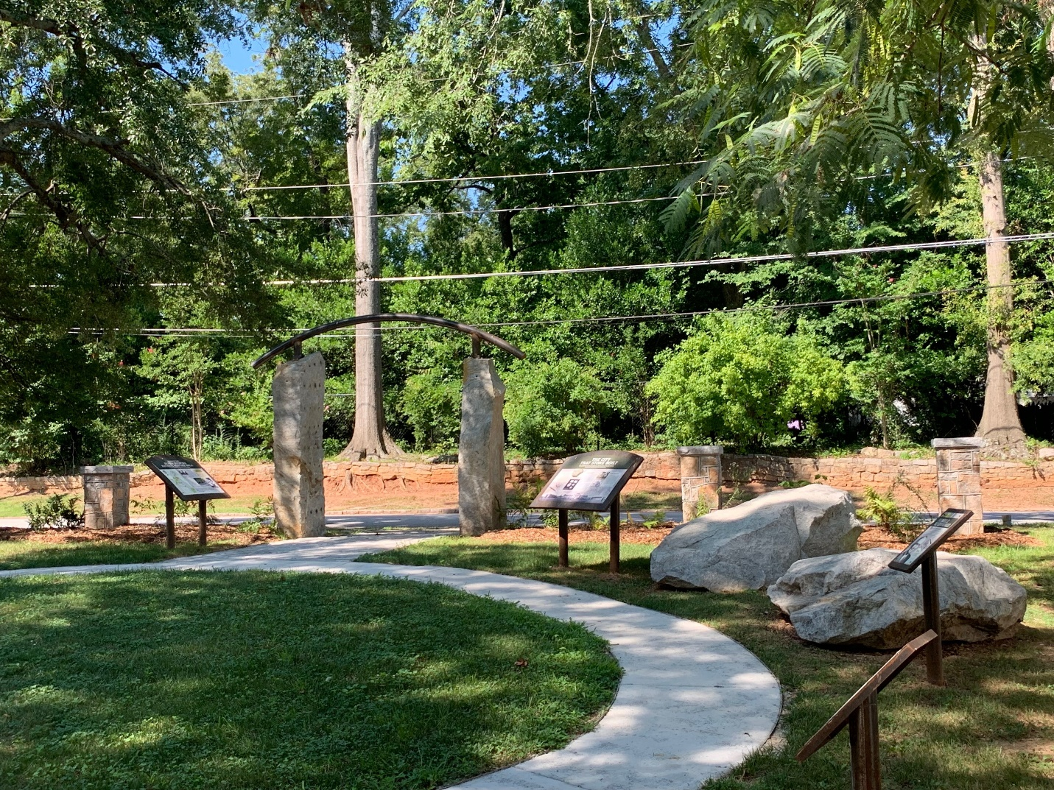
The Ruth Carroll Dally Johnson Interpretive Garden, located next to the Lithonia Woman’s Club in historic downtown Lithonia. This garden is the Historic Gateway to the Arabia Mountain National Heritage Area.
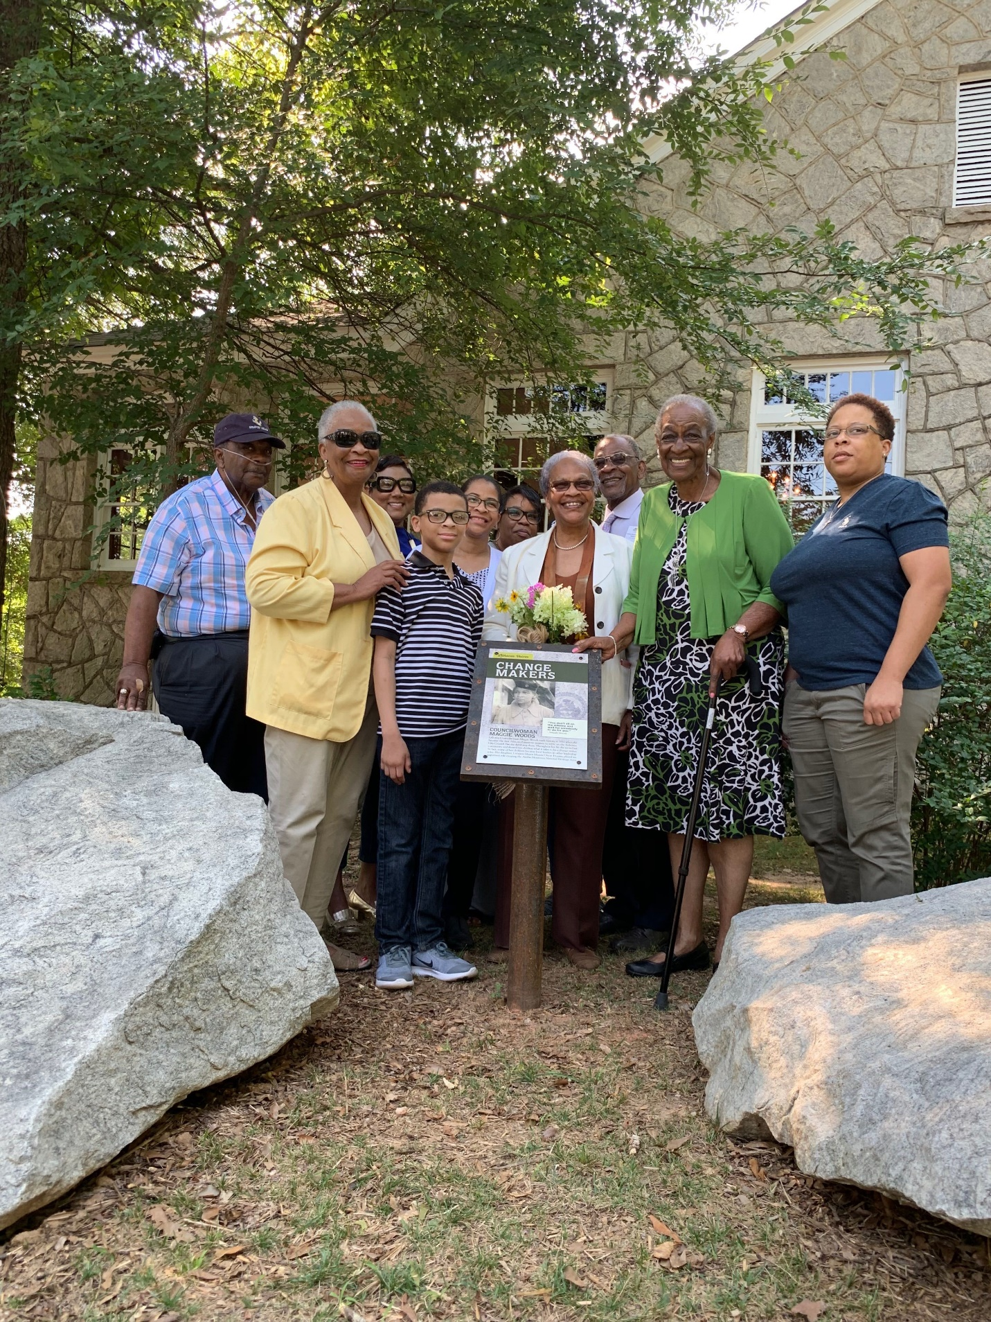
Multiple generations of the Woods family, along with DeKalb County District 7 Commissioner Lorraine Cochran-Johnson, stand next to the plaque commemorating Maggie Woods, Civil Rights activist and Lithonia’s first African-American woman to serve on City Council.
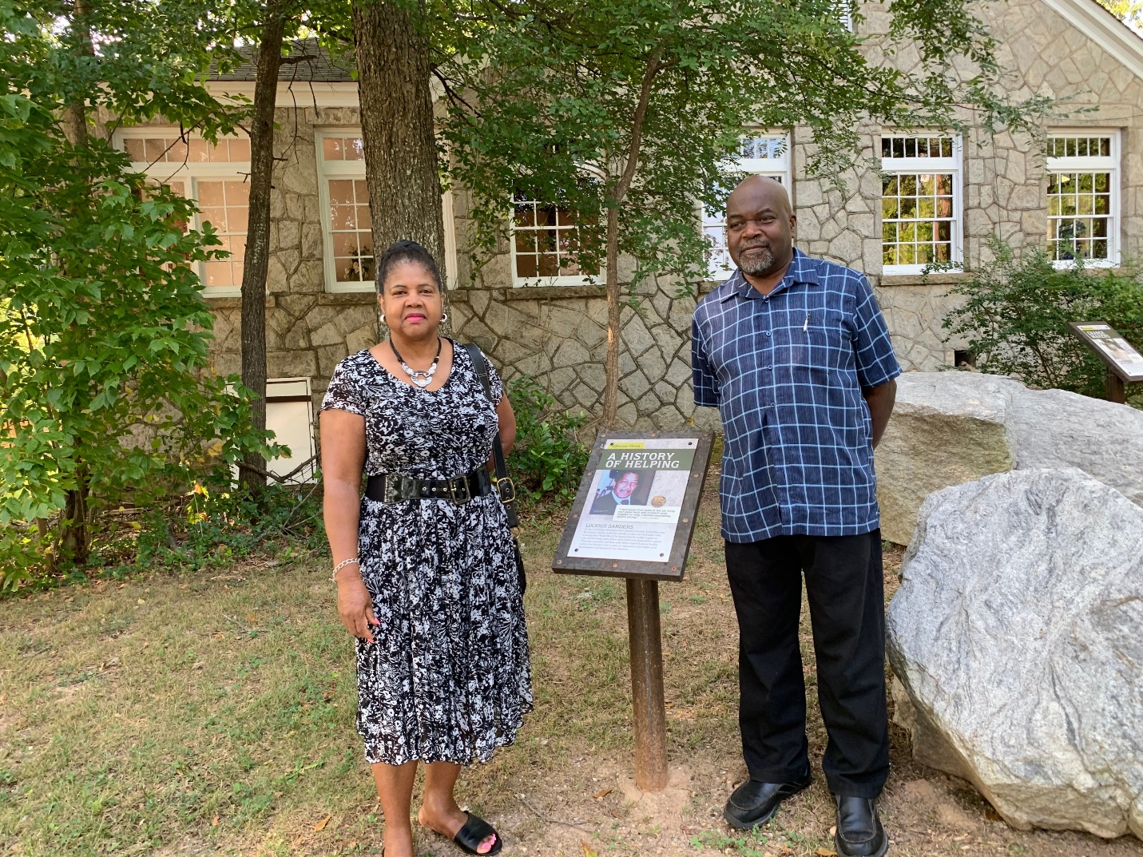
Lucious Sanders’ niece, Patrilla Arrington, and nephew, Richard Anderson, stand next to the plaque commemorating the late Civil Rights leader and community organizer.
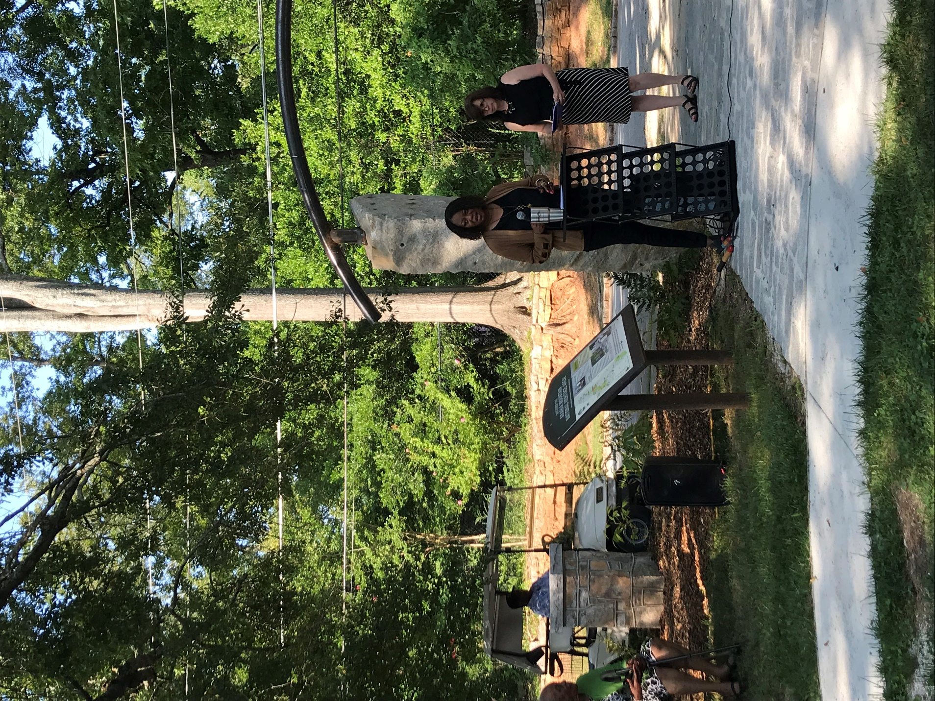
DeKalb County District 5 Commissioner Mereda Davis Johnson speaking at the Ruth Carroll Dally Johnson Interpretive Garden opening.
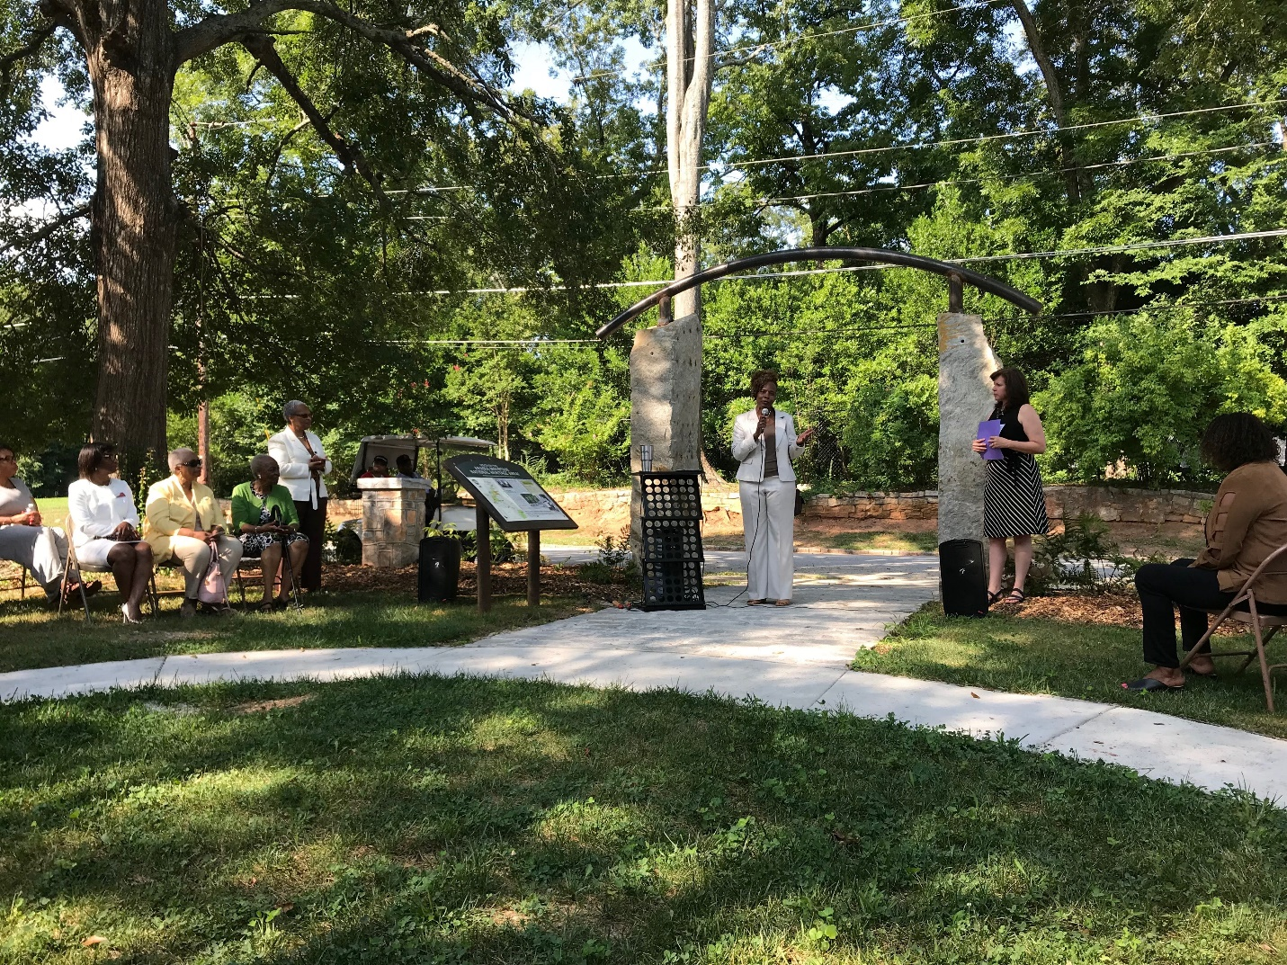
City of Lithonia Mayor Deborah Jackson speaking at the Ruth Carroll Dally Johnson Interpretive Garden opening.

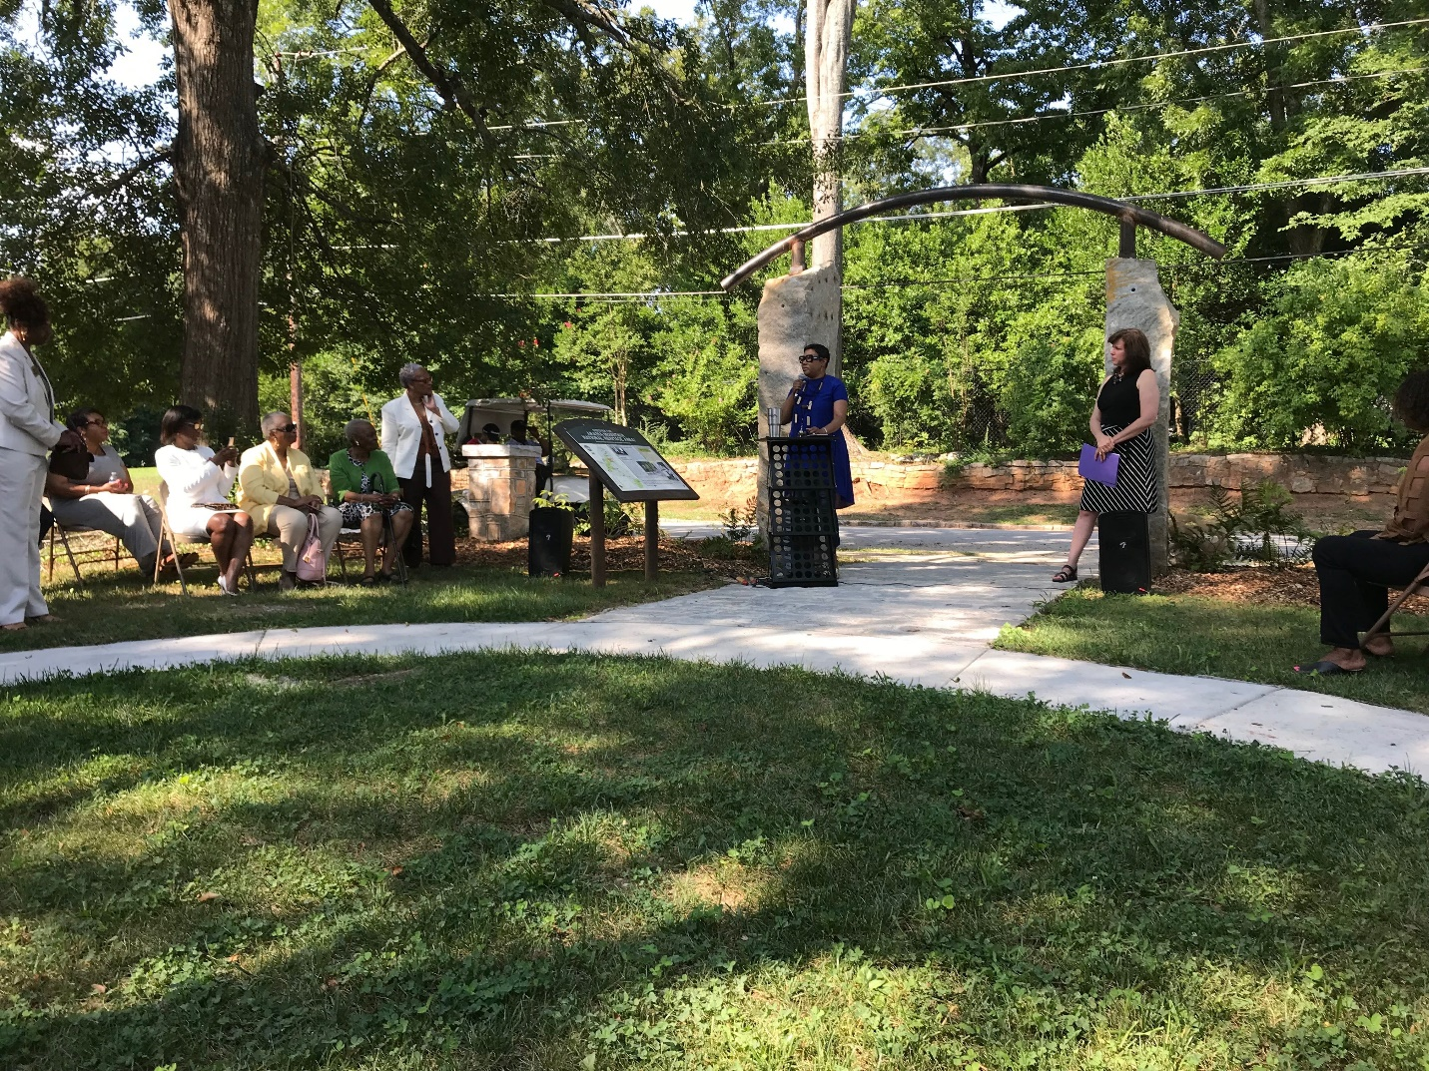
DeKalb County District 7 Commissioner Lorraine Cochran-Johnson speaking at the Ruth Carroll Dally Johnson Interpretive Garden opening.
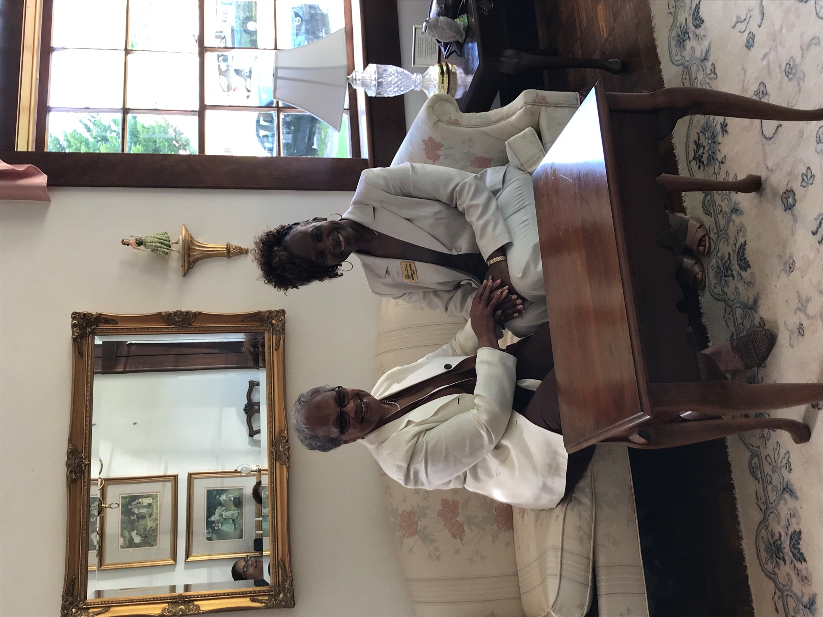
Current City of Lithonia Mayor Deborah Jackson sitting with former Mayor Marcia Glenn Hunter in the Lithonia Woman’s Club. Hunter was the first African-American woman to hold the office in Lithonia.

###
About the Arabia Alliance
The Arabia Mountain Heritage Area Alliance is dedicated to protecting, connecting and sharing the unique history, rich culture and engaging landscapes of the Arabia Mountain National Heritage Area (AMNHA) for the benefit and enjoyment of all. The staff and volunteer board of the Arabia Alliance work with partners across the AMNHA to ensure that everyone can benefit from the cultural and natural resources of the National Heritage Area. For more information, visit www.arabiaalliance.org.

