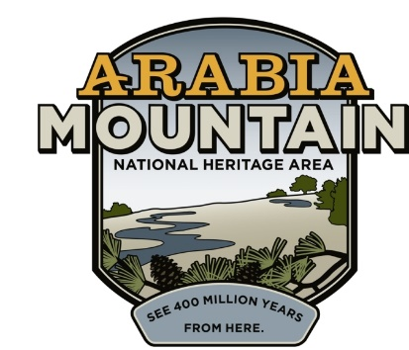
Media Contact: Zack Loehle, Communications Manager
Arabia Mountain Heritage Area Alliance
p: 404-998-8384 | e: zack@arabiaalliance.org

FOR IMMEDIATE RELEASE
June 4, 2019

Historic Lyon Farmhouse Stabilized
Partners Cheer Successful Effort at Restoration Celebration

STONECREST, Ga – After months of careful work, stabilization of the historic Lyon Farmhouse is complete. This building, considered to be the one of oldest in DeKalb County and a remnant of the area’s pre-Civil War history, underwent major preservation efforts to ensure that it will act as an educational and historic resource for generations to come. Partners on this project, which included the DeKalb County Board of Commissioners, the DeKalb County Department of Watershed Management and the Arabia Mountain Heritage Area Alliance, commemorated this milestone with a Restoration Celebration on Friday, May 31st.

The Lyon Family established their homestead in the shadow of Panola Mountain in the 1820s. For nearly 150 years, the family carved out a rural life where they cultivated crops and raised livestock. A log cabin was likely the first structure built on the property in the 1820s. The footprint was expanded multiple times over the years, creating the house that still stands today.

The Lyon Farm, over 100 acres, was purchased by the DeKalb County Department of Watershed Management (DWM) in 2003 as part of the Pole Bridge Advanced Wastewater Treatment Plant and Sprayfields. In 2016, the historic structures were placed on the Georgia Trust for Historic Preservation’s “Places in Peril” list due to excessive damage to the roof and other structural elements. In November of 2018, the Arabia Mountain Heritage Area Alliance (the nonprofit partner of the Arabia Mountain National Heritage Area), Flat Rock Archives, DeKalb County DWM and contractors F. H. Paschen kicked off work.

Since that time, the contractors have been busy ensuring the future of the farmhouse. This massive historic preservation project included jacking and leveling the entire structure, stabilizing the foundation, rebuilding part of one of the chimneys and replacing the roof and siding. “The ongoing preservation of the Lyon Farm is an exciting initiative within the Arabia Mountain National Heritage Area,” said Kelly Jordan, Board Member of the Arabia Alliance, adding that “future preservation efforts will explore the complicated, rich history of this compelling landscape and its people.”

DeKalb County and the Arabia Alliance joined partners at a celebratory event on May 31st at the Lyon House. The event included remarks by Congressman Hank Johnson (Georgia’s 4th District), DeKalb County Commissioner Mereda Davis Johnson, Stonecrest Mayor Jason Lary, Shawna Prescott of the DeKalb County DWM, Flat Rock Archives President and Co-Founder Johnny Waits, Arabia Alliance Executive Director Mera Cardenas and Board Member Kelly Jordan. Members of the Lyon family – some of whom grew up in the house – were also present to enjoy the restoration of this historic property. “Thank you so much for your family’s contribution to maintaining history,” Congressman Johnson said, referring to the Lyon family members. “Maintaining history is so important – both the good and the bad, because it all adds up for the good.” Following the remarks, guests enjoyed pie and tea by the muscadine vines and explored the interior of the newly stabilized house.

Members of the Lyon family are proud that the Farm has been preserved as part of history. “I am extremely impressed with all of the work that has been put into the Lyon Family Farm House restoration by DeKalb County & The Arabia Mountain National Heritage Area Alliance! I am thrilled that this house will be preserved for future generations to enjoy,” said Rebecca Bartels, a descendant of the Lyons. Another relative, Elaine Williams, agreed, saying, “I cannot thank everyone involved enough for preserving the Lyon Family Farm. What a wonderful part of history to be able to share with the world.”

Now that the farm is stabilized, it will become a historic centerpiece of the Arabia Mountain National Heritage Area and a place where people will learn about this area’s past. Johnny Waits, Executive Director and Co-Founder of the Flat Rock Archives, frequently leads tours around the site, discussing slavery and the start of the Flat Rock community. “This is the first leg of the tour – this is where we meet at, right here at the Lyon house,” said Waits, adding that visitors come “from all over the world” to learn about Flat Rock and discover the history of the Lyon property.

As well as guided tours, the farm site will feature interpretive signage detailing the stories of the Lyon family, the community of Flat Rock and rural life in Georgia. Sign installation is planned for this summer. Visitors enjoying the Arabia Mountain PATH, the paved trail crisscrossing the National Heritage Area, can see the farm site on a segment just north of Panola Mountain State Park. The homestead stands waiting for visitors to discover its history.

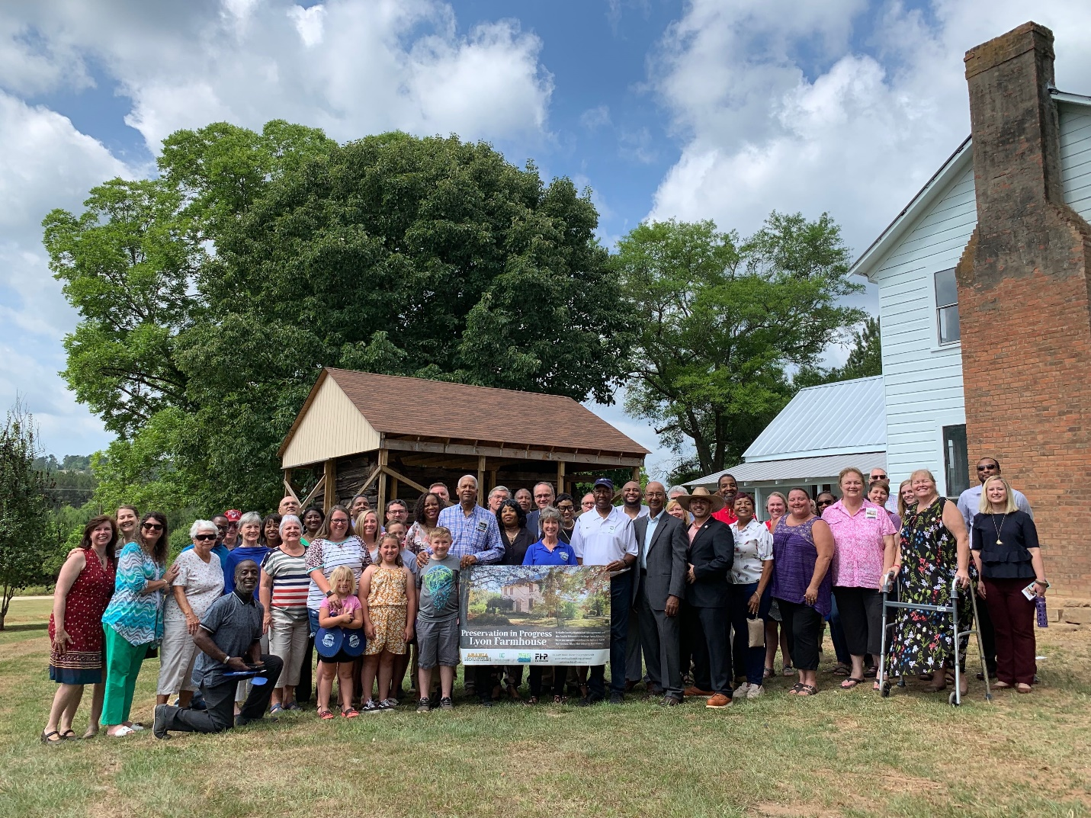
Lyon family members and National Heritage Area Partners (including Rep. Hank Johnson, center-left) celebrate the stabilization of the historic Lyon Farmhouse.

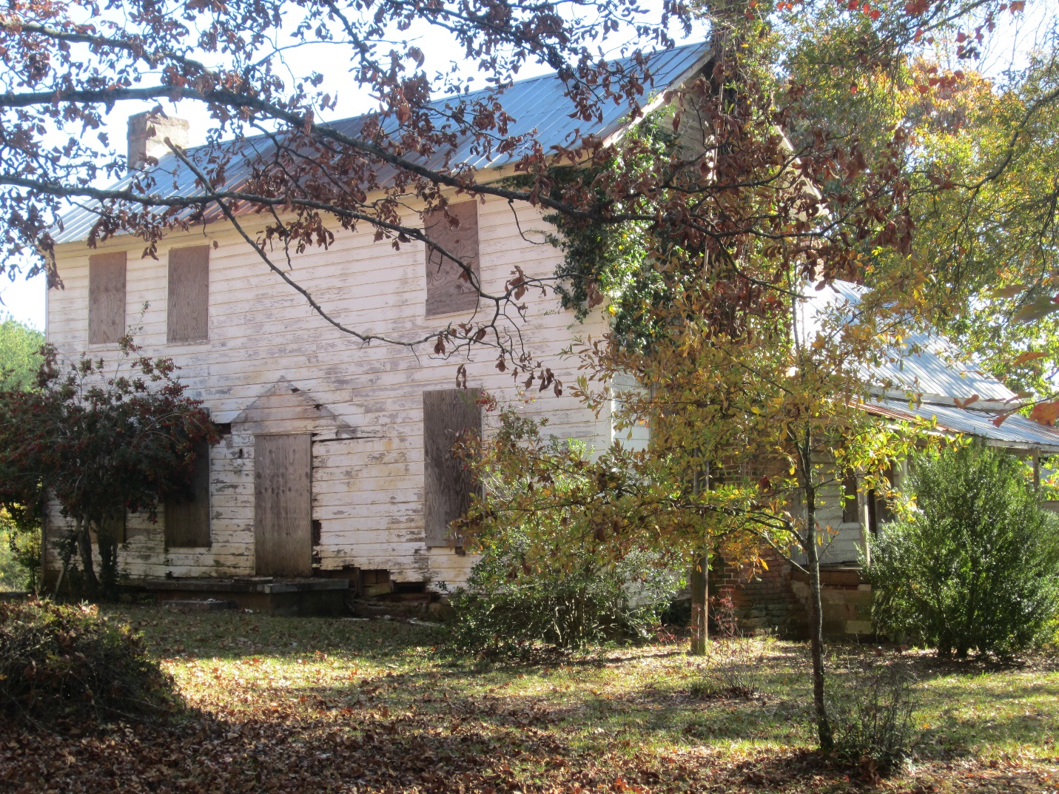
The Lyon Farmhouse prior to the 2018-2019 stabilization efforts. The structure was included in the Georgia Trust of Historic Preservation’s “Places in Peril” list in 2016.

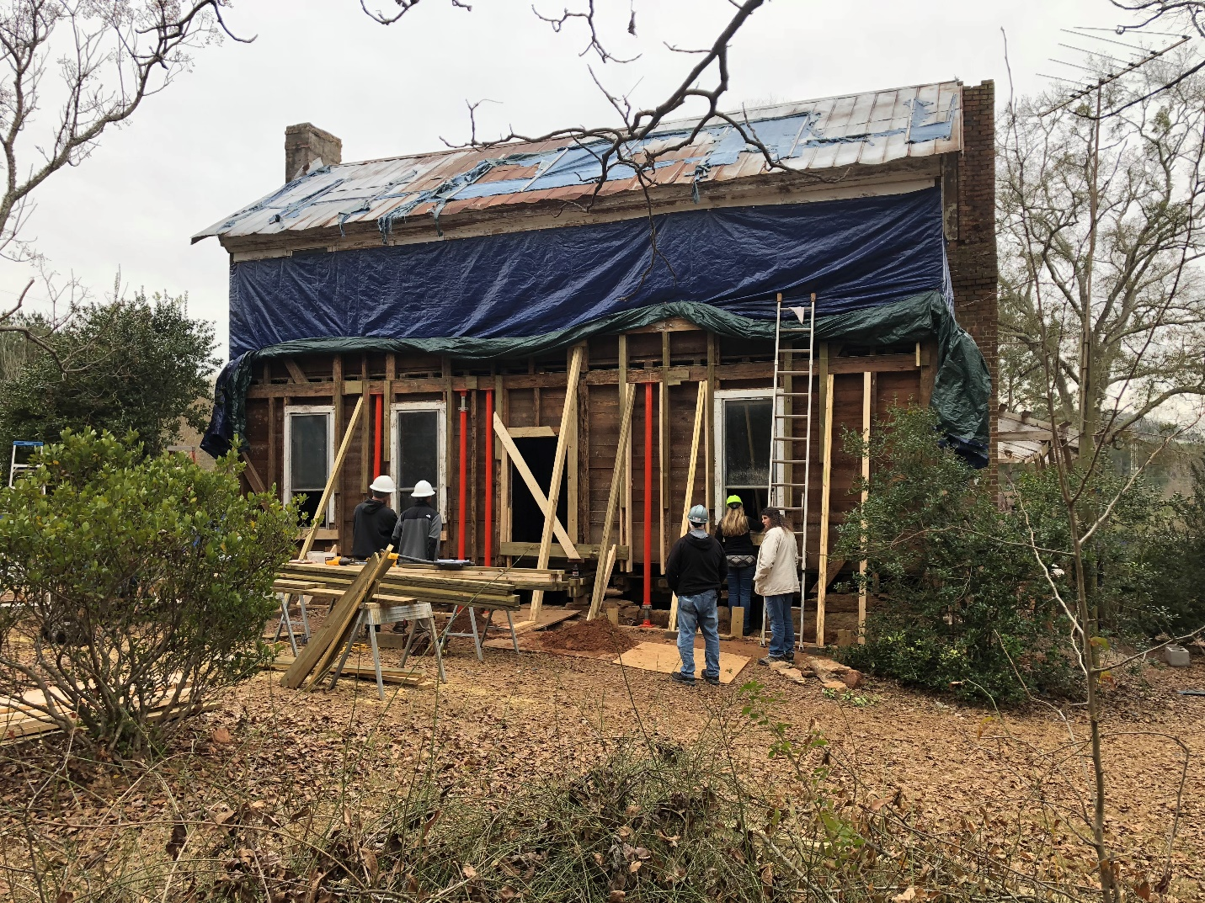
The Lyon Farmhouse, under construction in December 2018.

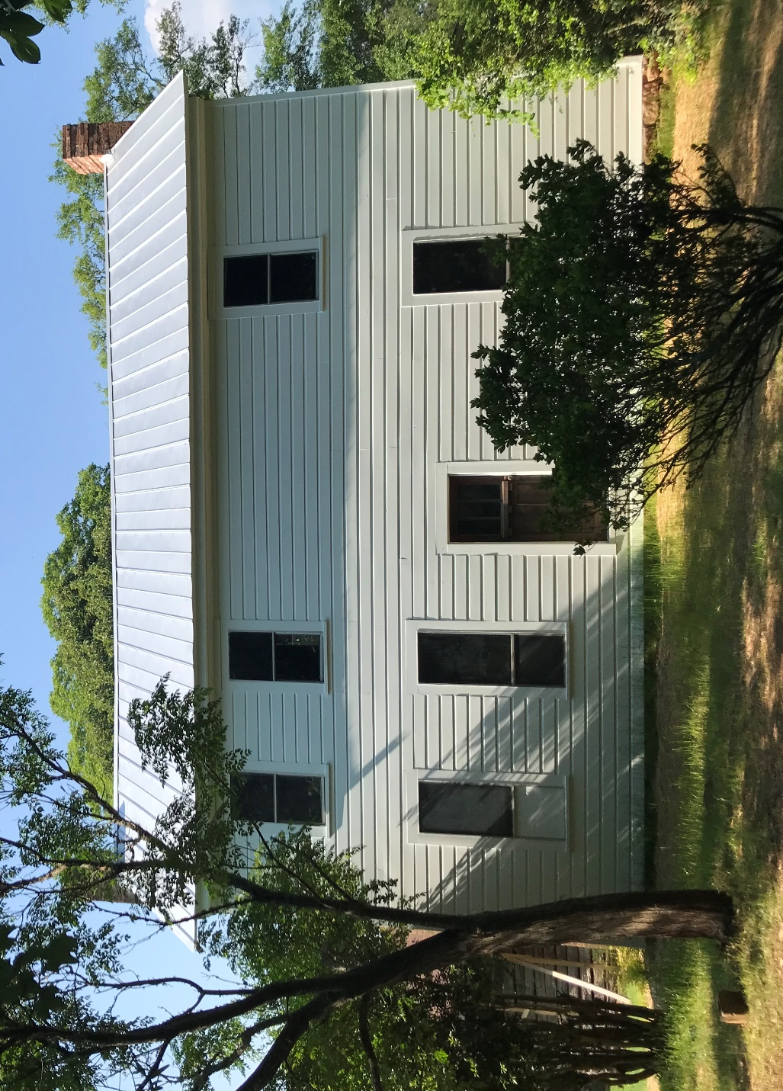
The front of the Lyon Farmhouse following successful stabilization. Educational signage will be added in the summer of 2019.

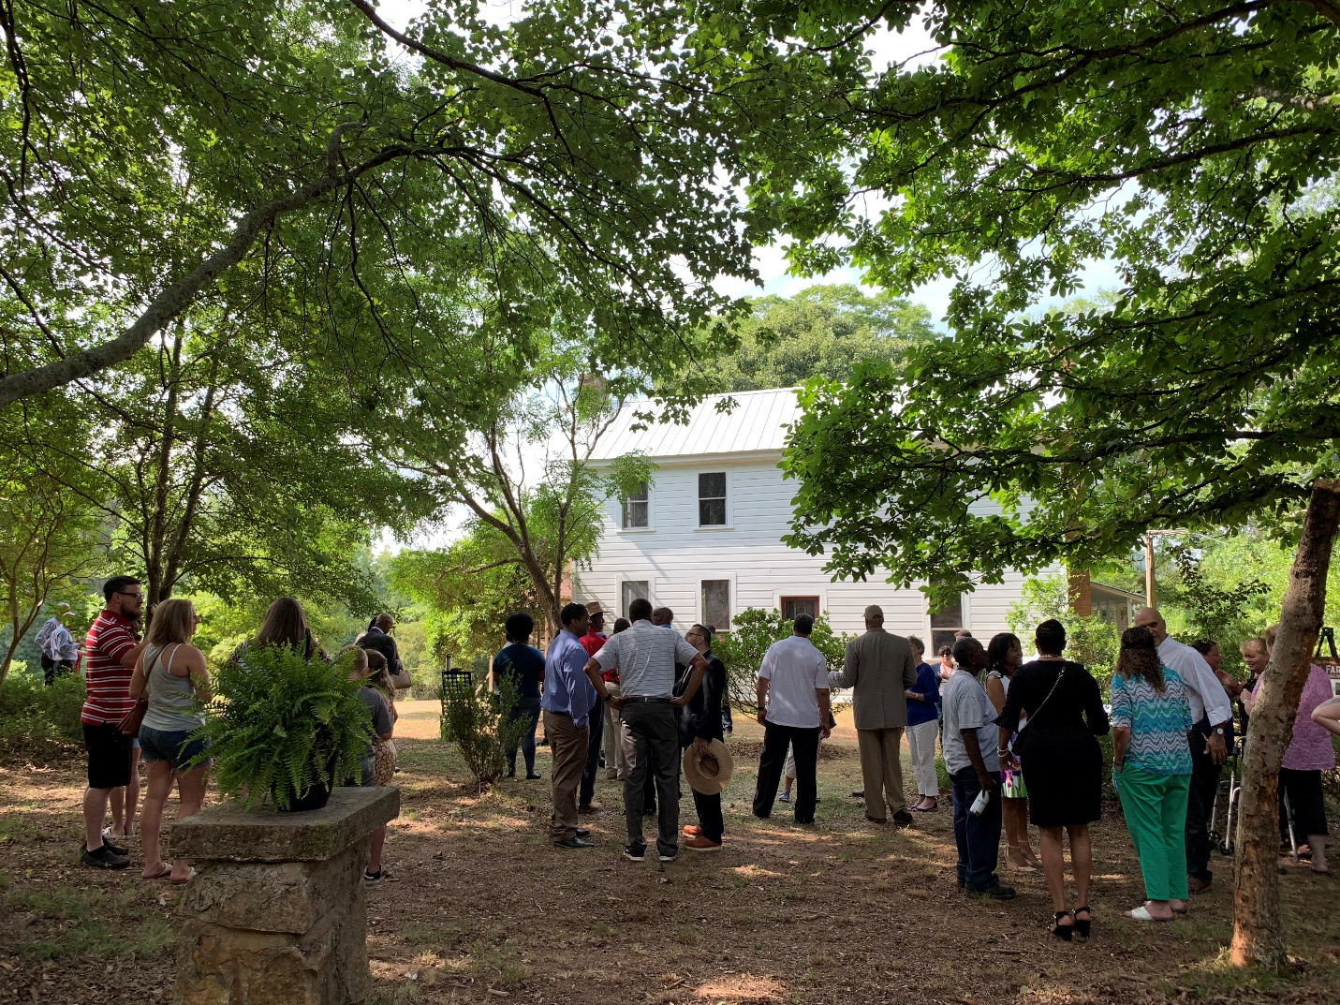
The Lyon Restoration Celebration on Friday, May 31st at the historic Lyon Homestead.

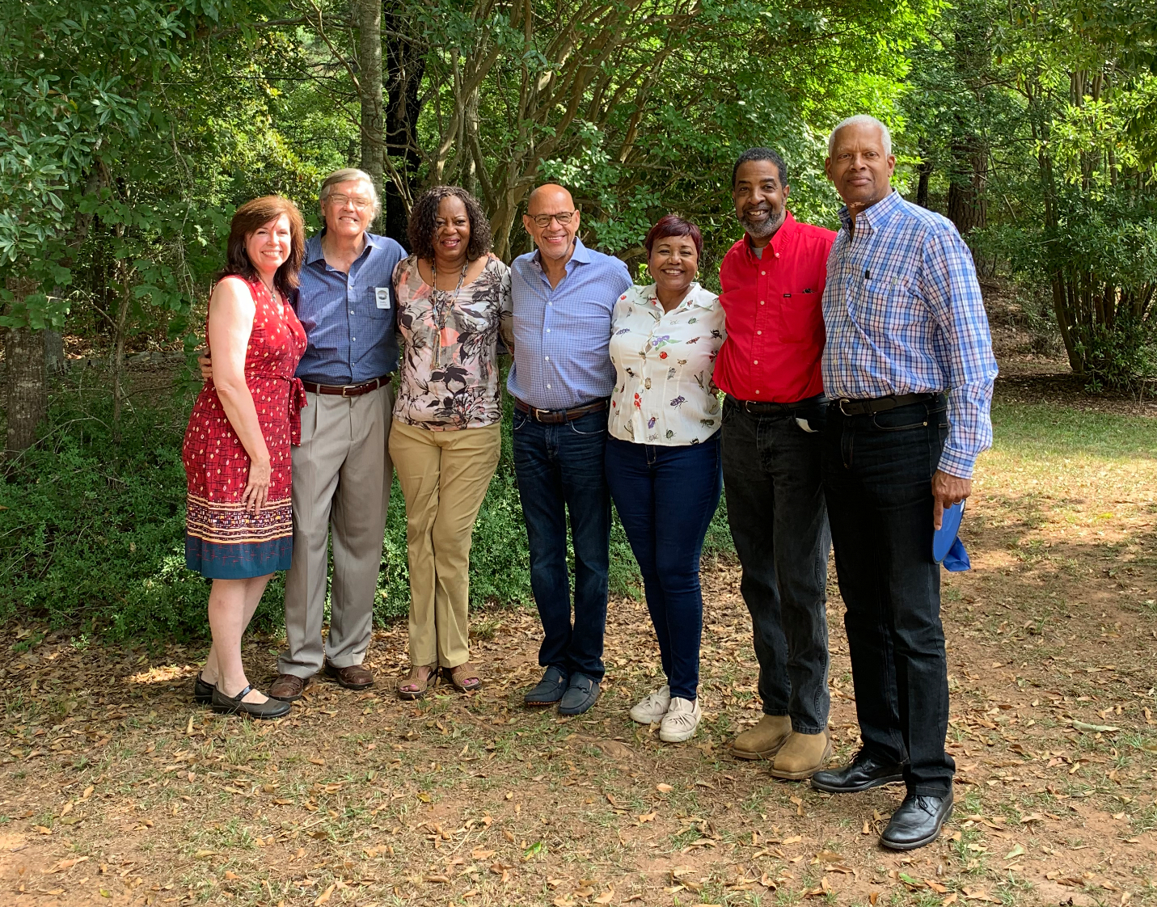
(Left to Right) Mera Cardenas, Executive Director of the Arabia Mountain Heritage Area Alliance; Kelly Jordan, Arabia Alliance Board Member; Mereda Davis Johnson, DeKalb County District 5 Commissioner; Jeff Dickerson; Deborah Summerville, local entrepeneur; Sheldon Fleming, City of Stonecrest Parks and Recreation staffmember; and Congressman Hank Johnson.
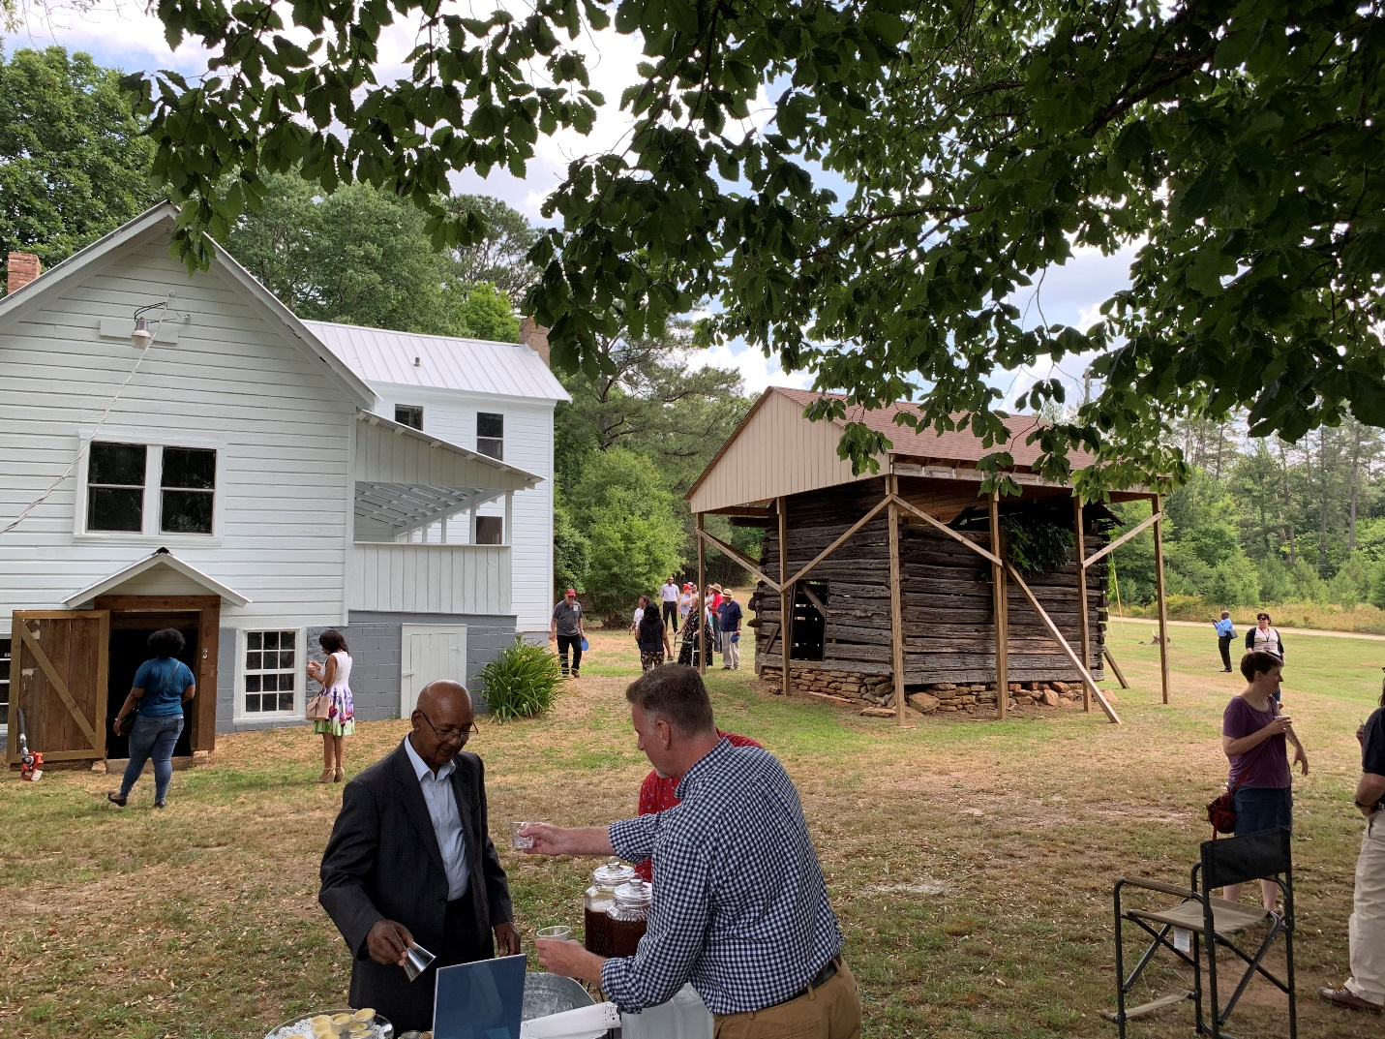
Guests explore the stabilized house while enjoying tea and a variation of Chess Pie, a dessert the original Lyon family themselves ate.

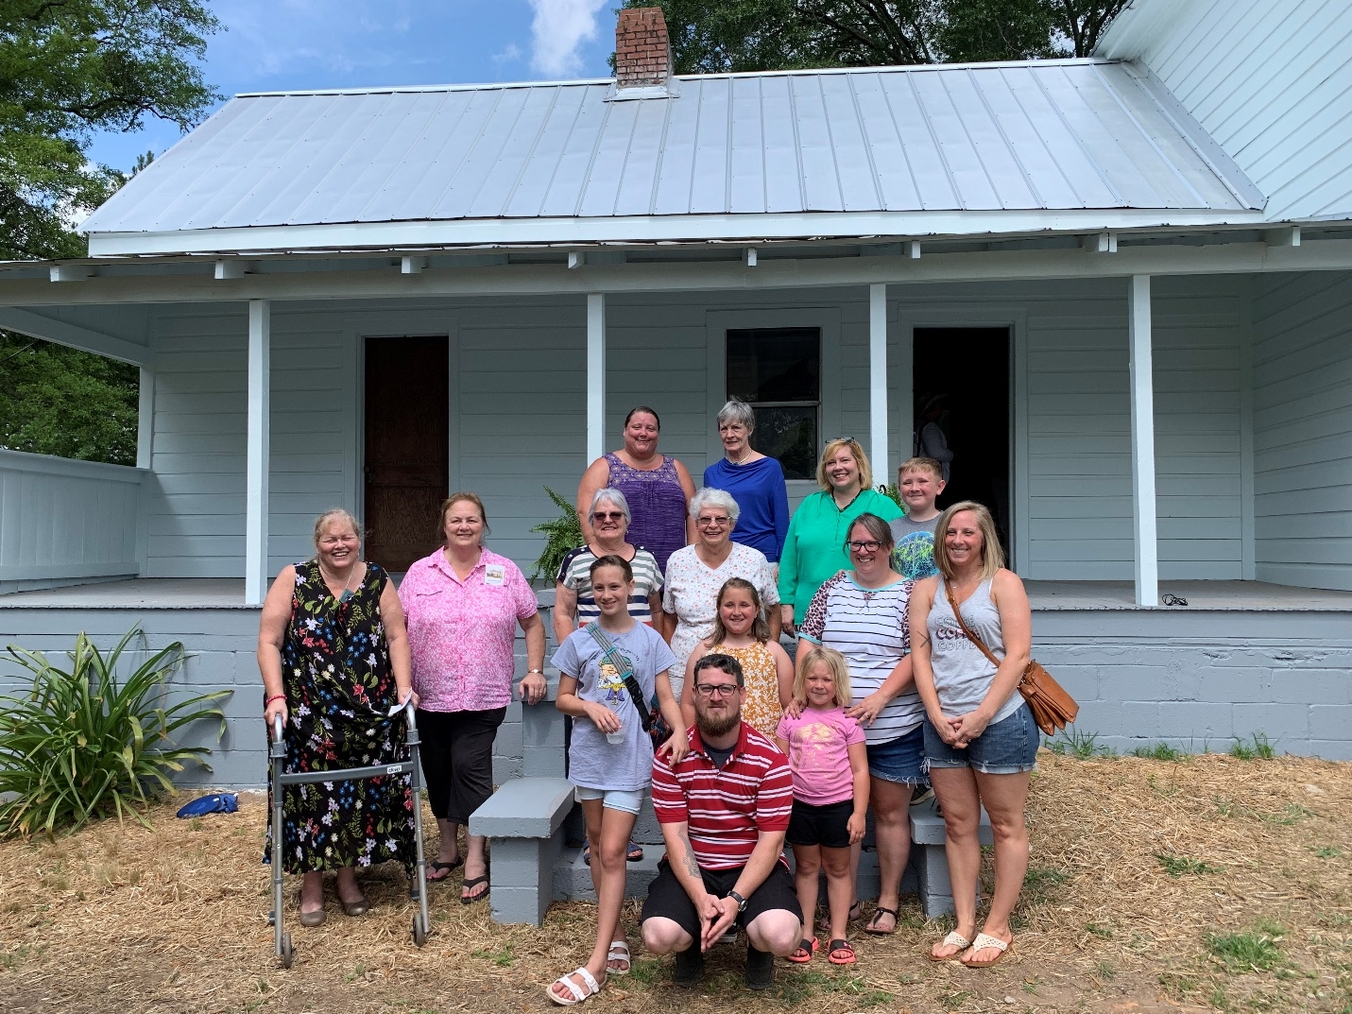
Members of the Lyon family – some of whom grew up in the house – in front of one of the Lyon Farmhouse porches. Lyon family members lived at the site for over 150 years. The historic site will now educate people about the rich and complicated history within the Arabia Mountain National Heritage Area.

###

About the Arabia Alliance
The Arabia Mountain Heritage Area Alliance is dedicated to protecting, connecting and sharing the unique history, rich culture and engaging landscapes of the Arabia Mountain National Heritage Area (AMNHA) for the benefit and enjoyment of all. The staff and volunteer board of the Arabia Alliance work with partners across the AMNHA to ensure that everyone can benefit from the cultural and natural resources of the National Heritage Area. For more information, visit www.arabiaalliance.org.

