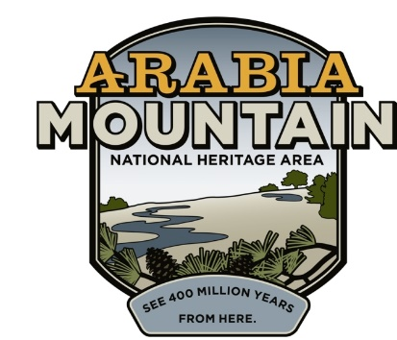
Media Contact: Zack Loehle, Communications Manager
Arabia Mountain Heritage Area Alliance
p: 404-998-8384 | e: zack@arabiaalliance.org

FOR IMMEDIATE RELEASE
June 4, 2019

Expert to Lead Tours Through DeKalb’s African-American History
Flat Rock Archives Co-Founder Johnny Waits at DeKalb History Center Every Wednesday in June

DECATUR, GA. – Every Wednesday during the month of June, the DeKalb History Center will host Johnny Waits, President and Co-Founder of the Flat Rock Archives, for guided tours of the exhibit Deep Roots in DeKalb: The Flat Rock Story of Resilience. One of the oldest African-American communities in Georgia, Flat Rock contains a rich history and a legacy of ingenuity in the face of oppression. Native to Flat Rock, Waits will provide an insider perspective into the community he grew up in and discuss the everyday life and challenges his family and neighbors have faced since the founding of the community in the 1830’s.

The Flat Rock Archives works to preserve and promote the historical significance of this African-American community. Following the Civil War, many black people left rural Georgia, escaping to the North, a movement called the Great Migration. T. A. Bryant, Sr., one of the founding members of Flat Rock, wanted to see his small community stay together. He and other local leaders were pivotal in ensuring the successful development of this black community; Bryant, Sr. even sold off small parcels of his land to community members so they would have a stake in the South. Though dogged by marginalization and animosity, the people of Flat Rock grew to flourish.

Today, the Flat Rock’s historic legacy makes it a key part of the Arabia Mountain National Heritage Area. Beyond the exhibit at the DeKalb History Center – located in the old DeKalb County Courthouse building, a place where African-Americans were once discouraged from entering – the Archives works to preserve historic resources in the original community. Partners at the Arabia Mountain Heritage Area Alliance (the nonprofit partner of the National Heritage Area), DeKalb County and the Georgia Trust for Historic Preservation have been engaged in long-term historic preservation efforts at Flat Rock, as well as creating educational signage so that any visitor can learn about this historic community. Most recently, these partners celebrated the stabilization of the historic Lyon Homestead, one of the oldest structures in DeKalb County and the starting point of the Flat Rock Archives’ Walk Through African-American History guided tour.

Join Johnny Waits at the DeKalb History Center this June for a fascinating introduction to a legacy of resilience, determination and ingenuity.

Tour details:
Every Wednesday in June, 1:00 – 2:00 pm.
Member tickets are $5 (includes DHC and Flat Rock Archives members); non-member tickets are $10.
Buy tickets here (scroll to “Flat Rock Exhibit Tours”) or at the DeKalb History Center.
Walk-ups allowed, but spots are limited.
Historic DeKalb Courthouse, 2nd floor
101 E. Court Square, Decatur GA 30030

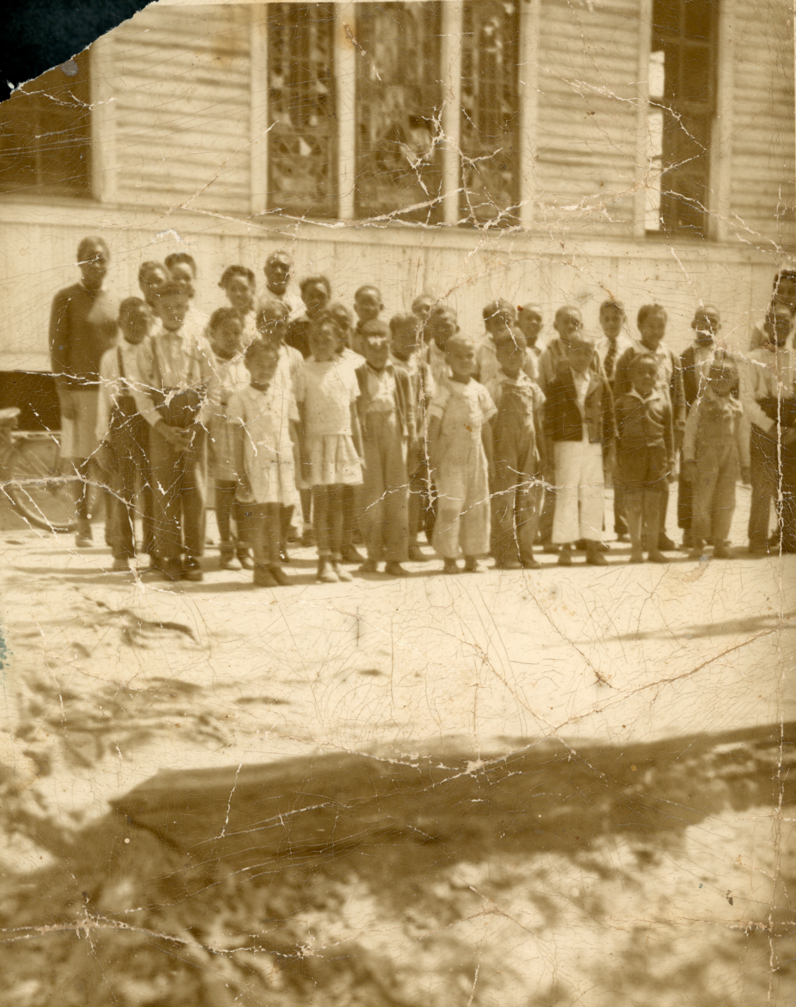
Flat Rock Elementary School Class Photo, circa 1947-48, courtesy of Flat Rock Archives.

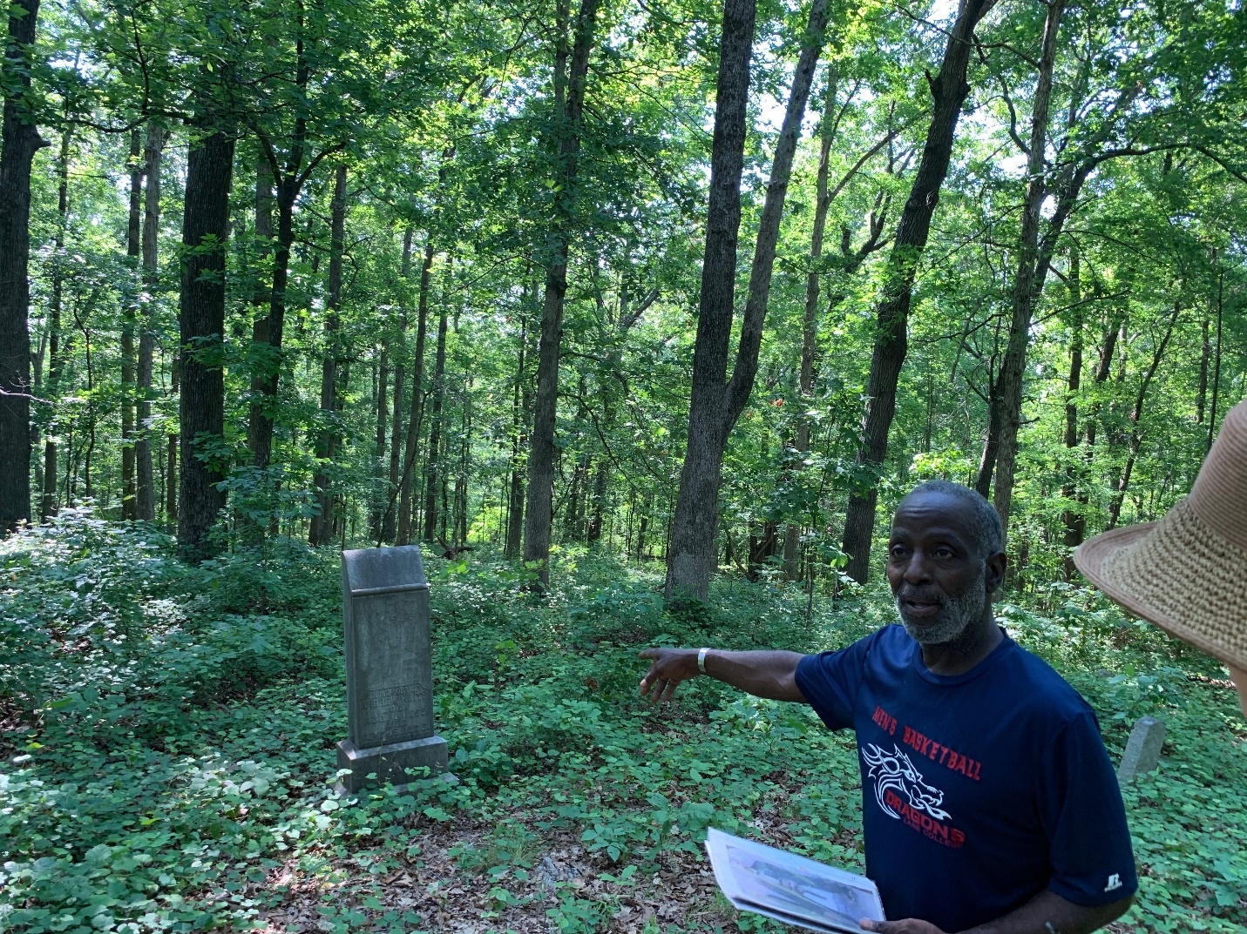
Flat Rock Archives President and Co-Founder Johnny Waits leads a tour of the historic Flat Rock Slave Cemetery. Waits guide visitors through the DeKalb History Center exhibit about Flat Rock every Wednesday in June.

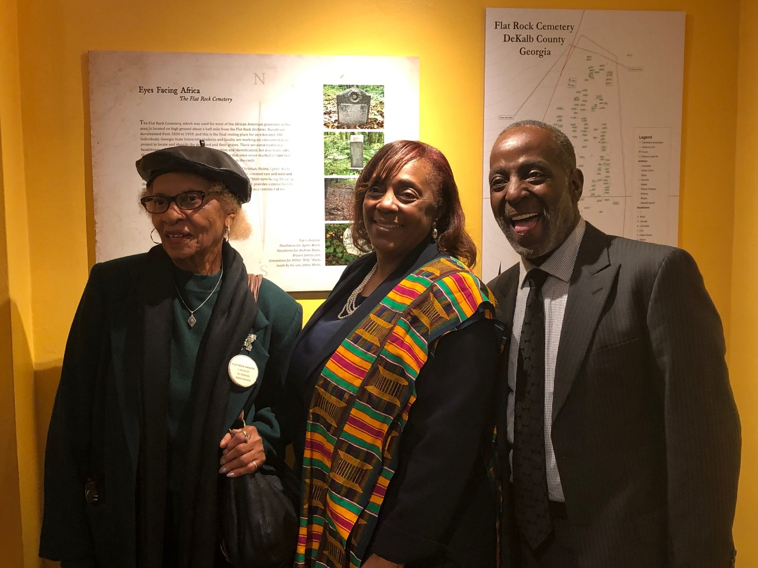
Flat Rock Archives Co-Founders Johnny Waits and Vera Whitaker with Apostle Joyce Waites (center) at the opening of the Deep Roots in DeKalb exhibit in February 2019. All three are members of the historic Flat Rock community.

###

About the Arabia Alliance
The Arabia Mountain Heritage Area Alliance is dedicated to protecting, connecting and sharing the unique history, rich culture and engaging landscapes of the Arabia Mountain National Heritage Area (AMNHA) for the benefit and enjoyment of all. The staff and volunteer board of the Arabia Alliance work with partners across the AMNHA to ensure that everyone can benefit from the cultural and natural resources of the National Heritage Area. For more information, visit www.arabiaalliance.org.

