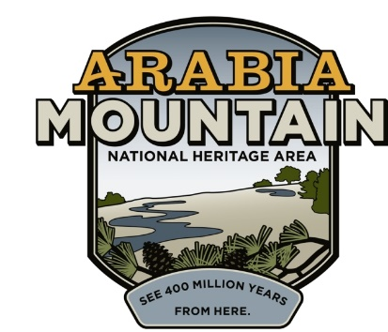
Media Contact: Zack Loehle, Communications Manager
Arabia Mountain Heritage Area Alliance
p: 404-998-8384 | e: zack@arabiaalliance.org

FOR IMMEDIATE RELEASE
June 25, 2019

New Smith Stewardship Interns Program Honors Legacy of Longtime Arabia Mountain Volunteers
Arabia Alliance & Davidson-Arabia Mountain Nature Preserve Partner to Support Conservation, Education in National Heritage Area

STONECREST, GA. – Honoring the impactful work of long-time volunteers Tom and Killian Smith, the Arabia Mountain Heritage Area Alliance will support a two-week park management and conservation internship at Davidson-Arabia Mountain Nature Preserve. For almost 20 years, the Smiths have donated their time, energy and knowledge to make the Nature Preserve a more welcoming place for everybody. Due in no small part to their efforts, Arabia Mountain has become a beloved jewel of the DeKalb County park system. The Tom and Killian Smith Stewardship Interns Program will continue their work of caring for this precious greenspace.

Tom and Killian began volunteering at the Davidson-Arabia Mountain Nature Preserve in the early 2000’s. The greenspace was far less cared for then than it is now: one of Tom’s first initiatives was removing and covering up graffiti on Arabia Mountain’s granite outcrops. Due to his months careful work, signs of graffiti are long gone. Tom also marked the park boundaries, built trails (along with another long-time volunteer and former Ranger, Tyrone Burkette), made and posted wayfinding signs, managed for erosion, made sure the trails stayed clear and built stairs and bridges. Killian has been one of the main forces behind the popular geocaching program within the Arabia Mountain National Heritage Area, has installed Little Free Libraries for book lovers of all ages, helped out with numerous administrative and outreach needs at the Visitors’ Center and created a detailed archive of any and all news clippings about Arabia Mountain. Both she and Tom have spent days staffing the Nature Center, providing countless park visitors with help and advice. They have also been active in the park’s education efforts, leading tours (including Tom’s annual Ruins Tour) of the historic and natural resources located throughout the greenspace. “Tom and Killian’s contribution is unmatched. This park would not be what it is today without them,” said Robby Astrove, Davidson-Arabia Mountain Nature Preserve Ranger.

In recognition of their work and dedication to the Nature Preserve, the Arabia Mountain Heritage Area Alliance (the nonprofit partner of the National Heritage Area) is partnering with DeKalb County Parks & Recreation to create the Tom and Killian Smith Stewardship Interns Program. Taking place over two weeks every winter (during the time period of most universities’ winter breaks), the paid internship will provide undergraduate and graduate students with experience in a variety of park stewardship responsibilities. This experience will help inspire and set interns on the path to careers in parks, land management, conservation and education. Applicants will be able to work on projects such as expanding the Nature Preserve pollinator garden, building trails and managing the geocaching program. The Davidson-Arabia Mountain Nature Preserve and the Arabia Alliance will begin the internship selection process in the fall.

“Part of being a National Heritage Area is supporting and educating those who will ensure the future of these parks and historic sites,” said Mera Cardenas, Executive Director of the Arabia Alliance. “Through this program, we’re helping open the door to the next generation of park stewards.” Tom and Killian Smith’s dedication to the Nature Preserve has created a lasting legacy. This internship will continue their work to preserve and care for Arabia Mountain and the surrounding greenspace.

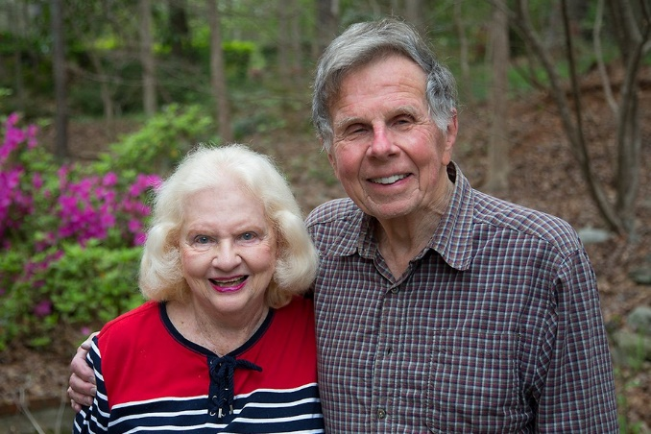
Tom and Killian Smith have donated countless hours to make the Davidson-Arabia Mountain Nature Preserve the welcoming, accessible place it is today.

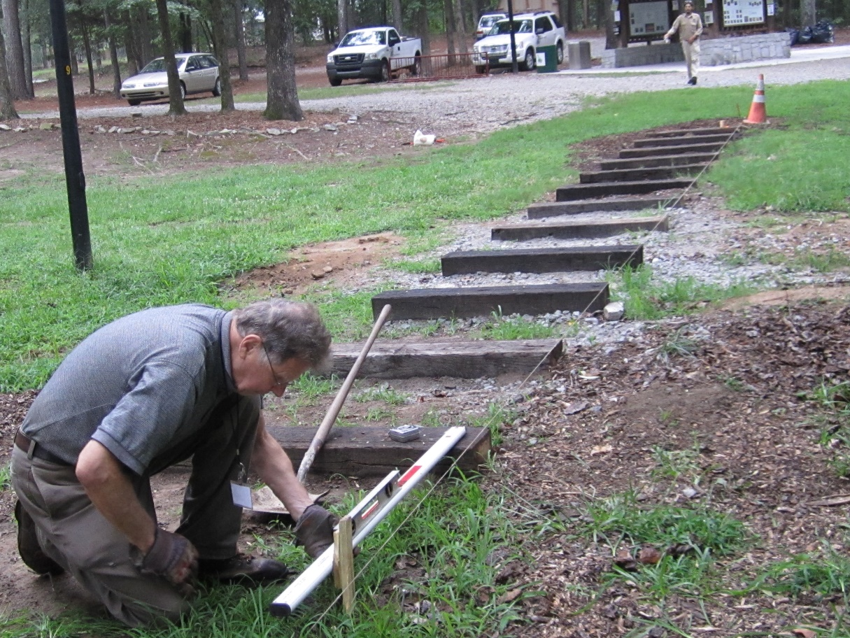
Tom Smith building a boardwalk near the Davidson-Arabia Mountain Nature Preserve for hikers. The selected Stewardship Interns will work to improve trail infrastructure around the Nature Preserve, among other duties.

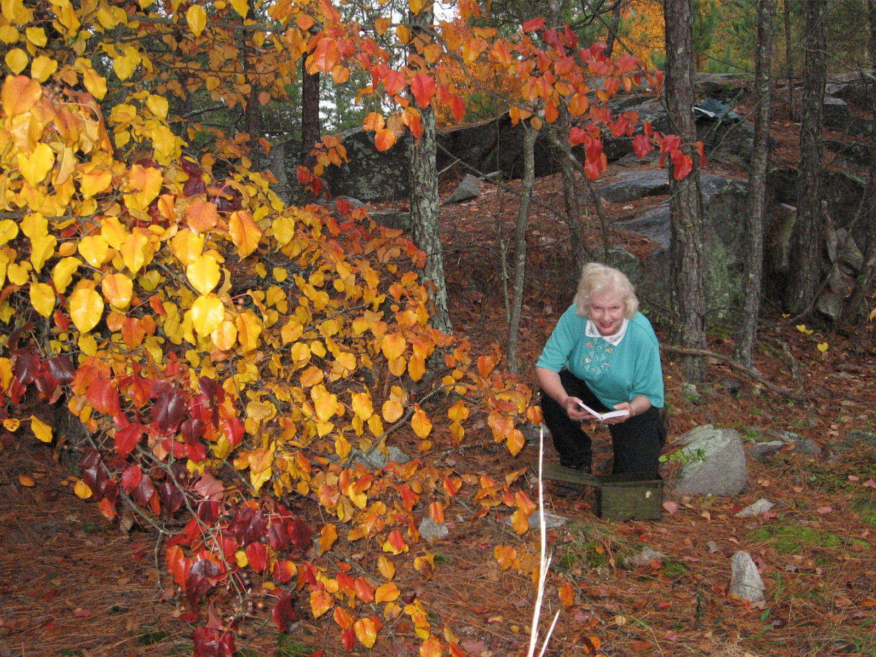
Killian Smith with a geocaching box at the Davidson-Arabia Mountain Nature Preserve. The selected Stewardship Interns will work to improve and maintain the geocaching program, among other duties.

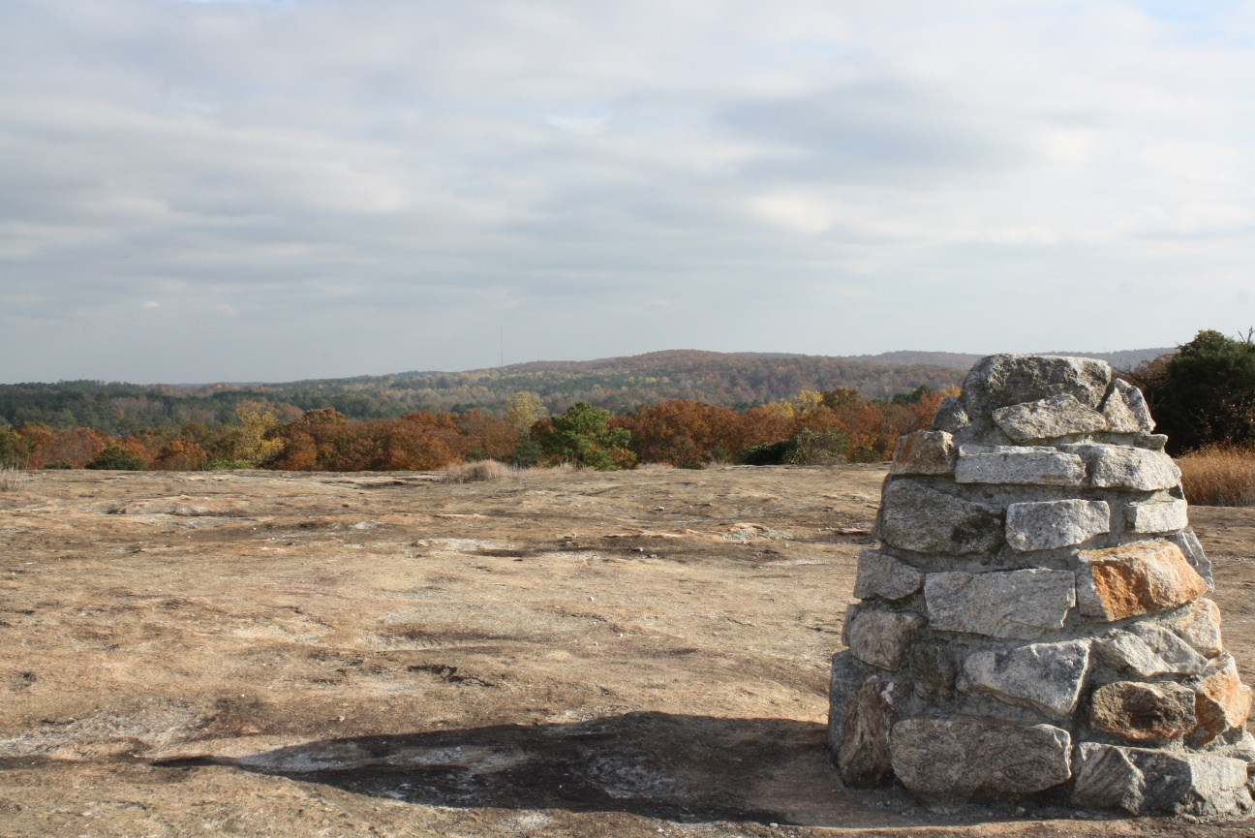
A cairn marking the trail on Arabia Mountain. Tom Smith played a major role in marking and establishing trails across the Nature Preserve.

###

About the Arabia Alliance
The Arabia Mountain Heritage Area Alliance is dedicated to protecting, connecting and sharing the unique history, rich culture and engaging landscapes of the Arabia Mountain National Heritage Area (AMNHA) for the benefit and enjoyment of all. The staff and volunteer board of the Arabia Alliance work with partners across the AMNHA to ensure that everyone can benefit from the cultural and natural resources of the National Heritage Area. For more information, visit www.arabiaalliance.org.

