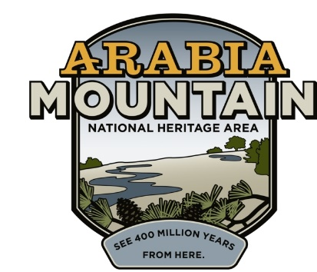
Media Contact: Zack Loehle, Communications Manager
Arabia Mountain Heritage Area Alliance
p: 404-998-8384 | e: zack@arabiaalliance.org

FOR IMMEDIATE RELEASE
May 14, 2019

Roving Rangers Explore Parks Across Atlanta
New Parks Partnership Promotes Outdoor Discovery, Learning

ATLANTA – Parks across Atlanta are working together to provide more fun for kids and families. The new Roving Junior Ranger Program is a self-guided, interactive tour of the Arabia Mountain National Heritage Area; Chattahoochee River National Recreation Area; Kennesaw Mountain National Battlefield Park; Martin Luther King, Jr. National Historical Park; Panola Mountain State Park; Sweetwater Creek State Park; and Stone Mountain Park. Kids can pick up a Roving Ranger Passport at any one of these participating parks. Earn the “Roving Ranger” Emblem of Honor when you finish!

The Roving Ranger Passport program will kick off on National Kids to Parks Day (May 18th). This day celebrates the importance of our parks and getting outdoors for kids of all ages. Begin your Roving Ranger adventure with Kids to Parks Day events at one or more of the participating parks. That includes Junior Ranger explorations at the Chattahoochee River National Recreation Area, Kennesaw Mountain National Battlefield Park and Martin Luther King, Jr. National Historical Park, as well as Kids to Parks Day festivities at the Davidson-Arabia Mountain Nature Preserve (part of the Arabia Mountain National Heritage Area).

The Roving Ranger Passport is an extension of various park Junior Ranger Programs, which use self-guided activities to introduce kids to the wonders of our parks. As they complete activities around each park, kids discover the history and nature of each site, gaining hands-on experience with the outdoors and a lifelong love of parks and public lands in the process. After finishing each Junior Ranger program, kids earn a badge and take a pledge to become official “Junior Rangers.”

Now, with the Roving Ranger Program, kids can take their love for parks to the next level by exploring seven parks scattered throughout the metro-Atlanta area. After completing the Junior Ranger program at each park, kids will earn a badge and a sticker for their Roving Ranger Passport. Earn all seven Roving Ranger passport stickers – one at each park – to receive the “Roving Ranger” Emblem of Honor. The Roving Ranger program will run throughout the summer of 2019.

“The Roving Ranger Passport reveals the connections between the parks across Atlanta,” said Mera Cardenas, Executive Director of the Arabia Mountain Heritage Area Alliance. “We have a rich natural and human history that kids will discover as they complete this engaging new program.” Parks across the metro area frequently collaborate on programs and events, but this is the first time that parks have connected their Junior Ranger programs together in this way. “Launch your Roving Ranger adventure to discover the amazing parks and stories in your backyard! These parks are only a step away,” said Christiana Admiral, Chief of Interpretation, Education and Community Partnerships for the National Park Service Southeast Region. Together, the participating parks are excited to provide this opportunity for kids to explore the complex tapestry of Atlanta’s natural and human history, becoming knowledgeable park stewards in the process. Kids can begin their Roving Ranger adventure this summer.

For more information about participating parks, please visit:
The Arabia Mountain National Heritage Area
Chattahoochee River National Recreation Area
Kennesaw Mountain National Battlefield Park
Martin Luther King, Jr. National Historical Park
Panola Mountain State Park
Stone Mountain Park
Sweetwater Creek State Park

Use #rovingrangerATL to tag your social media posts! Help us tell this story of discovery.

For more information about the Roving Ranger program, or to download a passport, please visit: http://arabiaalliance.org/roving-junior-ranger/.

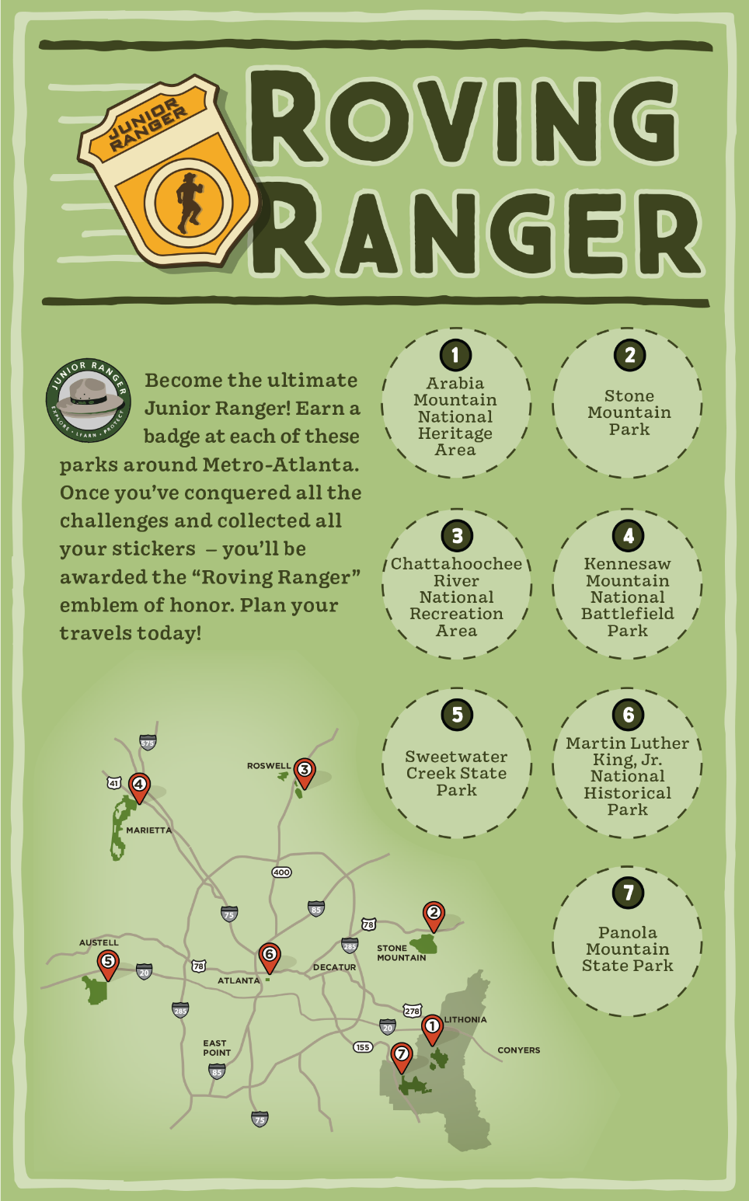
The Roving Ranger Passport. Passports can be downloaded online or picked up at any of the seven participating park units. Complete all seven Junior Ranger programs to earn a special prize.

###

About the Arabia Alliance
The Arabia Mountain Heritage Area Alliance is dedicated to protecting, connecting and sharing the unique history, rich culture and engaging landscapes of the Arabia Mountain National Heritage Area (AMNHA) for the benefit and enjoyment of all. The staff and volunteer board of the Arabia Alliance work with partners across the AMNHA to ensure that everyone can benefit from the cultural and natural resources of the National Heritage Area. For more information, visit www.arabiaalliance.org.

