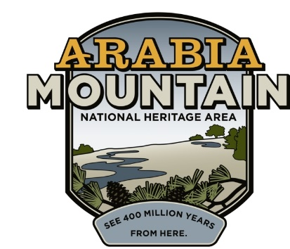
Media Contact: Zack Loehle, Communications Manager
Arabia Mountain Heritage Area Alliance
p: 404-998-8384 | e: zack@arabiaalliance.org

FOR IMMEDIATE RELEASE
Mar. 21, 2019

A Day of Discovery with Junior Ranger Ramble
Arabia Mountain National Heritage Area Joins Celebrations of National Junior Ranger Day

STONECREST, Ga. – The Arabia Mountain National Heritage Area (AMNHA) invites families to enjoy the 2019 Junior Ranger Ramble at the Davidson-Arabia Mountain Nature Preserve. Join us on April 20th, 2019 for hands-on activities and an exciting day outdoors.

In celebration of National Junior Ranger Day, the 2019 Junior Ranger Ramble introduces kids to the area’s wonderful parks and historic sites. The event is organized by the Arabia Mountain Heritage Area Alliance, the nonprofit coordinator of the AMNHA, and brings together partners from throughout the 40,000-acre National Heritage Area. This year’s partners include the Atlanta Wild Animal Rescue Effort, Monarchs Across Georgia, the Monastery of the Holy Spirit and the Flat Rock Archives, as well as the Davidson-Arabia Mountain Nature Preserve. Fun and educational, the Junior Ranger Ramble celebrates the many ways to get outside and explore this National Heritage Area located right outside of Atlanta.

Activities will be spread out in the woods and rock outcrops near the Davidson-Arabia Mountain Nature Center, with rangers leading groups from one station to the next. As well as enjoying the striking landscape of the nature preserve, kids will have the opportunity to learn about Georgia’s native wildlife, get their hands dirty with gardening and participate in a variety of other exciting events. Upon completion of the various Junior Ranger Ramble activities, kids will take an oath and earn their Junior Ranger badge. The day culminates with a hike to the top of Arabia Mountain and a swearing-in ceremony for the new rangers.

“I love the Junior Ranger program because it lets kids experience this incredible resource right in their backyards,” said Sarah Lisle, Director of Interpretation for the Arabia Mountain Heritage Area Alliance. “From iconic historic sites to the peace of the Monastery to the rich beauty of this area’s greenspace, there is so much to explore.” Beginning north of Lithonia and extending south of Conyers, the AMNHA encompasses over 400 million years of natural and human history. Including historic sites, resilient communities and beautiful natural areas, this National Heritage Area provides a gateway to the Georgia Piedmont region across time. Kids and parents can join the Junior Ranger Ramble for an introduction to this rich and fascinating landscape.

The event lasts from 10am to 1pm on Saturday, April 20th. Tickets are $5 for kids (free for adults) and can be purchased here. For group ticket rates, contact Sarah Lisle at (404) 998-8384 ext. 6.

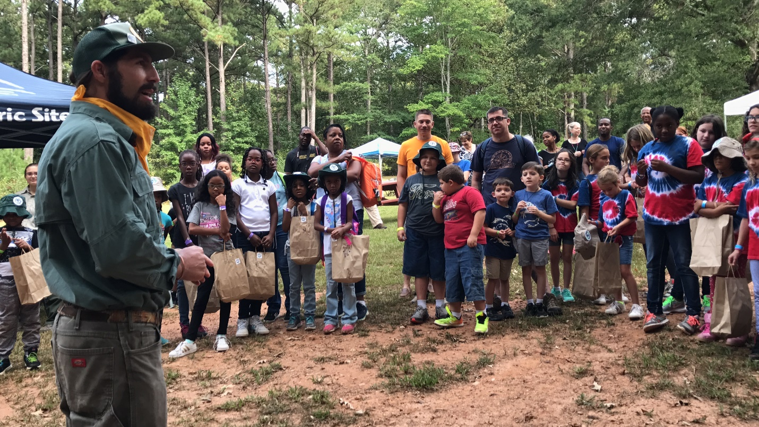
Ranger Robby Astrove and other Davidson-Arabia Mountain Nature Preserve Staff will guide children through the event.

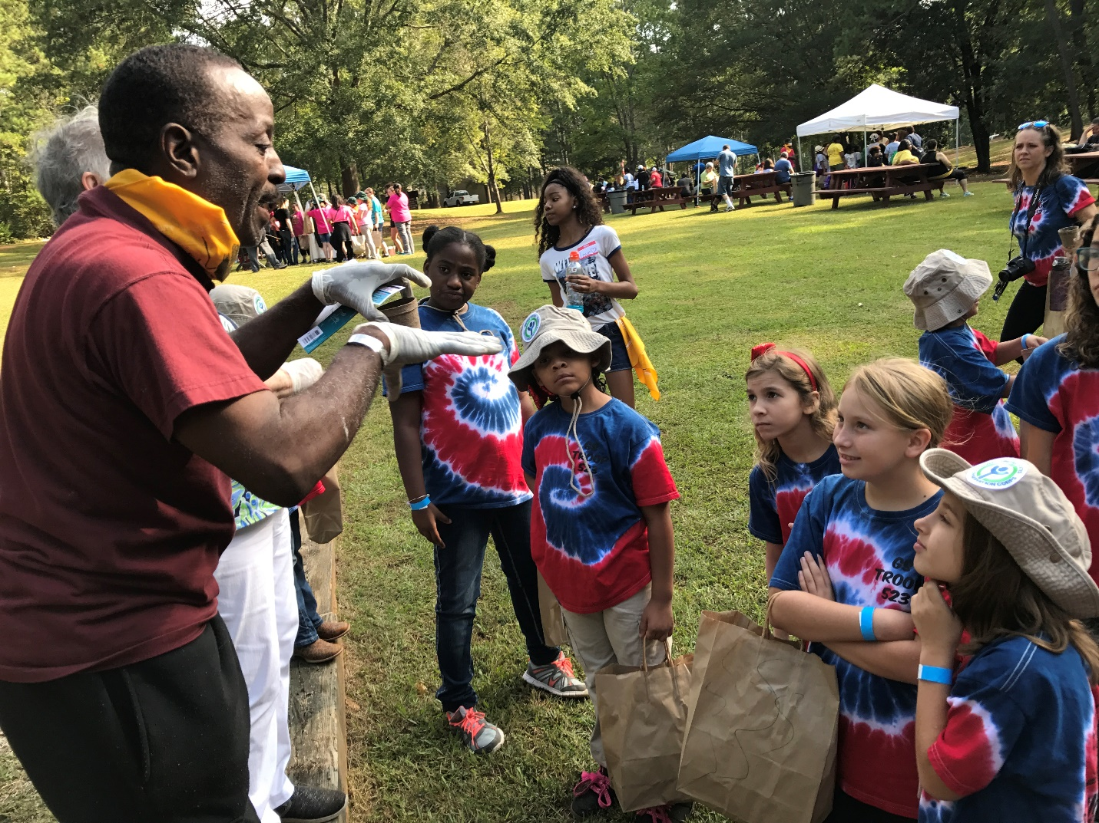
Flat Rock Archives President and Co-Founder Johnny Waits introduces kids to gardening at Junior Ranger Day.

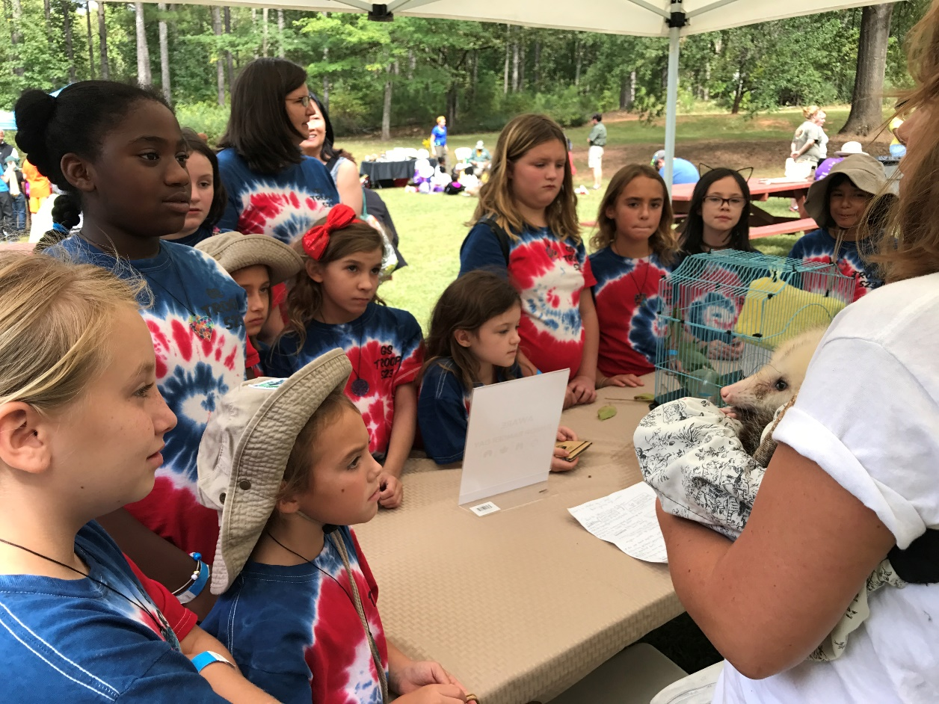
Kids will have the opportunity to learn about Georgia’s native wildlife with volunteers from the Atlanta Wild Animal Rescue Effort (AWARE).

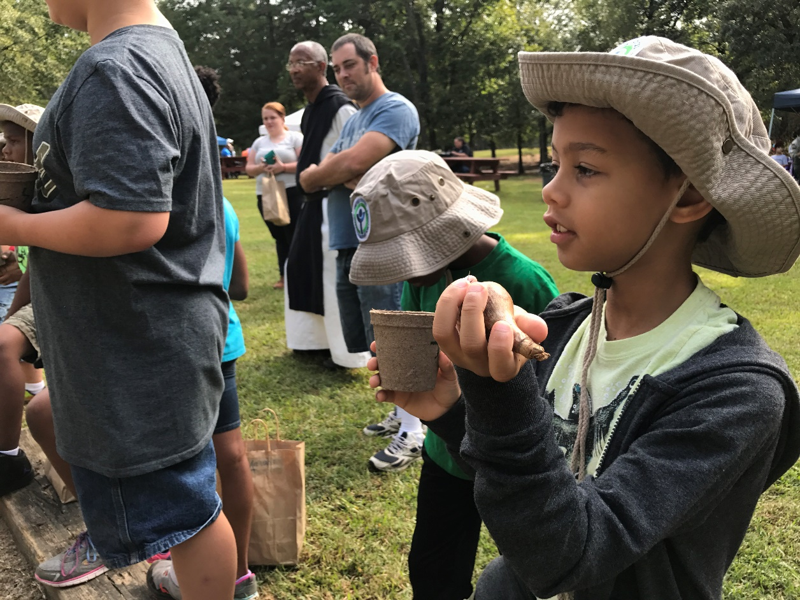
Get in the dirt with a hands-on planting workshop.
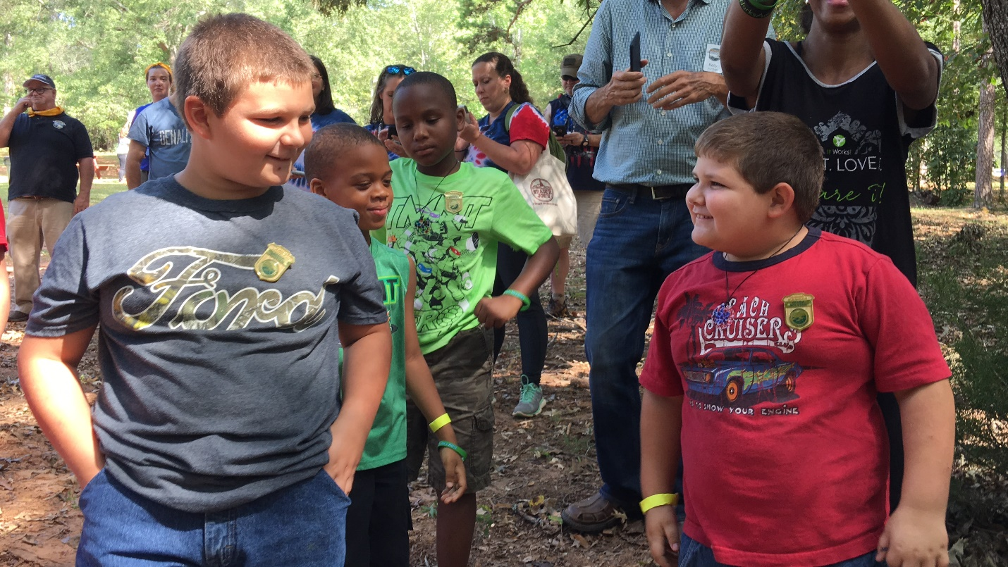
A group of newly-minted Junior Rangers proudly sport their badges at a previous Junior Ranger event. Junior Ranger Day ends with a hike and swearing-in at Arabia Mountain.
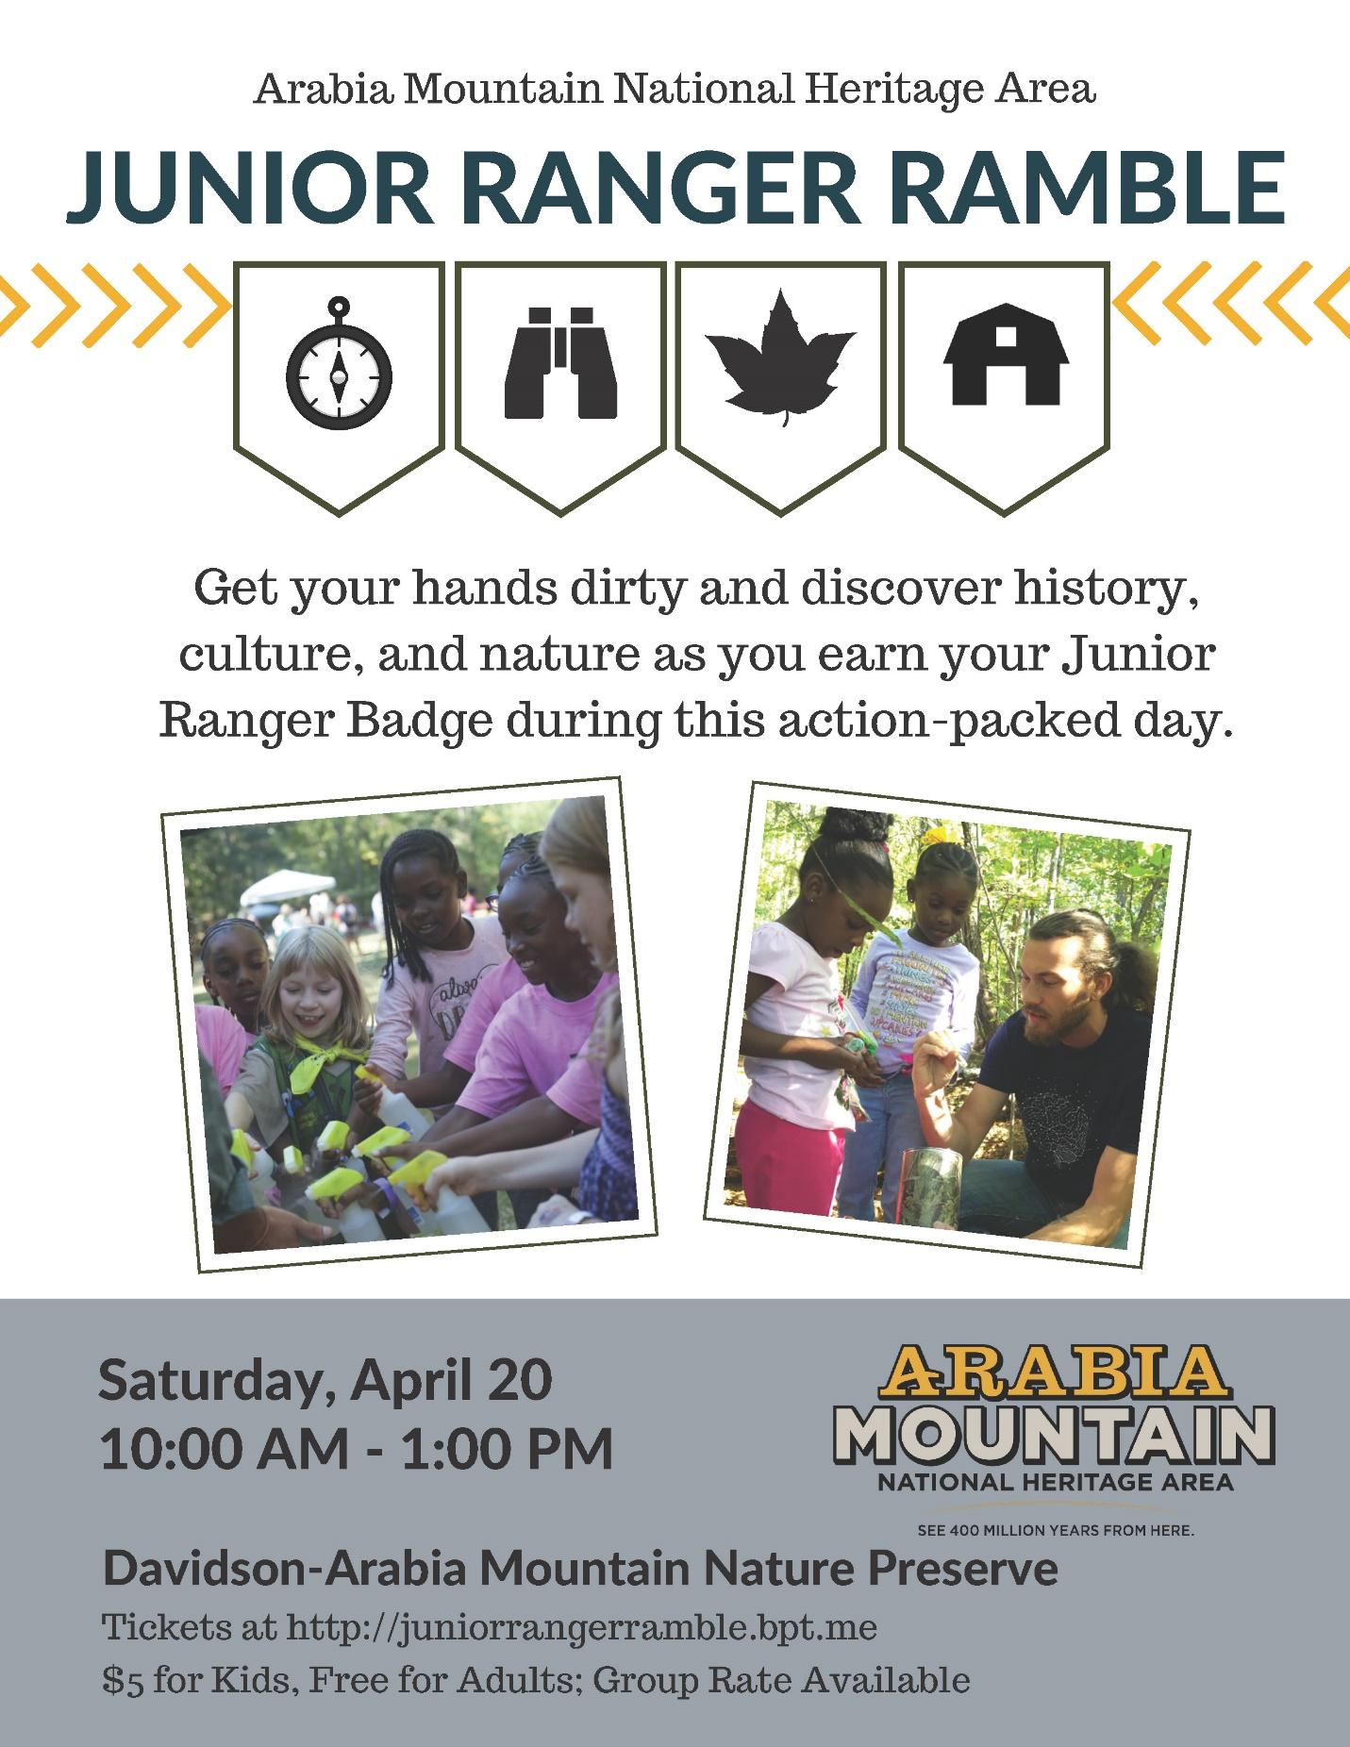
Flyer for this year’s Junior Ranger Day, taking place on April 20th from 10am – 1pm.
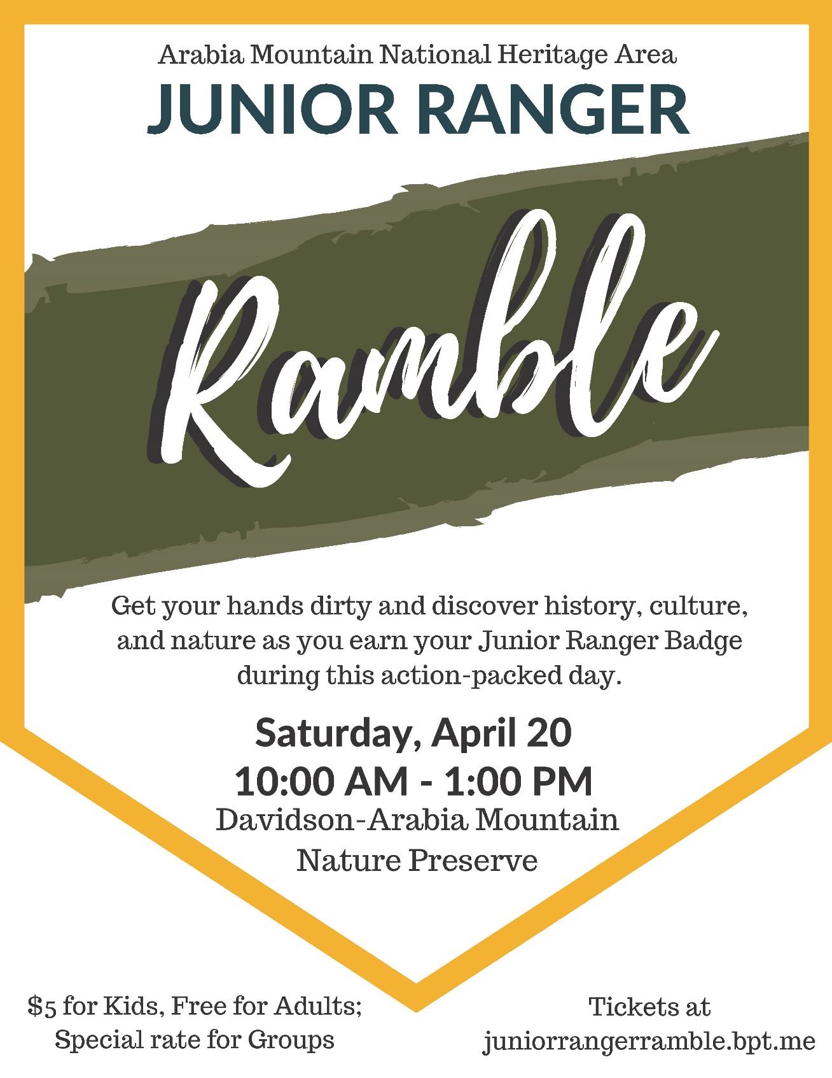
Poster for this year’s Junior Ranger Day, taking place on April 20th from 10am – 1pm.

###

About the Arabia Alliance
The Arabia Mountain Heritage Area Alliance is dedicated to protecting, connecting and sharing the unique history, rich culture and engaging landscapes of the Arabia Mountain National Heritage Area (AMNHA) for the benefit and enjoyment of all. The staff and volunteer board of the Arabia Alliance work with partners across the AMNHA to ensure that everyone can benefit from the cultural and natural resources of the National Heritage Area. For more information, visit www.arabiaalliance.org.

