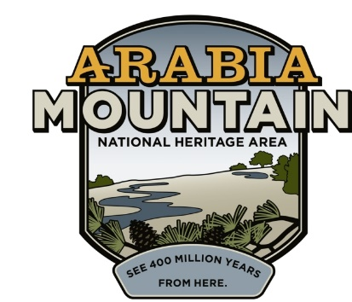
Media Contact: Zack Loehle, Communications Manager
Arabia Mountain Heritage Area Alliance
p: 404-998-8384 | e: zack@arabiaalliance.org

FOR IMMEDIATE RELEASE
Feb. 27, 2019

Monadnock Madness 2019: New Events Added
Triple Hikes, New Geo-Challenge and More Begin Mar. 1

STONECREST, Ga. – Events are now finalized for Monadnock Madness, the annual celebration of Atlanta’s granite mountains. Organized by the Arabia Mountain Heritage Area Alliance, Davidson-Arabia Mountain Nature Preserve, Panola Mountain State Park and the Stone Mountain Memorial Association, Monadnock Madness encompasses over 40 events taking place at the three parks throughout the month of March. As well as the longstanding (and ever-popular) Triple Hikes, Nature Photography Workshops and Mountaintop Yoga, event organizers are excited to announce the inaugural Geocaching Challenge.

Geocaching is an outdoor treasure hunt in which people use a smartphone or GPS to find a container of artifacts hidden in the landscape. The Monadnock Madness Geocaching Challenge features a total of eight caches at Arabia, Panola and Stone Mountains. After downloading a special geocaching passport, explorers must visit each park and find the selected caches to complete the challenge. Those who complete the challenge will receive a special souvenir.

To introduce new people to geocaching, the Arabia Alliance has organized a “Geocaching 101” workshop on Sunday, March 17th from 2:00 to 4:00pm at the Vaughters’ Farmhouse on Klondike Road (registration required). Learn how to geocache from experienced volunteers and discover a whole new way to explore the outdoors.

“Geocaching takes us to places we would never have seen otherwise, especially in the National Heritage Area,” said Sarah Lisle, Director of Interpretation at the Arabia Alliance. Lisle has been working with a variety of volunteers to make the special geocaching challenge possible: “We wouldn’t have a geocaching program without our passionate group of volunteers, and we’re so excited to add this special challenge as a part of Monadnock Madness,” she said. Nearly 90 geocaches are hidden throughout the Arabia Mountain National Heritage Area, and explorers can earn prizes year-round as they find the caches. More information about geocaching in the Arabia Mountain National Heritage Area is available at the Arabia Alliance’s website.

As well as the geocaching challenge, Monadnock Madness gives visitors a variety of opportunities to explore the three parks. One of the most popular events is the Triple Hike Challenge, a series of guided hikes in which people summit Arabia, Panola and Stone Mountains in one day. A full list of hikes, gatherings and other events taking place during Monadnock Madness can be found online.

For those who prefer to go at their own pace, the “Hike as you Like” option is another way to complete the Triple Hike Challenge. Guests can pick up a passport at one of the three parks and receive a stamp from park rangers after they have finished hiking. Passports can also be found online.
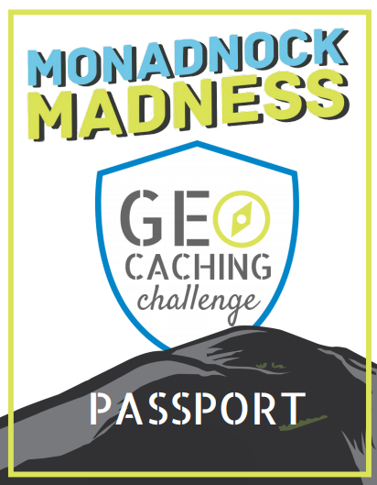
The 2019 Monadnock Madness Geocaching Challenge passport cover. Complete your passport to get a special souvenir.

Monadnock Madness highlights are listed below:
Monadnock Madness begins! | Friday, March 01
Triple Hike | Saturday, March 02
Photography Workshop | Saturday, March 02
Triple Hike* | Saturday, March 16
Photography Workshop | Sunday, March 17
Geocaching Workshop | Sunday, March 17
Mountaintop Yoga | Saturday, March 23
Triple Hike* | Saturday, March 30

*Note that there are two triple hike options per day on March 16th and 30th.

Begin your adventure at the Monadnock Madness website, where you can learn more about the events and purchase tickets.

###
About Arabia Alliance
The Arabia Mountain Heritage Area Alliance is dedicated to protecting, connecting and sharing the unique history, rich culture and engaging landscapes of the Arabia Mountain National Heritage Area (AMNHA) for the benefit and enjoyment of all. The staff and volunteer board of the Arabia Alliance work with partners across the AMNHA to ensure that everyone can benefit from the cultural and natural resources of the National Heritage Area. For more information, visit www.arabiaalliance.org.

