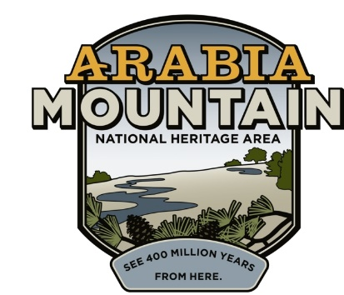
Media Contact: Zack Loehle, Communications Manager
Arabia Mountain Heritage Area Alliance
p: 404-998-8384 | e: zack@arabiaalliance.org

FOR IMMEDIATE RELEASE
Dec. 12, 2018

Historic Vaughters’ Barn Stabilization Complete
Monthlong Effort to Salvage Historic DeKalb Icon a Success

Stonecrest, Ga. – Following a month of work, stabilization of historic Vaughters’ Barn – the iconic white-painted structure located off of Klondike Road – is complete. The building required significant renovations to fix years of wear and tear, the result of aging materials and the elements. Now that construction has finished, the Barn and meadow loop trail are once again available for hikers and photographers.

Vaughters’ Barn is surrounded by over 140 acres of former dairy pasture that now serves as wildlife habitat. DeKalb County was at one point the biggest dairy producer in the state of Georgia, and this tract of land was part of a sprawling agricultural economy. Owned by S. B. Vaughters, the barn held cows and horses for most of the 20th century. As most of the surrounding landscape was filled with development, Vaughters sought a different future for his land. “Nearly all the rest of DeKalb County is covered up with homes and businesses...I didn’t want that here,” he told the Atlanta Journal Constitution in 2002. He sold his farm, including the barn and family home, to the Georgia Department of Natural Resources that same year; the land is now managed as part of Panola Mountain State Park. The barn, which sits adjacent to Klondike Road and the Arabia Mountain PATH trail, is a central feature of the AMNHA and a popular spot for photographs. (Please note that commercial photography requires a permit from Panola Mountain State Park.)

Prior to the recent renovation, the walls and roof of the barn were bowing outwards and parts of the building had sustained significant water damage. Workers repaired the interior, replaced windows, braced the roof and made other repairs throughout the month of November. The restoration was completed in partnership with the Department of Natural Resources and the Arabia Mountain Heritage Area Alliance, the nonprofit arm of the AMNHA.

Now that the building is again secure, it will be used as an interpretive tool for people to learn about the history of DeKalb County. “Vaughters’ Barn is a key feature of Arabia Mountain NHA, and we are looking forward to further educating visitors about the natural and human history of this former farm,” said Mera Cardenas, Executive Director of the Arabia Alliance. Included in the renovation is the ability to bring guided tours inside the barn, something that was not possible before. Now, through guides and interpretive signage, Vaughters’ Barn will be an educational resource as well as a picturesque historic icon for DeKalb county.

-more-

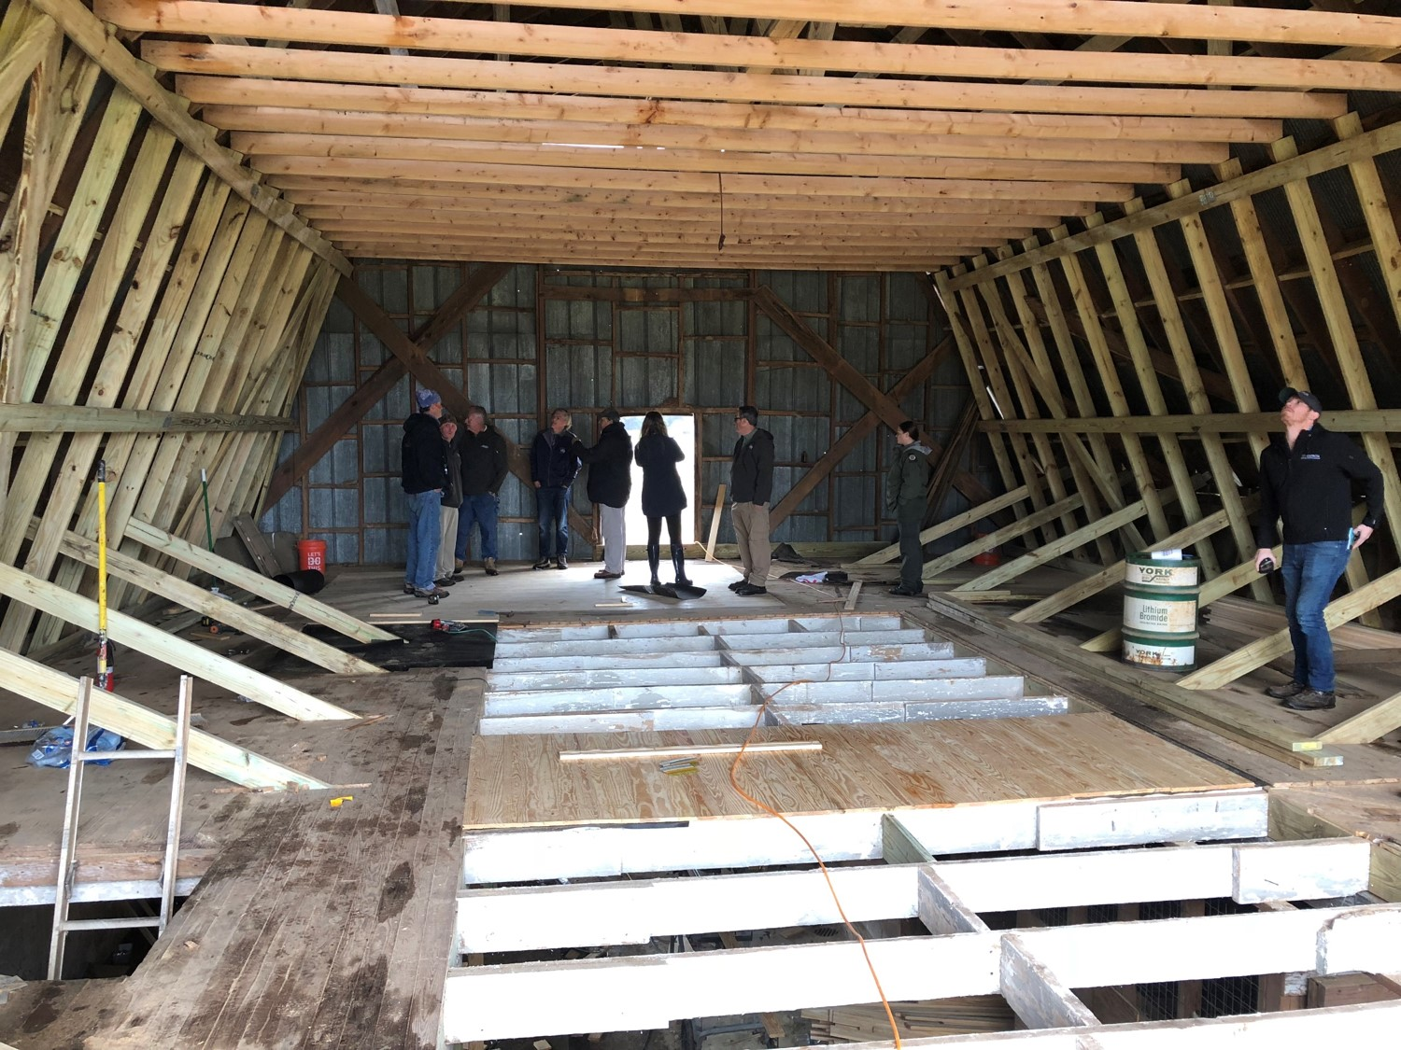
Renovators at work on Vaughters’ Barn. Construction took place throughout November.

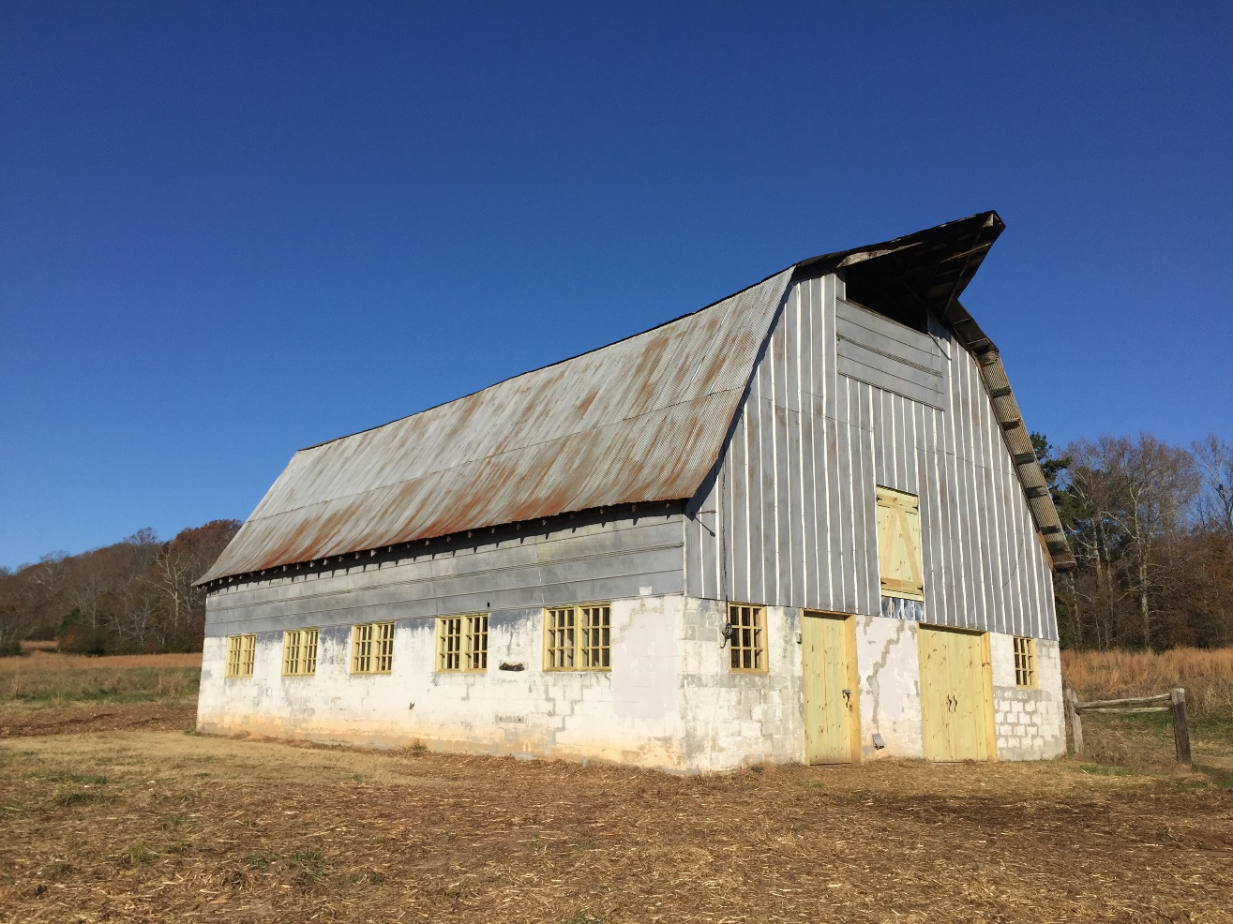
Vaughters’ Barn following renovations. New wood doors and windows will age to match older building materials.

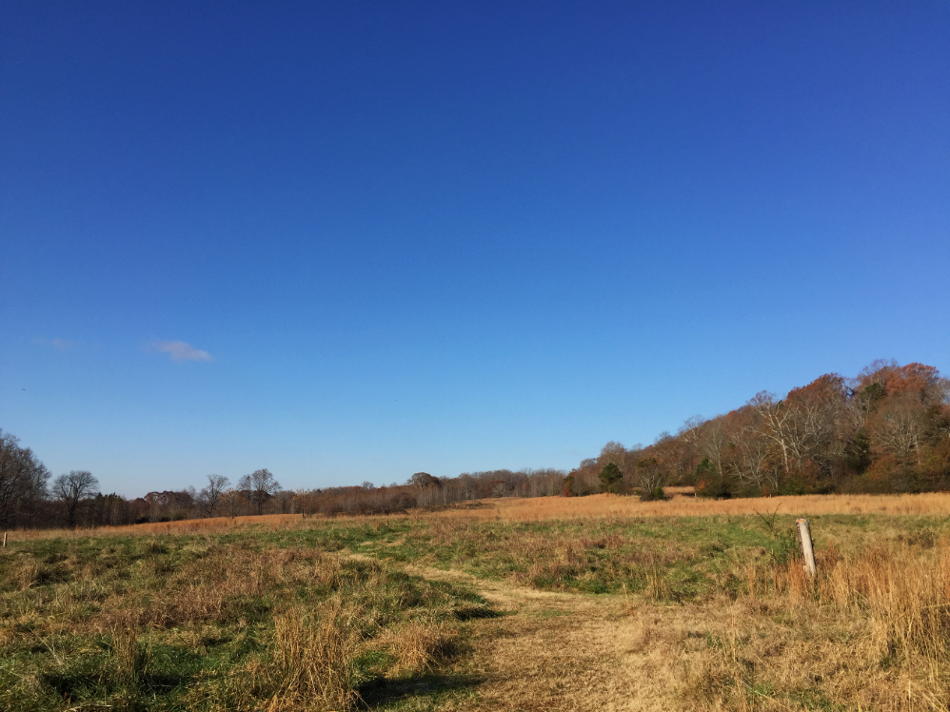
Now that renovations are complete, the Meadow Loop Trail (beginning behind Vaughters’ Barn) is once again open for hiking.
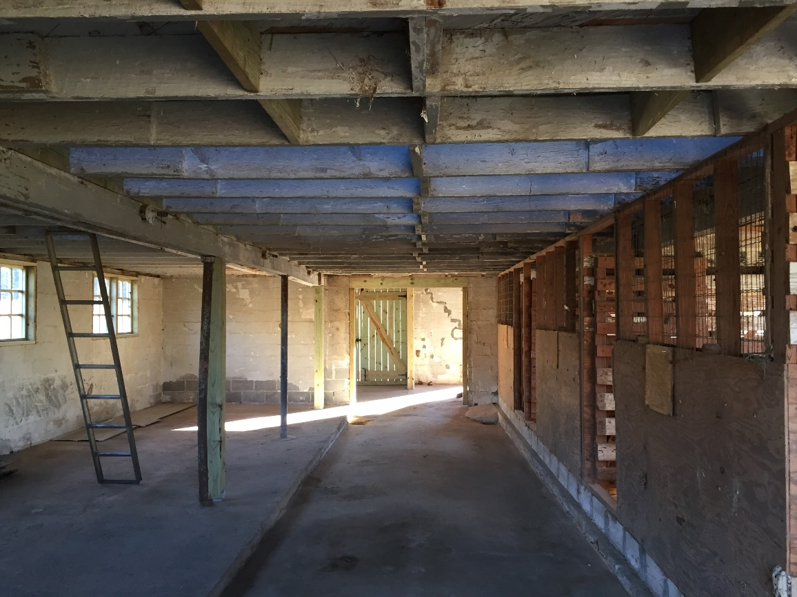
Interior of barn following renovation. Visitors will be able to view the inside of the barn on a guided basis.
Historic photo of Vaughters’ Barn, date unknown. Horse paddock and livestock pasture are visible to the west of the barn.

###

About the Arabia Alliance
The Arabia Mountain Heritage Area Alliance is dedicated to protecting, connecting and sharing the unique history, rich culture and engaging landscapes of the Arabia Mountain National Heritage Area (AMNHA) for the benefit and enjoyment of all. The organization was established in 2006 Congressional legislation as the nonprofit entity tasked with coordination and oversight of the AMNHA. The staff and volunteer board of the Arabia Alliance works to ensure that everyone can benefit from the cultural and environmental resources of the National Heritage Area.

