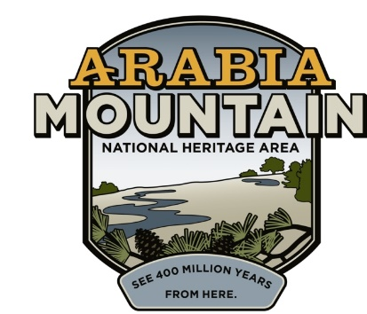
Media Contact: Zack Loehle, Communications Manager
Arabia Mountain Heritage Area Alliance
p: 404-998-8384 | e: zack@arabiaalliance.org

Oct. 15, 2019

Arabia Mountain Heritage Area Alliance
Announces Transition in Leadership
Executive Director Mera Cardenas Leaves Lasting Mark on
National Heritage Area, Metro Atlanta

STONECREST, Ga. – With much gratitude for her service, the Board of Directors of the Arabia Mountain Heritage Area Alliance announces the departure of Mera Cardenas, its longtime Executive Director. She has served with the organization for nearly a decade. Over that time, Cardenas has worked with the Arabia Alliance’s board and its many partners to connect and protect the area’s cultural legacy, greenspace, trails and historic narrative across the 40,000-acre Arabia Mountain National Heritage Area (AMNHA). Those strong partnerships will ensure the success of the AMNHA far into the future.

Cardenas was the first non-volunteer Executive Director of the Arabia Mountain Heritage Area Alliance, which was founded in 1998 to protect and promote the rich landscapes and engaging history of this swath of land in the southeast Atlanta metro. The area was officially designated a National Heritage Area by Congress in 2006. Cardenas has guided the Arabia Alliance to achievements in historic preservation, outdoor recreation and environmental education, as well as managing the growing organization.

Cardenas says her departure is bittersweet: “It has been a great honor and privilege to be part of the Arabia Alliance at such an important juncture in the community’s development. It’s also been great fun, working with our board and partners, to create programs, grow partnerships and share these remarkable landscapes and touching stories. That foundation is solid. With a strong board of directors, numerous non-profit and governmental partners, and excellent staff, I am confident the Arabia Alliance is poised for its next act and prepared to welcome its next leader.”

In a statement, Arabia Alliance co-founders Kelly Jordan and Becky Kelley say: “Hiring Mera was one of the best moves the Arabia Alliance has made in its 20-year history. On behalf of the Alliance Board and staff, we wish her the very best in her new role. We look forward to continuing the exciting projects underway that started under her tenure with the Alliance.”

Cardenas will assume the role of Executive Director at Canalway Partners, a managing entity of the Ohio-Erie Canalway National Heritage Area based in Cleveland, OH. Her departure will be effective by mid-December 2019. The Arabia Alliance will soon announce the search for her successor.

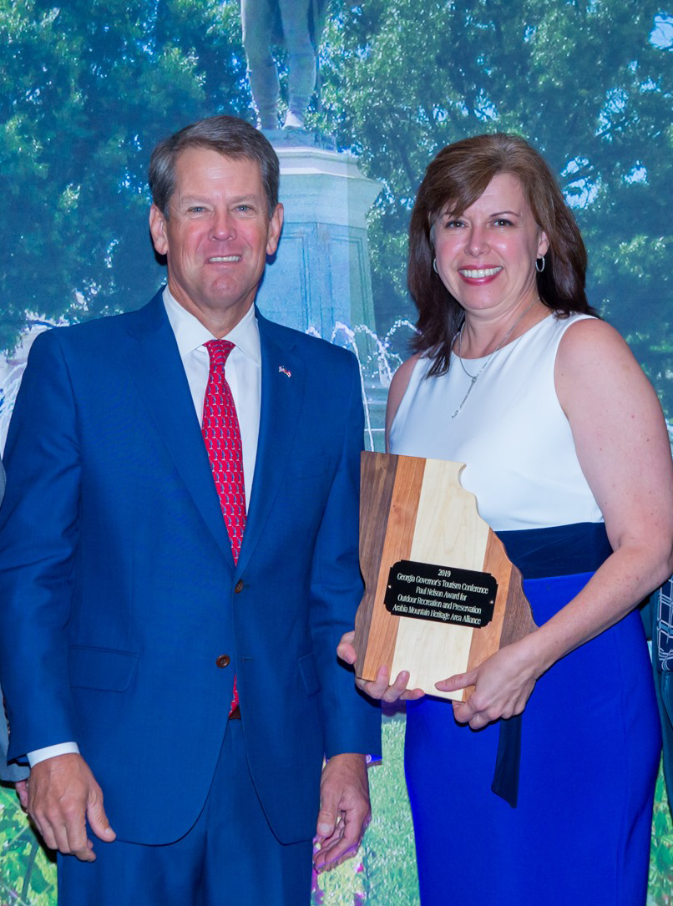

Georgia Governor Brian Kemp presented the Paul Nelson Award for Outdoor Recreation and Preservation to the Arabia Mountain Heritage Area Alliance last month. Accepting on the organization’s behalf is Executive Director Mera Cardenas.
Photo: Georgia Governor’s Tourism Conference.

###
About Arabia Alliance
The Arabia Mountain Heritage Area Alliance, founded in 1998, is dedicated to protecting, connecting and sharing the powerful history, rich culture and engaging landscapes of the Arabia Mountain National Heritage Area (AMNHA) for the benefit and enjoyment of all. The staff and volunteer board of the Arabia Alliance work with partners across the AMNHA and throughout Metro-Atlanta to ensure that everyone can benefit from the cultural and natural resources of the National Heritage Area. For more information, visit www.arabiaalliance.org.

