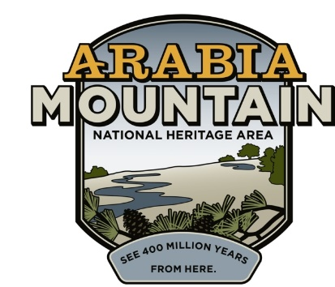
Media Contact: Zack Loehle, Communications Manager
Arabia Mountain Heritage Area Alliance
p: 404-998-8384 | e: zack@arabiaalliance.org

FOR IMMEDIATE RELEASE
Oct. 10, 2019

Arabia Alliance Recruiting for Winter Park Internship
Tom and Killian Smith Arabia Mountain Stewardship Internship Provides Experience in Field of Outdoor Recreation and Conservation

STONECREST, GA. –The Arabia Mountain Heritage Area Alliance is now accepting applications for a two-week park management and conservation internship at Davidson-Arabia Mountain Nature Preserve, in honor of the impactful work of long-time volunteers Tom and Killian Smith. For almost 20 years, the Smiths donated their time, energy and knowledge to make the Nature Preserve a more welcoming place for everybody. Due in no small part to their efforts, Arabia Mountain has become a beloved jewel of the DeKalb County park system. The Tom and Killian Smith Arabia Mountain Stewardship Interns Program will continue their work of caring for this precious greenspace. The Arabia Alliance is accepting applications until Oct. 31, with a priority deadline of Oct. 18.

The Davidson-Arabia Mountain Nature Preserve (DAMNP), in partnership with the Arabia Mountain Heritage Area Alliance, is seeking an intern to lead stewardship and park maintenance projects at DAMNP during the winter of 2019-2020. Interns will receive a stipend, materials budget, and the opportunity to engage in hands-on park projects. This position is ideal for driven, self-directed workers who are comfortable outdoors in all weather.

The internship is designed for undergraduate and graduate students in the fields of: environmental studies, natural resources, recreation management, education, natural sciences and sustainability. Previous parks and recreation experience preferred, or any equivalent combination of education, training, and experience which provides the requisite knowledge, skills, and abilities for this internship.

“Part of being a National Heritage Area is supporting and educating those who will ensure the future of these parks and historic sites,” said Mera Cardenas, Executive Director of the Arabia Alliance. “Through this program, we’re helping open the door to the next generation of park stewards.” Tom and Killian Smith’s dedication to the Nature Preserve has created a lasting legacy. This internship will continue their work to preserve and care for Arabia Mountain and the surrounding greenspace.

For more information and to apply for the internship, please visit: http://arabiaalliance.org/tom-and-killian-smith-arabia-mountain-stewardship-interns-program-2019-2020-applications-open/.
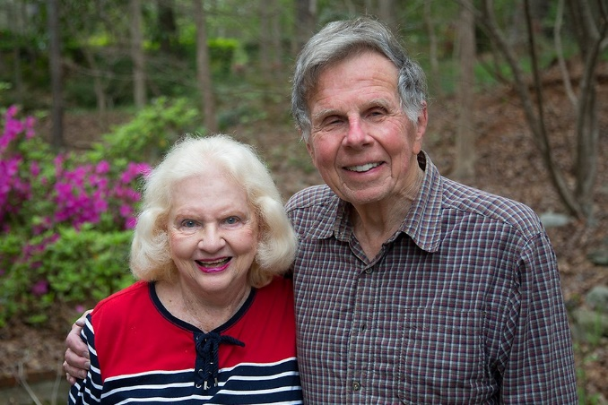
Tom and Killian Smith have donated countless hours to make the Davidson-Arabia Mountain Nature Preserve the welcoming, accessible place it is today. They recently relocated to North Carolina.

###

About the Arabia Alliance
The Arabia Mountain Heritage Area Alliance is dedicated to protecting, connecting and sharing the powerful history, rich culture and engaging landscapes of the Arabia Mountain National Heritage Area (AMNHA) for the benefit and enjoyment of all. The staff and volunteer board of the Arabia Alliance work with partners across the AMNHA to ensure that everyone can benefit from the cultural and natural resources of the National Heritage Area. For more information, visit www.arabiaalliance.org.

