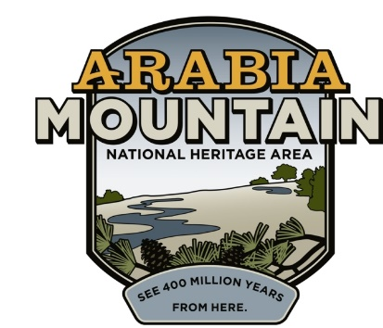
Media Contact: Zack Loehle, Communications Manager
Arabia Mountain Heritage Area Alliance
p: 404-998-8384 | e: zack@arabiaalliance.org

FOR IMMEDIATE RELEASE
Jan. 22, 2019

Monadnock Madness Tickets are LIVE!
Ticket sales open for triple hikes, mountaintop yoga and more

STONECREST, Ga. – Tickets for Monadnock Madness events, part of an annual celebration of metro-Atlanta’s granite outcrops (Arabia, Panola and Stone Mountains), are now open. Events include the ever-popular Triple Hike Challenge, in which hikers summit all three granite mountains in a single day, as well as Mountaintop Yoga and Nature Photography Workshops. The events occur throughout the month of March.

All hikers will earn a commemorative souvenir after completing the Triple Hike Challenge. If you are interested in completing the challenge at your own pace, each park offers visitors the option to “hike as you like,” a self-guided tour of the three monadnocks. Pick up a passport at one of the parks or online at monadnockmadness.com during the month of March.

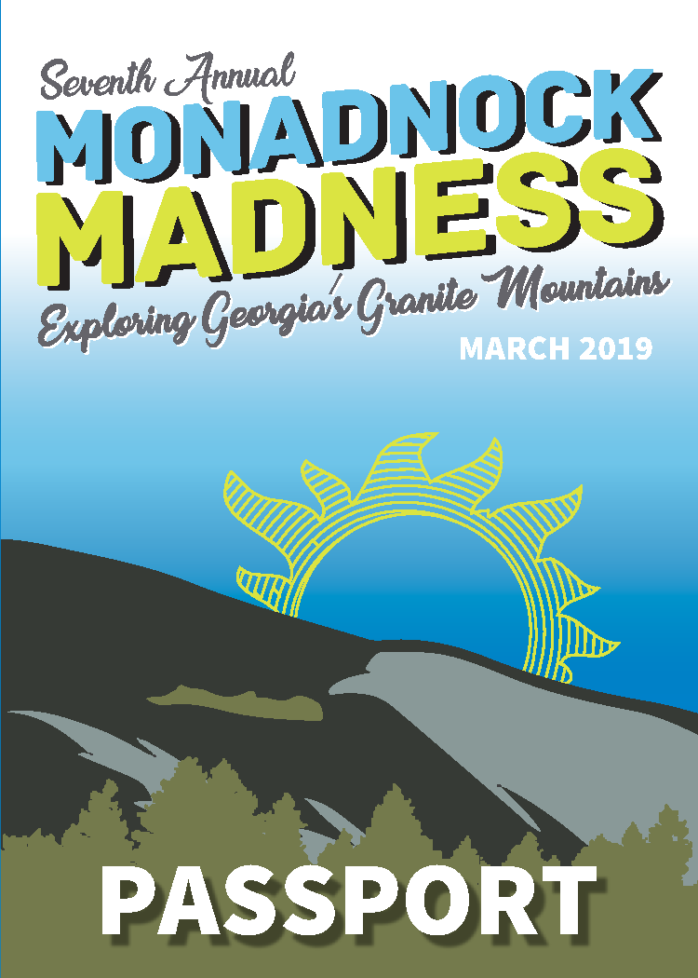
The 2019 Monadnock Madness passport cover. Complete your passport to get a special souvenir at the end of your triple hike.

“Monadnock Madness celebrates our granite giants,” said Mera Cardenas, Executive Director of the Arabia Mountain Heritage Area Alliance, an organizer for the event. “Georgia has a rich natural legacy that we want everyone to share and experience.” Other organizers include the Davidson-Arabia Mountain Nature Preserve, Panola Mountain State Park, and the Stone Mountain Memorial Association. Sponsors include Keep DeKalb Beautiful and the DeKalb Convention and Visitors Bureau.

Event highlights are listed below:
Monadnock Madness begins! | Friday, March 01
Triple Hike | Saturday, March 02
Triple Mountain Photography | Saturday, March 02
Triple Hike* | Saturday, March 16
Triple Mountain Photography | Sunday, March 17
Mountaintop Yoga | Saturday, March 23
Triple Hike* | Saturday, March 30

*Note that there are two triple hike options per day on March 16th and 30th.

Begin your adventure at the Monadnock Madness website, where you can learn more about the events and purchase tickets.

###
About Arabia Alliance
The Arabia Mountain Heritage Area Alliance is dedicated to protecting, connecting and sharing the unique history, rich culture and engaging landscapes of the Arabia Mountain National Heritage Area (AMNHA) for the benefit and enjoyment of all. The staff and volunteer board of the Arabia Alliance work with partners across the AMNHA to ensure that everyone can benefit from the cultural and natural resources of the National Heritage Area. For more information, visit www.arabiaalliance.org.

